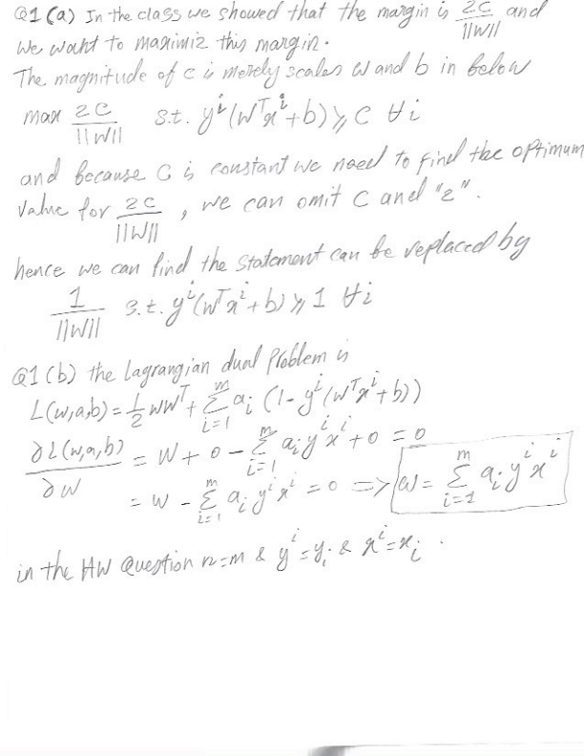

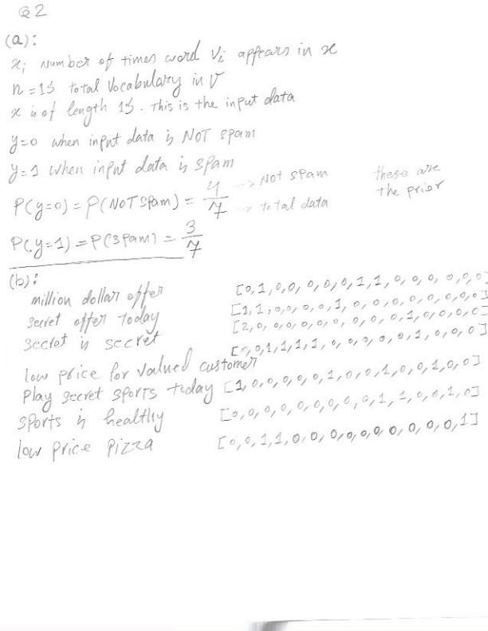

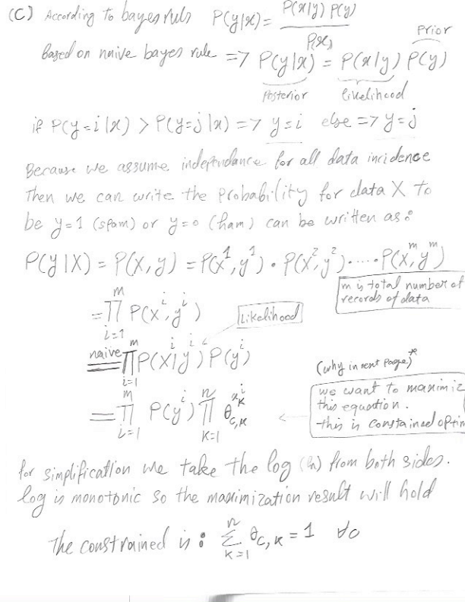

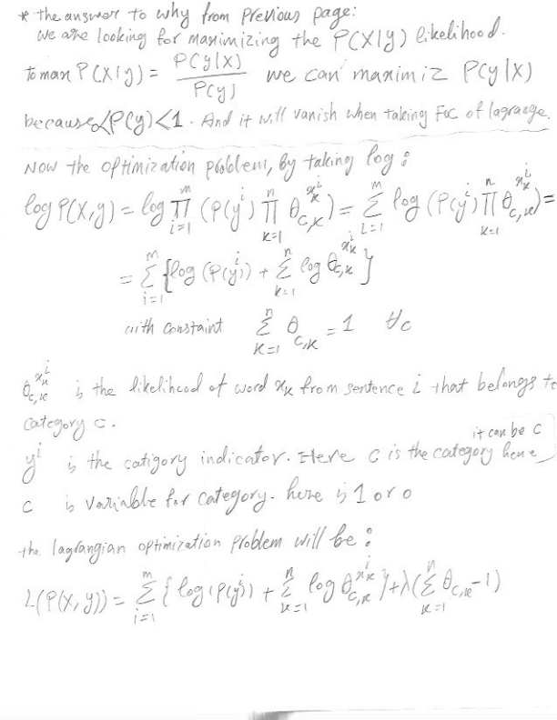

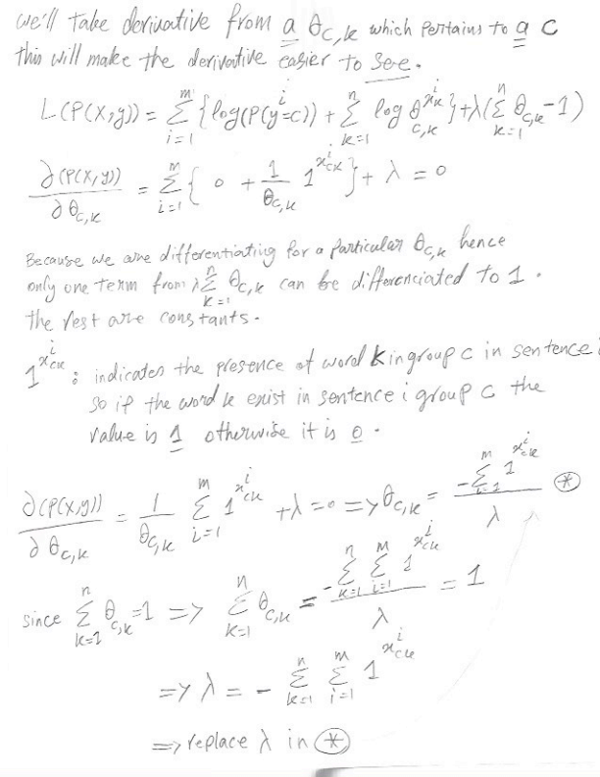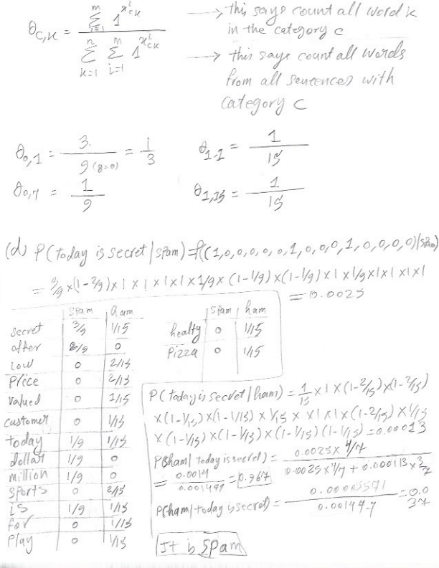

Q3

# Q3-a-i

When I ran the classification with the test data (20%), all three classifiers performed the same. As shown below.

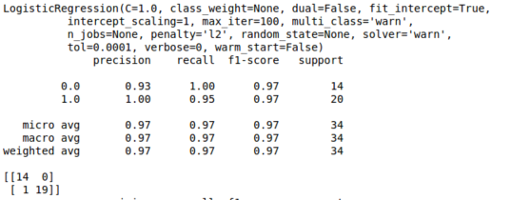

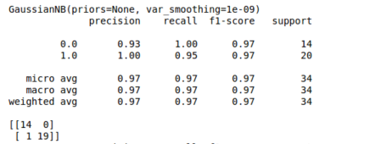

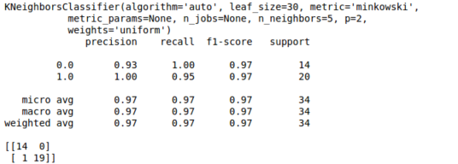

But then I ran the classification on the entire data, the I noticed that logistic regression had higher precision. I believe that data in the divorce dataset is linearly separable and therefore logistic regression performed the best and Gaussian Naïve Bayes and KNN performed slightly worse than logistic regression.

Logistic Regression

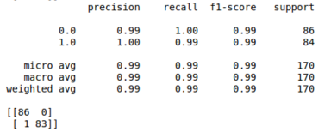

Guassian Naïve Bayes

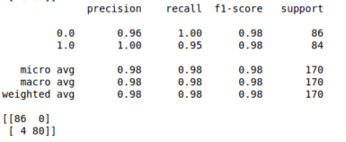

KNearest Neighbor

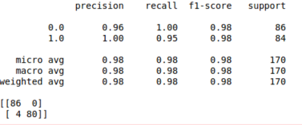

# Q3-a-ii

As can be seen from the figures below, logistic regression is classifiers works best for data that linearly separable. KNN shows more overfitting, and Naïve Bayes is more suitable for non- linearly separable data sets classification.

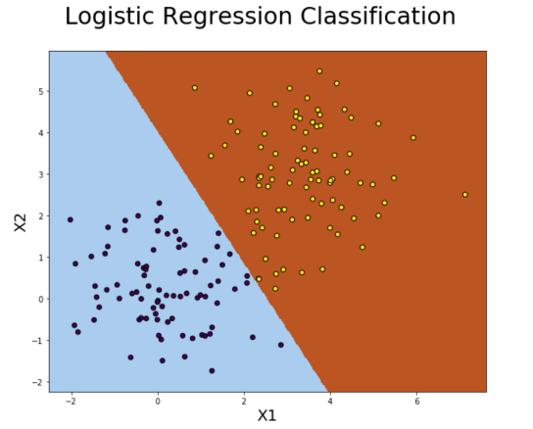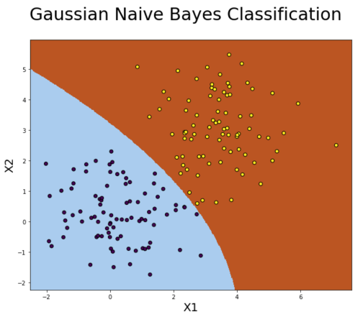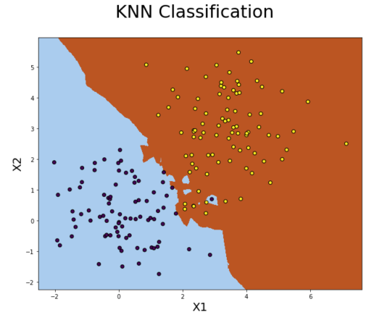

# Q3-b

For the part b, we had more data in our test dataset. The results are more impressive than section before. As it can be seen in figure below, KNN performed the best. And the reason for this performance is because the MNIST data set is less linearly separable and KNN performed the best here.

