Experiment 9: DNS Server Configuration
Aim: To configure Ubuntu linux system to work as DNS server.

Learning Outcomes:
After completion of this experiment, student should be able to
- Configure DNS server as primary and caching name server.
- Modify various DNS records
- Troubleshoot DNS problems.

Theory:
Domain Name Service (DNS) is an Internet service that maps IP addresses and fully qualified domain names (FQDN) to one another. In this way, DNS alleviates the need to remember IP addresses. Computers that run DNS are called name servers. Ubuntu ships with BIND (Berkley Internet Naming Daemon), the most widely deployed DNS server. Domain names are arranged within a tree structure rooted at the root domain, which is designated by a single dot. Underneath the root domain are a series of top-level domains (TLDs) whose names take one of two forms:
  - generic suffixes loosely indicating organization type (gTLDs)
  - Two-character country codes (ccTLDs).
Name servers provide name resolution services for a DNS zone. A zone is the name given to the collection of hosts within a domain, excluding any subdomains.
The DNS configuration files are stored in the /etc/bind directory. The primary configuration file is /etc/bind/named.conf.
The include line specifies the filename which contains the DNS options. The directory line in the/etc/bind/named.conf.options file tells DNS where to look for files. All files BIND uses will be relative to this directory.
The file named /etc/bind/db.root describes the root nameservers in the world. The servers change over time, so the/etc/bind/db.root file must be maintained now and then. This is usually done as updates to the bind9 package. The zonesection defines a master server, and it is stored in a file mentioned in the file option.
Some of the most common configurations are a caching nameserver, primary master, and as a secondary master.
  - When configured as a caching nameserver BIND9 will find the answer to name queries and remember the answer when the domain is queried again.
  - As a primary master server BIND9 reads the data for a zone from a file on it's host and is authoritative for that zone.
  - In a secondary master configuration BIND9 gets the zone data from another nameserver authoritative for the zone.

It is possible to configure the same server to be a caching name server, primary master, and secondary master. A server can be the Start of Authority (SOA) for one zone, while providing secondary service for another zone. All the while providing caching services for hosts on the local LAN.

Procedure:
Task 1: Installation of BIND

- At a terminal prompt, enter the following command to install dns:
sudo apt-get install bind9
- A very useful package for testing and troubleshooting DNS issues is the dnsutils package. To install dnsutils enter the following:
sudo apt-get install dnsutils
Task 2: Configure Cache NameServer

- The default configuration is setup to act as a caching server. All that is required is simply adding the IP Addresses of your ISP's DNS servers. Simply uncomment and edit the following in /etc/bind/named.conf.options:
forwarders {
1.2.3.4;
5.6.7.8;
};
- Replace 1.2.3.4 and 5.6.7.8 with the IP Adresses of actual nameservers. Use 8.8.8.8 and 8.8.4.4

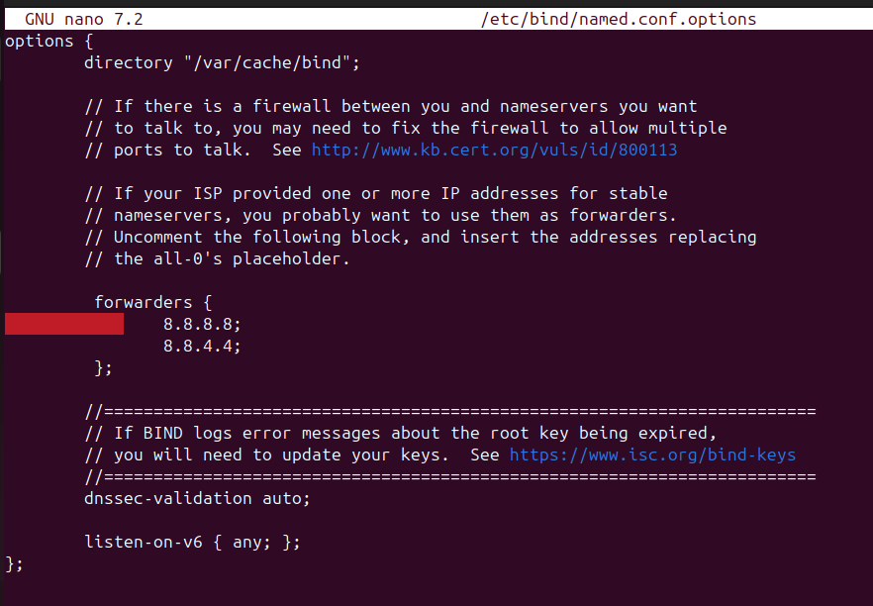
- After the above change, restart the DNS server.

$ sudo service bind9 restart or sudo /etc/init.d/bind9 restart

Task 3: Configuring primary master

- To add a DNS zone to BIND9, turning BIND9 into a Primary Master server, the first step is to edit /etc/bind/named.conf.local:
zone "example.com" { type master;
file "/etc/bind/db.example.com";
};
- 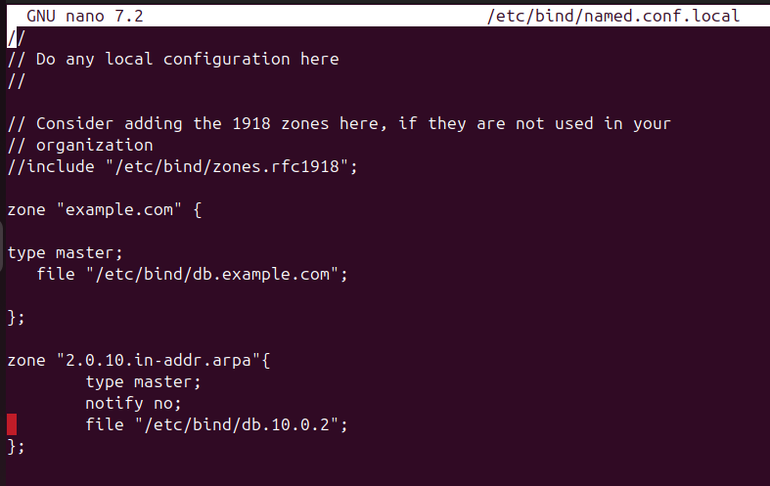

- Now use an existing zone file as a template to create the /etc/bind/db.example.com file:

sudo cp /etc/bind/db.local /etc/bind/db.example.com
- Edit the new zone file /etc/bind/db.example.com change localhost. to the FQDN of your server, leaving the additional "." at the end. Change 127.0.0.1 to the nameserver's IP Address and root.localhost to a valid email address, but with a "." instead of the usual "@" symbol, again leaving the "." at the end.
- Also, create an A record for ns.example.com. The name server in this example:
;
; BIND data file for local loopback interface
;
$TTL 604800
@ IN SOA ns.example.com. root.example.com. (
2 ; Serial
604800 ; Refresh
86400 ; Retry
2419200 ; Expire
604800 ) ; Negative Cache TTL
;
@ IN NS ns.example.com. @ IN A 127.0.0.1
@ IN AAAA ::1
ns IN A 10.0.2.15
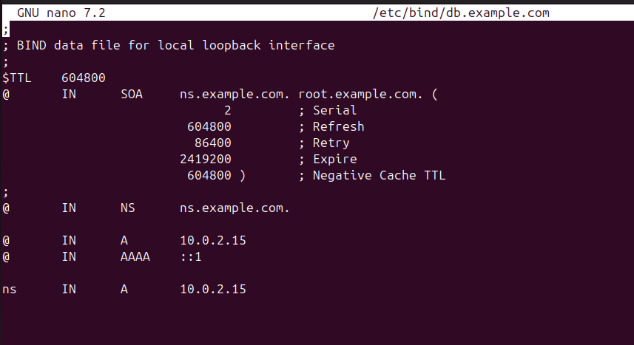

- You must increment the Serial Number every time you make changes to the zone file. If you make multiple changes before restarting BIND9, simply increment the Serial once.
- Once you have made a change to the zone file BIND9 will need to be restarted for the changes to take effect:
sudo /etc/init.d/bind9 restart
- Reverse Zone File

Now that the zone is setup and resolving names to IP Adresses a Reverse zone is also required. A Reverse zone allows DNS to resolve an address to a name.

Edit /etc/bind/named.conf.local and add the following:

zone "2.0.10.in-addr.arpa" { type master;
notify no;
file "/etc/bind/db.10.0.2";
};
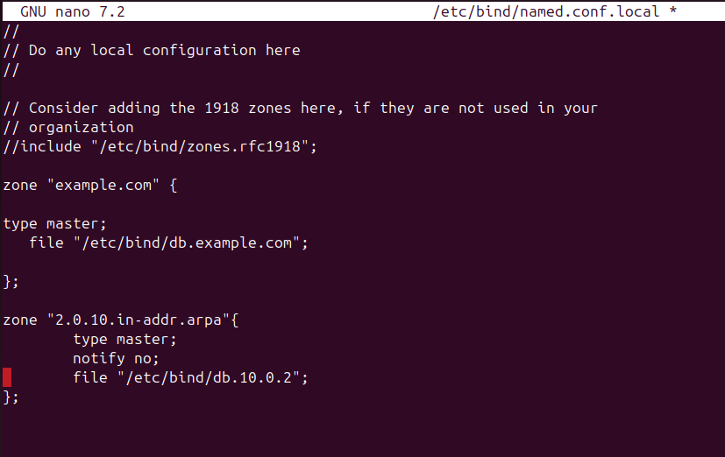

Now create the /etc/bind/db.192 file:
sudo cp /etc/bind/db.127 /etc/bind/db.192

Next edit /etc/bind/db.192 changing the basically the same options as /etc/bind/db.example.com:
;
; BIND reverse data file for local loopback interface
;
$TTL 604800
@ IN SOA ns.example.com. root.example.com. (
2 ; Serial
604800 ; Refresh
86400 ; Retry
2419200 ; Expire
604800 ) ; Negative Cache TTL
;
@ IN NS ns.
10 IN PTR ns.example.com.
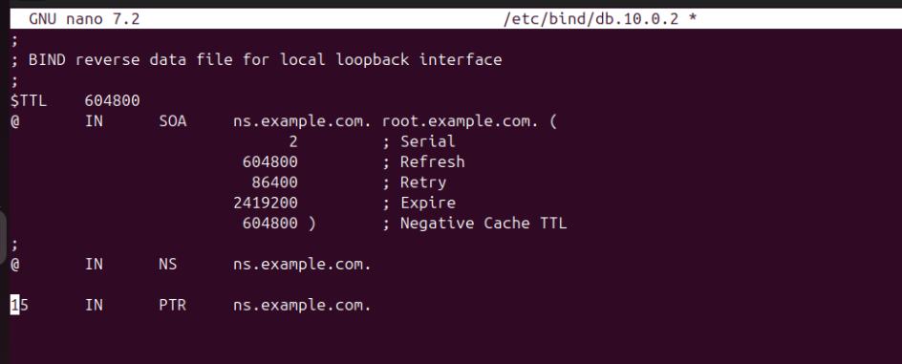

The Serial Number in the Reverse zone needs to be incremented on each changes as well. For each A record you configure in /etc/bind/db.example.com you need to create a PTR record in /etc/bind/db.192.

After creating the reverse zone file restart BIND9:
sudo /etc/init.d/bind9 restartsu

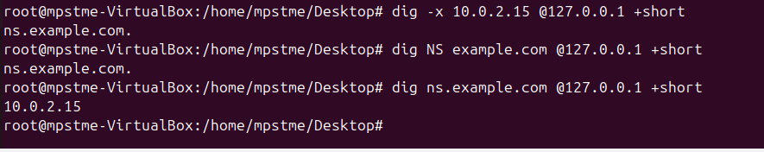
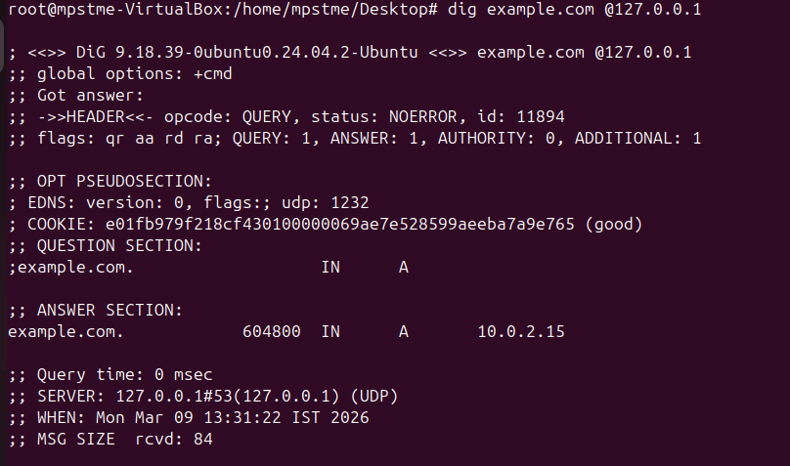

In /var/log/syslog you should see something similar to:
slave zone "example.com" (IN) loaded (serial 6)
slave zone "100.18.172.in-addr.arpa" (IN) loaded (serial 3)

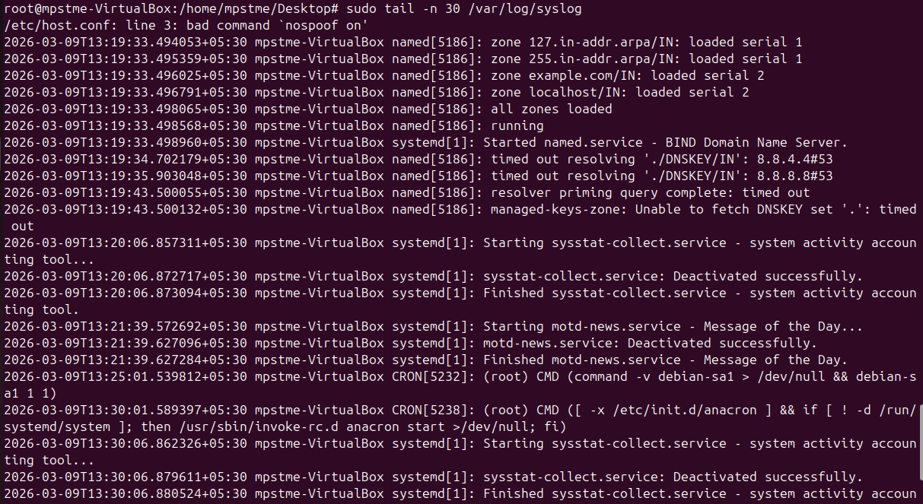

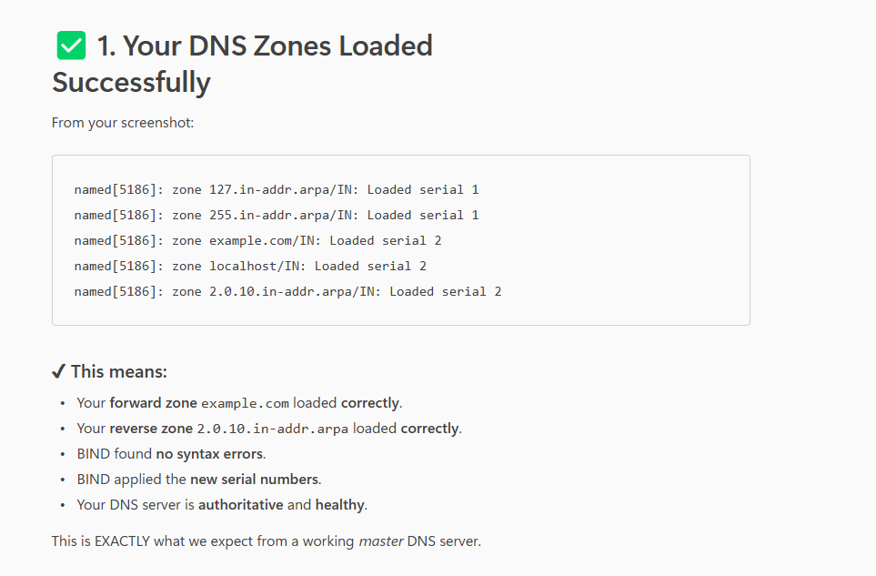

Note:
  - Replace 192.168.1.10 with the IP Address of your Primary nameserver.
  - Replace 192.168.1.11 with the IP Address of your Secondary nameserver.

For more information refer Ubuntu help page.
  - https://ubuntu.com/server/docs/service-domain-name-service-dns
  - https://help.ubuntu.com/community/BIND9ServerHowto

Review question:
- What are most common configuration for nameserver? Explain each configuration in brief.
- Explain difference between domain and zone?
- What are various types of records in DNS?
- Which commands can be used to troubleshoot DNS?
- What is zone transfer?

