A Network Alignment Based Method for Phylogenetic Analysis of Interdependent Morphological Characters

Tristan J. Canterbury
Supervisor: Dr. Martin D. Brazeau
Imperial College London
MSc Computational Methods in Ecology and Evolution
tjc19@ic.ac.uk

Introduction
Terminology:
- Homology:
- Dynamic homology:
- Evolutionary Morphology:
- Graphs:
- isomorphisms:
- Graphlets: small, connected, non-isomorphic, “induced” subgraphs of a larger graph (Pržulj, Corneil and Jurisica, 2004)⁠.
- Automorphism orbit: within each graphlet, some nodes are topologically identical (Pržulj, 2007)⁠.
- Graphlet degrees: whilst node degree is the number of edges connected to a particular node/vertex, graphlet degree is the number of times a given node, v, touches a graphlet or orbit i.

Thoughts:
- The most informative character states in phylogenetic analysis are those that have effectively neutral fitness effects and so are less likely to emerge across taxa convergently. This means character states can vary greatly in function across a taxa without much meaning in phylogenetic analysis. This makes morphological methods difficult, as what aspects of morphology are effectively neutral? Molecular phylogenetics has a great advantage here, as any mutation that doesn’t cause a change in gene expression is assumed neutral and so can make for an informative character in phylogenetic analysis.
- The use of graphs for comparing morphology in terms of physical connections seems flawed for the following reasons:
- The amount of physical connection between 2 characters is not binary, using a proportion of surface area in contact would be a better measure of connection (fixed with a weighted graph).
- Using only the top surface of the head gives an unrealistic graph structure where all characters eminate from the center (Could a weighted graph fix this? If the graph is weighted in the below manner, there will be connections between nodes that otherwise wouldn’t be connected giving the graph a less problematic centralised structure. However this may also generate a connected graph in which topology becomes homogenous except for weights; biologically realistic but computationally feasible?.).
- We are continuing to use similarity scores from other aspects of the character nodes. Are some of these not also relations, as would be hypothesised? For instance, is the likeness of tissue between characters not a relationship between them? And if so should this not also be constructed as a network? (Fixed with multigraph, represented as a weighted graph)
- The analysis must make use of weights.

The Importance of Morphological evidence: As most species that have ever lived are extinct, few of which we have fossils for, the value of robust methods for inferring phylogenetic relationships from morphology becomes apparent. Where we also have molecular data, morphology continues to be an invaluable independent source of data (Lee and Palci, 2015)⁠ and when there appears to be disagreement between these sources there is room for improvement in our methods and understanding (Morlon, Parsons and Plotkin, 2011; Slater, Harmon and Alfaro, 2012)⁠. As sparse as the fossil record is, surprisingly we expect 1%-10% of known fossil species to be directly ancestral to other known fossil species (Foote, 1996). The idea of identifying such ancestor-descendent relationships (ADR) started with Darwin in 1859 but most work has focused instead on sister group relationships (SGRs) (Dayrat, 2005)⁠. Interest remains however, with some success even for taxa where the fossil record is less dense (Tsai and Fordyce, 2015)⁠, but more frequent success for those taxa with a dense fossil record (Foote and Sepkoski, 1999; Aze et al., 2011; Scannella et al., 2014). In this paper I will just be testing the new method on finding SGRs but I speak of ADRs to inspire interest in the potential of this apparently unfashionable source of evidence.

Fundamentals of Morphological Phylogenetics: The concept of homology has been at the heart of comparative morphology since before we understood the causes of homology (Jardine, 1967)⁠. The concept of homology precedes Darwin’s explanation of its origins as it simply described an apparent correspondence between parts of two or more organisms in terms of shape and position relative to other parts (Rieppel, 2020). We would now only call too organs homologous between species if they have derived from the same ancestral character. For instance most arthropods have an antennae like appendages, for sensing their environment at a distance, however they are attached to the body at very different locations on the body of different subphyla of Arthropods and so are not all homologous but are the result of convergent evolution. As most arthropods have many appendages, there’s usually some that are redundant and so can be used for this purpose, and at not much extra cost (CITE). For instance Amblipygi use their first pair of legs as antennae whilst the origins of antennae of insects are less obvious but may be homologous to the chelicerae of Chelicerates, where these appendages are used as mouthparts (CITE).

The issue of relations between characters: An issue that arises when we attempt to measure phylogenetic distances based on morphological similarities, from which homology is somewhat arbitrarily inferred, is that many morphological characters do not evolve independently and tend to form hierarchical structures (Hopkins and St. John, 2021)⁠. Taking a wide glance at biology we should expect morphological characters to be interdependent for many different reasons: All morphological characters grow from the same embryo, they are physically connected, most are polygenetic, most alleles that code for a particular character will also code for another (pleiotropy), and they all coevolve and they may serve similar adaptive purposes and so may converge on similar features. Whilst many of these relationships are hard to ascertain, the physical relationships between these characters are often obvious but underutilised in current quantitative methods of phylogenetic analysis as there has been no good way to codify them.

The solution to be investigated: The aim of my project is to represent morphological interdependencies as a network/graph of characters, an anatomical network, and infer phylogenetic distance based on evidence of transformation events between the topologies of these networks, with the assumption that fewer graph transformations means greater parsimony (Grant and Kluge, 2004)⁠. Further questions to explore would be to ask what other useful information can be gained from anatomical networks besides phylogenetic distance, how effective is this method in comparison to other methods and how can the software be further optimised. To best explore the potential of this method I will apply it to the Arthropod head problem.

The Arthropod Head Problem: Problems that do rely heavily on morphological evidence, such as the long unresolved Arthropod head problem (Rempel, 1975; Budd, 2002)⁠, might benefit from this new method. The Arthropod head problem arises from the diversity of segments and appendages to be found across extinct and extant Arthropod taxa for which we struggle to determine homology. We can easily identify homology in part between families of arthropods in the same subphyla but between subphyla homology is much trickier as the common ancestors of these taxa occurred very early in the history of life on earth and so we rely on palaeontology (Budd, 2002)⁠. We can look at the fossil record and observe similarities in position and structure of characters to determine the homology but this leads to much disagreement due to the vagueness of fossil evidence and subjectivity of this kind of method (CITE).

Methods
Graphs: iuhkyg
- Graphlet degrees: are used to measure the topological distance between 2 networks (Pržulj, 2007)⁠, the similarities among nodes of a network (Milenković and Pržulj, 2008), and so are used for network alignment in the GRAAL family and for comparing network structures (Malod-Dognin and Prẑulj, 2014)⁠, or potentially anatomical networks.
- Integer Programming:
- Lagrangian relaxation:
MI-GRAAL allows use of multiple measures of similarity and so is more general purpose – better suited to our needs (Kuchaiev and Pržulj, 2011)⁠.

GRAAL: hfudtc

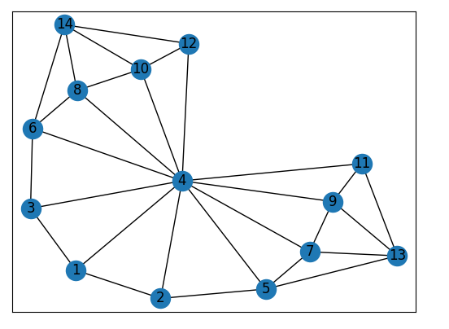
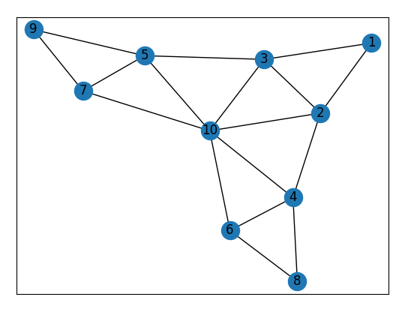
References

Aze, T. et al. (2011) ‘A phylogeny of Cenozoic macroperforate planktonic foraminifera from fossil data’, Biological Reviews, 86(4), pp. 900–927. doi: 10.1111/j.1469-185X.2011.00178.x.
Budd, G. E. (2002) ‘A palaeontological solution to the arthropod head problem’, Nature, 417(6886), pp. 271–275. doi: 10.1038/417271a.
Dayrat, B. (2005) ‘Ancestor-descendant relationships and the reconstruction of the Tree of Life’, Paleobiology, 31(3), pp. 347–353. doi: 10.1666/0094-8373(2005)031[0347:aratro]2.0.co;2.
Foote, M. (1996) ‘On the probability of ancestors in the fossil record’, Paleobiology, 22(2), pp. 141–151. doi: 10.1017/S0094837300016146.
Foote, M. and Sepkoski, J. J. (1999) ‘Absolute measures of the completeness of the fossil record’, Nature, 398(6726), pp. 415–417. doi: 10.1038/18872.
Grant, T. and Kluge, A. G. (2004) ‘Transformation series as an ideographic character concept’, Cladistics, 20(1), pp. 23–31. doi: 10.1111/j.1096-0031.2004.00003.x.
Hopkins, M. J. and St. John, K. (2021) ‘Incorporating Hierarchical Characters into Phylogenetic Analysis’, Systematic Biology. Edited by A. Wright, 0(0), pp. 1–18. doi: 10.1093/sysbio/syab005.
Jardine, N. (1967) ‘The concept of homology in biology’, British Journal for the Philosophy of Science, 18(2), pp. 125–139. doi: 10.1093/bjps/18.2.125.
Kuchaiev, O. and Pržulj, N. (2011) ‘Integrative network alignment reveals large regions of global network similarity in yeast and human’, Bioinformatics, 27(10), pp. 1390–1396. doi: 10.1093/bioinformatics/btr127.
Lee, M. S. Y. and Palci, A. (2015) ‘Morphological phylogenetics in the genomic age’, Current Biology, pp. R922–R929. doi: 10.1016/j.cub.2015.07.009.
Malod-Dognin, N. and Prẑulj, N. (2014) ‘GR-Align: Fast and flexible alignment of protein 3D structures using graphlet degree similarity’, Bioinformatics, 30(9), pp. 1259–1265. doi: 10.1093/bioinformatics/btu020.
Milenković, T. and Pržulj, N. (2008) ‘Uncovering biological network function via graphlet degree signatures’, Cancer Informatics, 6, pp. 257–273. doi: 10.4137/cin.s680.
Morlon, H., Parsons, T. L. and Plotkin, J. B. (2011) ‘Reconciling molecular phylogenies with the fossil record’, Proceedings of the National Academy of Sciences of the United States of America, 108(39), pp. 16327–16332. doi: 10.1073/pnas.1102543108.
Pržulj, N. (2007) ‘Biological network comparison using graphlet degree distribution’, in Bioinformatics. Oxford University Press, pp. e177–e183. doi: 10.1093/bioinformatics/btl301.
Pržulj, N., Corneil, D. G. and Jurisica, I. (2004) ‘Modeling interactome: Scale-free or geometric?’, Bioinformatics, 20(18), pp. 3508–3515. doi: 10.1093/bioinformatics/bth436.
Rempel, J. (1975) ‘Evolution of the Insect Head: the Endless Dispute’, Quaestiones Entomologicae, 11, pp. 7–25. Available at: https://agris.fao.org/agris-search/search.do?recordID=US201302736485 (Accessed: 6 April 2021).
Rieppel, O. (2020) ‘Morphology and Phylogeny’, Journal of the History of Biology, 53(2), pp. 217–230. doi: 10.1007/s10739-020-09600-x.
Scannella, J. B. et al. (2014) ‘Evolutionary trends in Triceratops from the Hell Creek Formation, Montana’, Proceedings of the National Academy of Sciences of the United States of America, 111(28), pp. 10245–10250. doi: 10.1073/pnas.1313334111.
Slater, G. J., Harmon, L. J. and Alfaro, M. E. (2012) ‘Integrating fossils with molecular phylogenies improves inference of trait evolution’, Evolution, 66(12), pp. 3931–3944. doi: 10.1111/j.1558-5646.2012.01723.x.
Tsai, C. H. and Fordyce, R. E. (2015) ‘Ancestor - Descendant relationships in evolution: Origin of the extant pygmy right whale, Caperea marginata’, Biology Letters, 11(1). doi: 10.1098/rsbl.2014.0875.
Wood, H. M. (2017) ‘Integrating fossil and extant lineages: An examination of morphological space through time (Araneae: Archaeidae)’, Journal of Arachnology, 45(1), pp. 20–29. doi: 10.1636/JoA-S-16-039.1.

