**CRM Training Material**

Table of Contents

1 Sales Opportunity 4

1.1 Area/Tab Explanation 5

1.1.1 General Area 5

1.1.2 Potential Tab 5

1.1.3 General Tab 5

1.1.4 Stages Tab 6

1.1.5 Partners Tab 6

1.1.6 Competitors Tab 6

1.1.7 Summary Tab 7

1.1.8 Attachments Tab 7

1.2 Create New Sales Opportunity 8

1.3 Update Existing Sales Opportunity 11

1.4 Sales Opportunity Reports 13

1.4.1 Opportunities Forecast Report 13

1.4.2 Opportunities Forecast Over Time Report 13

1.4.3 Opportunities Statistics Report 13

1.4.4 Opportunities Report 13

1.4.5 Stage Analysis 13

1.4.6 Information Source Distribution Over Time Report 14

1.4.7 Won Opportunities Report 14

1.4.8 Lost Opportunities Report 14

1.4.9 My Open Opportunities Report 14

1.4.10 My Closed Opportunities Report 14

1.4.11 Opportunities Pipeline 14

2 Sales Quotation 15

2.1 Create New Sales Quotation 16

2.2 Edit Existing Sales Quotation 17

2.3 Print Sales Quotation 19

3 Activity 22

3.1 Tab/Area Explanation 23

3.1.1 General Area 23

3.1.2 General Tab 23

3.1.3 Content Tab 23

3.1.4 Linked Document Tab 24

3.1.5 Attachments Tab 24

3.2 Create New Activity 25

3.3 Edit Existing Activity 27

# Sales Opportunity

The Sales Opportunities module lets you track and analyze pending opportunities according to the progress of activities such as meetings, negotiations, and other proceedings in the sales pipeline.

Comprehensive forecasting methods enable you to project potential earnings and prioritize sales activities.

Using the various tabs of the Sales Opportunity window you can process a sales opportunity from creation and field configuration, through updating and reporting, to closure.

It’s located under Opportunities > Opportunity.

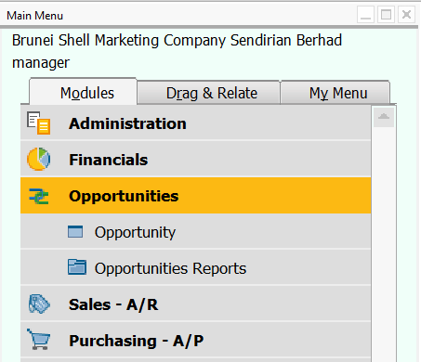

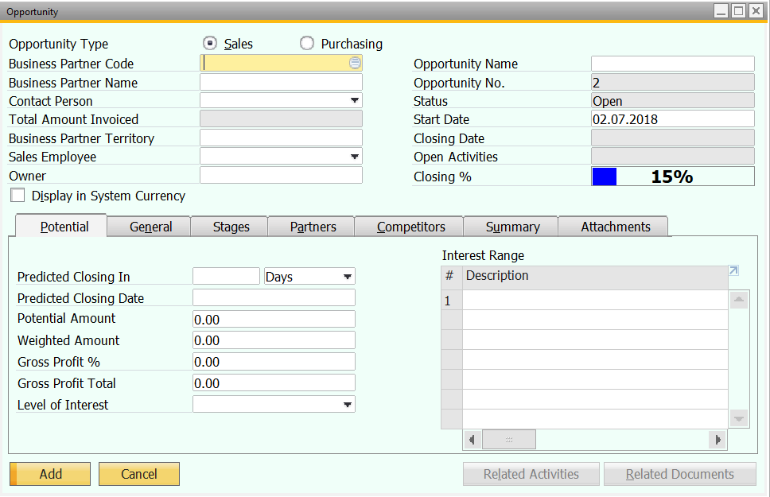

## Area/Tab Explanation

### General Area

Use these fields to enter basic customer or lead information, and to provide information about a specific sales opportunity.

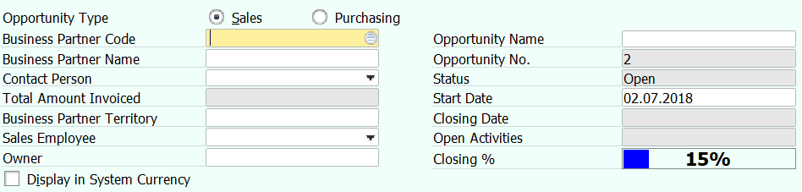

### Potential Tab

Use this tab to estimate the potential profit from the sales opportunity, and the duration of the process.

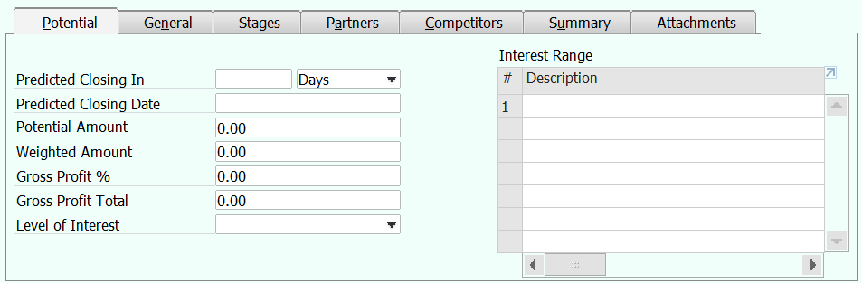

### General Tab

Use this tab to classify sales opportunities according to the business partner channel and other factors.

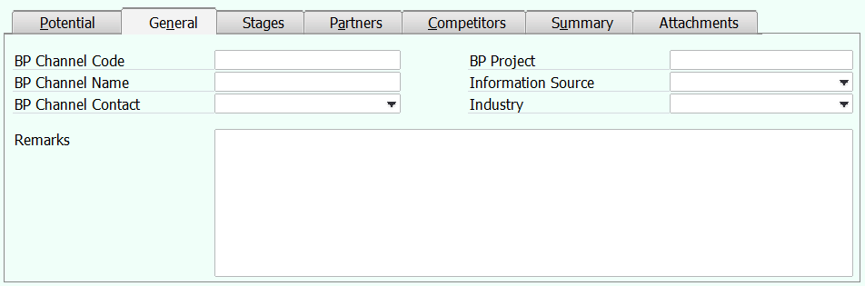

### Stages Tab

Use this tab to monitor the various phases of a sales activity, and to create a new phase, as necessary.

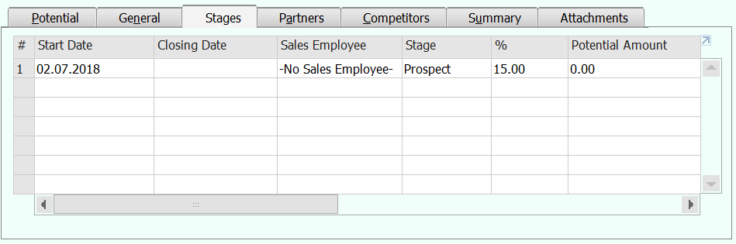

### Partners Tab

Use this tab to monitor the business partners (vendors and leads) with whom this sales opportunity is being jointly handled.

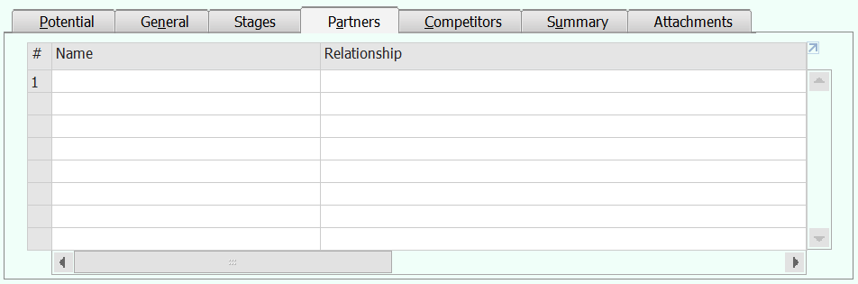

### Competitors Tab

Use this tab to monitor any competitors, per sales opportunity.

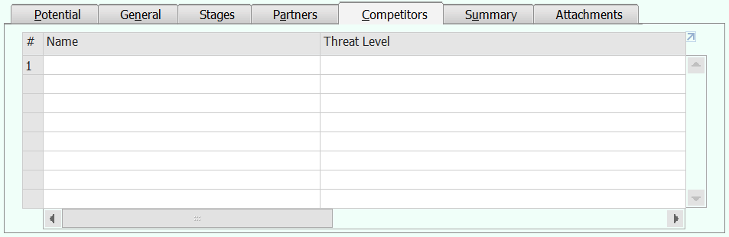

### Summary Tab

Use this tab to close a sales opportunity as either Won or Lost. To update any fields, you must reopen the sales opportunity.

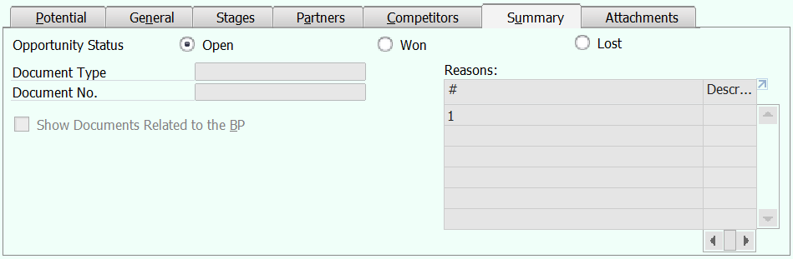

### Attachments Tab

Use this tab to attach relevant files, using the standard Browse, Display, and Delete functions. Acceptable file types include Microsoft Excel files, images, Web links, and so on.

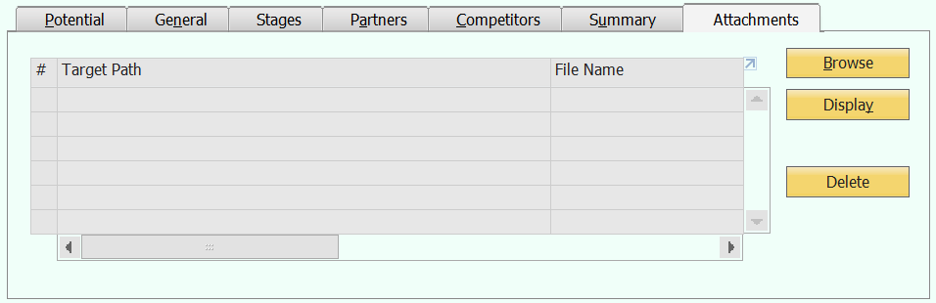

## Create New Sales Opportunity

1. Open Sales Opportunity screen.
2. Click “Add New” icon.



Ignore this step if the bottom left button already showing “Add” which indicate you already in add mode.

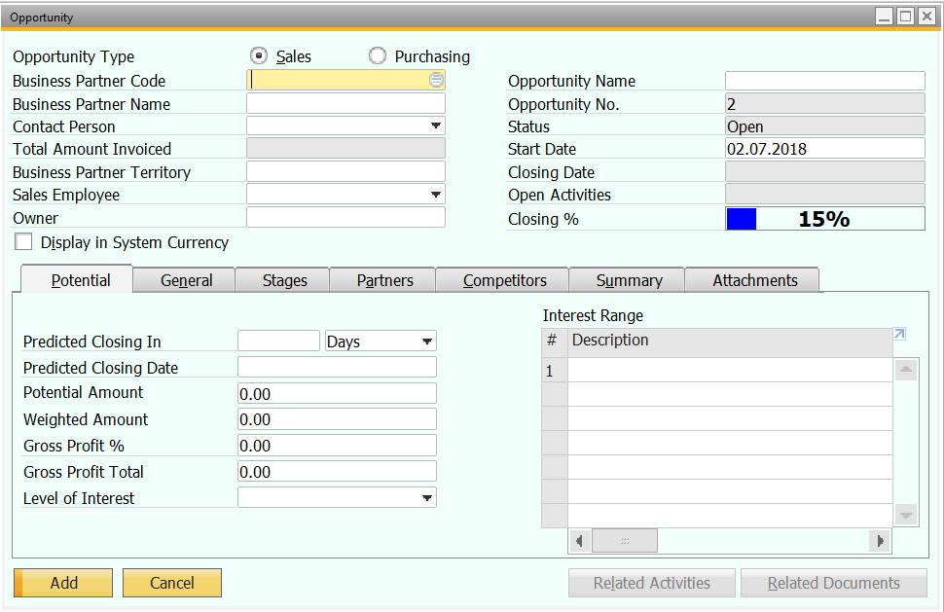

1. In General Area, select Sales as Opportunity Type, select Customer/Lead, input Opportunity Name and change owner and start date if necessary.

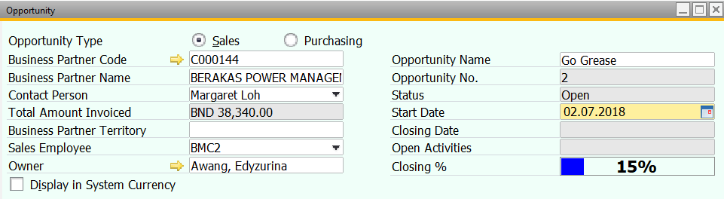

1. In Potential Tab, put in predicted closing date and enter other optional information where necessary.

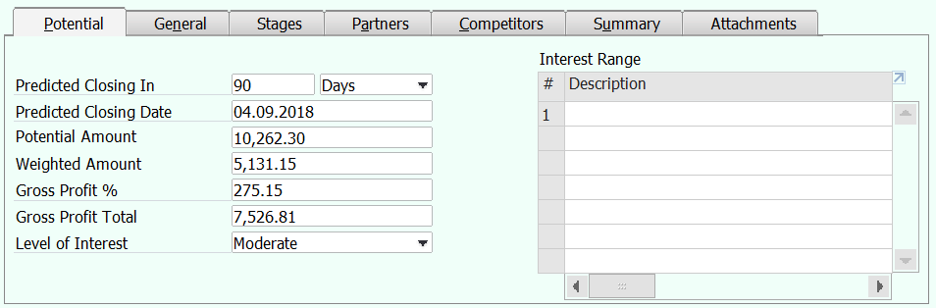

1. In General Tab, these fields are all optional, you can enter where necessary.

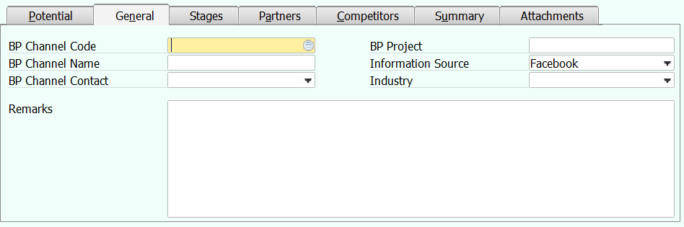

1. In Stages Tab, change start date if necessary, select stage, put in potential amount and bind document to this stage where necessary.

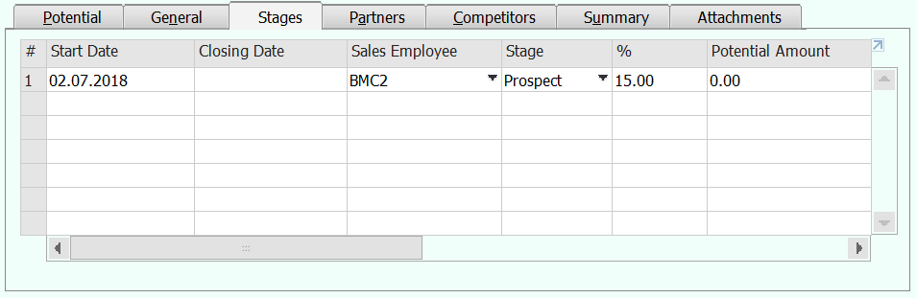

If you want to add another row of new status, insert closing date for previous row, then right click on the row and select “Add Row” option. It will close previous row and a new row will appear as below.

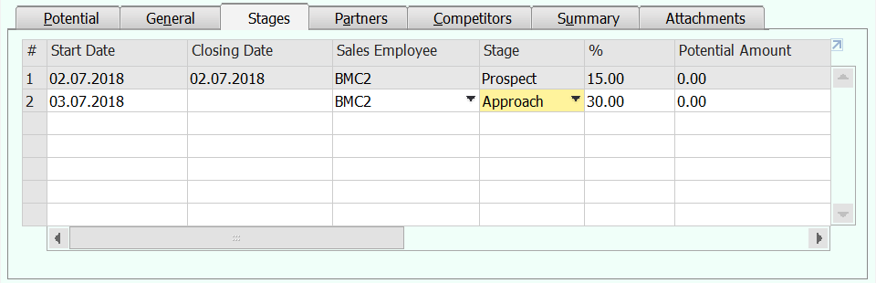

1. In Partners Tab, these fields are all optional, you can enter where necessary.

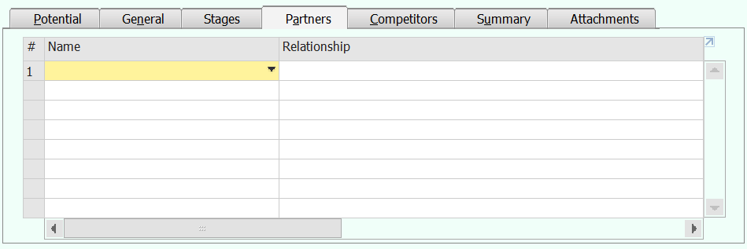

1. In Competitors Tab, these fields are all optional, you can enter where necessary.

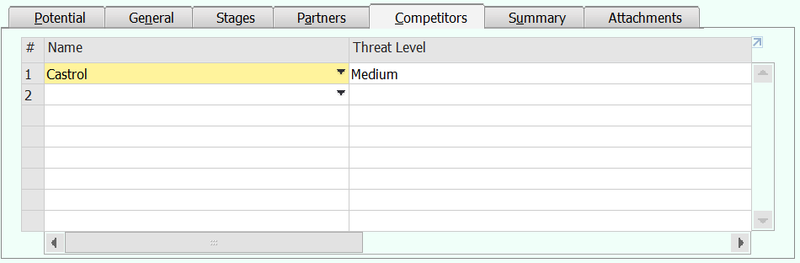

1. In Summary Tab, change the opportunity status if it’s won or lost. You can also select reason of success and failure to get this opportunity and tagged any document if necessary.

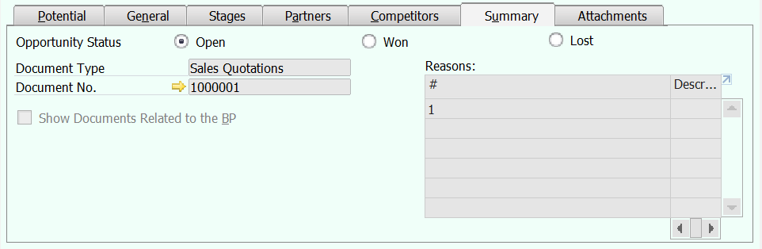

1. In Attachments Tab, attach any related document or picture for this opportunity.

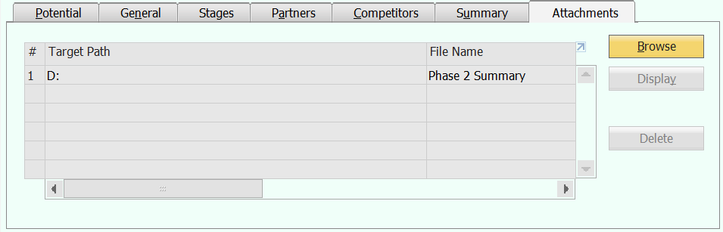

1. Once finished enter the opportunity information, click “Add” button to save.

## Update Existing Sales Opportunity

1. Open Sales Opportunity screen.
2. Click “Search” icon or use the arrow key to browse the existing sales opportunity.



If you’re using search function, once you click the search icon your screen’s searchable field all turn into yellow color. The bottom left button will become “Find”.

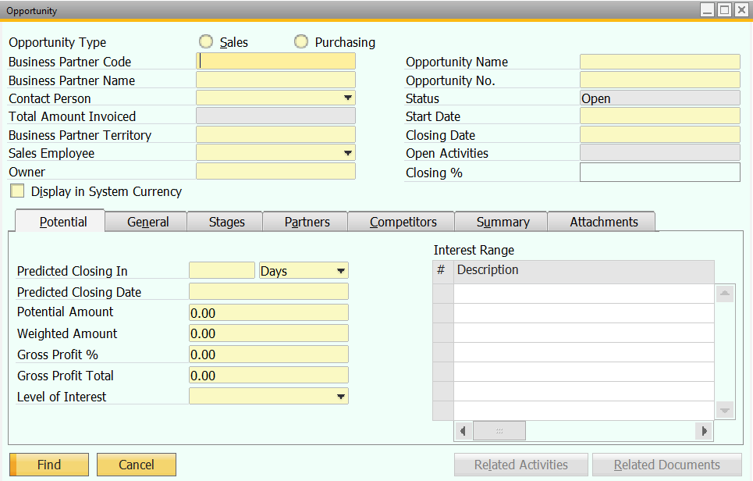

Enter your search criteria and click “Find” button.

If you have only 1 matched records, it will be retrieved automatically, else it will pop up a list of available record.

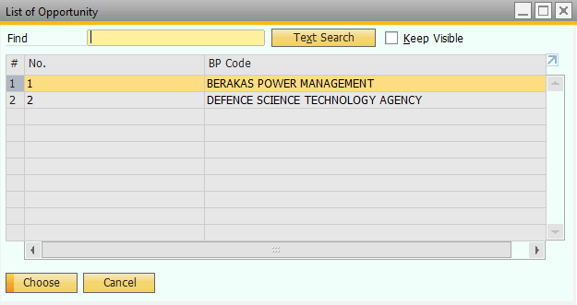

Double click on the sales opportunity you looking for.

1. Once you’ve selected, sales opportunity information will be retrieved.

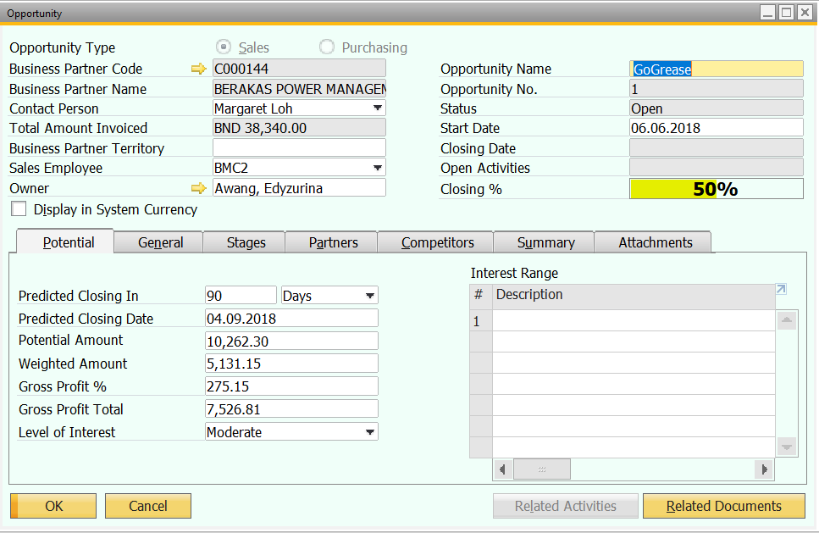

1. Amend the sales opportunity information where necessary. The tab is exactly the same as those mentioned in create New Sales Opportunity. Once you’ve amended, you will see the bottom left button changed to “Update”.

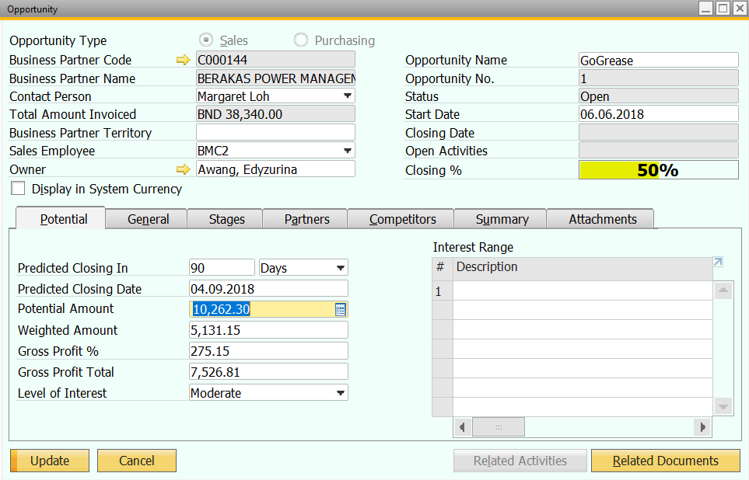

1. Click “Update” to save the changes.

## Sales Opportunity Reports

There is a list of standard SAP B1 Sales Opportunity Report available in the system. Each of the report have their own parameters/filters.

It’s all located under Opportunities > Opportunities Reports

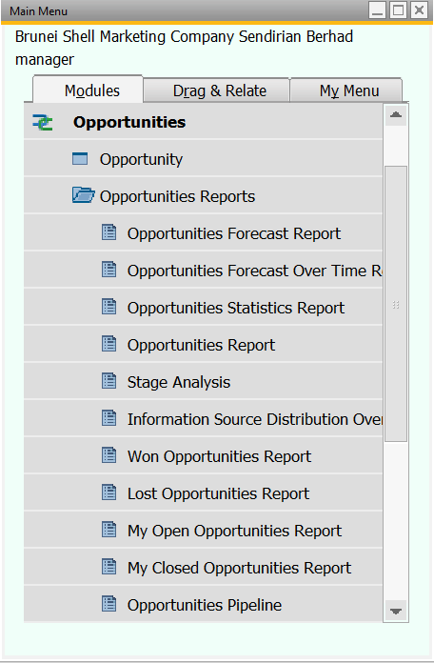

### Opportunities Forecast Report

This report generates a projection of future sales opportunities, based on the predicted dates. The information presented is useful for planning and prioritizing.

### Opportunities Forecast Over Time Report

This report presents a prognosis of open and closed opportunities, grouped by selected time periods. It displays the total number of won, lost, and closed opportunities.

### Opportunities Statistics Report

This report generates a projection of future sales opportunities, based on the predicted dates. The information presented is useful for planning and prioritizing.

### Opportunities Report

This report summarizes, in table format, all sales opportunities.

### Stage Analysis

This report provides an overview of the success rate of sales activities. It contains data such as how many sales opportunities were concluded in a specific stage, or for how long sales opportunities remained in each stage of the sales process. Note that only closed opportunities are displayed as either won or lost.

### Information Source Distribution Over Time Report

This report presents sales opportunities according to their sources. The data can be grouped to display in specific time periods, either days, weeks, or months.

### Won Opportunities Report

This report details information about successful sales opportunities. It displays:

* Days remaining until closing
* Number of won opportunities
* Total receivables
* Total income and number of opportunities within a specific time range (graph form).

You can filter the report to include specific dates, sales employees, and business partners.

### Lost Opportunities Report

Use this report to analyze unsuccessful sales opportunities. Filter the report according to various relevant criteria such as business partner and territory.

### My Open Opportunities Report

This report displays all open sales opportunities, per sales employee, and requires no selection criteria. The report is restricted to the sales employee concerned, and users who are linked to this sales employee.

### My Closed Opportunities Report

This report displays all closed sales opportunities, per sales employee, and requires no selection criteria. The report is restricted to the selected sales employee, and users who are linked to this sales employee.

### Opportunities Pipeline

This report lets you analyze open opportunities in the sales pipeline and to identify the most potentially successful ones.

# Sales Quotation

You create the sales quotation document as an offer or proposal that you send either to a customer, or to a lead.

The sales quotation, as it is displayed in SAP Business One, is not a legally binding document. It is generally used for information purposes only, and can be the first link in the sales process chain.

Entering a quotation does not result in any posting that alters quantities or values in inventory management or accounting.

It’s located under Sales A/R -> Sales Quotation

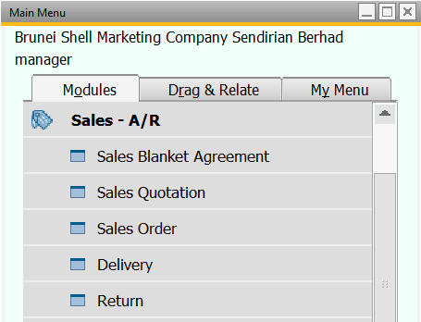

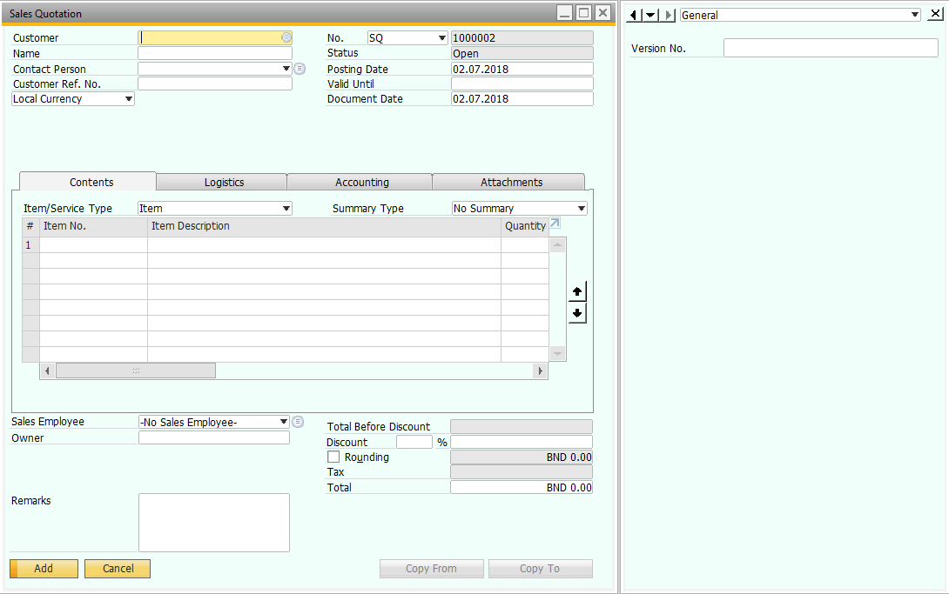

## Create New Sales Quotation

1. Open Sales Quotation Screen.
2. Click “Add New” icon.



Ignore this step if the bottom left button already showing “Add” which indicate you already in add mode.

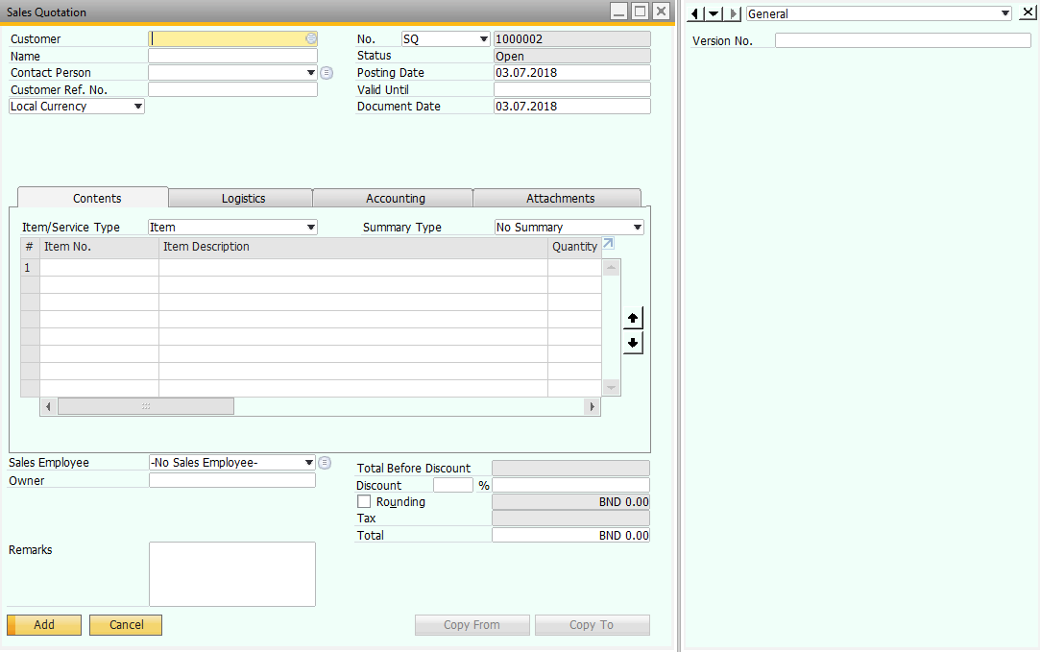

1. Select Customer, insert customer reference number if any and amend the valid until date if necessary. By default, valid until date is one month later than your posting date.
2. In Contents Tab, under Item No. or Item Description, select the item you wish to issue quotation.
3. Insert the quantity quoted and any discount given.
4. In the bottom remarks field, enter remark if any.
5. On the right side of the screen, enter the version no. as well. This can help to record which version of quotation you’re issuing currently.

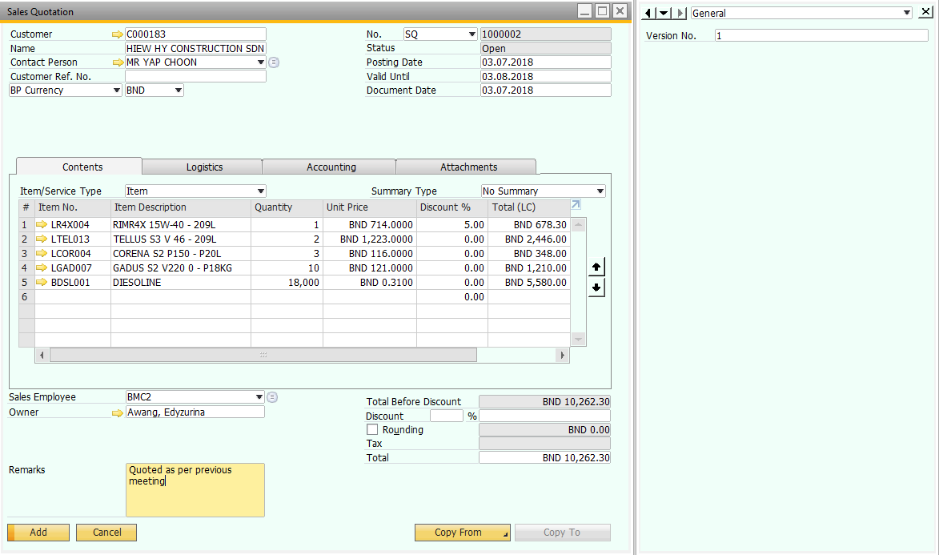

1. Click “Add” button to add the new sales quotation.

## Edit Existing Sales Quotation

1. Open Sales Quotation screen.
2. Click “Search” icon or use the arrow key to browse the existing sales quotation.



If you’re using search function, once you click the search icon your screen’s searchable field all turn into yellow color. The bottom left button will become “Find”.

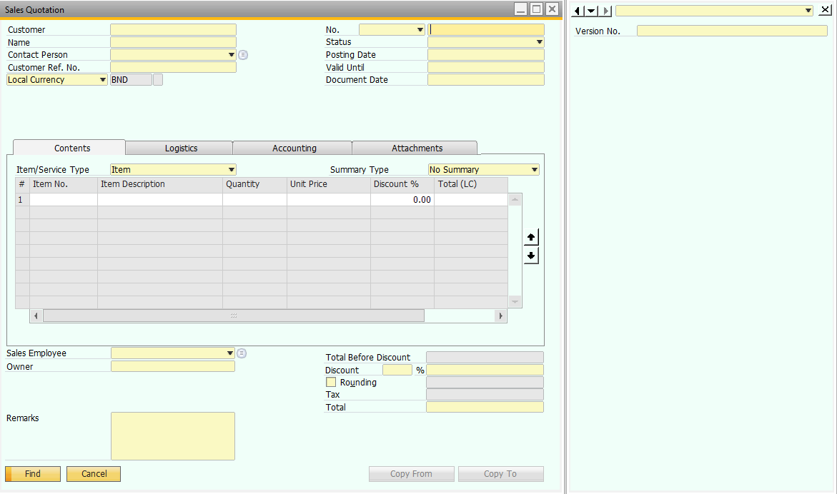

Enter your search criteria and click “Find” button.

If you have only 1 matched records, it will be retrieved automatically, else it will pop up a list of available record.

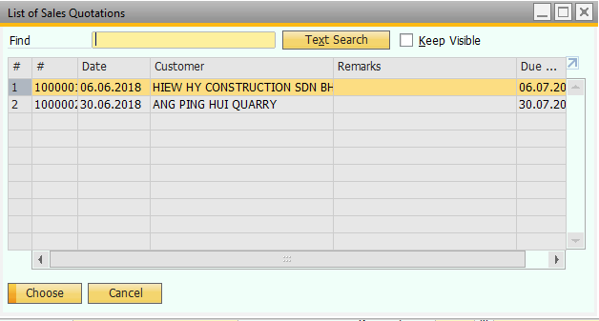

Double click on the sales quotation you looking for.

1. Once you’ve selected, sales quotation information will be retrieved.

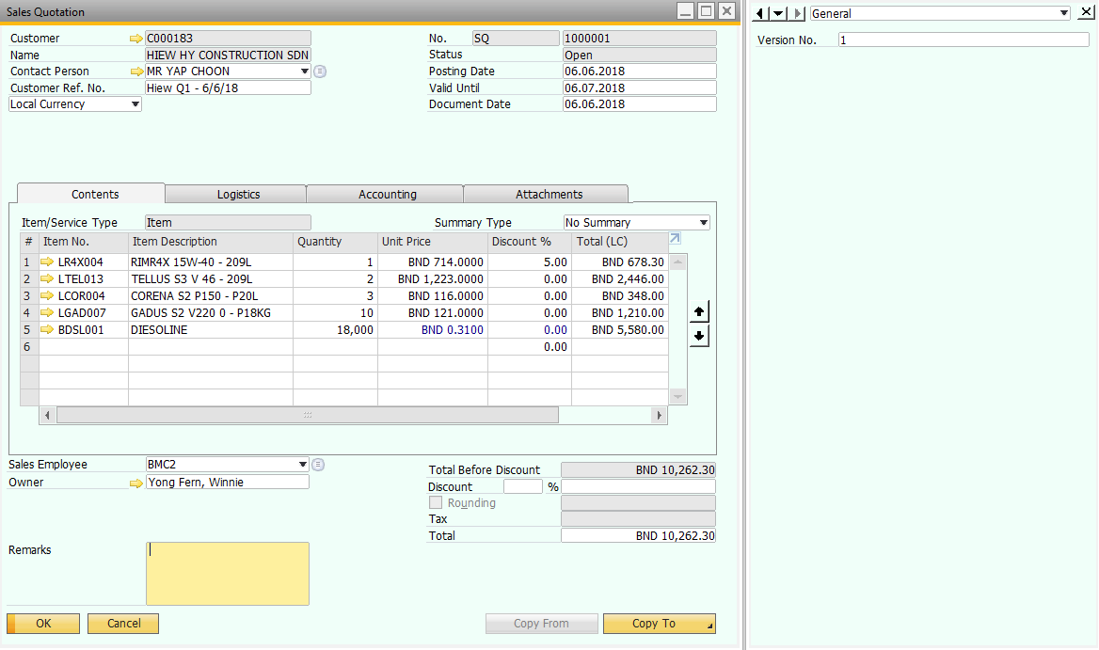

1. Amend sales quotation where necessary, and update version no if it’s another version. Once you’ve amended, you will see the bottom left button changed to “Update”.

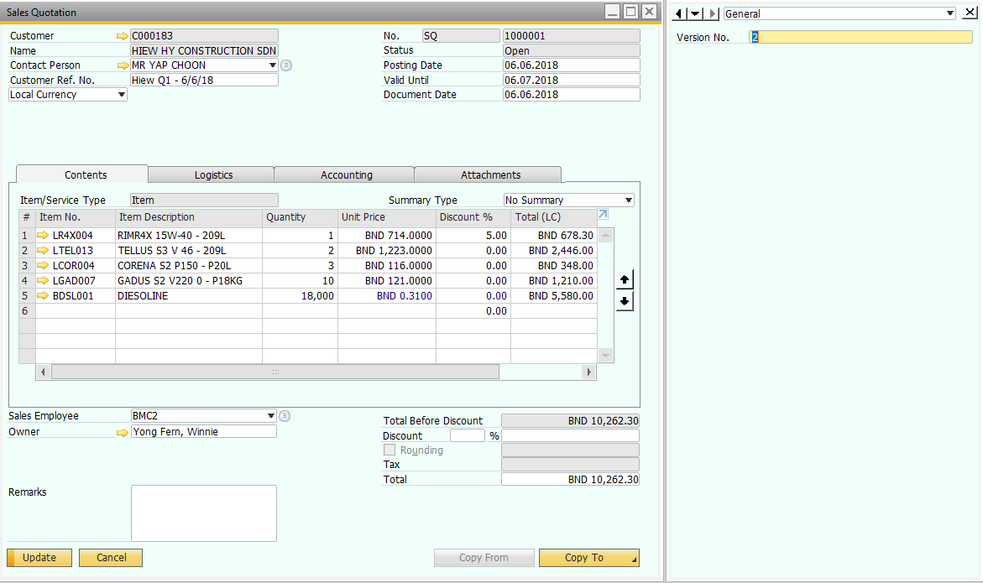

1. Click “Update” button to save the changes made.

## Print Sales Quotation

1. Open Sales Quotation screen.
2. Click “Search” icon or use the arrow key to browse the existing sales quotation.



If you’re using search function, once you click the search icon your screen’s searchable field all turn into yellow color. The bottom left button will become “Find”.



Enter your search criteria and click “Find” button.

If you have only 1 matched records, it will be retrieved automatically, else it will pop up a list of available record.



Double click on the sales quotation you looking for.

1. Once you’ve selected, sales quotation information will be retrieved.



1. Click the print preview button to preview the layout if you wish to preview the layout before print. Or ignore this step, go straight to step 5.



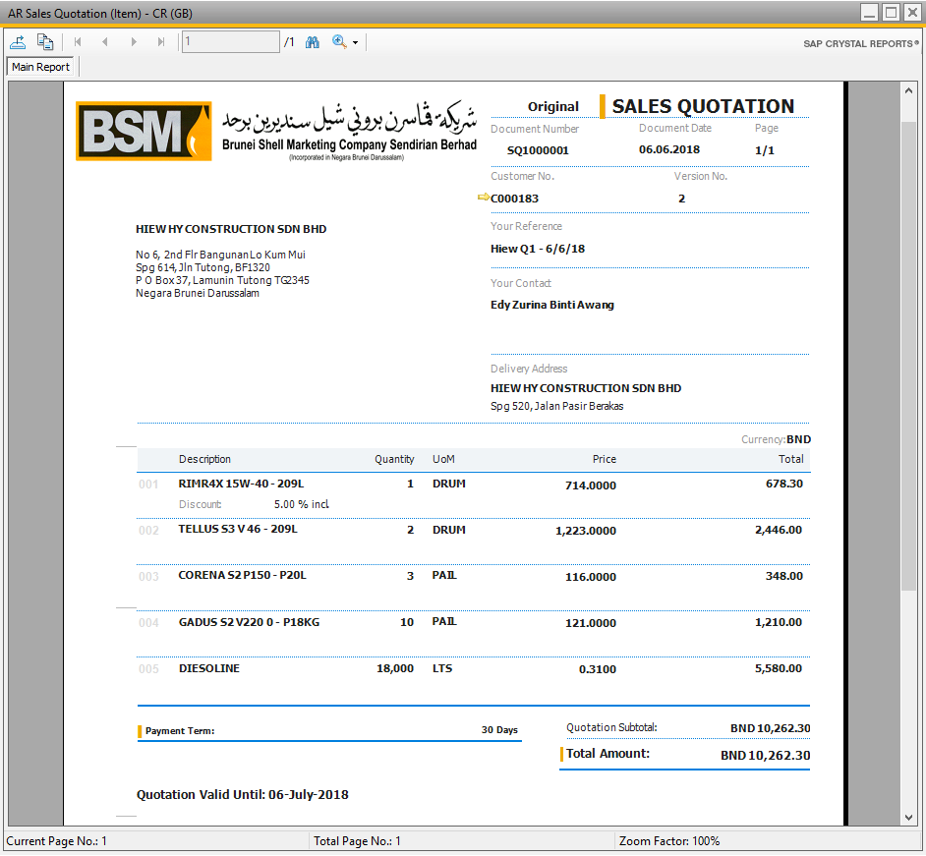

1. Click the print button to print the sales quotation.



1. If you wish to export the sales quotation as PDF, click “PDF” button.



# Activity

Activities refer to interactions you have with business partners, such as phone calls, meetings, tasks, or other types of activities. You are able to manage a one-time activity, or recurring activities.

All activities are automatically recorded in your calendar and in activity reports (all in SAP B1), which you can use to:

* Plan your day, week, and month.
* Analyze your communications with business partners, both currently open activities and activities that have been closed.
* Monitor the progress of your sales opportunities and the service calls of business partners.

It’s located under Business Partner > Activity

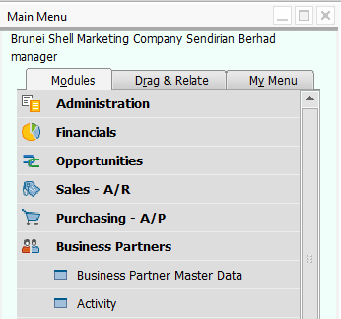

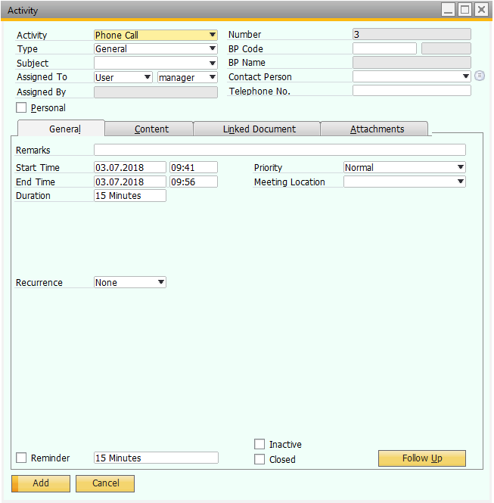

## Tab/Area Explanation

### General Area

Use this area to enter the main information about an activity.

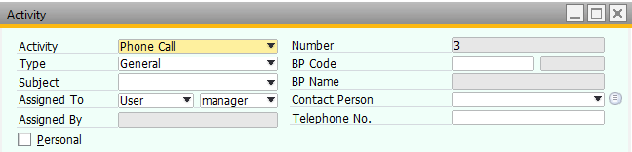

### General Tab

Use this tab to enter the general information about the activity you’ve selected in the General Area.

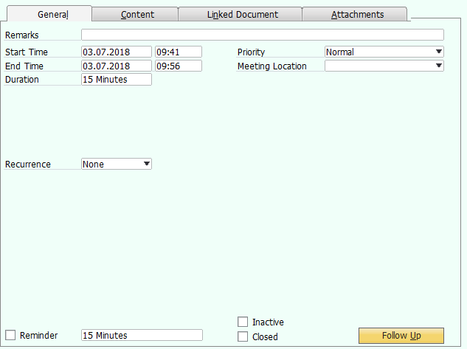

### Content Tab

Use this tab to briefly describe the meeting, phone call, or any other event that took place during the activity.

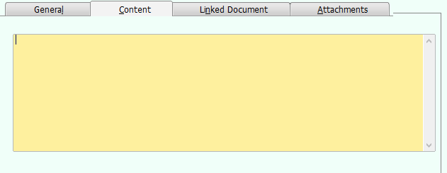

### Linked Document Tab

Use this tab to:

* Link a document to an activity
* View the linked sales opportunity or service call from which an activity was created
* View the base activity, if an activity is a follow-up

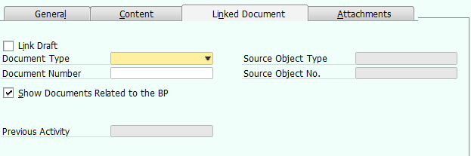

### Attachments Tab

Use this tab to attach relevant files to an activity, such as a printed copy of a sales order sent to a customer. You can attach as many files as needed.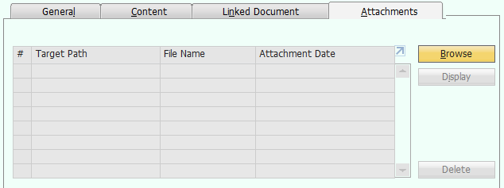

## Create New Activity

1. Open Activity Screen.
2. Click “Add New” icon.



Ignore this step if the bottom left button already showing “Add” which indicate you already in add mode.

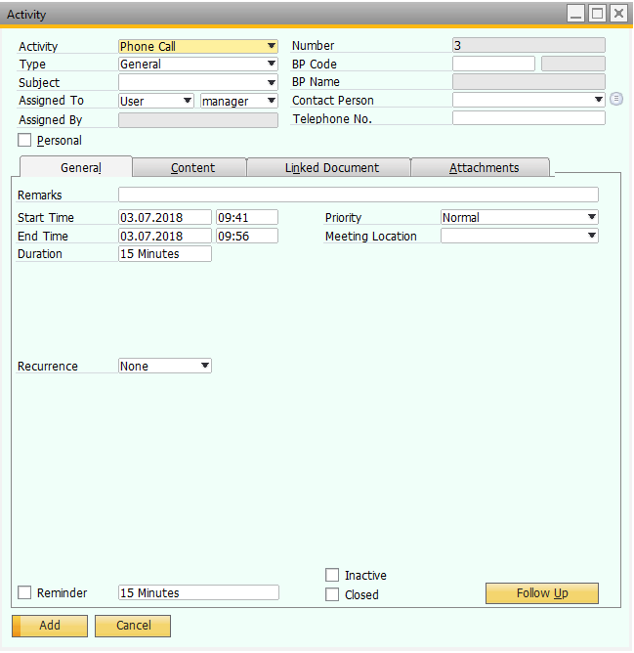

1. In General Area, specify the activity, type, subject and also customer.
2. In General Tab, insert any additional remarks, and specify the time, priority and meeting location of this activity. If this is a recurrence activity, you can select the recurrence option in this tab as well. Besides, you can have reminder of activity in SAP B1 by tick on the Reminder checkbox and specify the time you wish the reminder to pop up before the activity start.
3. In Content Tab, specify any additional information regarding this activity in free text form.
4. In Linked Document Tab, link a document to this activity if any.
5. In Attachments Tab, attach any related documents for this activity.

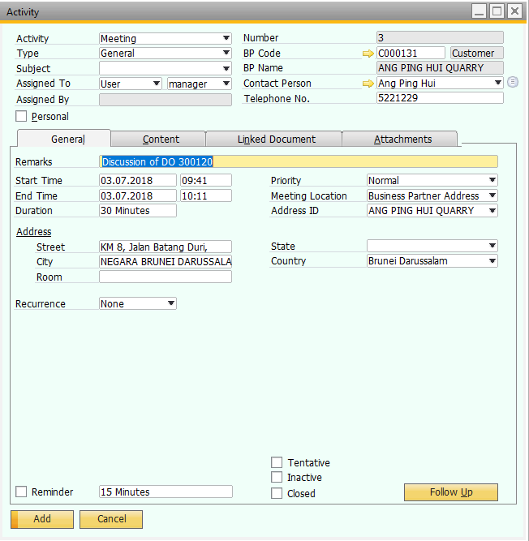

1. Click “Add” to add the new activity.

## Edit Existing Activity

1. Open Activity screen.
2. Click “Search” icon or use the arrow key to browse the existing acitivity.



If you’re using search function, once you click the search icon your screen’s searchable field all turn into yellow color. The bottom left button will become “Find”.

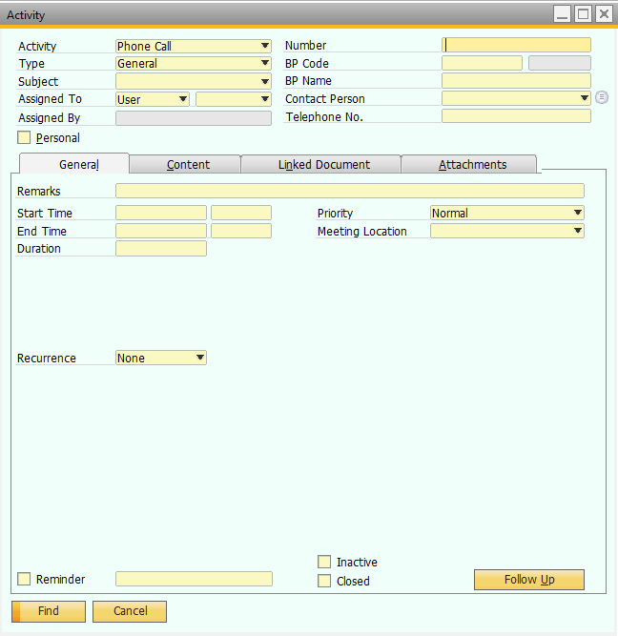

Enter your search criteria and click “Find” button.

If you have only 1 matched records, it will be retrieved automatically, else it will pop up a list of available record.

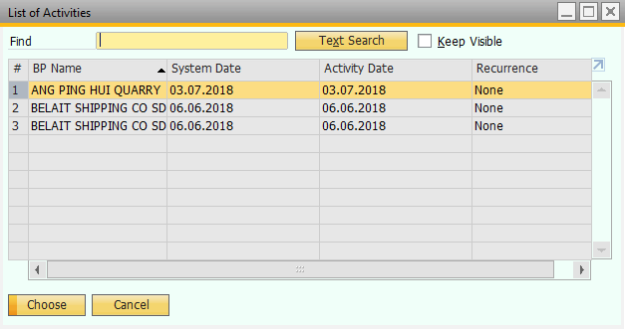

Double click on the activity you looking for.

1. Once you’ve selected, activity information will be retrieved.

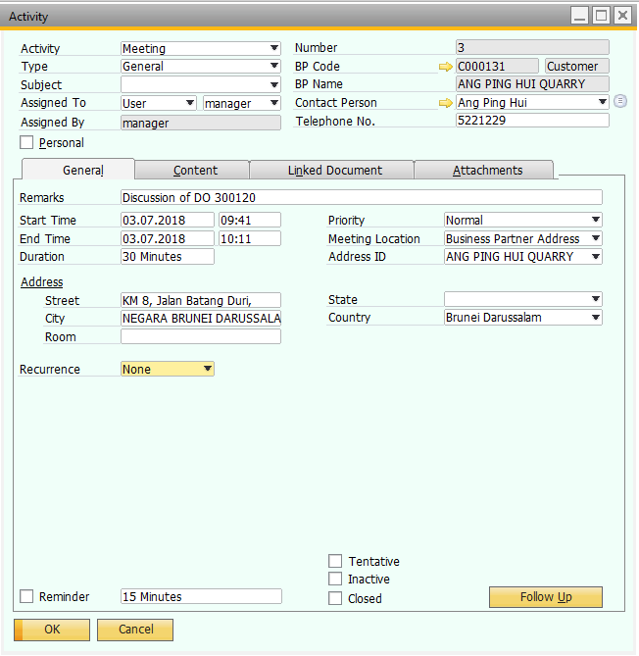

1. Amend the activity information where necessary. If you wished to closed this activity, in General Tab, tick the Closed checkbox. Once you’ve amended, you will see the bottom left button changed to “Update”.

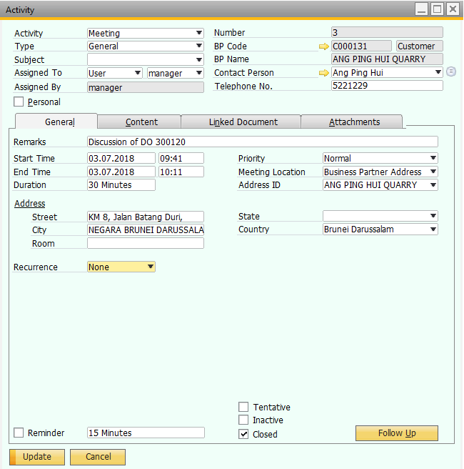

1. Click “Update” button to save the changes.
2. If you wish to create another follow up activity, click “Follow Up” button to create another new activity.