**Shipping Problem.**

A common problem in the shipping industry is to ensure that a shipping container is filled to the max. This is difficult because, the pallets come in one size, but the cardboard box, come in various sizes.

The average container has the following dimensions are 6.3 M long, 2.6 M high and 2.3 M wide. Boxes are moved in and out of the contain on a pallet, that has the following dimension, 48 inches long and 40 inches wide. Pallets cannot be stacked on top of each other, otherwise, it would crush the boxes and damage the goods within the boxes. Leave about 6 inches for the height of the pallet and 1 M = 39 inches.

If the average box size was rectangular 23” high by 12” wide by 20” long, how many boxes can the container hold? Keeping the same height and length of each box, you should be able to test your application with boxes that are 16”, 18”, 20”, 22” and 24” wide.

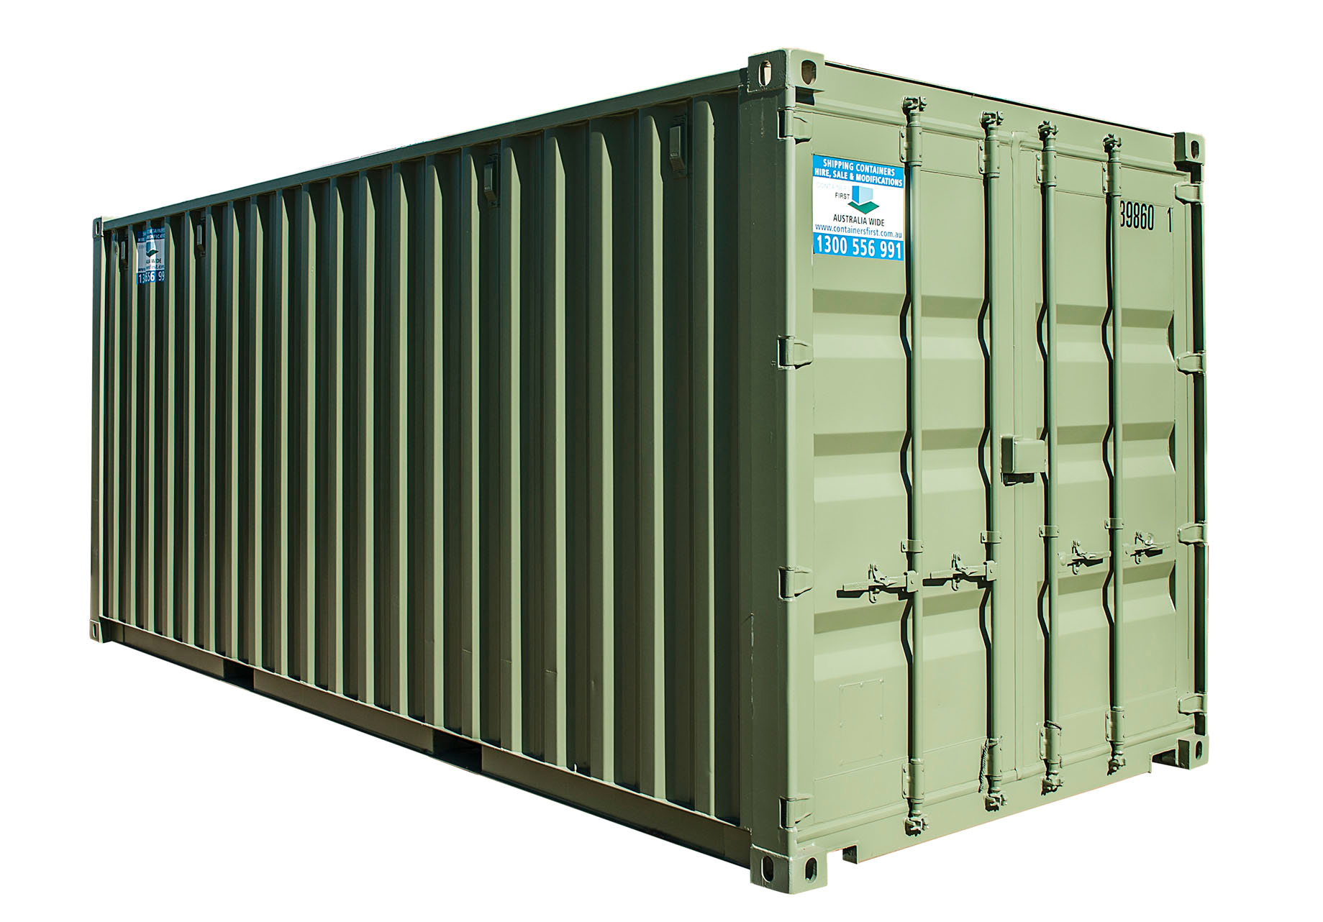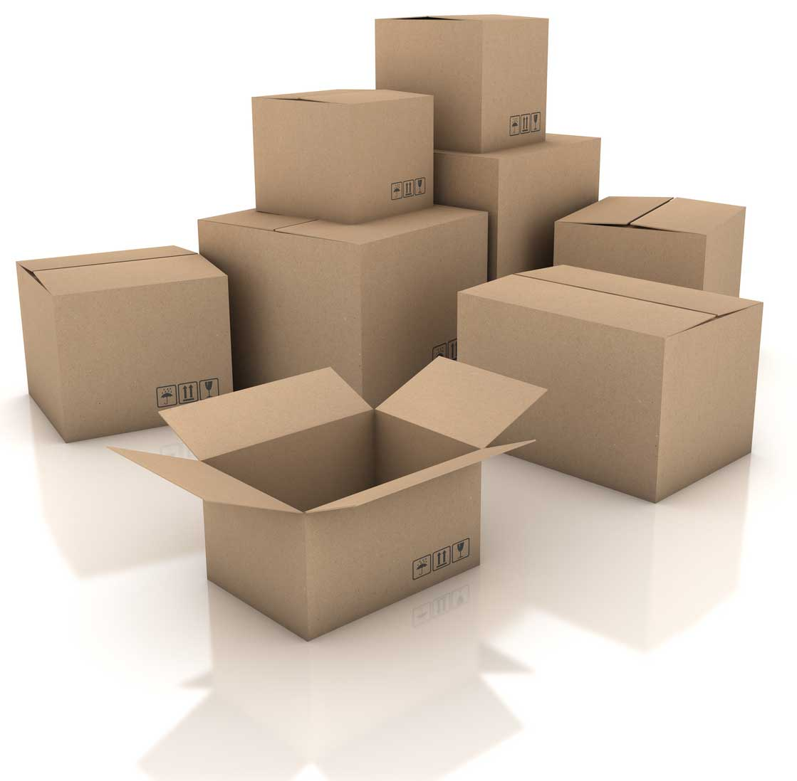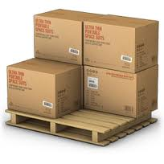

Your Pallet class should have

* Setters/getters

Your Box class should have

* Setters/getters
* calculateBoxWeight () method that returns an float.

Your ShippingContainer class should have

* An overloaded constructor taking the measurements of the container.
* calculateContainerWeight that takes a pallet and a box as a parameter.

Your ShippingContainerTest class should have

* main(String [] args ), but no args should be passed
* private final static int METRIC_CONVERSION = 39;
  + used for metric conversion

**Hint:** Don’t overload a pallet so that boxes get crushed or damage, as that can be expensive for shipping companies. This is not a simple divide volume equation.