# Learning Outcomes

1. Construct highly graphical and responsive user interfaces quickly

I feel I have met this learning outcome by implementing user interfaces in accordance with the material design principles of Android. All the screens are tidy and easy to look at and use without too much thinking.

1. Employ appropriate technologies to develop a mobile application

I have developed using the latest Android version targeting the minSdkVersion 16 to the targetSdkVersion 25. I have used Firebase Authentication, Firebase Realtime Database and Firebase Storage to help complete my objectives.

1. Implement non-local storage

All my storage is in the cloud and none is stored on the phone when the user has connection.

1. Comprehend appropriate web services

Incorporating Firebase SDK (which has intuitive API’s bundled inside) was a smooth process and helped a lot with building an application quickly.

## The Link to the application on play store

<https://play.google.com/store/apps/details?id=tk.seller.trevor.letssellit&hl=en>

## Issues that remain outstanding

When the user clicks on an image, it should display the relevant information the that product, but I did not get this implemented on time and the messaging other users is not unique to 2 people anyone that downloads the application will be able to see all the messages. I did not get these down as I ran out of time and would not have got them done in time if I made a start on them

## Screen Shots of applicationC:\Users\Trevor\Downloads\18296911_10207325757782342_1013372413_o (1).png

Figure .1 selecting the categories

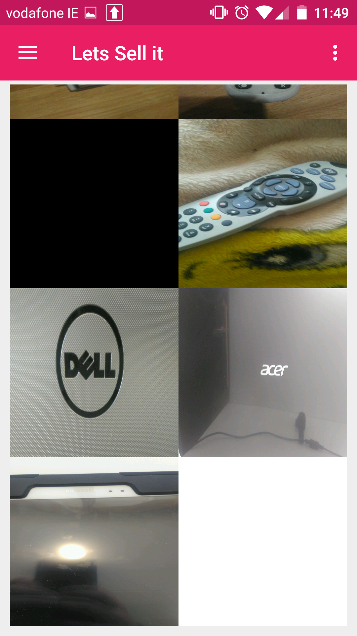

Figure .2 Scrolling down the screen



Figure .3 Putting somthing up for sale