**LockedMe – Virtual Key for Repositories**

* This document contains sections for:
* Sprint planning and Task completion
* Core concepts used in project
* Flow of the Application.
* Demonstrating the product capabilities, appearance, and user interactions.
* Unique Selling Points of the Application
* Conclusions

The code for this project is hosted at <https://github.com/sreelakshmanaramesh/MYPROJECT>

The project is developed by TEJA.SUNKARA.

## Sprints planning and Task completion

The project is planned to be completed in 2 sprint. Tasks assumed to be completed in the sprints are:

* Creating the flow of the application
* Initializing git repository to track changes as development progresses.
* Writing the Java program to fulfill the requirements of the project.
* Testing the Java program with different kinds of User input
* Pushing code to GitHub.
* Creating this specification document highlighting application capabilities, appearance, and user interactions.

## Core concepts used in project

Collections framework, File Handling, Sorting, Flow Control, Recursion, Exception Handling, Streams API .

## Flow of the Application

## Demonstrating the product capabilities, appearance, and user interactions

To demonstrate the product capabilities, below are the sub-sections configured to highlight appearance and user interactions for the project:

1. Creating the project in Eclipse
2. Writing a program in Java for the entry point of the application (**LockedMeMain.java**)
3. Writing a program in Java to display Menu options available for the user (**MenuOptions.java**)
4. Writing a program in Java to handle Menu options selected by user (**HandleOptions.java**)
5. Writing a program in Java to perform the File operations as specified by user (**FileOperations.java**)
6. Pushing the code to GitHub repository

## **Step 1:** Creating a new project in Eclipse

* Open Eclipse
* Go to File -> New -> Project -> Java Project -> Next.
* Create a project named as LockedMeProject , click on finish.
* Select your project and go to File -> New -> package.
* Create a package named as LockedMeProject , click on finish.
* Select your package and go to -> New -> class.
* Create 3 classes named Locker.java, LockerMenus .java, FileOperations.java.

## **Step 2:** Writing a program in Java for the entry point of the application (**LockedMeMain.java**)

**package** companyLockers;

**public** **class** Locker {

/*Enter your desired Directory path */

**public** **static** **final** String ***path*** = "C:\\Users\\sreel\\OneDrive\\Desktop\\LockedMe";

**public** **static** **void** main(String[] args) {

LockerMenus menu = **new** LockerMenus();

menu.introScreen();

menu.mainMenu();

}

}

## **Step 3:** Writing a program in Java to display Menu options available for the user (**MenuOptions.java**)

* Select your project and go to File -> New -> Class.
* Enter **MenuOptions** in class name and click on “Finish.”
* **MenuOptions** consists methods for -:
  1. Displaying Welcome Screen
  2. Displaying Initial Menu
  3. Displaying Secondary Menu for File Operations available

**Step 3.1:** Writing method to display Welcome Screen

**package** companyLockers;

**import** java.io.IOException;

**import** java.util.Scanner;

**public** **class** LockerMenus {

Scanner scan = **new** Scanner(System.***in***);

FileOperations dao = **new** FileOperations();

**public** **void** introScreen() {

System.***out***.println();

System.***out***.println("*************************************************");

System.***out***.println("* DEVELOPED BY TEJA SUNKARA *");

System.***out***.println("*************************************************");

System.***out***.println("* LOCKEDME.COM *");

System.***out***.println("*************************************************");

System.***out***.println("* Directory: " + Locker.***path*** +" *");

System.***out***.println("*************************************************");

System.***out***.println("\n\n");

}

**public** **void** exitScreen() {

System.***out***.println("*************************************************");

System.***out***.println("*************************************************");

System.***out***.println("* *");

System.***out***.println("* THANK YOU FOR VISITING LOCKEDME.COM :) *");

System.***out***.println("* *");

System.***out***.println("*************************************************");

System.***out***.println("*************************************************");

System.***out***.println("\n\n");

}

**OUTPUT:**

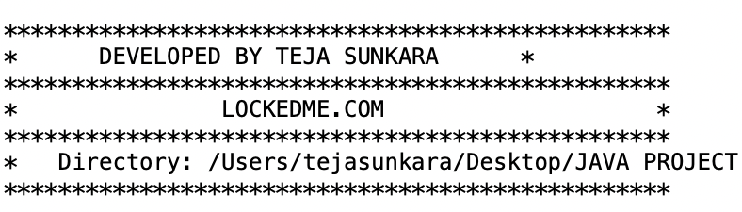

**Step 3.2:** Writing method to display Initial Menu

**public** **void** mainMenuOptions() {

System.***out***.println("=====================================");

System.***out***.println("| MAIN MENU |");

System.***out***.println("=====================================");

System.***out***.println("| Select any one of the following: |");

System.***out***.println("| 1 - List All Files |");

System.***out***.println("| 2 - More Options |");

System.***out***.println("| 3 - Exit |");

System.***out***.println("=====================================");

System.***out***.println("Enter your choice : "); }

**OUTPUT:**

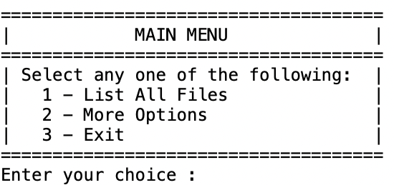

**Step 3.3:** Writing method to display Secondary Menu for File Operations

**public** **void** subMenuOptions() {

System.***out***.println("=====================================");

System.***out***.println("| SUB MENU |");

System.***out***.println("=====================================");

System.***out***.println("| Select any one of the following: |");

System.***out***.println("| 1 - Add a file |");

System.***out***.println("| 2 - Delete a file |");

System.***out***.println("| 3 - Search a file |");

System.***out***.println("| 4 - Go Back |");

System.***out***.println("=====================================");

System.***out***.println("Enter your choice : ");

**OUTPUT:**

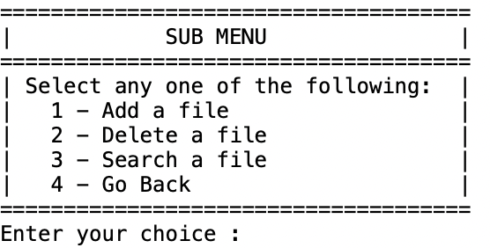

## **Step 4:** Writing a program in Java to handle Menu options selected by user (**HandleOptions.java**)

* Select your project and go to File -> New -> Class.
* Enter **HandleOptions** in class name and click on “Finish.”
* **HandleOptions** consists methods for -:
  1. Handling input selected by user in initial Menu
  2. Handling input selected by user in secondary Menu for File Operations

**Step 4.1:** Writing method to handle user input in initial Menu

**public** **void** mainMenu() {

**int** choice = 0;

**char** decision = 0;

**do** {

mainMenuOptions();

**try** {

choice = Integer.*parseInt*(scan.nextLine());

} **catch** (NumberFormatException e) {

System.***out***.println("\nInvalid Input \nValid Input Integers:(1-3)\n");

mainMenu();

}

**switch** (choice) {

**case** 1:

System.***out***.println();

**try** {

dao.listAllFiles(Locker.***path***);

}**catch**(NullPointerException e) {

System.***out***.println(e.getMessage());

}**catch**(IllegalArgumentException e) {

System.***out***.println(e.getMessage());

}**catch**(Exception e) {

System.***out***.println(e.getMessage());

}

System.***out***.println("\n***********************************\n");

**break**;

**case** 2:

System.***out***.println();

subMenu();

**break**;

**case** 3:

System.***out***.println("\n Are you sure you want to exit ? ");

System.***out***.println(" (Y) ==> Yes (N) ==> No ");

decision = scan.nextLine().toUpperCase().charAt(0);

**if**(decision == 'Y') {

System.***out***.println("\n");

exitScreen();

System.*exit*(1);

}**else** **if**(decision == 'N') {

System.***out***.println("\n");

mainMenu();

}**else** {

System.***out***.println("\nInvalid Input \nValid Inputs :(Y/N)\n");

mainMenu();

}

**default**:

System.***out***.println("\nInvalid Input \nValid Input Integers:(1-3)\n");

mainMenu();

}

}**while**(**true**);

}

**OUTPUT:**

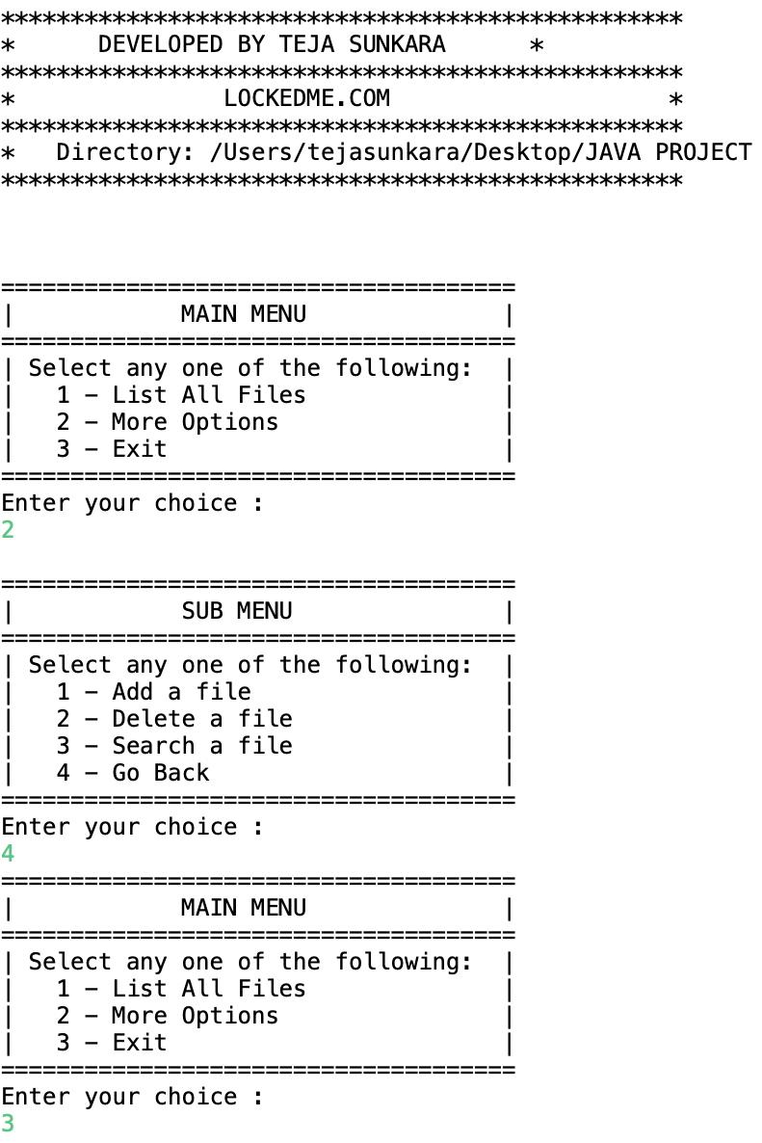

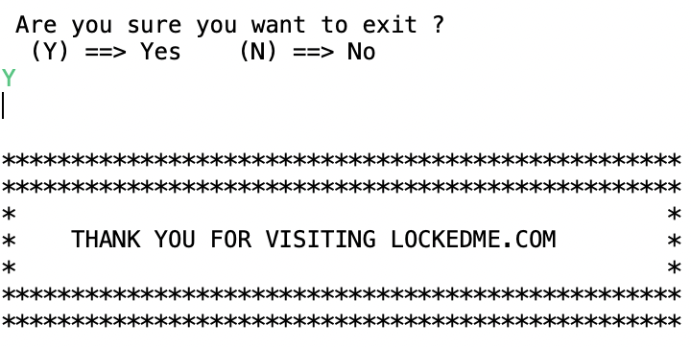

**Step 4.2:** Writing method to handle user input in Secondary Menu for File Operations

**public** **void** subMenu() {

String file = **null**;

String fileName = **null**;

**int** choice = 0;

**do** {

subMenuOptions();

**try** {

choice = Integer.*parseInt*(scan.nextLine());

} **catch** (NumberFormatException e) {

System.***out***.println("Invalid Input \nValid Input Integers:(1-4)");

subMenu();

}

**switch** (choice) {

**case** 1:

System.***out***.println("\n==> Adding a File...");

System.***out***.println("Please enter a file name : ");

file = scan.nextLine();

fileName = file.trim();

**try** {

dao.createNewFile( Locker.***path***, fileName);

}**catch**(NullPointerException e) {

System.***out***.println(e.getMessage());

}**catch**(IOException e) {

System.***out***.println("Error occurred while adding file..");

System.***out***.println("Please try again...");

}**catch**(Exception e) {

System.***out***.println("Error occurred while adding file..");

System.***out***.println("Please try again...");

}

System.***out***.println("\n**********************************\n");

**break**;

**case** 2:

System.***out***.println("\n==> Deleting a File...");

System.***out***.println("Please enter a file name to Delete : ");

file = scan.nextLine();

fileName = file.trim();

**try** {

dao.deleteFile( Locker.***path***, fileName);

}**catch**(NullPointerException e) {

System.***out***.println(e.getMessage());

}**catch**(IOException e) {

System.***out***.println("Error occurred while Deleting File..");

System.***out***.println("Please try again...");

}**catch**(Exception e) {

System.***out***.println("Error occurred while Deleting File..");

System.***out***.println("Please try again...");

}

System.***out***.println("\n***********************************\n");

**break**;

**case** 3:

System.***out***.println("\n==> Searching a File...");

System.***out***.println("Please enter a file name to Search : ");

file = scan.nextLine();

fileName = file.trim();

**try** {

dao.searchFile( Locker.***path***, fileName);

}**catch**(NullPointerException e) {

System.***out***.println(e.getMessage());

}**catch**(IllegalArgumentException e) {

System.***out***.println(e.getMessage());

}**catch**(Exception e) {

System.***out***.println(e.getMessage());

}

System.***out***.println("\n***********************************\n");

**break**;

**case** 4: mainMenu();

**break**;

**default**:

System.***out***.println("Invalid Input \nValid Input Integers:(1-4)");

subMenu();

}

file = **null**;

fileName = **null**;

}**while**(**true**);

}

}

**OUTPUT:**

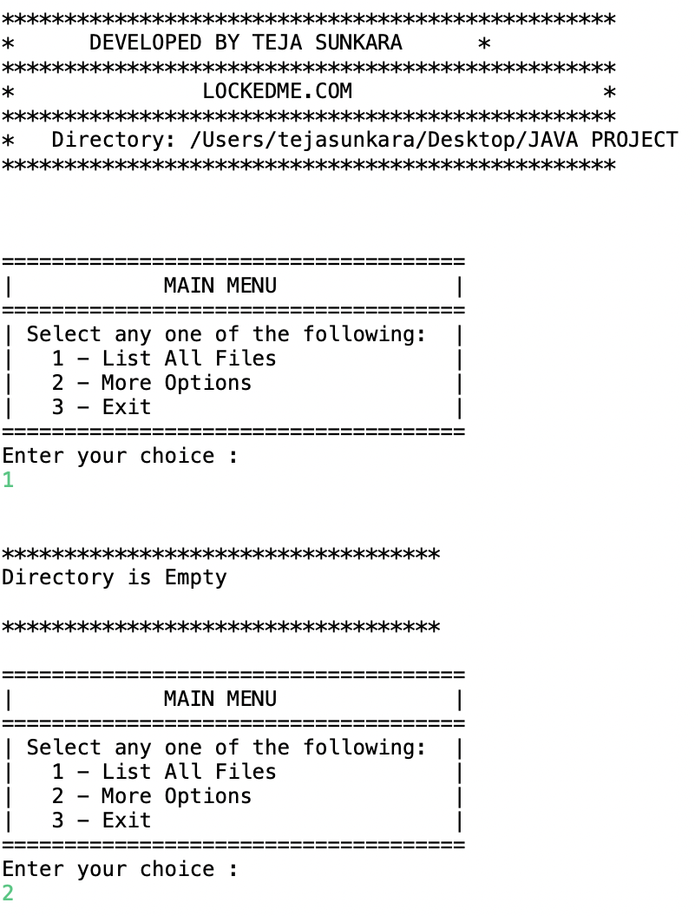

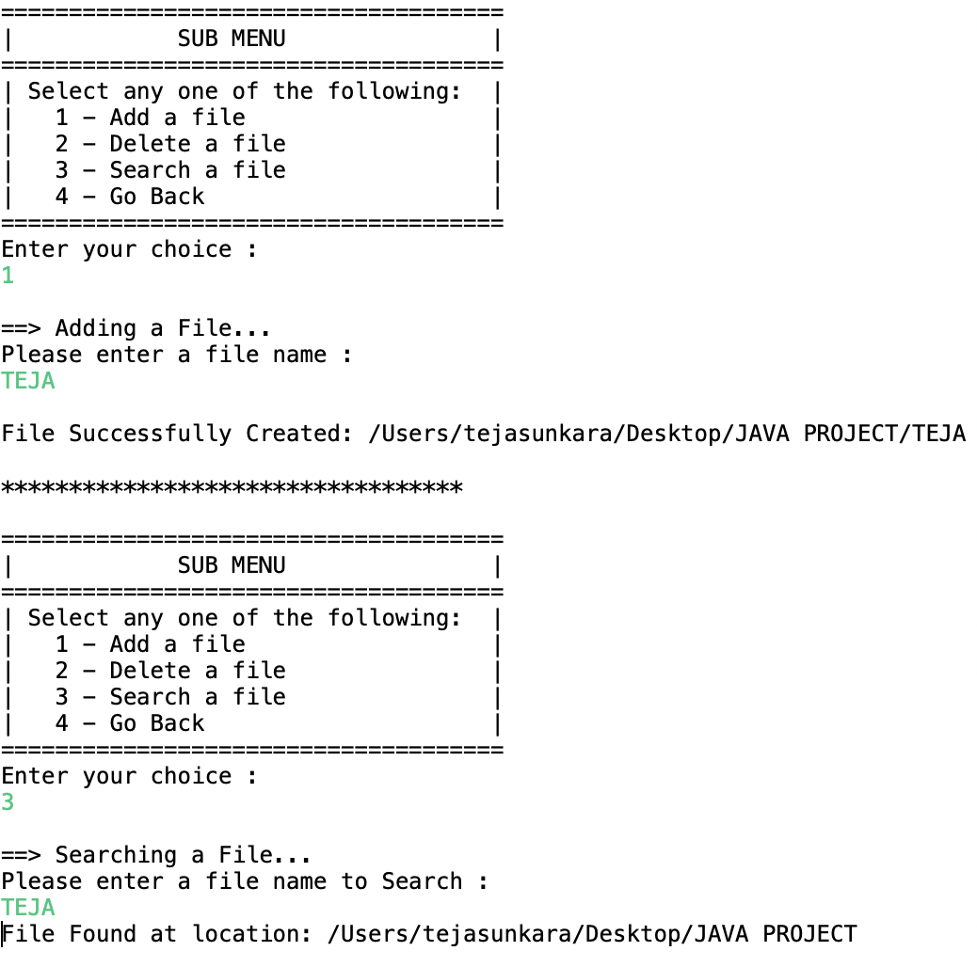

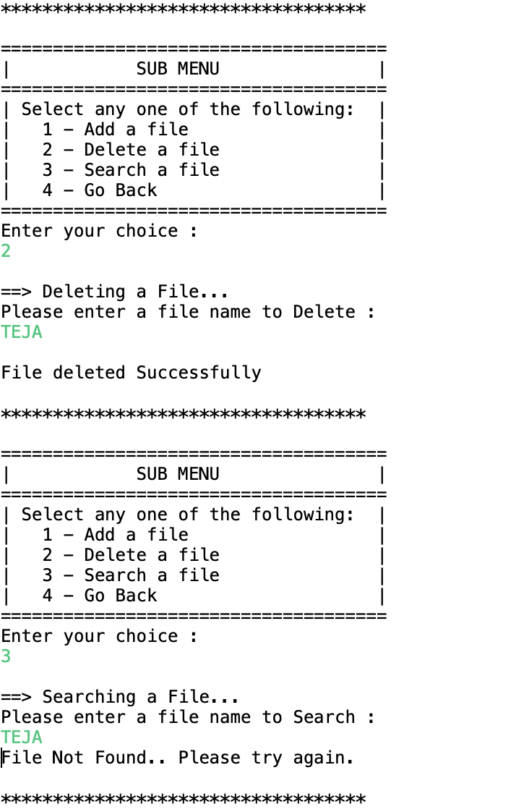

## **Step 5:** Writing a program in Java to perform the File operations as specified by user (**FileOperations.java**)

* Select your project and go to File -> New -> Class.
* Enter **FileOperations** in class name and click on “Finish.”
* **FileOperations** consists methods for -:
  1. Creating “main” folder in project if it’s not already present
  2. Displaying all files in “main” folder in ascending order and also with directory structure.
  3. Creating a file/folder as specified by user input.
  4. Search files as specified by user input in “main” folder and it’s subfolders.
  5. Deleting a file/folder from “main” folder

**Step 5.1:** Writing method to create “main” folder in project if it’s not present

**package** companyLockers;

**import** java.io.File;

**import** java.io.IOException;

**import** java.util.Arrays;

**import** java.util.Set;

**import** java.util.TreeSet;

**import** java.util.regex.Matcher;

**import** java.util.regex.Pattern;

**public** **class** FileOperations{

**public** **void** listAllFiles(String path) {

**if** (path == **null** || path.isEmpty() || path.isBlank())

**throw** **new** NullPointerException("Path cannot be Empty or null");

File dir = **new** File(path);

**if**(!dir.exists())

**throw** **new** IllegalArgumentException("Path does not exist");

**if**(dir.isFile())

**throw** **new** IllegalArgumentException("The given path is a file. A directory is expected.");

String [] files = dir.list();

**OUTPUT:**

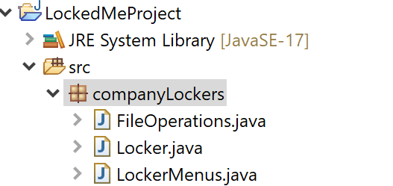

**Step 5.2:** Writing method to display all files in “main” folder in ascending order and also with directory structure. (“`--" represents a directory. “|--” represents a file.)

**if**(files != **null** && files.length > 0) {

Set<String>filesList = **new** TreeSet<String>(Arrays.*asList*(files));

System.***out***.println("The Files in "+ dir.getAbsolutePath() + " are: \n");

**for**(String file1:filesList) {

System.***out***.println(file1);

}

System.***out***.println("\nTotal Number of files: "+ filesList.size());

}**else** {

System.***out***.println("Directory is Empty");

}

}

**OUTPUT:**

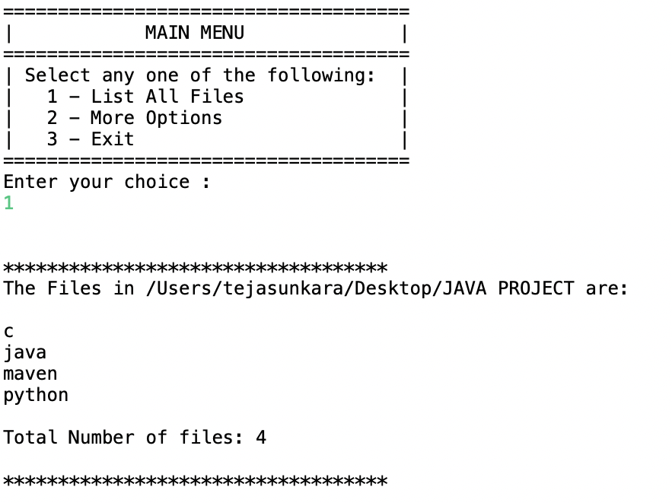

**Step 5.3:** Writing method to create a file/folder as specified by user input.

**public** **void** createNewFile(String path , String fileName) **throws** IOException {

**if** (path == **null** || path.isEmpty() || path.isBlank())

**throw** **new** NullPointerException("Path cannot be Empty or null");

**if** (fileName == **null** || fileName.isEmpty() || fileName.isBlank())

**throw** **new** NullPointerException("File Name cannot be Empty or null");

File newFile = **new** File(path + File.***separator*** + fileName);

**boolean** createFile = newFile.createNewFile();

**if** (createFile) {

System.***out***.println("\nFile Successfully Created: " + newFile.getAbsolutePath());

}**else** **if**(!createFile) {

System.***out***.println("\nFile Already Exist.. Please try again." );

}

}

**OUTPUT:**

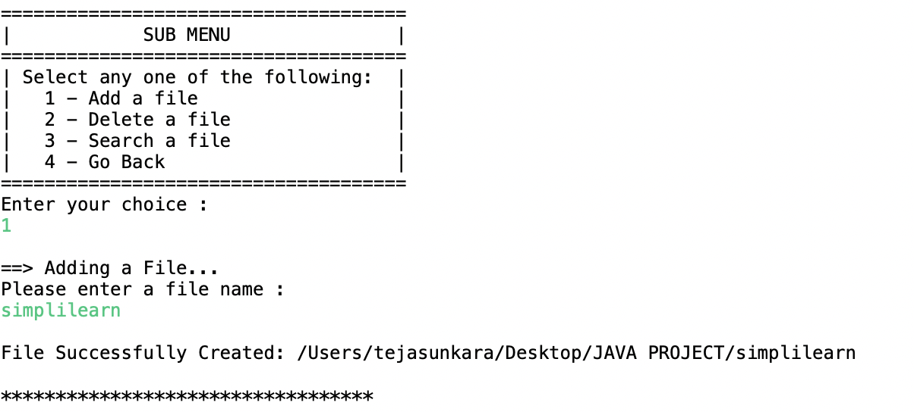

**Step 5.4:**  Writing method to search for all files as specified by user input in “main” folder and it’s subfolders.

**public** **void** searchFile(String path , String fileName){

**if** (path == **null** || path.isEmpty() || path.isBlank())

**throw** **new** NullPointerException("Path cannot be Empty or null");

**if** (fileName == **null** || fileName.isEmpty() || fileName.isBlank())

**throw** **new** NullPointerException("File Name cannot be Empty or null");

File dir = **new** File(path);

**if**(!dir.exists())

**throw** **new** IllegalArgumentException("Path does not exist");

**if**(dir.isFile())

**throw** **new** IllegalArgumentException("The given path is a file. A directory is expected.");

String [] fileList = dir.list();

**boolean** flag = **false**;

Pattern pat = Pattern.*compile*(fileName);

**if**(fileList != **null** && fileList.length > 0) {

**for**(String file:fileList) {

Matcher mat = pat.matcher(file);

**if**(mat.matches()) {

System.***out***.println("File Found at location: " + dir.getAbsolutePath());

flag = **true**;

**break**;

}

}

}

**if**(flag == **false**)

System.***out***.println("File Not Found.. Please try again.");

}

}**OUTPUT:**

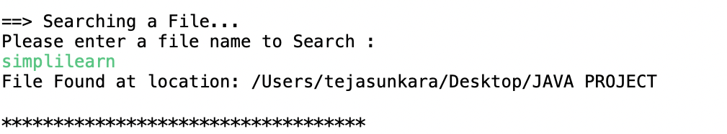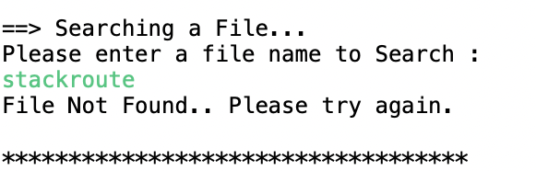

**Step 5.5:**  Writing method to delete a file as specified by user input in “main” folder and it’s subfolders.

**public** **void** deleteFile(String path , String fileName) **throws** IOException {

**if** (path == **null** || path.isEmpty() || path.isBlank())

**throw** **new** NullPointerException("Path cannot be Empty or null");

**if** (fileName == **null** || fileName.isEmpty() || fileName.isBlank())

**throw** **new** NullPointerException("File Name cannot be Empty or null");

File newFile = **new** File(path + File.***separator*** + fileName);

**boolean** deleteFile = newFile.delete();

**if** (deleteFile) {

System.***out***.println("\nFile deleted Successfully");

}**else** {

System.***out***.println("\nFile Not Found.. Please try again." );

}

}

**OUTPUT:**

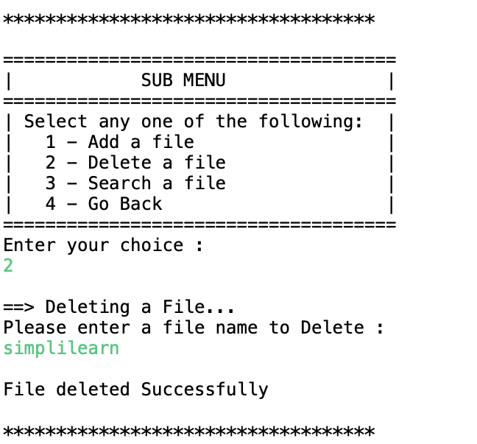

## **Step 6:** Pushing the code to GitHub repository

* Open your command prompt and navigate to the folder where you have created your files.

**cd <folder path>**

* Initialize repository using the following command:

**git init**

* Add all the files to your git repository using the following command:

**git add .**

* Commit the changes using the following command:

**git commit . -m <commit message>**

* Push the files to the folder you initially created using the following command:

**git push -u origin master**

## Conclusions:-

Further enhancements to the application can be made which may include:

•Conditions to check if user is allowed to delete the file or add the file at the specific locations.

• Asking user to verify if they really want to delete the selected directory if it’s not empty.

•Retrieving files/folders by different criteria like Last Modified, Type, etc.

•Allowing user to append data to the file.