Spatiotemporal Symmetric Convolutional Neural Network for Video Bit-Depth Enhancement

Images was motion compensated before feeding into VBDE Net. Only VBDE net was provided in our work. You can use your own MC algorithm to get motion compensated frames before feeding them into VBDE network.

VBDE Architecture

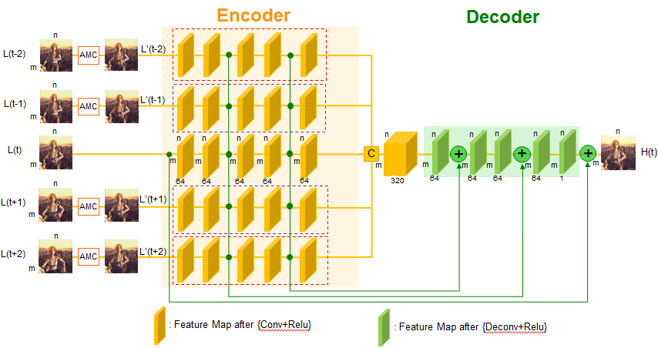

Results

Config

You need to set model path, pretrained parameter path and result path in 【main_VBDEnet_test_tmp16.m】. Please guarantee video frames were motion compensated before feeding into VBDE network.

Test

For ‘Sintel’ test images, run main_VSRnet_test_tmp16.m to get 16-bit image.