**BUSINESS PROCESS MANAGEMENT**

**MASTER’S DEGREE PROGRAM IN DATA SCIENCE AND ADVANCED ANALYTICS**

**GROUP K**

Gabriel Felipe Martins de Souza, m20210598

Luiz Humberto Polaro Vizeu, m20210554

Rogério Domingos Paulo, m20210597

Tongjiuzhou Liu, m20211012

**TABLE OF CONTENTS**

Introduction 4

Background 4

Objectives 4

Process Identification 5

Process Description 6

As-Is Model 7

Qualitative Analysis 8

Value-added Analysis 8

Waste Analysis 11

Issue Register 12

Pick Chart 12

Quantitative Analysis 13

To-Be Model 15

Process Redesign 16

WHAT-IF Analysis 17

Flow Analysis 18

Queuing Analysis 21

Cost-benefit Analysis 22

Limitations 23

Future Work and Conclusion 23

References 24

ANNEXES 25

**TABLE OF FIGURES**

Figure 1: Business Process Management Lifecycle 5

Figure 2: Main Tasks of The Process 6

Figure 3: As-Is Model Overview 7

Figure 4: Admission Process - Value-Adding Analysis 8

Figure 5: Call Patient - Value-Adding Analysis 9

Figure 6: Make Consultation - Value-Adding Analysis 9

Figure 7: Finalize Consultation - Value-Adding Analysis 10

Figure 8: Waste Analysis 11

Figure 9: Issue Register 12

Figure 10: Pick Chart Prioritization 13

Figure 11: Instances Completed by Activity 14

Figure 12: Resource Utilization by Resource Type 14

Figure 13: Cycle Time Efficiency for As-Is Model 15

Figure 14: Admission Process Redesign 16

Figure 15: Call Patient Process Redesign 16

Figure 16: Make Consultation Process Redesign 17

Figure 17: Finalize Consultation Process Redesign 17

Figure 18: What-if Scenarios Simulation 18

Figure 19: Instances Completed / Activity To-Be vs As-Is 19

Figure 20: Instances Completed To-Be vs As-Is 19

Figure 21: Average Processing Time To-Be vs As-Is 20

Figure 22: Cycle Time Efficiency To-Be vs As-Is 20

Figure 23: Work in Progress To-Be vs As-Is 21

Figure 24: Queue Analysis in a View To-Be vs As-Is 21

Figure 25: Cost-benefit Analysis 22

Figure 26: Annex 1 25

Figure 27: Annex 2 25

Figure 28: Annex 3 25

Figure 29: Annex 4 25

Figure 30: Annex 4 25

Figure 31: Annex 5 26

Figure 32: Annex 6 26

Figure 33: Annex 7 26

Figure 34: Annex 8 26

Figure 35: Annex 9 27

Figure 36: Annex 10 27

Figure 37: Annex 11 27

Figure 38: Annex 12 27

Figure 39: Annex 13 27

Figure 40: Annex 14 28

Figure 41: Annex 15 28

Figure 42: Annex 16 28

Figure 43: Annex 17 29

Introduction

In the past years, the world has been experiencing several changes in how companies and businesses create value for different contexts, industries, environments, and people. The increasing competitiveness, fluctuations in stock markets, the recent pandemic, politics, and economics conflicts, all these subjects push businesses to move forward, adapting the way they have been managing their available resources such as people, time, and money, in order to generate more value for the customer, while seeking to continually innovate and remain competitive.

Background

Grace Hospital was founded in 1998. Located in Lisbon, Portugal, the hospital has more than 800 employees working across over 30 different departments, such as cardiology, orthopedics, dermatology, endocrinology, and others. Currently, the hospital has been struggling with one of its vital processes: attending patients in a typical medical consultation. Apart from being a core procedure, medical consultations have been generating a huge impact on patients’ satisfaction, besides a potential waste of resources (time and supplies), which consequently could result in loss of money for Grace Hospital.

Objectives

Business Process Management (BPM) can be translated as “a body of methods, techniques and tools to discover, analyze, redesign, execute and monitor business processes.” (Dumas et a., 2013). In this project, the Business Process Management Lifecycle (*figure 1*) will be used to identify, understand, model, analyze, and redesign the process of attending patients during a medical consultation. From the many existent departments in the hospital, the project scope focuses on the Orthopedics, and any opportunity of improvement founded can be further implemented to different departments, if appropriate.

Figure 1: Business Process Management Lifecycle

Process Identification

A process is “a complete set of activities end to end that creates value for the customer” (Michael Hammer, Harper Business, 1996). In general, a business process consists of the following parts: events, activities, tasks, decision points, actors, and outcomes.

The process of attending patients during a medical consultation is defined as an order-to-cash (O2C) process, which according to Dumas, is a “type of process performed by a vendor, which starts when a customer submits an order to purchase a product or a service and ends when the product or service in question has been delivered to the customer and the customer has made the corresponding payment.”

From the situation presented in the project guideline, it is possible to abstract the Receptionist, Patient, Internal staff, Doctor, and the Information System as the actors of the process. The *figure 2* shows the main tasks performed across the Orthopedics department.

|  |  |  |
| --- | --- | --- |
| **Receptionist** | **Internal Staff** | **Doctor** |
| Receive patient on the desk | Verify medical availability | Attend the patient |
| Ask for patient Citizen Card and medical consultation | Direct patient to Doctor's office | Register prescription into system |
| Insert patient personal data into the system |  | Register exams into the system |
| Confirm consultation |  | Print the exams prescription |
| Receive the payment from patient |  |  |
| Sign papers with hospital signature |  |  |
| Print justification for the patient |  |  |
| Deliver all necessary papers to the patient |  |  |

Figure 2: Main Tasks of The Process

Based on the knowledge acquired after Michael Porter’s value chain model, business processes are designed to generate value for the customer, and in the observed case, offering an excellent service and experience during the medical consultation is considered the expected value. Some possible outcomes can be enumerated in two perspectives: customer satisfaction, consultations in time, correct prescriptions, and treatments as the positive possible outcomes. Consultations delay, customer unsatisfaction, and errors as the negative ones.

Process Description

The process starts when the patient arrives to the hospital and the receptionist calls his/her ticket number, then after a few minutes numerous steps take place to guarantee that the customer has all the documents required and that the consultation is in the right day and hour. Once the admission process has ended, the Internal Staff manages the waiting room to drive the patients to the Doctor’s room only when the availability is confirmed. The patient is then attended by the Doctor, and whether it is necessary to prescribe medicines, exams, the patient leaves the room with a couple of information, digitally or in paper. The process finishes when the patient pays for the consultations, which occurs 90% of the time, and in the reception some extra procedures are made to provide the customer with medical certificate, signed prescriptions, new appointment, invoice, and other information, whenever required.

As-Is Model

The objective of the As-Is Model is to have a deep understanding of the current situation, involving all the activities, actors, and decision points, and finally performing qualitative and quantitative analysis which will help to raise improvements opportunities to model a more efficient process to achieve the expected results of Grace Hospital. In the figure 3 it is possible to see an overview of the As-Is process built in Bizagi, which comprehends the subprocesses *admission process, call patient, make consultation and finalize consultation.* About the process described in the project guideline, some assumptions have been made to support the As-Is modeling, particularly regarding the decision point after the *Make Consultation* sub-process. In this case, it is considered that the patient leaves the hospital right after the consultation ends, which means that the patient does not return to the reception but decides to exit the building not only refusing to pay at the time, but also without making any further requests (justifications, new appointments, stamped prescriptions, and others). Further details of the As-Is process can also be found in the Annex.

Figure 3: As-Is Model Overview

Qualitative Analysis

“Qualitative process analysis techniques allow us to identify, classify, and understand weaknesses and improvement opportunities in a process” (Dumas, M., La Rosa, M., Mendling, J., Reijers, H.A., 2018).

In the next sections, a set of qualitative process analysis is going to be performed to evaluate the process under different perspectives, such as Value-Adding Analysis, Waste Analysis, and Issue Register. At the end, the decision on which activities and tasks must be kept or eliminated tends to be smoother.

Value-added Analysis

Value-added analysis aims to identify unnecessary parts of the process that can be eliminated. Following, each activity of the subprocesses is going to be decomposed into steps and classified from the value-adding perspective.

Admission Process - Receptionist

Figure 4: Admission Process - Value-Adding Analysis

Call Patient – Internal Staff

Figure 5: Call Patient - Value-Adding Analysis

Make Consultation - Doctor

Figure 6: Make Consultation - Value-Adding Analysis

Finalize Consultation - Receptionist

Figure 7: Finalize Consultation - Value-Adding Analysis

Waste Analysis

The Waste Analysis is a method focused on finding wastes throughout processes, and can be grouped into three categories: Move, Hold, and Overdo.

Figure 8: Waste Analysis

Issue Register

The Issue Register aims to maintain, to organize and to prioritize identified weaknesses within the business process. The spreadsheet below illustrates the main issues identified throughout the process, and the impacts to the business in a quantitative and qualitative perspective.

Figure 9: Issue Register

Pick Chart

From the Issue Register, a Pick Chart was raised to better illustrate the prioritization and which tasks must be eliminated or modified in order to increase the process efficiency from a qualitative perspective.

Figure 10: Pick Chart Prioritization

Quantitative Analysis

This section introduces techniques for analyzing business processes quantitatively in terms of process performance measures such as cycle time, waiting time, cost, and resource utilization. The outputs presented below were obtained after a simulation on Bizagi, aimed to evaluate the Instances Completion rate, Resource Utilization, and the Cycle time. More information about the parameters used in the simulation can be found in the Annex.

The Grace Hospital receives around 200 patients per day for the medical consultation in the Orthopedics department. With the process As-Is, only 39% of the patients finalizes the consultation after the end of the day, as it is possible to verify in the funnel below.

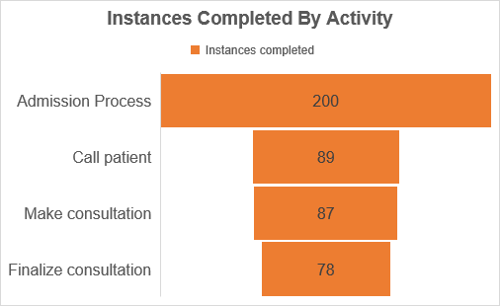

**39% of all instances**

**44% of all instances**

**45% of all instances**

**100% of all instances**

Figure 11: Instances Completed by Activity

According to Gartner analyst Robert Handler¹ the best rate for resource utilization ranges from 70% to 80%. Anything above this can present risks of burnout for the employees, and anything bellow will not utilize resourcefully. The chart below shows that Internal Staffs are too busy and working around 100% of the capacity, while Doctors are under the acceptable utilization rate.

Figure 12: Resource Utilization by Resource Type

Process cycle time is the average time it takes between the moment a process starts and when it ends. The table below shows the average processing time, waiting time and cycle time efficiency for the Orthopedics department and each subprocess within it. Theoretically, in average the total cycle time should be 30 minutes, but in the process As-Is it could take around 4.65 hours from the moment a patient enters the hospital until the moment he leaves. The Cycle Time Efficiency is 11%, which is mostly impacted by the Call Patient activity.

Figure 13: Cycle Time Efficiency for As-Is Model

The information and results observed in the quantitative and qualitative analysis were the basis for the following decisions that will be presented in the To-Be model.

To-Be Model

Before moving to the process redesign, it is important to define what are the expected outcomes to be achieved with the To-Be Model. From the previous analysis, it was possible to identify problems such as the low level of instances (patients) that finish the cycle, only 39%. Also, there is an unbalanced resource utilization that needs to be addressed. The internal staff working around 99,38% of the capacity, while Doctors with 46% approximately. The overall Cycle Time efficiency for the Orthopedics department is about 11%, mainly impacted by Processing Time and Waiting Time within the Call Patient activity. Furthermore, it is necessary to meet some key expectations raised by the Hospital in the project guideline, which are: increasing customer service satisfaction, and reducing costs with supplies, such as papers and print toners.

Process Redesign

To proceed with the prescriptive modeling of the To-Be model, the Exploitative Redesign approach was adopted. Its objective is to identify problems within the system, and to solve them incrementally. The redesign was focused on bringing improvements under the perspective of cost, time, quality, and flexibility. From the many different heuristics applied regarding the task, flow, and process levels, the ones that brought more impact were the Heuristic 1 (task elimination) and the Heuristic 9 (automation), which is based on task-level and process-level, respectively. Following each activity is going to be classified, using the heuristics approach.

Admission Process – Receptionist

Figure 14: Admission Process Redesign

Call Patient – Internal Staff

Figure 15: Call Patient Process Redesign

Make Consultation - Doctor

Figure 16: Make Consultation Process Redesign

Finalize Consultation – Receptionist

Figure 17: Finalize Consultation Process Redesign

WHAT-IF Analysis

What-if analysis is about making changes on the simulation parameters, by adding or removing resources, and re-running the simulation. Starting from the results obtained in the As-Is model simulation, four different What-if scenarios were performed to improve the baseline efficiency. Each simulation is demonstrated below:

* What-if 1 - based on As-Is: reducing the average time from 10.5 min to 5 min in the activity Call Patient.
* What-if 2 - based on What-if 1: reducing the average time from 15 min to 10 min in the activity Make Consultation.
* What-if 3 - based on What-if 2: adding three receptionist machines on Admission process and using a gate “OR” to parallelize the task into more resources.
* What-if 4 - based on What-if 3: adding two internal machines on the activity Call Patient and using a gate “OR” in the resource option.

Figure 18: What-if Scenarios Simulation

The What-if scenarios reinforced the possible changes that could be applied in the prior process to improve the overall performance of the business. Afterwards, the To-Be model was built based on the insights collected from the qualitative and quantitative analysis of As-Is model, the application of the heuristics of process redesign, and finally from the simulation of different scenarios. It is possible to verify the outputs of each What-if scenario, and the final proposal for the To-Be process in the Annex.

Flow Analysis

Flow analysis is a family of techniques that allow to assess the global performance of a process given some knowledge about the performance of its activities. Following, the principal metrics such as Average Processing Time, Average Waiting Time, Cycle Time, and Working in Progress, will be used to compare the results between the To-Be model and the As-Is model.

The next figures show an increase of 117% in the number of instances completed, which can be noticed step by step.

Figure 19: Instances Completed / Activity To-Be vs As-Is

At the end of the day, with the To-Be model, 169 patients finish their medical consultations in the Grace Hospital.

Figure 20: Instances Completed To-Be vs As-Is

The average processing time of the To-Be model presented a reduction of 86% when compared to the As-Is model. The activity Call a Patient had its average processing time decreased from 133 minutes to 5 minutes, which mostly contributed to the overall performance improvement.

Figure 21: Average Processing Time To-Be vs As-Is

From the following radar plot, it is visible that the cycle time efficiency increased in virtually in all the activities within the department and reached an overall improvement of 753% compared to the prior efficiency of the As-Is model.

Figure 22: Cycle Time Efficiency To-Be vs As-Is

The chart below illustrates the number of cases that are running but not completed yet, also known as the Work in Progress (WIP). It is possible to see the huge improvement when comparing the To-Be model with the prior model.

Figure 23: Work in Progress To-Be vs As-Is

Queuing Analysis

Flow analysis does not consider waiting times due to resource contention, therefore a queuing analysis was made to overcome these limitations and give a broader solution.

Figure 24: Queue Analysis in a View To-Be vs As-Is

Cost-benefit Analysis

Cost-benefit is a financial metric that is widely used to measure the probability of gaining a return from an investment. It is a ratio that compares the gain or loss from an investment relative to its cost. It is as useful in evaluating the potential return from a stand-alone investment as it is in comparing returns from several investments. Is this case, a comparison of the As-Is and To-Be model is going to be placed, considering all the modifications in the second model, acquisition of new technologies, processes performance and opportunities improvements. More detailed information about the assumptions and the source used to calculate the return on investment can be obtained in the references.

Figure 25: Cost-benefit Analysis

By implementing the improvements addressed in the To-Be model, they could get a cost reduction of 85%, compared to the current state. The opportunity cost of patients leaving the Hospital without making a consultation seems the biggest problems, which affects potentially the Hospital finances.

Limitations

The project was developed using information from the Grace Hospital project guideline, and several other information have been taken from external sources, and it can add a theoretical effect in the project. The assumptions used was based on the experience of the group participants, trying to focus on a business perspective and more technical expertise. It is known that this kind of project demands field experience, observation, interviews, and research to achieve a top-of-mind impact using the Business Process Management. However, the project did not use any further research or field information to direct the BPM roadmap that could helped to obtain more assertive results, or still could allowed to have more sources of inspiration to create different scenarios or explore further analysis that could be made.

Future Work and Conclusion

The project followed a full BPM lifecycle methodology, which provided a clear guide to identify, understand, model, analyze, and redesign the process in the Grace Hospital, of attending patients in a regular medical consultation. Although the Process Implementation and Process Monitoring and Controlling phases were not part of the scope of this project, the developed work can be widely explored to direct the business on the next steps towards the implementation of quick wins and robust changes in the company.

After all the many analyses that helped understanding the opportunities, and the process redesign phase, the To-Be model demonstrated a large advantage against the current model (As-Is), not only because of the efficiency in the optic of Time, Quality, but also under the financial perspective, which was reinforced by the Cost-benefit analysis. Also, the Ambiental impact was considered in the project, considering the paper and print toner that can be avoided if the Hospital decides on moving with the implementation.

The next step is to create an implementation and monitoring plan, which may help to identify other relevant costs or constraints before making the chances become real. All the steps need to be performed and reviewed during the implementation, since there are many factors that can ease or difficult the success of the implementation.

References

Dumas, M., Rosa, M. L., Mendling, J., & Reijers, H. A. (2018). Fundamentals of Business Process Management 2 nd Edition. Springer Berlin Heidelberg;

W.M.P. van der Aalst, Business process simulation survival guide, in Handbook of Business

M. Hammer, J. Champy, Reengineering the Corporation: A Manifesto for Business Revolution (Harpercollins, New York, 1993)

Process Management 1, ed. by J. vom Brocke, M. Rosemann (Springer, Berlin, 2015), pp. 337–370

https://static.staples.pt/resources/medias/mediamanagement/medias/copia-impressao-P-B-3.pdf

https://www.pccomponentes.pt/wacom-signature-set-stu-540-capturador-de-firmas-electronicas?codesf=153164983&utm_medium=cpc&utm_campaign=Shopping-feed&utm_term=Wacom+Signature+Set+STU-540+Capturador+de+Assinaturas+Eletr%C3%B3nicas&utm_source=googleShopping(via+Shopping+Feed)&gclid=CjwKCAjwkYGVBhArEiwA4sZLuCl5apl9IajlN8zbc7aQeVB4v_pYEsTqJQUmlzIsQvDaA_bGHCx3FBoCKmkQAvD_BwE

https://fr.aliexpress.com/item/4000070753699.html?spm=a2g0o.detail.1000023.11.17bc33f7GK4xsZ&gatewayAdapt=glo2fra

https://www.hospitaldaluz.pt/agueda/pt/para-clientes/precos-e-faturas

ANNEXES



Figure 26: Annex 1



Figure 27: Annex 2



Figure 28: Annex 3



Figure 29: Annex 4



Figure 30: Annex 4



Figure 31: Annex 5



Figure 32: Annex 6



Figure 33: Annex 7



Figure 34: Annex 8



Figure 35: Annex 9



Figure 36: Annex 10



Figure 37: Annex 11



Figure 38: Annex 12

Figure 39: Annex 13

Figure 40: Annex 14

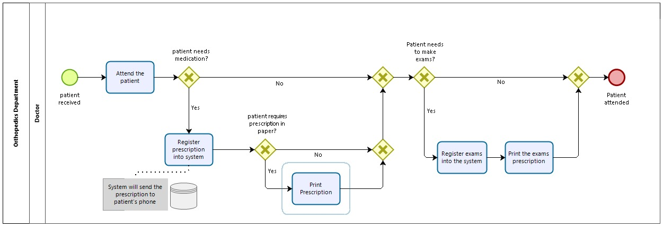

Figure 41: Annex 15

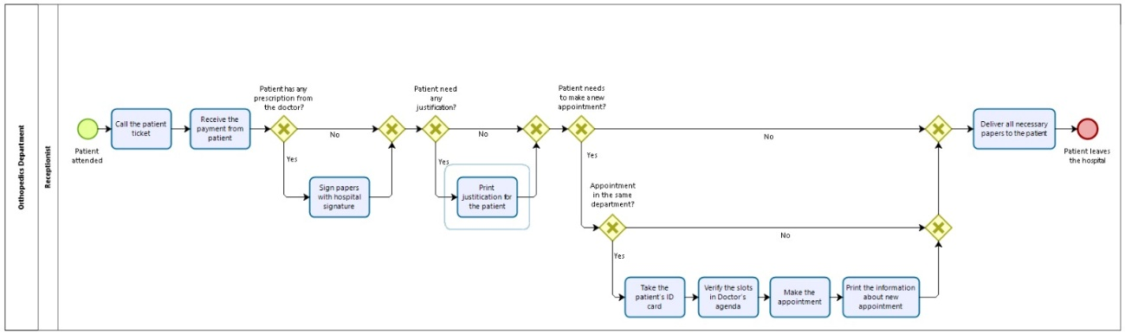

Figure 42: Annex 16

Figure 43: Annex 17