Jan/Feb 07 issue of Home Shop Machinist
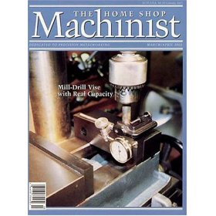

Now There’s a Smarter Way
to Rent How-To DVDs

Renting from NetFlix is fine when there’s time for popcorn and a movie. But when there’s a project that needs to be done, SmartFlix has come up with the answer.

Formerly Technical Video Rental, SmartFlix has recognized the growing demand in the metalworking market, and will start fresh with the launch of its new website. With more than 3,200 titles covering roughly 100 categories, SmartFlix offers the most expansive library of how-do DVDs in the world. No other movie-rental store – online or brick-and-mortar – provides the titles found at SmartFlix. Whether it’s aircraft piloting or the Zen of screaming, SmartFlix has everything from A to Z for the metalworking hobbyist and do-it-yourself enthusiast.

Detailed instructional DVDs that typically retail for $60-$100 can be rented through SmartFlix for an average of $9.99 per week, including round-trip postage in the U.S. The DVDs take viewers step-by-step through each project or hobby from beginning to end in real-time, not the edited, sliced up version found on the various cable shows.

The SmartFlix website, found at www.smartflix.com, includes a simple guide and search engine for renting from its wide selection. There’s also a blog where the experts share their advice in weekly interviews.

