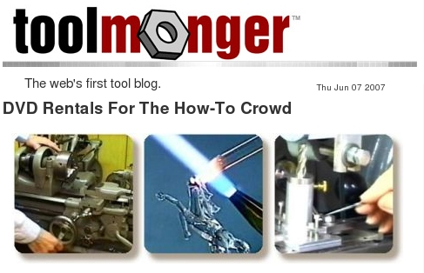
http://toolmonger.com/2007/06/05/dvd-rentals-for-the-how-to-crowd/

TM reader Trucker Joe turned us on to SmartFlix a few weeks ago, and it’s good stuff. Think of it as Netflix, but with how-to DVDs covering everything from woodworking, metalworking, and blacksmithing to crafts and digital art.
After registering on the SmartFlix site, you can select the videos you want and pay for the rental online. The rentals are $10 per week. They arrive in a cardboard mailer. When you’re done, you simply stick on a pre-printed return-postage label and drop ‘em in the mailbox. And yes, you get a full week from the day they arrive, not the day they ship.
These are hard-core DIY DVDs that you’ll never find at your local rental shop, and if you’re looking to increase your handwork skill set, this is a great way to do it.
One concern: many of the DVDs are DVD+R or DVD-R format, so you need to make sure your player can play them first. Most can, but it’s worth checking.

