**Lab Worksheet 05:**

**CT_2021_077**

**Q1.**

**Code:**

package Q_01;  
  
public class Q_01 {  
 public static void main(String[] args) {  
 int i;  
  
 for(i=10; i<50 ;i++){  
 if(i % 10 == 0){  
 System.*out*.println("\n");  
 }  
 System.*out*.print(i + "\t");  
 }  
 }  
}

**Output:**

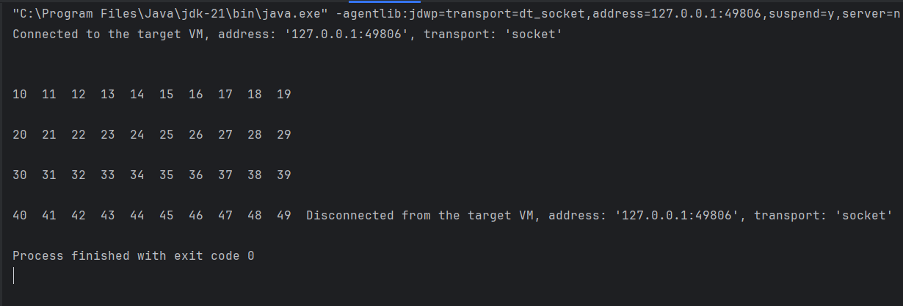

**Q2.**

**Code:**

package Q_02;  
  
import java.util.Scanner;  
  
public class Q_02 {  
 Scanner scanner = new Scanner(System.*in*);  
 static int *Number*;  
 int count = 0;  
 int i = *Number*;  
  
 public void Digit() {  
 while (i > 0){  
  
 while (*Number* != 0) {  
 *Number* = *Number* / 10;  
  
 count++;  
 }  
 System.*out*.println("Number of digits : " + count);  
 count = 0;  
  
 System.*out*.println("Enter the Number (If you wat to stop enter negative number ) : ");  
 *Number* = scanner.nextInt();  
 i = *Number*;  
 }  
  
 }  
 public static void main(String[] args) {  
 Scanner scanner = new Scanner(System.*in*);  
 System.*out*.println("Enter the Number (If you wat to stop enter negative number ) : ");  
 *Number* = scanner.nextInt();  
 Q_02 meth = new Q_02();  
 meth.Digit();  
 }  
}

**Output:**

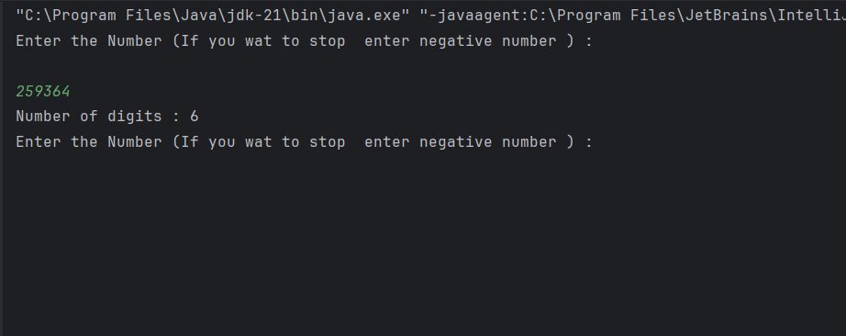

**Q3:**

**Code:**

package Q_03;  
  
import java.util.Scanner;  
public class Q_03 {  
 public static void main(String[] args) {  
 Scanner scanner = new Scanner(System.*in*);  
  
 System.*out*.println("Enter the number to get multiplication table : ");  
 int N = scanner.nextInt();  
  
 for(int i = 0; i <=10; i++){  
 System.*out*.println(N + " * " + i + " = " + N*i);  
 }  
 }  
}

**Output:**

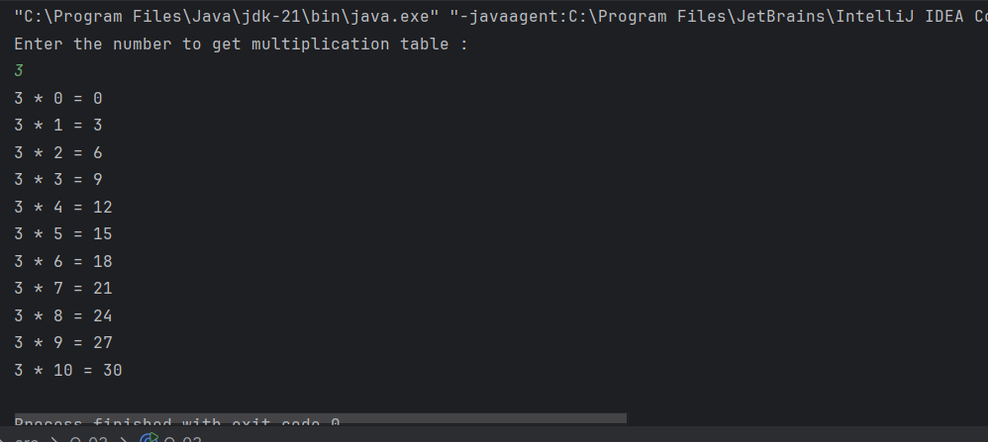

**Q4.**

**Code:**

package Q_04;  
  
import java.util.Scanner;  
  
public class Q_04 {  
 public static void main(String[] args) {  
 int row;  
 Scanner scan = new Scanner(System.*in*);  
 System.*out*.print("Enter the number of rows for the pattern: ");  
 row = scan.nextInt();  
  
  
 for(int i = 1; i <= row; i++){  
  
 for(int j = i; j < row; j++){  
 System.*out*.print(" ");  
 }  
  
 for(int k = 1; k <= (2*i-1); k++){  
 System.*out*.print("*");  
 }  
  
 System.*out*.println();  
 }  
 }  
}

**Output:**

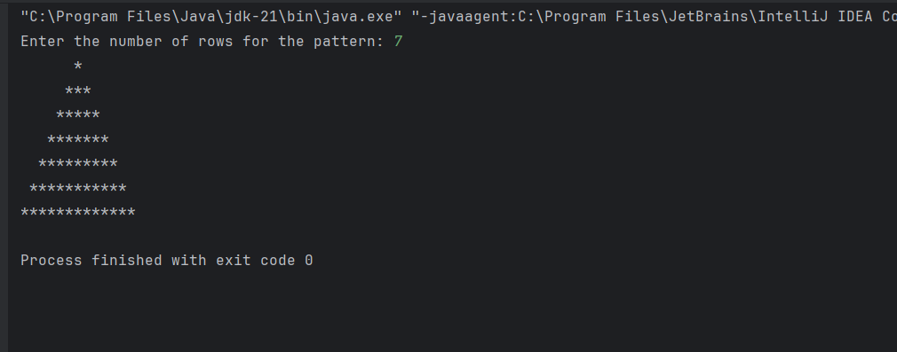

**Q5.**

**Code:**

package Q_05;  
  
import java.util.Scanner;  
  
public class Q_05 {  
 public static void main(String[] args) {  
 Scanner scanner = new Scanner(System.*in*);  
 System.*out*.print("Enter a word or phrase(Enter all characters in lowercase): ");  
 String input = scanner.nextLine();  
  
 String reversed = new StringBuilder(input).reverse().toString();  
  
 if (input.equals(reversed)) {  
 System.*out*.println("It's a palindrome..");  
 } else {  
 System.*out*.println("Not a palindrome..");  
 }  
 scanner.close();  
 }  
}

**Output:**

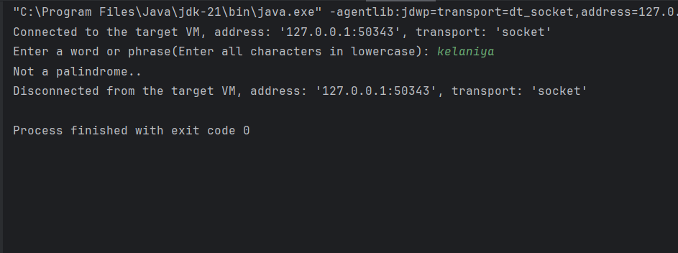

**Q6.**

**Code:**

package Q_06;  
  
import java.util.Random;  
import java.util.Scanner;  
  
public class Q_06 {  
 public static void main(String[] args) {  
 Scanner scanner = new Scanner(System.*in*);  
 Random rand = new Random();  
  
 int random = rand.nextInt(100);  
 int guessNo;  
 int attempt = 0;  
 do{  
 System.*out*.println("Guess the secret number (1 to 100) : ");  
 guessNo = scanner.nextInt();  
 attempt++;  
 if (guessNo > random){  
 System.*out*.println("Number is higher.");  
 }  
 else if (guessNo < random){  
 System.*out*.println("Number is lower.");  
 }  
 else{  
 System.*out*.println("You guess the secret number in " +attempt + " attempts");  
 }  
 }  
 while(guessNo != random);{  
 }  
 }  
  
}

**Output:**

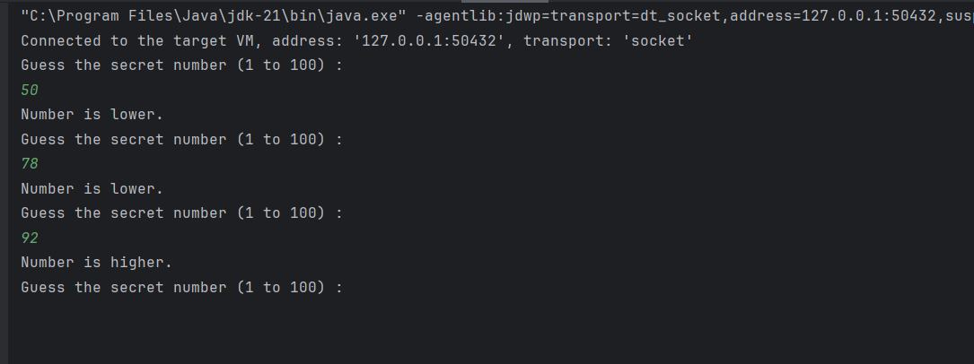

**Q7.**

**Code:**

package Q_07;  
  
import java.util.Scanner;  
  
public class Q_07 {  
 public static void main(String[] args) {  
 Scanner scan = new Scanner(System.*in*);  
  
 System.*out*.print("Enter a sentence: ");  
 String sentence = scan.nextLine();  
  
 System.*out*.print("Enter word to replace: ");  
 String oldWord = scan.nextLine();  
  
 System.*out*.print("Enter new replacement word: ");  
 String newWord = scan.nextLine();  
  
 String replaced = sentence.replace(oldWord, newWord);  
  
 System.*out*.println("New sentence: " + replaced);  
 }  
}

**Output:**

