CT_2021_077_LW_02

**Q1.**

**Code:**

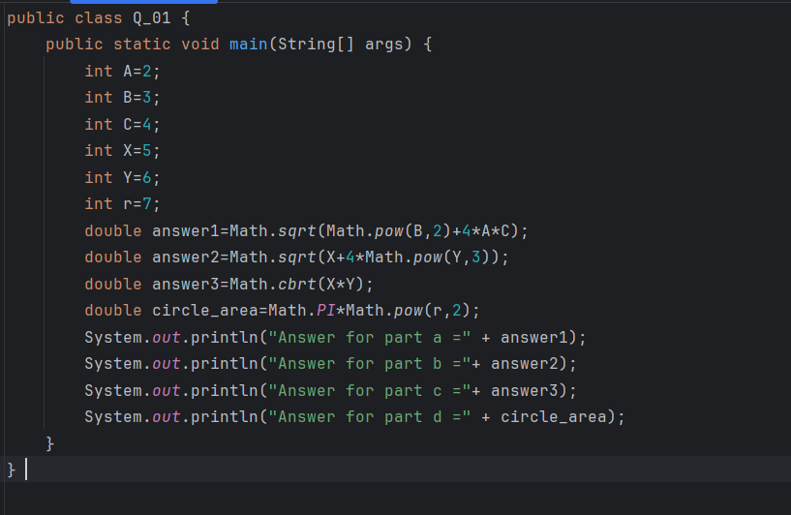

**Output:**

**Q2.**

**Code:**

**Output:**

**Q3.**

**Code:**

**Output:**

**Q4.**

**Code:**

**Output:**

**Q5.**

**Code:**

**Output:**

**Q6.**

**Code:**

**Output:**

**Q7.**

**Code:**

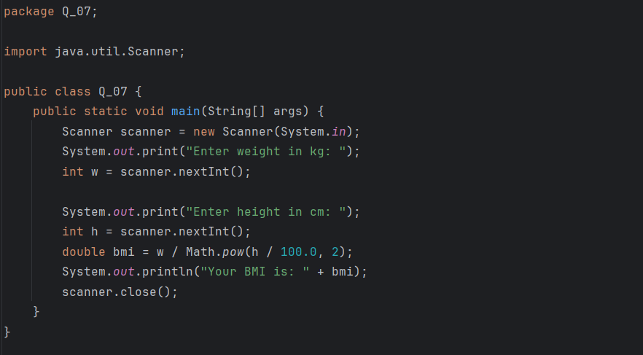

**Output:**

**Q8.**

**Code:**

**Output:**

**Q9.**

**Code:**

**Output:**

**Q10.**

**Code:**

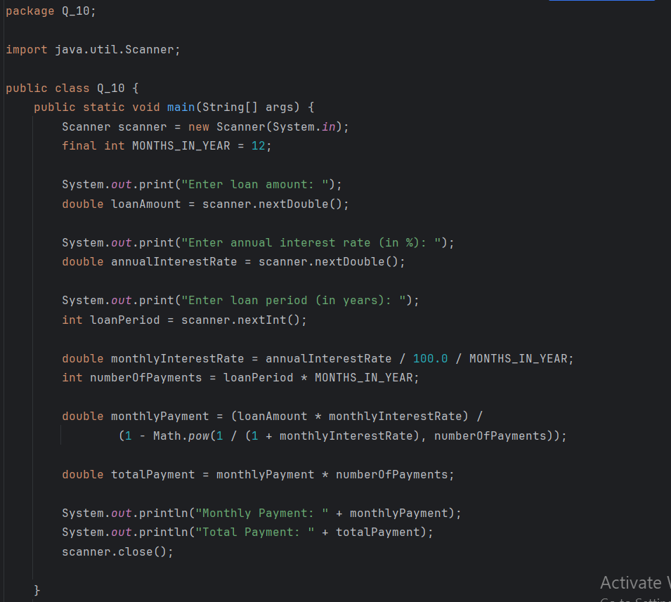

**Output:**

