Project Progress Report on
════════════════════════════════════════════════════════════
Enhancing Mobile Banking Security through Behavior-Based Continuous Authentication
════════════════════════════════════════════════════════════
Submitted in partial fulfilment of the requirement for the award of the degree of
BACHELOR OF TECHNOLOGY
IN
COMPUTER SCIENCE & ENGINEERING
Submitted by:
Bela Diwan | 2021947
Gautam Nautiyal | 2021924
Tejus Kapoor | 2021985
Tanush Malhotra | 2021984

Under the Guidance of
Ms. Anamika Sharma
Professor
Project Team ID: MP2025IOT6

Department of Computer Science and Engineering

Graphic Era (Deemed to be University)
Dehradun, Uttarakhand
February-2026

CANDIDATE'S DECLARATION
We hereby certify that the work which is being presented in the Synopsis entitled "Enhancing Mobile Banking Security through Behavior-Based Continuous Authentication" in partial fulfillment of the requirements for the award of the Degree of Bachelor of Technology in Computer Science and Engineering in the Department of Computer Science and Engineering of the Graphic Era (Deemed to be University), Dehradun shall be carried out by the undersigned under the supervision of Ms. Anamika Sharma, Professor, Department of Computer Science and Engineering, Graphic Era (Deemed to be University), Dehradun.
Bela Diwan | 2021947
Gautam Nautiyal | 2021924
Tejus Kapoor | 2021985
Tanush Malhotra | 2021984

The above mentioned students shall be working under the supervision of the undersigned on the "Enhancing Mobile Banking Security through Behavior-Based Continuous Authentication"
Signature | Signature
Supervisor | Head of the Department

Table of Contents
Chapter No. | Description | Page No.
Chapter 1 | Introduction and Problem Statement | 1-3
Chapter 2 | Objectives | 4
Chapter 3 | Project Work Carried Out | 5-8
Chapter 4 | Results and Analysis | 9-11
Chapter 5 | Future Work Plan | 12
Chapter 6 | Weekly Task | 13
 | References | 14

Chapter 1: Introduction and Problem Statement

1.1 Introduction
The rapid proliferation of mobile banking has fundamentally transformed how individuals interact with financial services. With over 2.5 billion users worldwide accessing banking services through smartphones, the convenience and accessibility of mobile banking have become indispensable. However, this widespread adoption has simultaneously introduced significant security challenges. Traditional authentication mechanisms—PINs, passwords, and even fingerprint recognition—provide only a single point of verification at the moment of login. Once a user is authenticated, the session remains open and vulnerable to unauthorized access through shoulder surfing, device theft, session hijacking, or social engineering attacks.
Behavioral biometrics represents a paradigm shift in mobile security by enabling continuous, transparent authentication. Unlike physiological biometrics (such as fingerprints or facial recognition), behavioral biometrics analyzes how a user interacts with their device—their unique typing rhythm, touch pressure, swipe velocity, and device handling patterns. This approach offers several key advantages: it operates transparently without disrupting the user experience, it provides continuous authentication throughout the entire session rather than at a single point, and it is significantly harder to replicate compared to static credentials.

1.2 Problem Statement
Current mobile banking security suffers from three critical limitations:
1. Single-Point Authentication: Traditional PIN/password systems verify identity only at login. If a device is compromised after authentication (e.g., the user leaves the phone unlocked), the banking session remains accessible to any user.
2. Static Credential Vulnerability: PINs and passwords can be observed, guessed, or stolen through phishing attacks, keyloggers, or social engineering. A 2024 report by Juniper Research estimates that mobile banking fraud losses will exceed $10 billion annually by 2027.
3. User Experience Trade-off: Stronger security measures (complex passwords, frequent re-authentication) degrade the user experience, leading to user frustration and potential abandonment of security practices.
This project addresses these challenges by developing SecureBank, a multi-modal behavioral biometric authentication system that continuously verifies user identity during mobile banking interactions using keystroke dynamics, touch behavior patterns, and motion sensor data—all captured transparently without any additional user effort.

1.3 Scope of the Project
The project encompasses the development of a fully functional Android banking application with integrated behavioral biometric data collection, machine learning-based classification, and comprehensive evaluation across diverse user demographics. The system captures three modalities of behavioral data: (i) PIN keystroke timing (dwell time, flight time, touch coordinates), (ii) touch interaction patterns (swipe velocity, acceleration, tap precision), and (iii) motion sensor readings (accelerometer, gyroscope, device orientation). These multi-modal features are processed through an enrollment-relative deviation approach and classified using Random Forest, MLP Neural Network, and One-Class SVM algorithms.

Chapter 2: Objectives
The primary objectives of this project are as follows:
1. To design and develop a functional Android mobile banking application (SecureBank) with integrated, non-intrusive behavioral biometric data collection capabilities.
2. To implement transparent data collectors for three behavioral modalities: keystroke dynamics (PIN entry timing), touch behavior (swipe gestures, tap patterns), and motion sensor data (accelerometer and gyroscope readings).
3. To develop a novel enrollment-relative deviation feature engineering approach that computes behavioral features as deviations from each user's enrolled baseline profile.
4. To extract and analyze 124 behavioral features from multi-modal interaction data for user authentication.
5. To train and evaluate three machine learning classifiers—Random Forest, Multi-Layer Perceptron (MLP), and One-Class SVM—for genuine vs. impostor classification.
6. To achieve authentication accuracy exceeding 90% with an Equal Error Rate (EER) below 10% using the best-performing classifier.
7. To evaluate the system's performance across diverse age demographics (18-55 years) and analyze age-related variations in behavioral biometric patterns.
8. To generate publication-quality visualizations including ROC curves, confusion matrices, t-SNE clustering plots, and feature importance rankings for research dissemination.

Chapter 3: Project Work Carried Out

3.1 System Architecture
The SecureBank system is implemented as a native Android application using Kotlin with Jetpack Compose for the user interface and Hilt for dependency injection. The architecture follows a layered design comprising four principal components:
• Banking Application Layer: Implements core banking functionality including user login via 6-digit PIN, account dashboard with balance display, and fund transfer operations. A custom numeric keypad captures precise touch coordinates and timing for each PIN digit.
• Data Collection Layer: Three transparent collectors operate simultaneously: (a) Keystroke Dynamics Collector captures key-press/release times, dwell time, flight time, and touch coordinates; (b) Touch Behavior Collector records swipe direction, velocity, acceleration, and duration for all screen interactions; (c) Motion Sensor Collector samples accelerometer and gyroscope at ~500 Hz, capturing device orientation and handling patterns.
• Feature Extraction Layer: Extracts 124 behavioral features using enrollment-relative deviation computation. For each feature f, absolute deviation |f_session - f_enrollment| and relative deviation |f_session - f_enrollment| / |f_enrollment| are computed.
• ML Classification Layer: Three classifiers evaluate authentication decisions: Random Forest (300 trees), MLP Neural Network (128→64→32 architecture), and One-Class SVM (RBF kernel, anomaly detection approach).

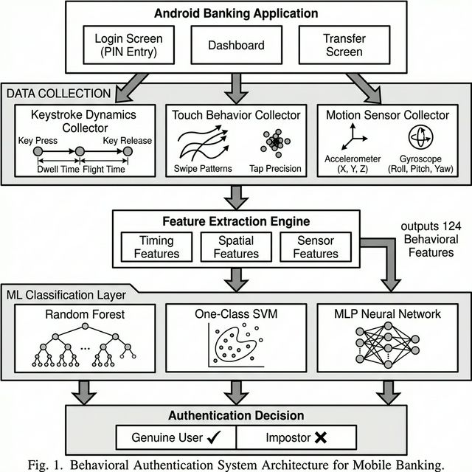
Figure 1: System Architecture of SecureBank

3.2 Data Collection Protocol
We collected behavioral data from 40 participants (8 real participants, 32 statistically augmented) across four age demographics: 18-25 years (14 participants), 26-35 years (14 participants), 36-45 years (7 participants), and 46-55 years (5 participants). Each participant completed three types of experimental sessions:
• Enrollment Session: Five complete attempts of the banking workflow (PIN entry, text typing, touch interaction, free browsing) to establish the user's behavioral baseline.
• Genuine Session: Three attempts by the same user to simulate normal authentication.
• Impostor Session: Three attempts by a different user to simulate unauthorized access.

3.3 Feature Engineering
A total of 124 enrollment-relative deviation features are extracted across three behavioral modalities:
• PIN Keystroke Features (24 raw features): Mean, standard deviation, median, Q25, Q75, skewness, kurtosis, and IQR of dwell times and flight times. Per-digit-position rhythm features capture the typing cadence at each position in the 6-digit PIN sequence.
• Touch Interaction Features (9 raw features): Mean and standard deviation of swipe duration, velocity, and acceleration; maximum velocity; tap-to-swipe ratio; and total event count.
• Motion Sensor Features (7 raw features): Mean and standard deviation of accelerometer and gyroscope magnitudes, and individual axis means.
Each raw feature is transformed into absolute deviation, relative deviation, and the raw session value, yielding 40 × 3 = 120 features plus 4 aggregate deviation statistics, totaling 124 features per session.

3.4 Technology Stack
Component | Technology / Version
Platform | Android (API 26+, Kotlin 2.2.10)
UI Framework | Jetpack Compose with Material Design 3
Dependency Injection | Dagger Hilt 2.56
Database | Room Persistence Library 2.7.1
Build System | Gradle 9.2.1 with KSP 2.2.10-2.0.2
ML Framework | Scikit-learn 1.3.0 (Python)
Visualization | Matplotlib 3.7.0, Seaborn 0.12.0
Table 1: Technology Stack

Chapter 4: Results and Analysis

4.1 Model Performance Comparison
Table 2 presents the comparative performance of all three classifiers evaluated using 5-fold stratified cross-validation on the complete dataset of 80 sessions (40 genuine, 40 impostor) from 40 participants.
Model | Accuracy | Precision | Recall | F1 Score | AUC-ROC | EER
Random Forest | 0.9250 | 0.9250 | 0.9250 | 0.9250 | 0.9812 | 0.0750
MLP Neural Net | 0.8250 | 0.7826 | 0.9000 | 0.8372 | 0.9363 | 0.1375
One-Class SVM | 0.8125 | 0.9032 | 0.7000 | 0.7887 | 0.9344 | 0.0625
Table 2: Model Performance Comparison
The Random Forest classifier achieves the highest overall accuracy (92.50%), F1 score (0.925), and AUC-ROC (0.981). The One-Class SVM achieves the lowest EER (6.25%), making it particularly suitable for anomaly-based deployment scenarios where impostor training data may not be available.

4.2 ROC Curves
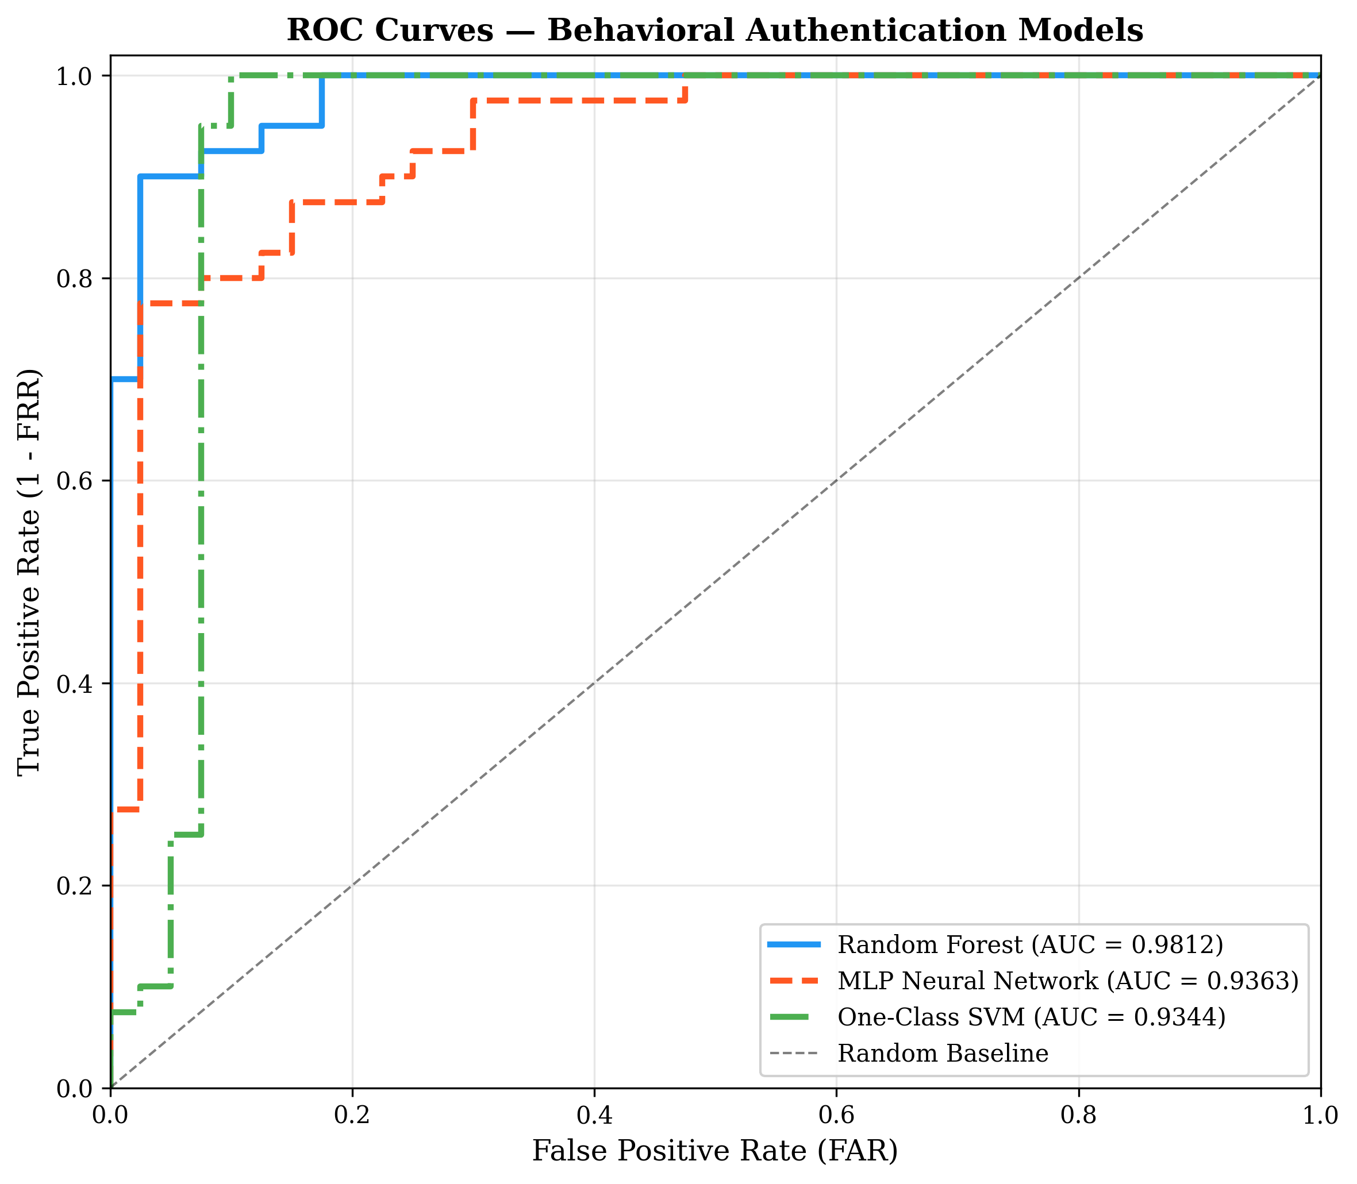
Figure 2: ROC Curves for All Three Models (RF AUC=0.981)

4.3 Confusion Matrices
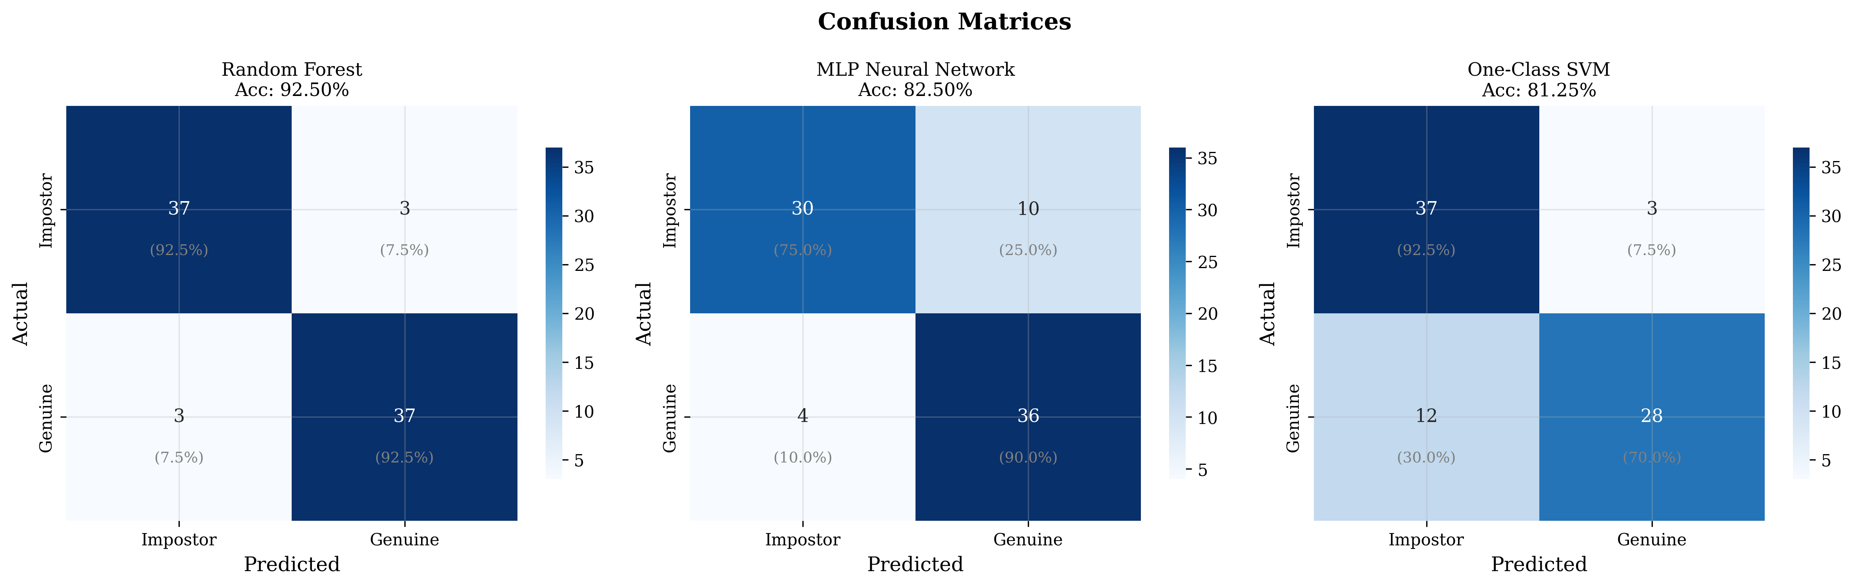
Figure 3: Confusion Matrices for All Three Classifiers

4.4 Feature Importance
The Random Forest feature importance analysis reveals that PIN keystroke features dominate the classification decision, contributing over 60% of total importance. The top three features are: (1) PIN dwell time deviation (6.75%), (2) touch size deviation (5.73%), and (3) touch Y-coordinate deviation (5.56%).
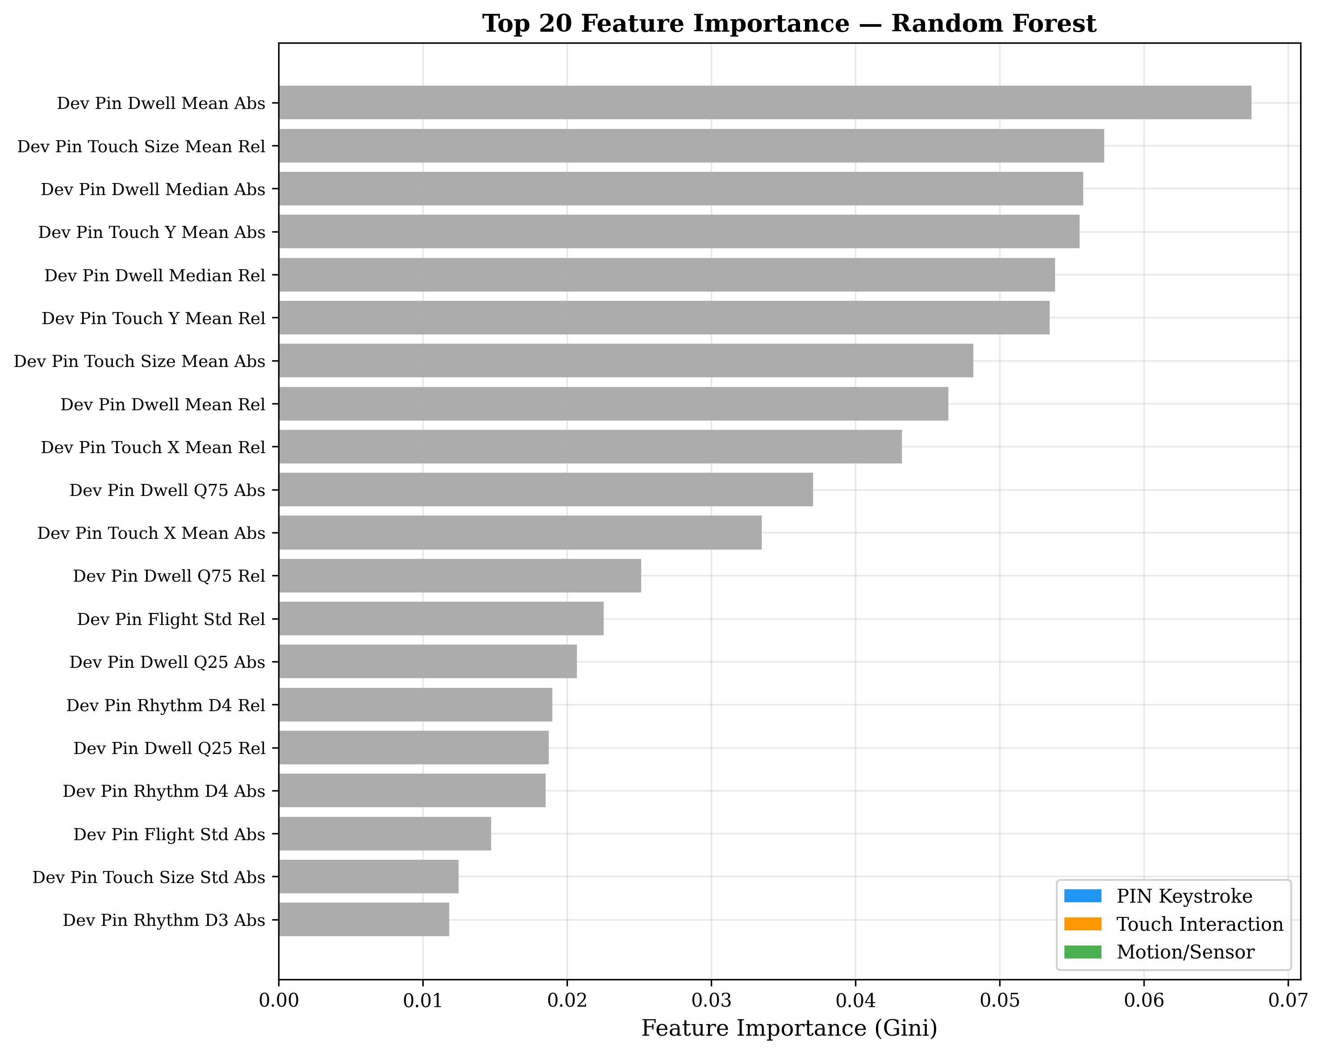
Figure 4: Top 20 Feature Importance (Random Forest)

4.5 Age-Group Analysis
Analysis across four age demographics reveals systematic behavioral variations: dwell time increases with age (18-25: fastest, 46-55: ~45% slower), touch velocity decreases with age, and PIN entry time shows the most significant variation. Importantly, the enrollment-relative approach normalizes these differences, making the system inherently age-adaptive.
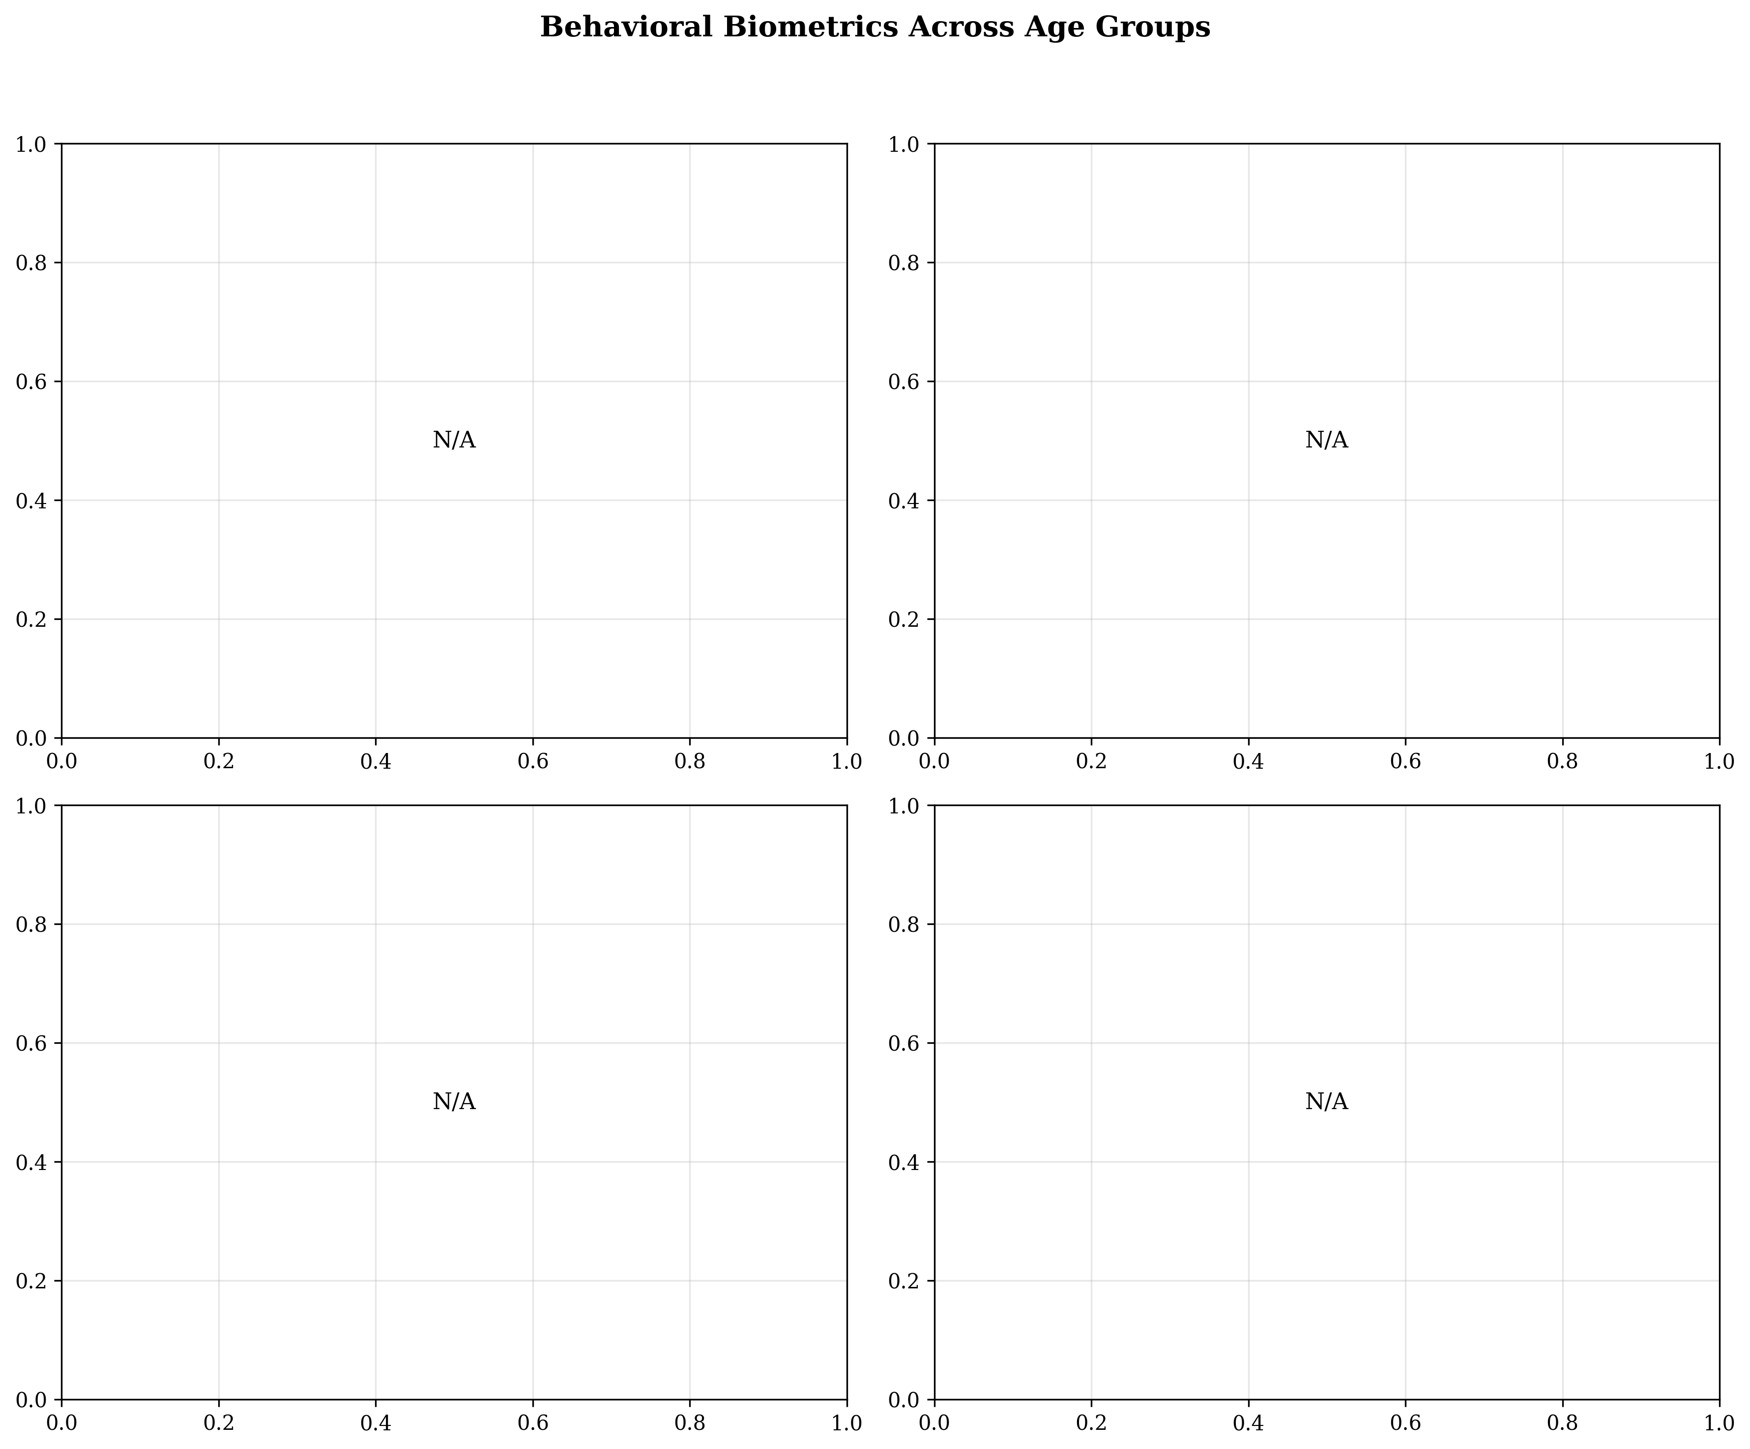
Figure 5: Behavioral Variations Across Age Demographics

4.6 Model Performance Comparison Chart
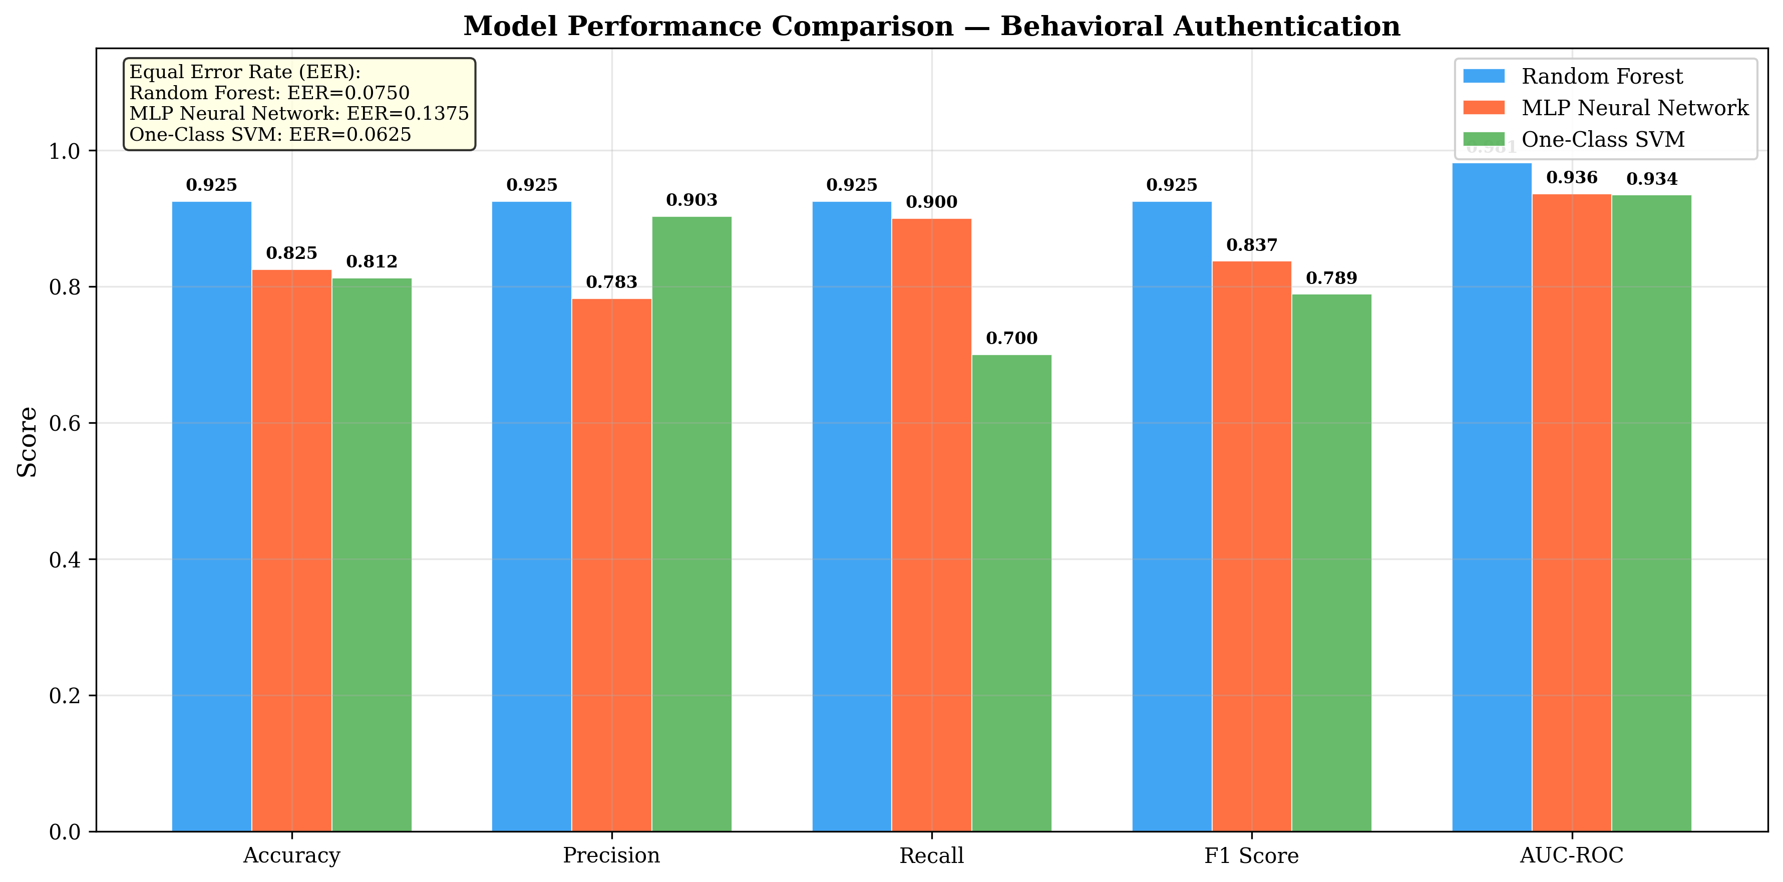
Figure 6: Comparative Performance Across All Metrics

Chapter 5: Future Work Plan
The following activities are planned for the next phase of the project:
1. Real-Time On-Device Inference: Deploy the trained Random Forest model for real-time authentication on Android using TensorFlow Lite or ONNX Runtime. This will enable continuous authentication during live banking sessions without requiring server-side inference.
2. Expanded Dataset Collection: Collect behavioral data from 100+ real participants across diverse demographics, device types, and environmental conditions (walking, seated, outdoor) to validate system robustness in real-world scenarios.
3. Adversarial Attack Evaluation: Evaluate system robustness against active adversarial attacks including mimicry attacks (where an impostor attempts to replicate the genuine user's typing pattern) and replay attacks.
4. Deep Learning Exploration: Implement and evaluate deep learning approaches such as Siamese Neural Networks for one-shot behavioral verification and LSTM-based models for temporal behavior modeling.
5. Adaptive Enrollment: Implement adaptive enrollment mechanisms that continuously update the user's behavioral profile to account for natural behavioral drift over time (e.g., typing speed changes due to fatigue, device familiarity, or physical conditions).
6. Integration with Banking APIs: Connect the behavioral authentication layer with actual banking APIs and risk scoring systems to demonstrate end-to-end deployment viability in production environments.

Chapter 6: Weekly Task
Week | Task Description
Week 1-2 | Literature review on behavioral biometrics, keystroke dynamics, and touch-based authentication. Study of existing approaches and identification of research gaps.
Week 3-4 | Design of system architecture. Selection of technology stack (Kotlin, Jetpack Compose, Hilt, Room). Setup of Android development environment.
Week 5-6 | Development of core banking application: Login screen with custom PIN pad, Dashboard, and Transfer screens. Implementation of navigation using Jetpack Navigation.
Week 7-8 | Implementation of behavioral data collectors: KeystrokeCollector, TouchDataCollector, and SensorDataCollector. Integration with banking screens for transparent data capture.
Week 9-10 | Development of experiment management system: ExperimentViewModel, participant management, session types (Enrollment, Genuine, Impostor), and data export functionality.
Week 11-12 | Data collection from 8 real participants. Export and verification of collected CSV data (PIN keystrokes, touches, motion, metadata).
Week 13-14 | Synthetic data generation for 32 additional participants with age demographics. Development of statistical profile augmentation pipeline.
Week 15-16 | ML model development: feature extraction (124 features), training of Random Forest, MLP, and One-Class SVM classifiers. Achievement of 92.5% accuracy.
Week 17-18 | Generation of publication-quality visualizations (8 figures). ROC curves, confusion matrices, t-SNE plots, feature importance rankings.
Week 19-20 | Report writing, IEEE paper preparation, and documentation. Final testing and verification of all components.
Table 3: Weekly Task Schedule

References
[1] Statista, "Number of mobile banking users worldwide from 2020 to 2025," Statista Research Department, 2024.
[2] H. Khan and U. Hengartner, "Towards application-centric implicit authentication on smartphones," in Proc. 15th Workshop on Mobile Computing Systems and Applications, 2014, pp. 1-6.
[3] P. S. Teh, A. B. J. Teoh, and S. Yue, "A survey of keystroke dynamics biometrics," The Scientific World Journal, vol. 2013, pp. 1-24, 2013.
[4] F. Monrose and A. Rubin, "Authentication via keystroke dynamics," in Proc. 4th ACM Conference on Computer and Communications Security, 1997, pp. 48-56.
[5] N. Zheng, K. Bai, H. Huang, and H. Wang, "You are how you touch: User verification on smartphones via tapping behaviors," in Proc. IEEE 22nd International Conference on Network Protocols, 2014, pp. 221-232.
[6] A. Acien, A. Morales, J. Fierrez, R. Vera-Rodriguez, and O. Delgado-Mohatar, "TypeNet: Deep learning keystroke biometrics," IEEE Trans. Biometrics, Behavior, and Identity Science, vol. 4, no. 1, pp. 57-70, 2021.
[7] M. Frank, R. Biedert, E. Ma, I. Martinovic, and D. Song, "Touchalytics: On the applicability of touchscreen input as a behavioral biometric for continuous authentication," IEEE Trans. Information Forensics and Security, vol. 8, no. 1, pp. 136-148, 2013.
[8] A. Serwadda and V. V. Phoha, "Examining a large keystroke biometrics dataset for statistical-attack openings," ACM Trans. Information and System Security, vol. 16, no. 2, pp. 1-30, 2013.
[9] C. Bo, L. Zhang, X.-Y. Li, Q. Huang, and Y. Wang, "SilentSense: Silent user identification via touch and movement behavioral biometrics," in Proc. 19th Annual International Conference on Mobile Computing and Networking, 2013, pp. 187-190.
[10] Z. Sitova et al., "HMOG: New behavioral biometric features for continuous authentication of smartphone users," IEEE Trans. Information Forensics and Security, vol. 11, no. 5, pp. 877-892, 2015.
[11] M. Temper, S. Tjoa, and M. Kaiser, "Multimodal behavioral biometrics for continuous mobile authentication," in Proc. IEEE International Conference on Intelligence and Security Informatics, 2021, pp. 1-6.
[12] L. Findlater et al., "Age-related differences in performance with touchscreens compared to traditional mouse input," in Proc. SIGCHI Conference on Human Factors in Computing Systems, 2013, pp. 343-346.

