README

**Note:** This file will look a bit strange until the required fonts are installed.

# Compatibility

WordTeX has been designed and tested on Microsoft Word 2016 for Windows. It probably mostly works on other versions of Word, but no promises. The fonts and template should work find on the Mac versions as well, but you should use the mac version of the template for better keyboard shortcuts.

# Installation Instructions

## Automatic Installation

Open WordTeXInstaller.exe and select which components you would like to install. Close Word before installation. You will need to unblock the zip before extracting, or installation will fail.

* **Install fonts** – installs the fonts at the root of the Fonts folder. If the font is already installed, it is skipped. Fonts in the Optional Fonts folder are not installed.
* **Copy template** – copies templates in the Templates folder to Word’s templates folder (if one exists), or copies them to Documents/Custom Office Templates.
* **Add AutoCorrect entries** – parses the autocorrect.xml file for formatted AutoCorrect entries and adds them to the Normal.dotm template.
* **Install or update plugin** – Runs the WordTeX.vsto file in the Plugin folder. This will confirm installation and install the plugin. You will need Pandoc for the plugin to work. [Download](https://pandoc.org/installing.html#windows) Pandoc

## Manual Installation

If you don’t like running exe files from random people from the internet, you can easily install the components manually.

* **Fonts** – install from the Fonts folder
* **Template** – copy from the Templates folder to a directory you would like to use for templates. The default is Documents/Custom Office Templates. Then set your template location in Word’s options (under the “Save” section). Open Word and select Personal to see locally installed templates. You can also open a template directly.
* **AutoCorrect** – The three AutoCorrect entries included are WordTeX (\wordtex), LaTeX (\latex), and □ (\qed). To add these manually:

1. Select one of the formatted entries above.
2. Open the AutoCorrect window (File, Options, Proofing, AutoCorrect Options)

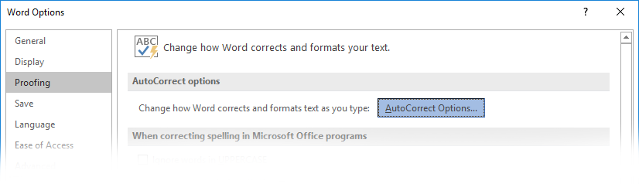

1. Type the string you want to replace and choose “Formatted text”

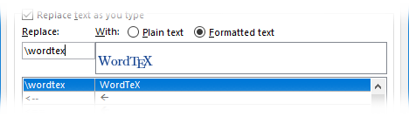

1. Click Add.

# Usage

Open Word and select Personal to see locally installed templates.

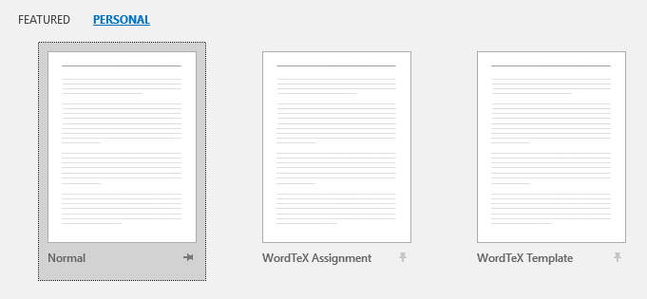

You can pin the template for easier access.

# Temp files and AppData

WordTeX creates the folders %temp%\WordTeX and %appdata%\WordTeX for storing files needed for Pandoc conversion. These can be safely deleted and will be recreated when the plugin needs them. The temp folder is automatically emptied when Word exits.

# Updates

Visit [tomwildenhain.com/wordtex](http://tomwildenhain.com/wordtex) to update the plugin and templates.

# Credits

The Latin Modern Math font is from gust.org. The other LM font files are from ctan.org. See the README in the Fonts folder for more information.