TERCERA PARTE DE COMANDOS A APLICAR

Manricon

# Clear all

rm(list = ls())

# Use ‘path’

library(tidyverse)  
haven::read_dta('dat/qw.dta') %>% # leer qw.dta  
 saveRDS('dat/qw.rds') # guardar data .r  
qw <- read_rds('dat/qw.rds') # leer qw.ds

# Limpieza de datos

Nombre de las variables de la data original nombre, Distrito, id, sexo, AÑOS, meses, meses_t, D, p1, p1_c, p1_, p2, p2_c, p2_, p3, p3_c, p3_, p4, p4_c, p4_, mem_ct, mem_ct_in, aten, aten_in, matematica, comunicacion, asistencia, faltas, peso, talla, imc, d_norm, d_bajo, d_sobr, DIAGNÓSTICO, tamiza_ane, descarte, d_cnane, d_snane

qw %>%   
 select(p1:aten) %>%   
 drop_na() %>% #eliminamos los 'missing values'  
 head(6) %>%   
 knitr::kable()

|  |  |  |  |  |  |  |  |  |  |  |  |  |  |  |
| --- | --- | --- | --- | --- | --- | --- | --- | --- | --- | --- | --- | --- | --- | --- |
| p1 | p1_c | p1_ | p2 | p2_c | p2_ | p3 | p3_c | p3_ | p4 | p4_c | p4_ | mem_ct | mem_ct_in | aten |
| 7 | 11 | 0.4 | 14 | 17 | 0.7 | 13 | 16 | 0.7 | 12 | 41 | 0.6 | 27 | 0.5 | 28 |
| 8 | 12 | 0.4 | 17 | 20 | 0.9 | 17 | 21 | 0.9 | 14 | 48 | 0.7 | 32 | 0.6 | 35 |
| 6 | 9 | 0.3 | 8 | 10 | 0.4 | 14 | 18 | 0.7 | 10 | 35 | 0.5 | 19 | 0.3 | 28 |
| 8 | 12 | 0.4 | 14 | 17 | 0.7 | 13 | 16 | 0.7 | 14 | 48 | 0.7 | 29 | 0.5 | 30 |
| 9 | 14 | 0.5 | 15 | 18 | 0.8 | 17 | 21 | 0.9 | 17 | 59 | 0.9 | 32 | 0.6 | 38 |
| 5 | 8 | 0.3 | 10 | 12 | 0.5 | 13 | 16 | 0.7 | 7 | 24 | 0.4 | 20 | 0.4 | 23 |

Se trabaja con estos datos:aten, sexo, tamiza_ane(nivel de hemoglobina), p3(planteamiento), p4(cancelacion de pares), IMCC, reasignando la como la base de datos qw1

qw1 <- qw %>%   
 drop_na() %>%   
 select(aten, sexo, tamiza_ane, p3, p4, imc) %>%   
 mutate(sexo = factor(sexo, labels = c("Masculino", "Femenino")))  
qw1 %>% head(6) %>% knitr::kable()

|  |  |  |  |  |  |
| --- | --- | --- | --- | --- | --- |
| aten | sexo | tamiza_ane | p3 | p4 | imc |
| 28 | Femenino | 13 | 13 | 12 | 17 |
| 35 | Femenino | 12 | 17 | 14 | 18 |
| 28 | Femenino | 12 | 14 | 10 | 18 |
| 30 | Masculino | 12 | 13 | 14 | 16 |
| 38 | Femenino | 13 | 17 | 17 | 19 |
| 23 | Masculino | 12 | 13 | 7 | 15 |

Descripcion de las variables

summary(qw1) %>% #resumen  
 knitr::kable()

|  |  |  |  |  |  |  |
| --- | --- | --- | --- | --- | --- | --- |
|  | aten | sexo | tamiza_ane | p3 | p4 | imc |
|  | Min. :18 | Masculino:102 | Min. :11 | Min. : 2 | Min. : 7 | Min. :15 |
|  | 1st Qu.:32 | Femenino :130 | 1st Qu.:13 | 1st Qu.:12 | 1st Qu.:17 | 1st Qu.:17 |
|  | Median :36 | NA | Median :14 | Median :14 | Median :19 | Median :18 |
|  | Mean :35 | NA | Mean :14 | Mean :14 | Mean :18 | Mean :18 |
|  | 3rd Qu.:38 | NA | 3rd Qu.:15 | 3rd Qu.:16 | 3rd Qu.:19 | 3rd Qu.:20 |
|  | Max. :45 | NA | Max. :20 | Max. :20 | Max. :20 | Max. :25 |

## Atencion

qw1 %>%   
 ggplot(aes(aten)) +  
 geom_histogram(aes(y = ..density.. ), fill = "#00AFBB", color = "white") +  
 geom_density(size = 2, color = "#D8DA9E") +  
 theme_minimal() +  
 labs(x = "Atencion de los estudiantes",   
 caption = "Datos: QW.dta")

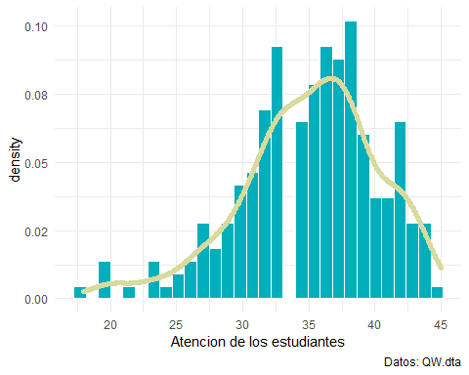

## Nivel de Hemoglobina

qw1 %>%   
 ggplot(aes(tamiza_ane)) +  
 geom_histogram(aes(y = ..density.. ), fill = "#00AFBB", color = "white") +  
 geom_density(size = 2, color = "#D8DA9E") +  
 theme_minimal() +  
 labs(x = "Hemoglobina de los estudiantes",   
 caption = "Datos: QW.dta")

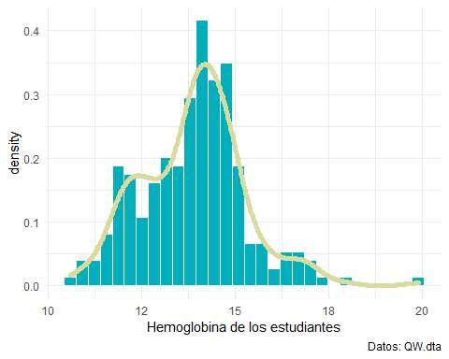

# Diagrama de caja y violin

## Atencion

qw1 %>%   
 ggplot(aes(aten)) +  
 geom_boxplot(color = "blue", fill = "steelblue") +scale_color_brewer(palette = "Dark2") +  
 theme_minimal() +  
 labs(x = "Atencion de los estudiantes",   
 caption = "Datos: QW.dta")

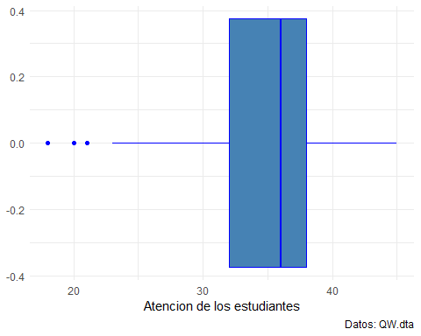

## Hemoglobina

qw1 %>%   
 ggplot(aes(tamiza_ane)) +  
 geom_boxplot(color = "blue", fill = "steelblue") +scale_color_brewer(palette = "Dark2") +  
 theme_minimal() +  
 labs(x = "Hemoglobina de los estudiantes",   
 caption = "Datos: QW.dta")

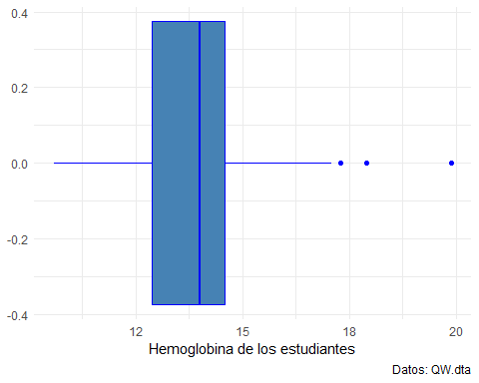

# correlaciones

library(GGally)  
ggpairs(qw1) + theme_minimal()

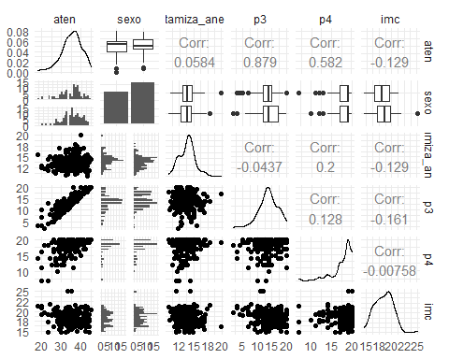

# Estimacion

## Modelo 1

library(broom)  
model <- aten ~ sexo + tamiza_ane + p3 + p4 +imc #definimos el modelo  
  
est1 <- lm(model, data = qw1)  
tidy(est1) %>%   
 knitr::kable()

|  |  |  |  |  |
| --- | --- | --- | --- | --- |
| term | estimate | std.error | statistic | p.value |
| (Intercept) | -0.3 | 0.3 | -0.9 | 0.4 |
| sexoFemenino | 0.0 | 0.0 | -0.3 | 0.8 |
| tamiza_ane | 0.0 | 0.0 | -0.1 | 0.9 |
| p3 | 1.3 | 0.0 | 212.4 | 0.0 |
| p4 | 1.0 | 0.0 | 123.6 | 0.0 |
| imc | 0.0 | 0.0 | 1.6 | 0.1 |

Extraccion del modelo

library(equatiomatic)  
extract_eq(est1)

$$\text{aten}=α+β_{1}({\text{sexo}}_{\text{Femenino}})+β_{2}(\text{tamiza_ane})+β_{3}(\text{p3})+β_{4}(\text{p4})+β_{5}(\text{imc})+ϵ$$

extract_eq(est1, use_coefs = T)

$$\text{aten}=−0.31−0.01({\text{sexo}}_{\text{Femenino}})+0(\text{tamiza_ane})+1.25(\text{p3})+1.01(\text{p4})+0.02(\text{imc})+ϵ$$

## Modelo 2

qw1 <- qw1 %>%   
 mutate(tamiza_ane = tamiza_ane/12)  
model <- aten ~ sexo + tamiza_ane + p3 + p4 +imc  
est2 <- lm(model, data = qw1)  
tidy(est1) %>%   
 knitr::kable()

|  |  |  |  |  |
| --- | --- | --- | --- | --- |
| term | estimate | std.error | statistic | p.value |
| (Intercept) | -0.3 | 0.3 | -0.9 | 0.4 |
| sexoFemenino | 0.0 | 0.0 | -0.3 | 0.8 |
| tamiza_ane | 0.0 | 0.0 | -0.1 | 0.9 |
| p3 | 1.3 | 0.0 | 212.4 | 0.0 |
| p4 | 1.0 | 0.0 | 123.6 | 0.0 |
| imc | 0.0 | 0.0 | 1.6 | 0.1 |

Extraccion del modelo

extract_eq(est2)

$$\text{aten}=α+β_{1}({\text{sexo}}_{\text{Femenino}})+β_{2}(\text{tamiza_ane})+β_{3}(\text{p3})+β_{4}(\text{p4})+β_{5}(\text{imc})+ϵ$$

extract_eq(est2, use_coefs = T)

$$\text{aten}=−0.31−0.01({\text{sexo}}_{\text{Femenino}})−0.02(\text{tamiza_ane})+1.25(\text{p3})+1.01(\text{p4})+0.02(\text{imc})+ϵ$$

# Normalidad de los residuos

Del ultimo modelo

qw1$residuals.est2 <- residuals( est2 ) # residuos  
qw1$rstudent.est2 <- rstudent( est2 ) # residuos estudentizados

Normalidad de residuos

sha <- shapiro.test(qw1$rstudent.est2)  
sha

Shapiro-Wilk normality test

data: qw1$rstudent.est2 W = 0.9, p-value = 2e-11

No hay normalidad de residuos

# Multicolineadlidad

library(caret)  
car::vif(est1)

sexo tamiza_ane p3 p4 imc   
 1 1 1 1 1

# Estimacion robusta

library(MASS)  
est3 <- rlm(model, data = qw1)  
tidy(est3) %>% knitr::kable()

|  |  |  |  |
| --- | --- | --- | --- |
| term | estimate | std.error | statistic |
| (Intercept) | -0.3 | 0.3 | -0.9 |
| sexoFemenino | 0.0 | 0.0 | -0.3 |
| tamiza_ane | 0.0 | 0.2 | -0.1 |
| p3 | 1.3 | 0.0 | 212.4 |
| p4 | 1.0 | 0.0 | 123.6 |
| imc | 0.0 | 0.0 | 1.6 |

# Modelos juntos

stargazer::stargazer(est1, est2, est3, type = "latex", header = F, title = "Todos los modelos")