**Lab08: 3D reconstruction**

**Problem 1:**

The epipolar lines and corresponding matching features are as below

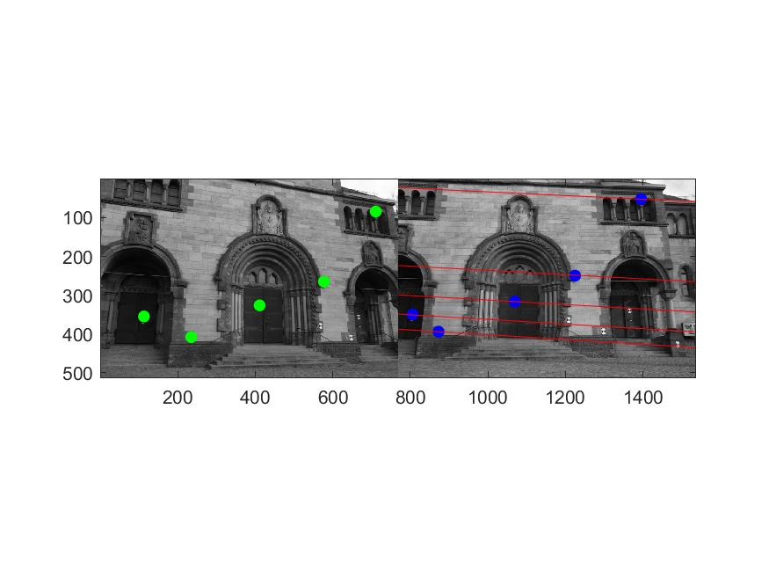

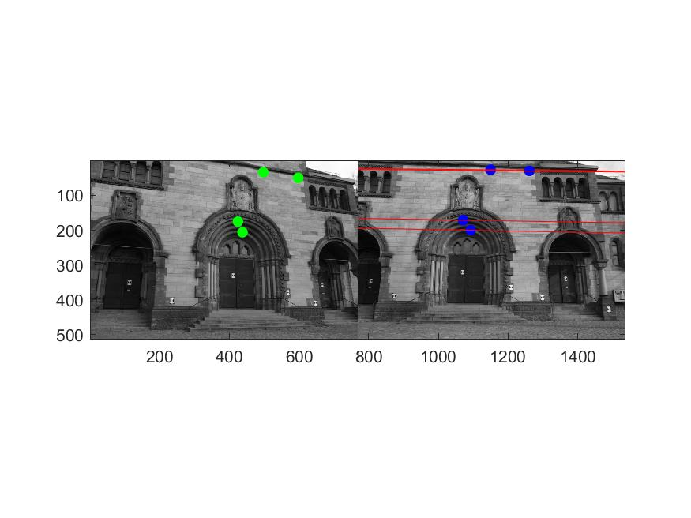

And the 3D reconstruction results shown as images are as below:

(1-3;4-5 pictures are from different attempts)

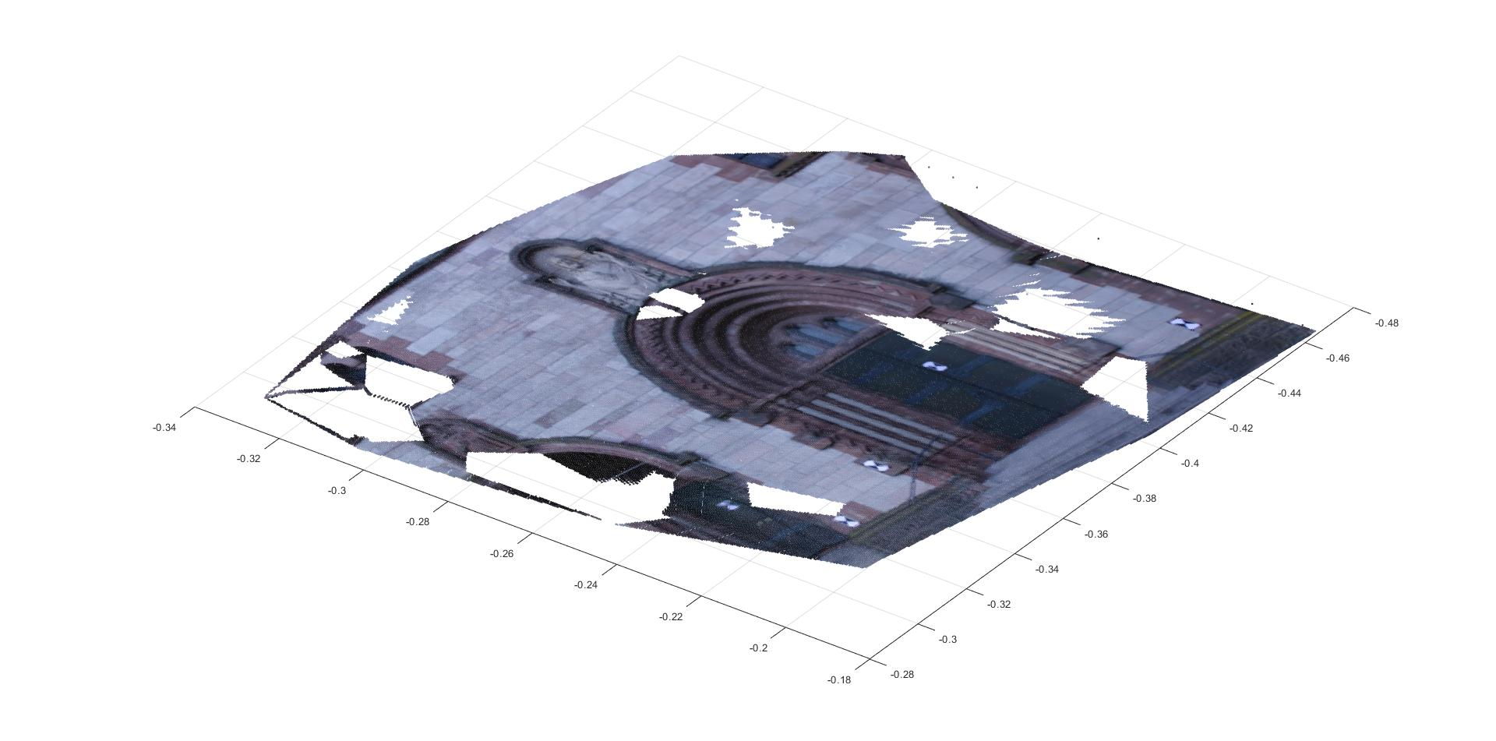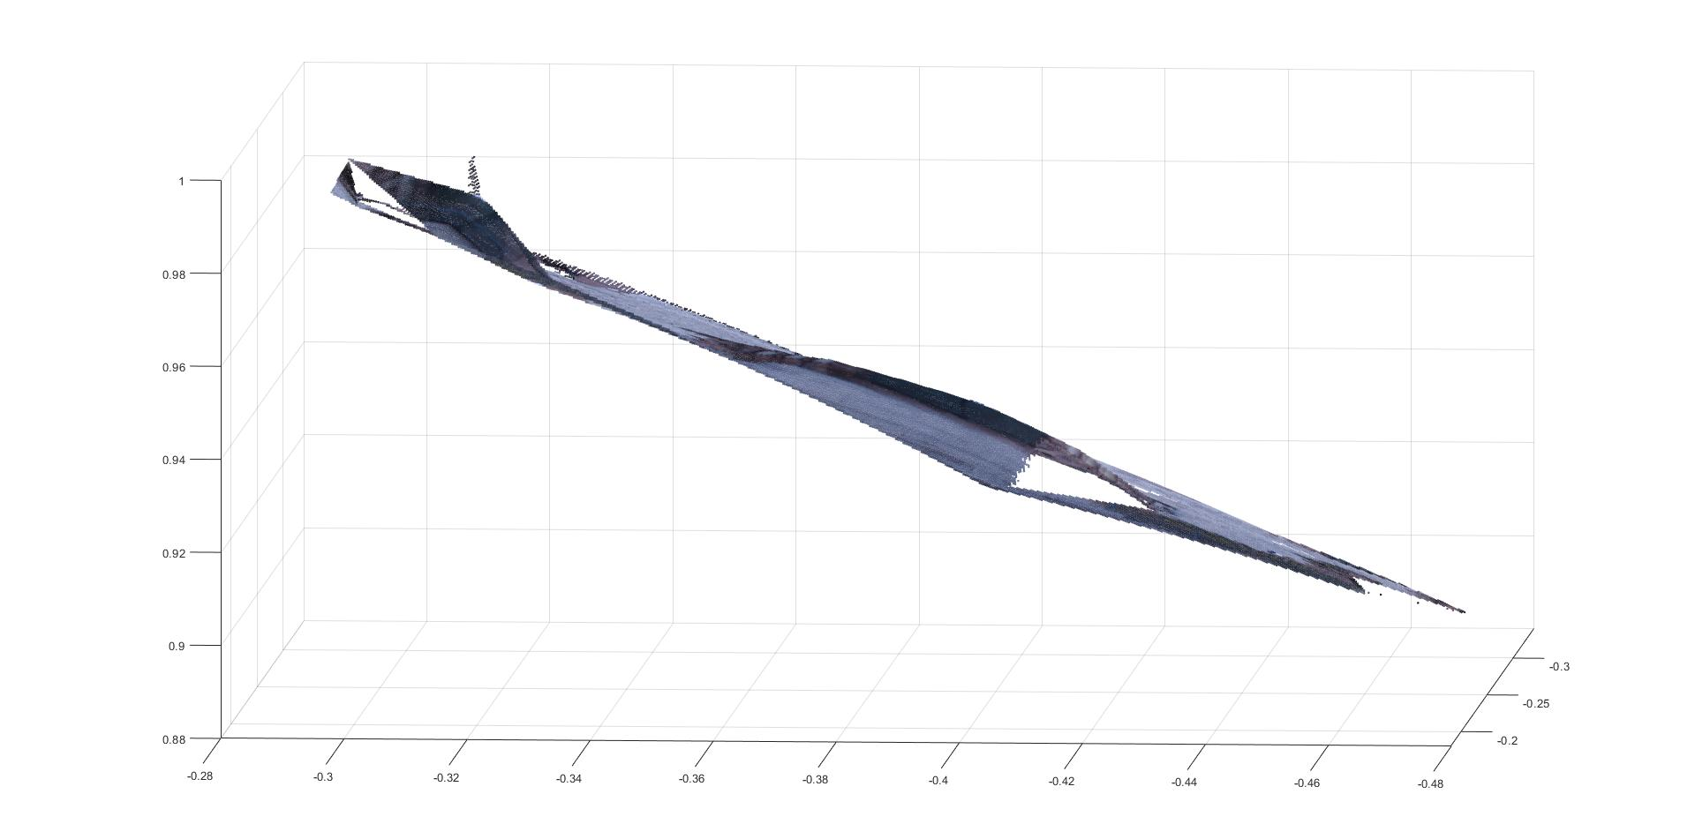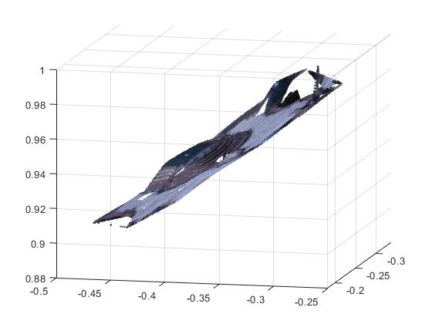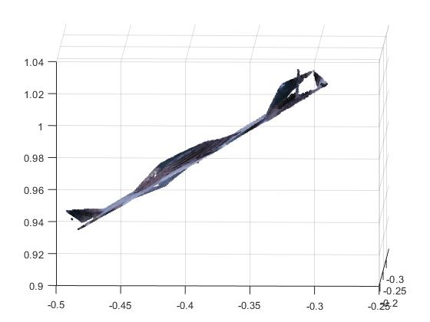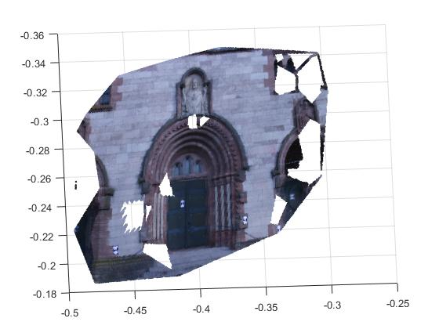

**Problem 2:**

Q1: The Densification.m take matchImg1 and matchIms2 and InlierIndx as inputs, make interpolation with meshgrid and griddata function to interpret data between known matches, setting threshold at the same time to regulate the newly-created matches are all lying at the epipolar lines.

The blank regions and gaps which can be seen from the above pictures. Since we apply a threshold (which is 2 in the given codes) to judge the dense matches valid or not, and thus some of the feature pixels are abandoned during the dense process, and making the gaps.

Q2: No, we cannot reconstruction with rotation-only images, since the center of two images are the same, thus the projection ray are identical as one, while we need two to complete the reconstruction.