B.E./B.Tech.DEGREE EXAMINATIONS,

Fourth Semester

# Computer Science and Engineering

CS3401–ALGORITHMS

# (regulations2021)

Time: Three Hours Maximum: 100Marks

**Part:A(10*2=20)**

1.Design an algorithm to compute area of circle.

2.Write worst case time complexity of insertion sort.

3.What is the advantages of Bellman-Ford algorithm?

4.Compare strongly connected and weakly connected graph?

5.What is optimal merge pattern?

6.Write the general divide and conquer approach to solve a problem.

7.What is state space tree?

8.Compare branch and bound method and backtracking method.

9.What is P and NP Problem?

10.What is NP Complete Problem?

PART-B(5*13=65)

11.a)Write the best case,worst case and average case efficiency of linear search.

Or

b)Explain the insertion sort algorithm and mention its time efficiency.

12.a)Explain about adjacency matrix and adjacency list.

Or

b)Explain about Kruskal algorithm with example.

13.a)Describe quicksort algorithm and sort given values 5,3,1,9,8,2,4,7

Or

b)Solve using matrix chain multiplication.Given sequence {7,1,5,4,2}

Matrix 7 x 1 , 1 x 5, 5 x 4, 4 x 2

14.a)Explain the concept of Knapsack problem with example.

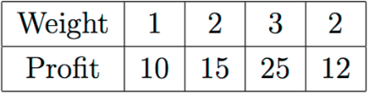 Knapsack Capcity =5

Or

b)What is subset sum problem.Draw state space tree S={2,3,4,5} d=9

15.a)Explain about NP hard and NP completeness.

or

b) Explain about randomised quick sort algorithm

PART-C(1*15=15)

16.a)Explain and Solve Assignment problem

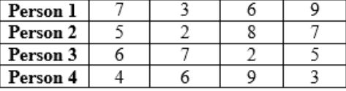

(or)

b)solve a travelling salesman problem.

