Lab2 Report

* Different between AXI Master and AXI Stream
* The main advantages for m_axi interface are: separate and independent read and write channels, support burst-based accesses with potential performance of ～17GB/s and provide support for outstanding transactions.
* The axis interface has no address information and burst length information. Therefore, the signal transfers like a stream with the TLAST signal telling the end of the data transfer.
* Different between C-simulation and Co-simulation
* C-simulation: This step is the algorithm-only simulation, which doesn’t include any hardware information, namely, the simulation is high level simulation.
* Co-simulation: This step is post-synthesis simulation, which means your high-level code has been translated into hardware description code. Therefore, the simulation is cycle accurate. You can see the signal at every cycle by opening the waveform report.
* Lab2-1 part

In lab2, we use FIR function to implement the HLS process. Lab2-1, we use AXI-master interface to build the system. The important thing to be aware is that m_axi protocol doesn’t support scalar input and return. By using this protocol, the resource usages may higher than using the AXI-stream interface.

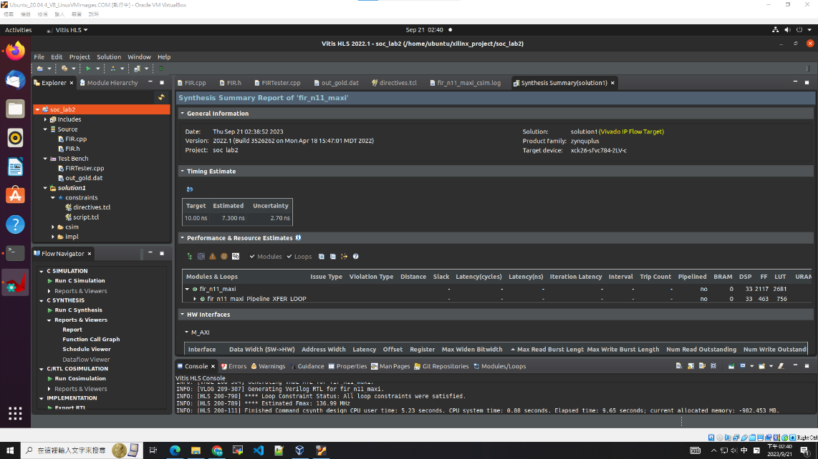

Synthesis report

一張含有 文字, 監視器, 室內, 螢幕擷取畫面 的圖片

描述是以非常高的可信度產生

HW interface 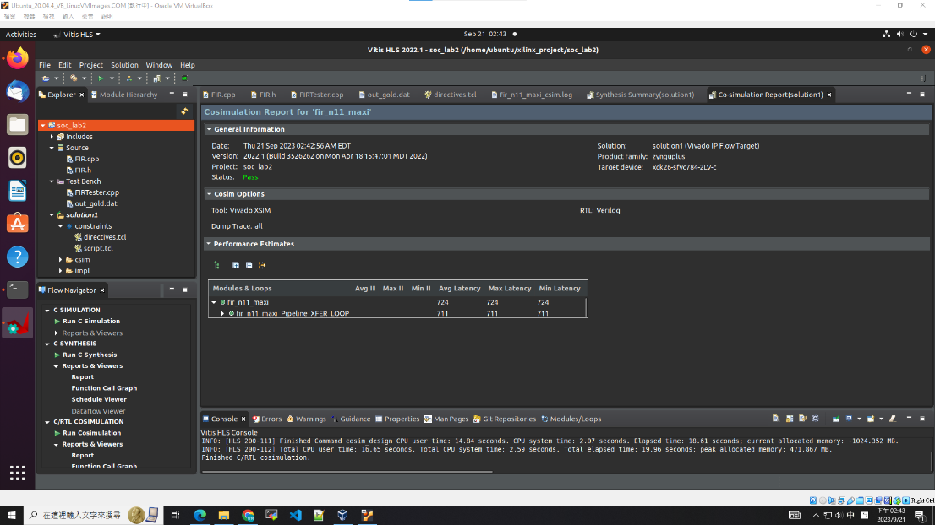

Co simulation

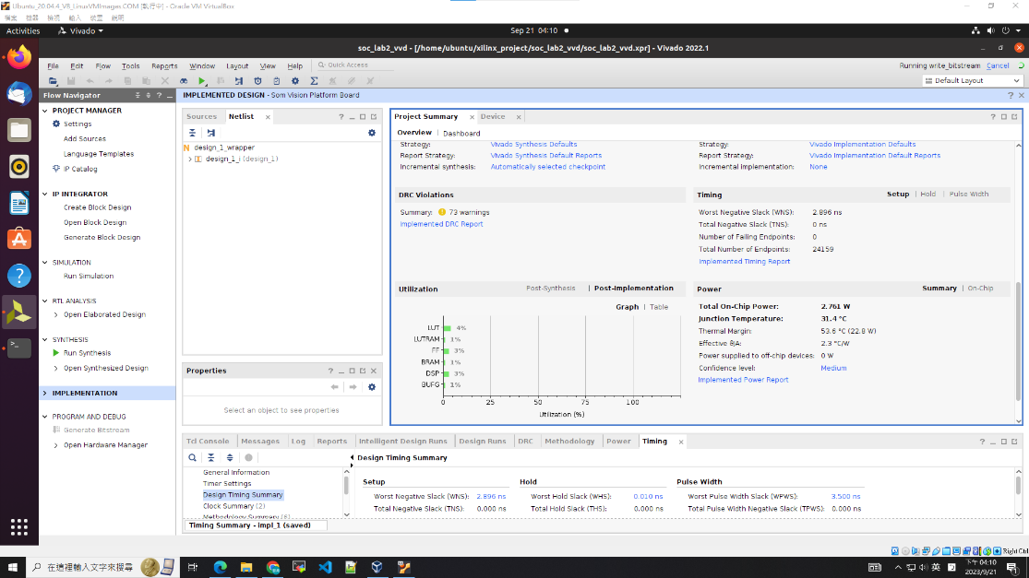

utilization

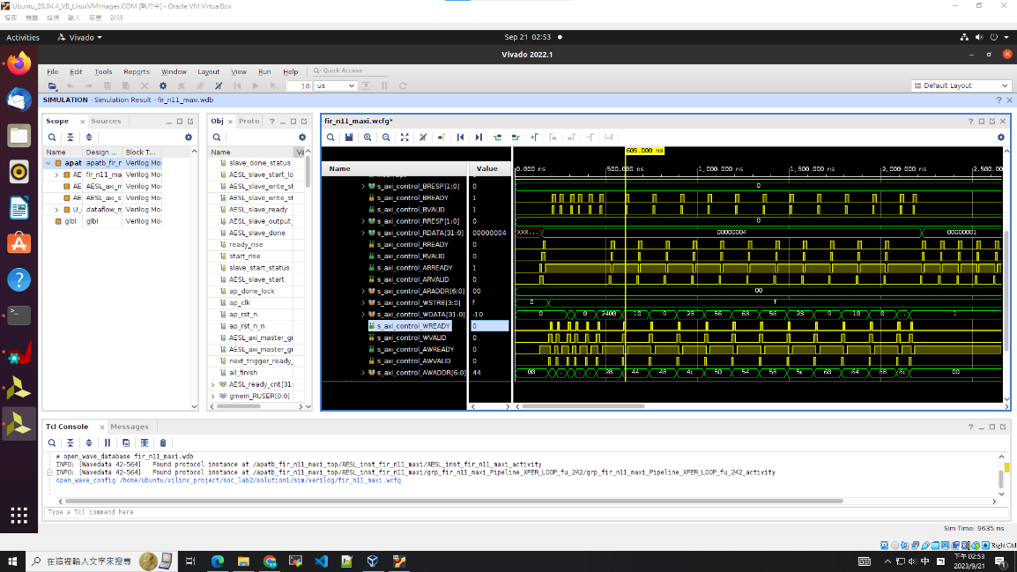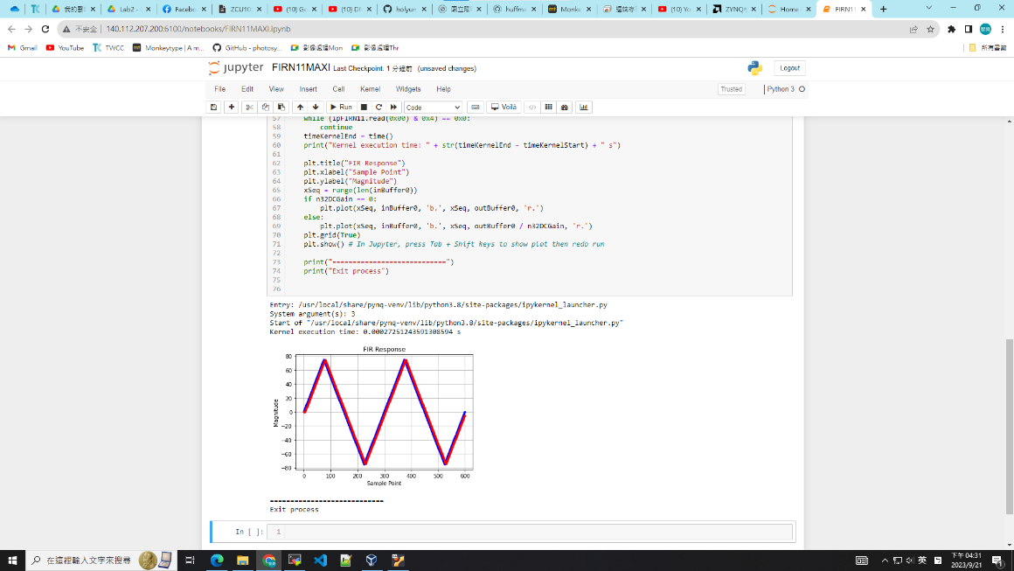

* Lab2-2 part

An AXI-stream interface can be applied to any input argument and any array or pointer output argument. It transfers data in a sequential streaming manner, so it cannot be used with arguments that are both read and written. The other important thing is we need to include <hls_stream.h> to use the hls::stream object for internal streams.

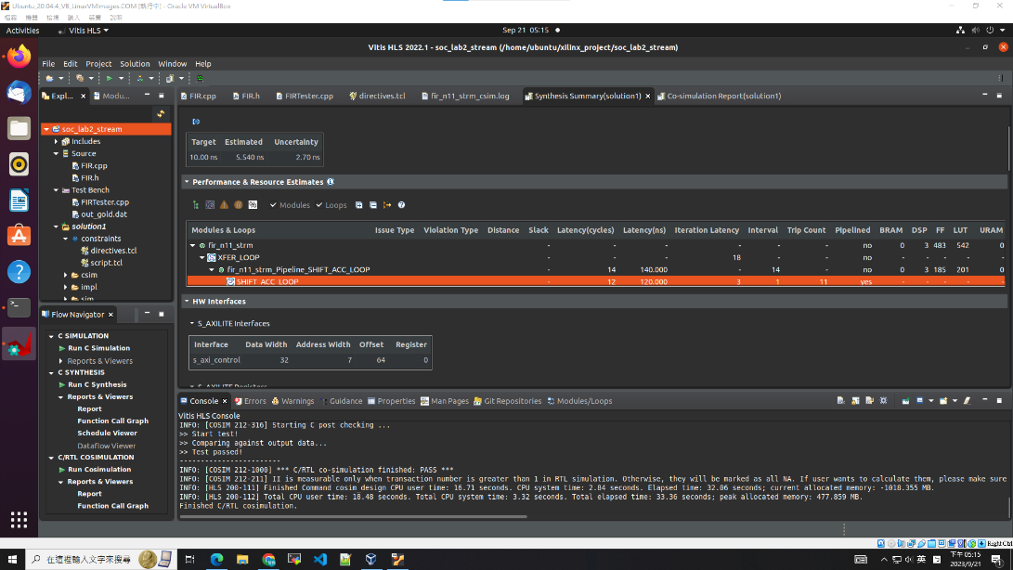

Synthesis report

一張含有 文字, 監視器, 室內, 螢幕擷取畫面 的圖片

描述是以非常高的可信度產生

HW interface

