Shift Up button pressed — ignition cut upshift
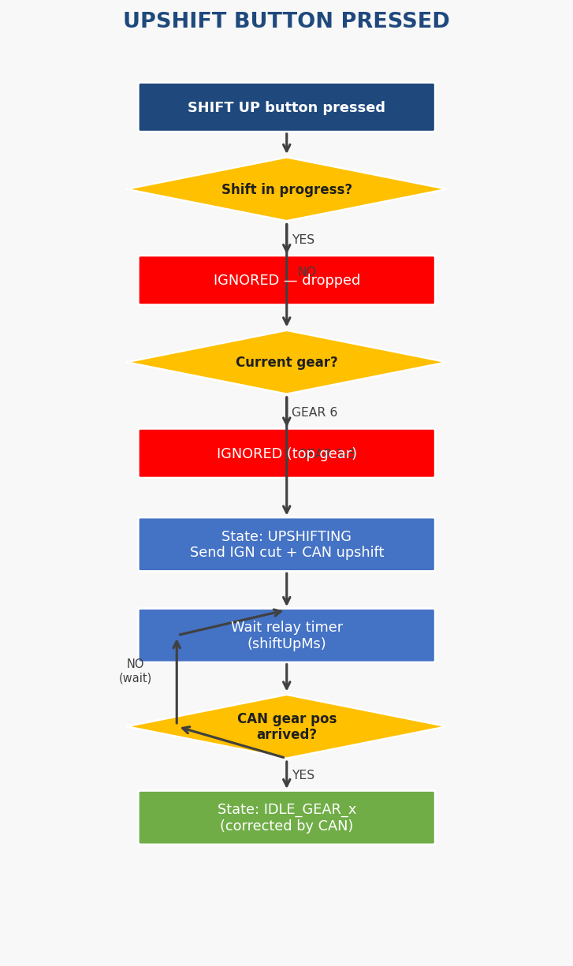

Shift Down button pressed — clutch servo downshift
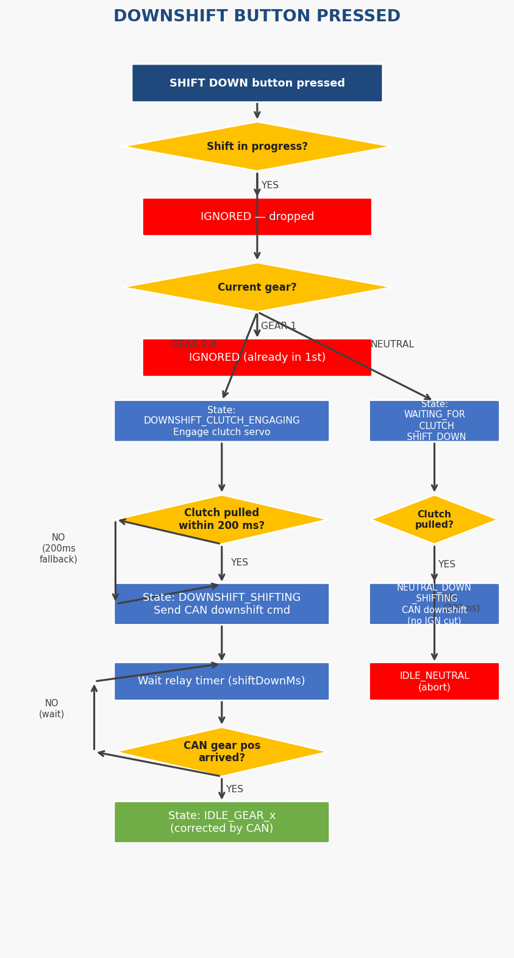

Neutral button pressed — single button, direction by gear
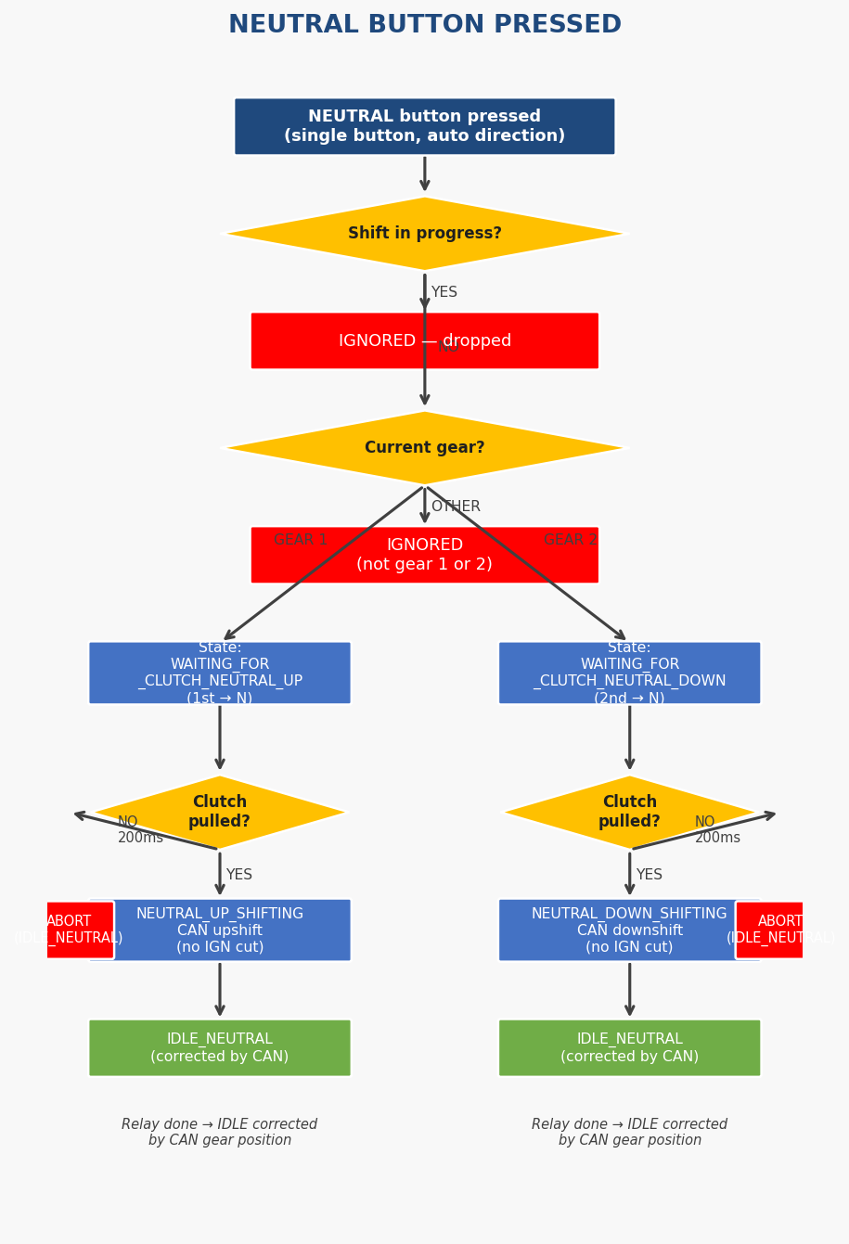

Manual mode — toggle and direct shift commands
