Assignment 1

Name:

Student Number:

Date: 03/11/2016

Question 1

1.1 The finalized query text

SELECT Customer.Name,

Customer.BillingContact,

Customer.BillingAddress1,

Customer.BillingCity,

Customer.BillingState,

Customer.BillingZipCode,

Customer.BillingEmail,

InvoiceHeader.TotalAmount, CONVERT(varchar(11),

PaymentInvoiceLink.PaidDate,105) as PaidDate

FROM Customer INNER JOIN

InvoiceHeader ON Customer.CustomerNumber = InvoiceHeader.CustomerNumber

INNER JOIN

PaymentInvoiceLink ON InvoiceHeader.InvoiceNumber = PaymentInvoiceLink.InvoiceNumber

AND InvoiceHeader.TotalAmount = PaymentInvoiceLink.PaidAmount

WHERE (InvoiceHeader.TotalAmount > 300)

ORDER BY Customer.Name

* 1. A snapshot of query ran successfully with it’s result in SQL Server Management Studio

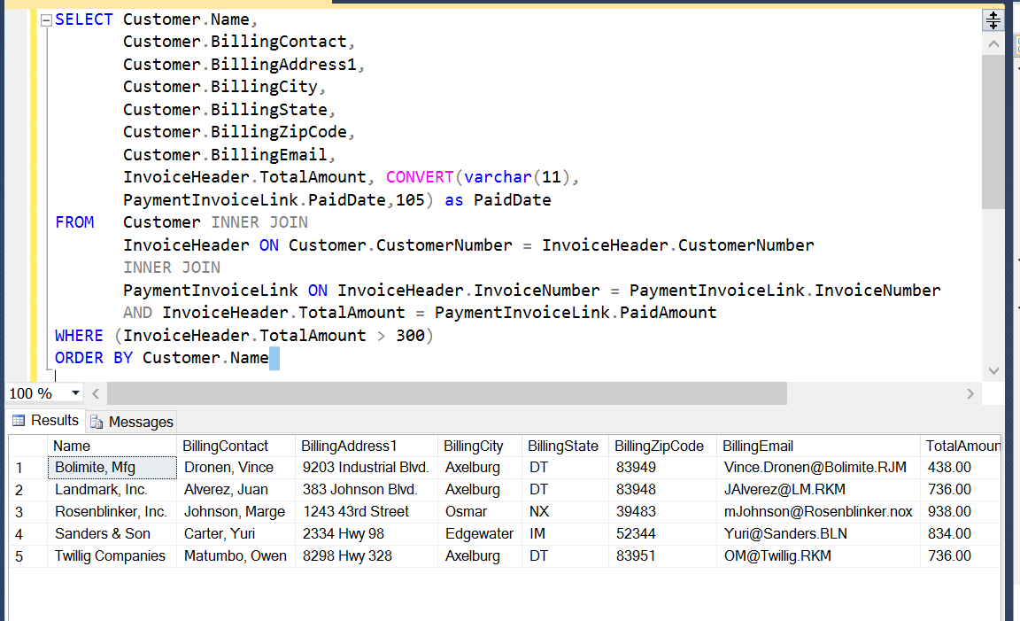

* 1. Data Sets details

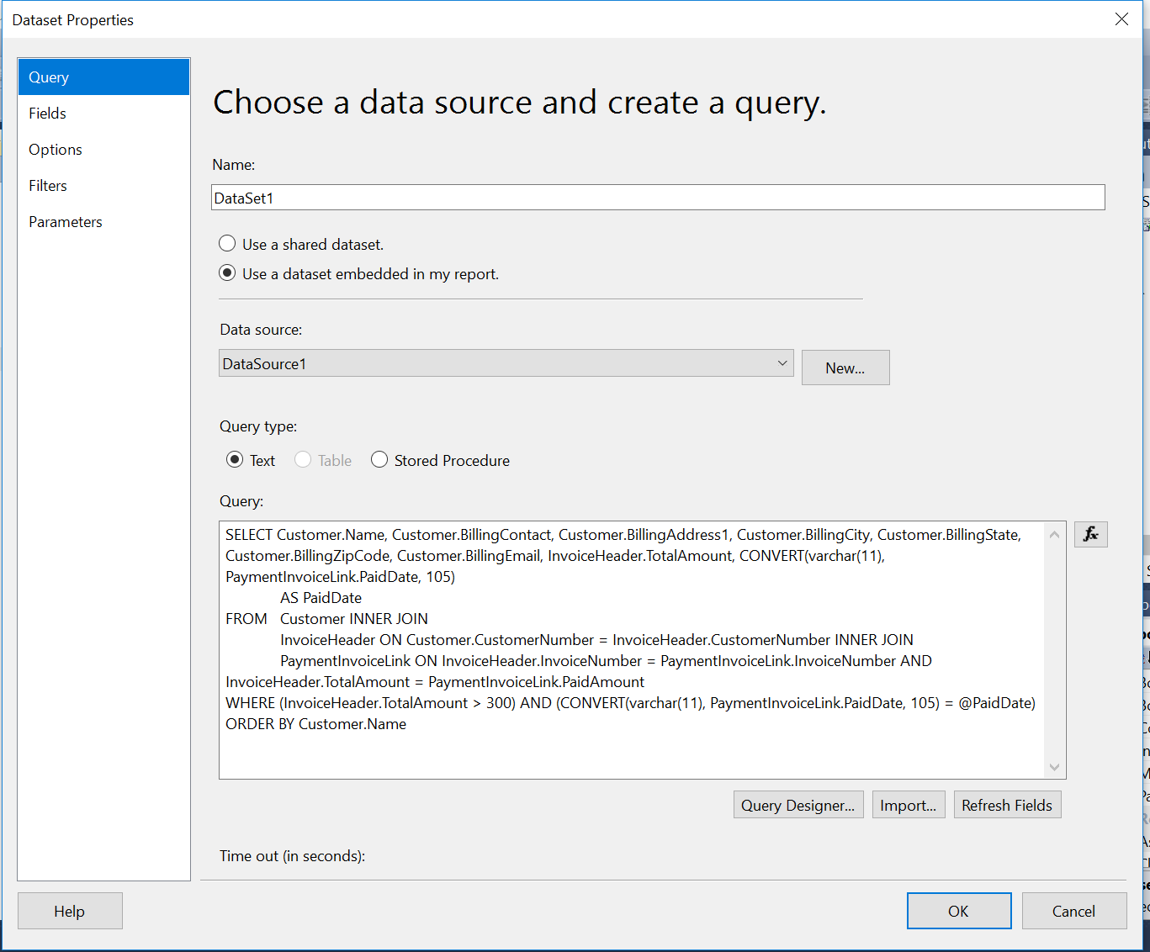

* 1. Parameter details

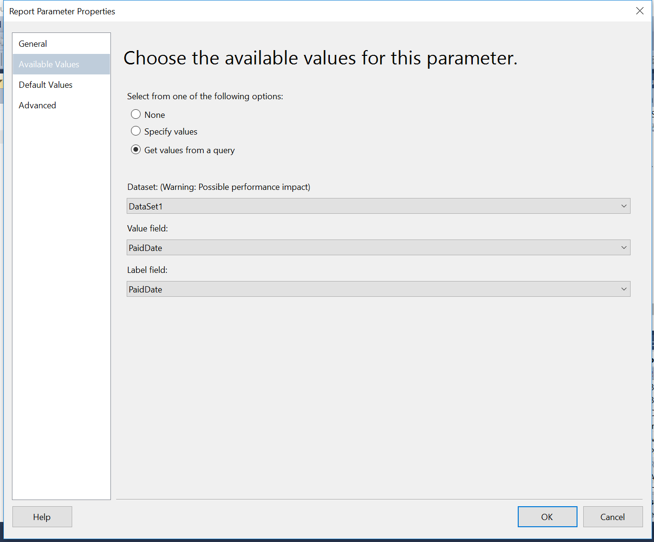

* 1. Table in design tab

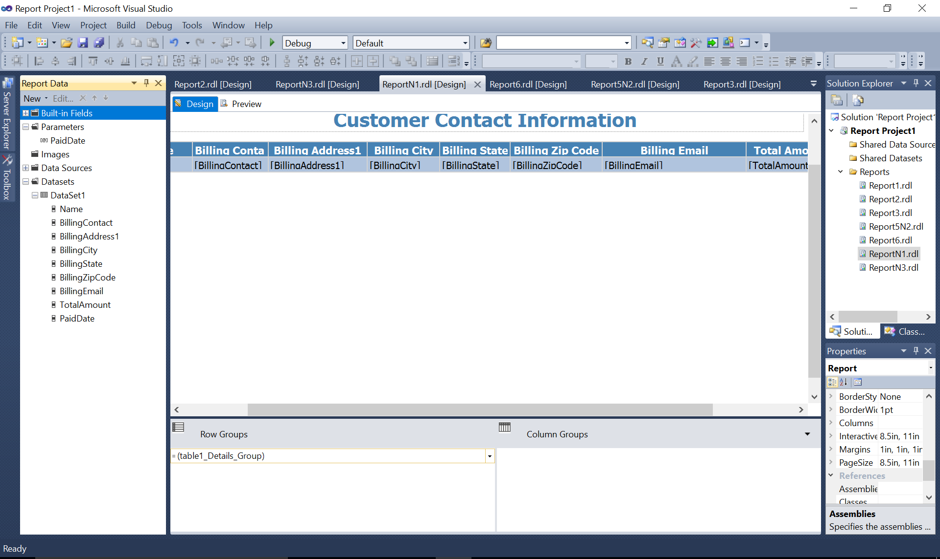

* 1. Report view after completion

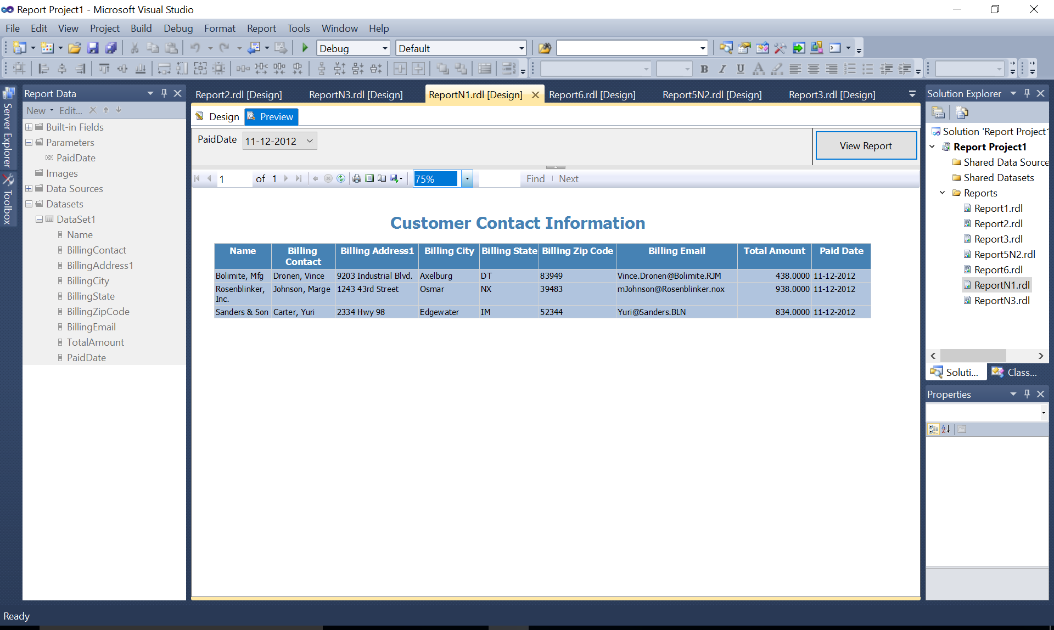

Question 2

* 1. The finalized query text

SELECT Delivery.DeliveryNumber,

Delivery.PickupDateTime,

Delivery.DeliveryDateTime,

Delivery.PackageWeight,

Delivery.PackageSize,

Delivery.PickupAddress1,

CASE WHEN (DATEDIFF(dd, Delivery.DeliveryDateTime, Delivery.PickupDateTime) = 1)

AND (DATEDIFF(hh, Delivery.DeliveryDateTime, Delivery.PickupDateTime) < 48)

THEN 'Deliveried 24hrs Before Pickup'

WHEN DeliveryStatus.StatusName = 'In Route'

THEN 'Not deliveried yet'

WHEN (DATEDIFF(dd, Delivery.PickupDateTime, Delivery.DeliveryDateTime) = 0)

THEN 'Deliveried Same Day'

WHEN (DATEDIFF(dd, Delivery.PickupDateTime, Delivery.DeliveryDateTime) = 1)

AND (DATEDIFF(hh, Delivery.PickupDateTime, Delivery.DeliveryDateTime) < 48)

THEN 'Deliveried 24hrs After Pickup'

END AS Categories

FROM Delivery INNER JOIN

DeliveryStatus ON Delivery.StatusCode = DeliveryStatus.StatusCode

WHERE (CASE WHEN (DATEDIFF(dd, Delivery.DeliveryDateTime, Delivery.PickupDateTime) = 1)

AND (DATEDIFF(hh, Delivery.DeliveryDateTime, Delivery.PickupDateTime) < 48)

THEN 'Deliveried 24hrs Before Pickup'

WHEN DeliveryStatus.StatusName = 'In Route'

THEN 'Not deliveried yet'

WHEN (DATEDIFF(dd, Delivery.PickupDateTime, Delivery.DeliveryDateTime) = 0)

THEN 'Deliveried Same Day'

WHEN (DATEDIFF(dd, Delivery.PickupDateTime, Delivery.DeliveryDateTime) = 1)

AND (DATEDIFF(hh, Delivery.PickupDateTime, Delivery.DeliveryDateTime) < 48)

THEN 'Deliveried 24hrs After Pickup'

END IS NOT NULL) AND (DeliveryStatus.StatusName <> 'Lost')

* 1. A snapshot of query ran successfully with it’s result in SQL Server Management Studio

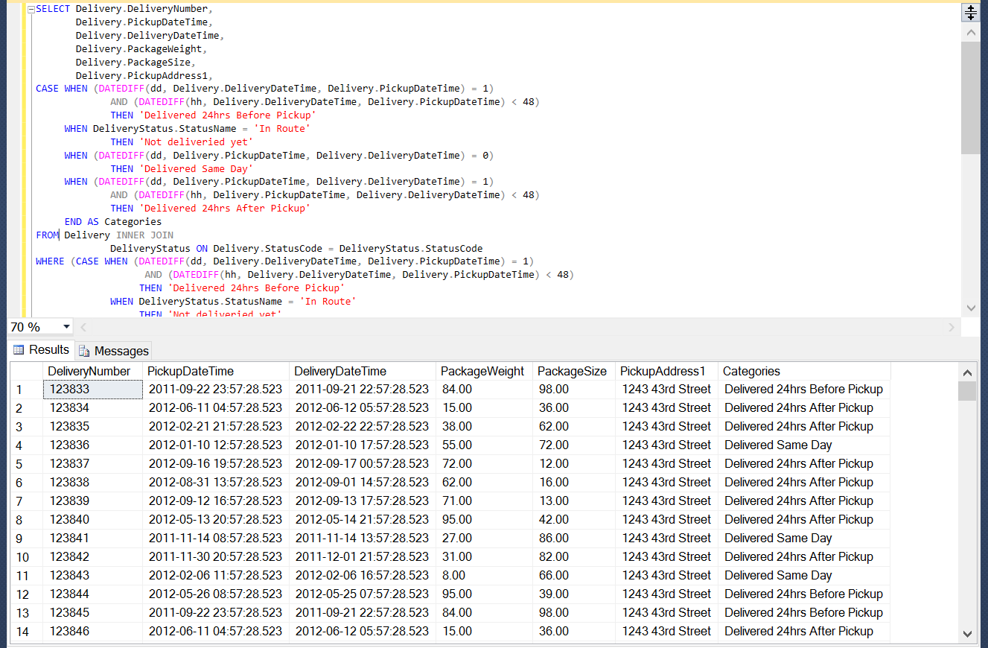

* 1. Data Sets details

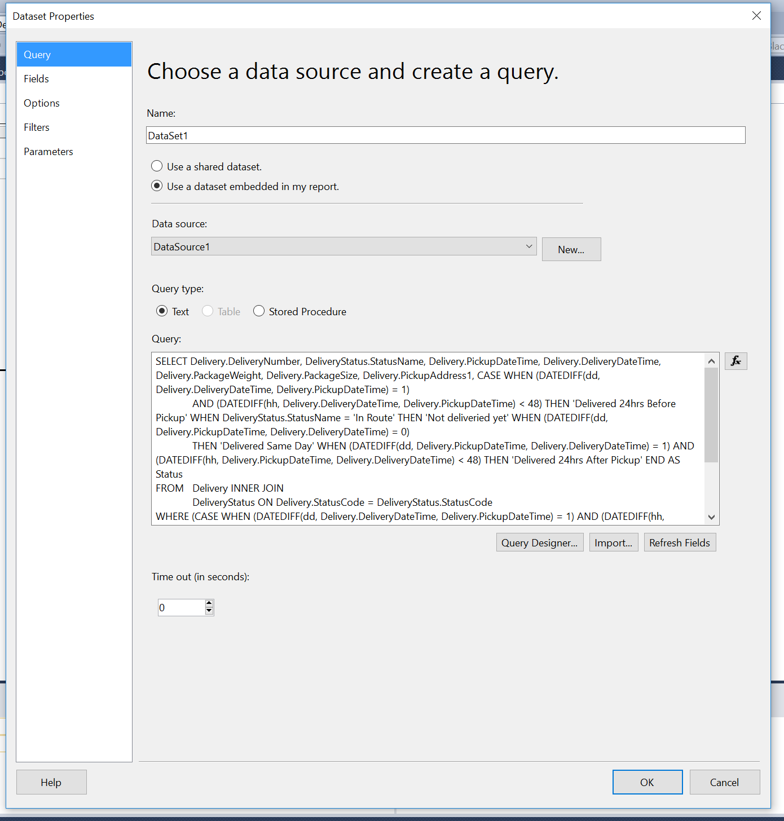

* 1. Parameter details

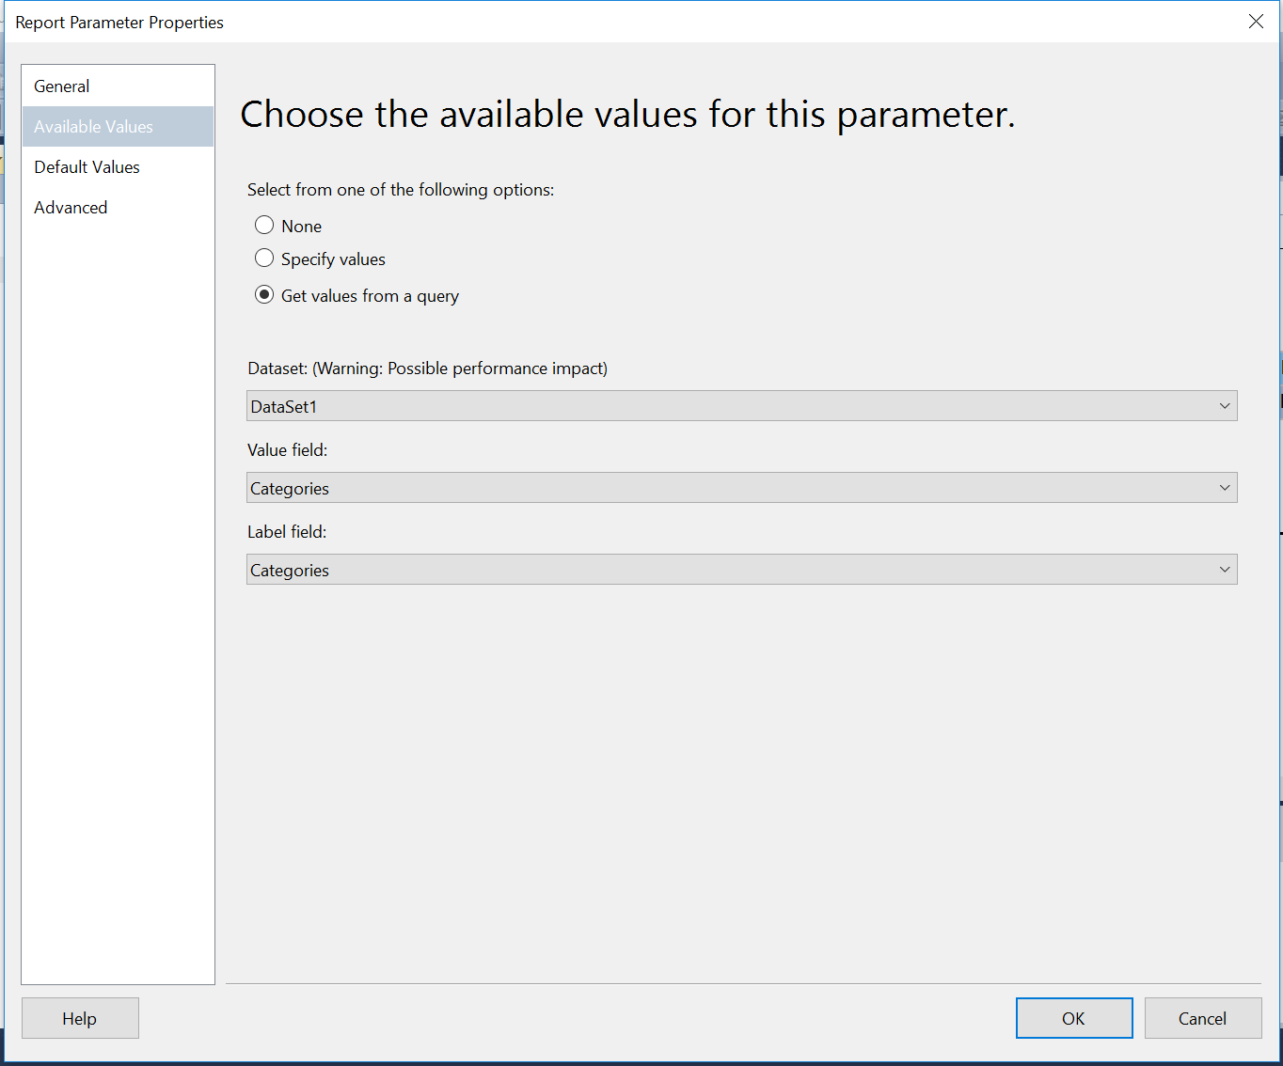

* 1. Table in design tab

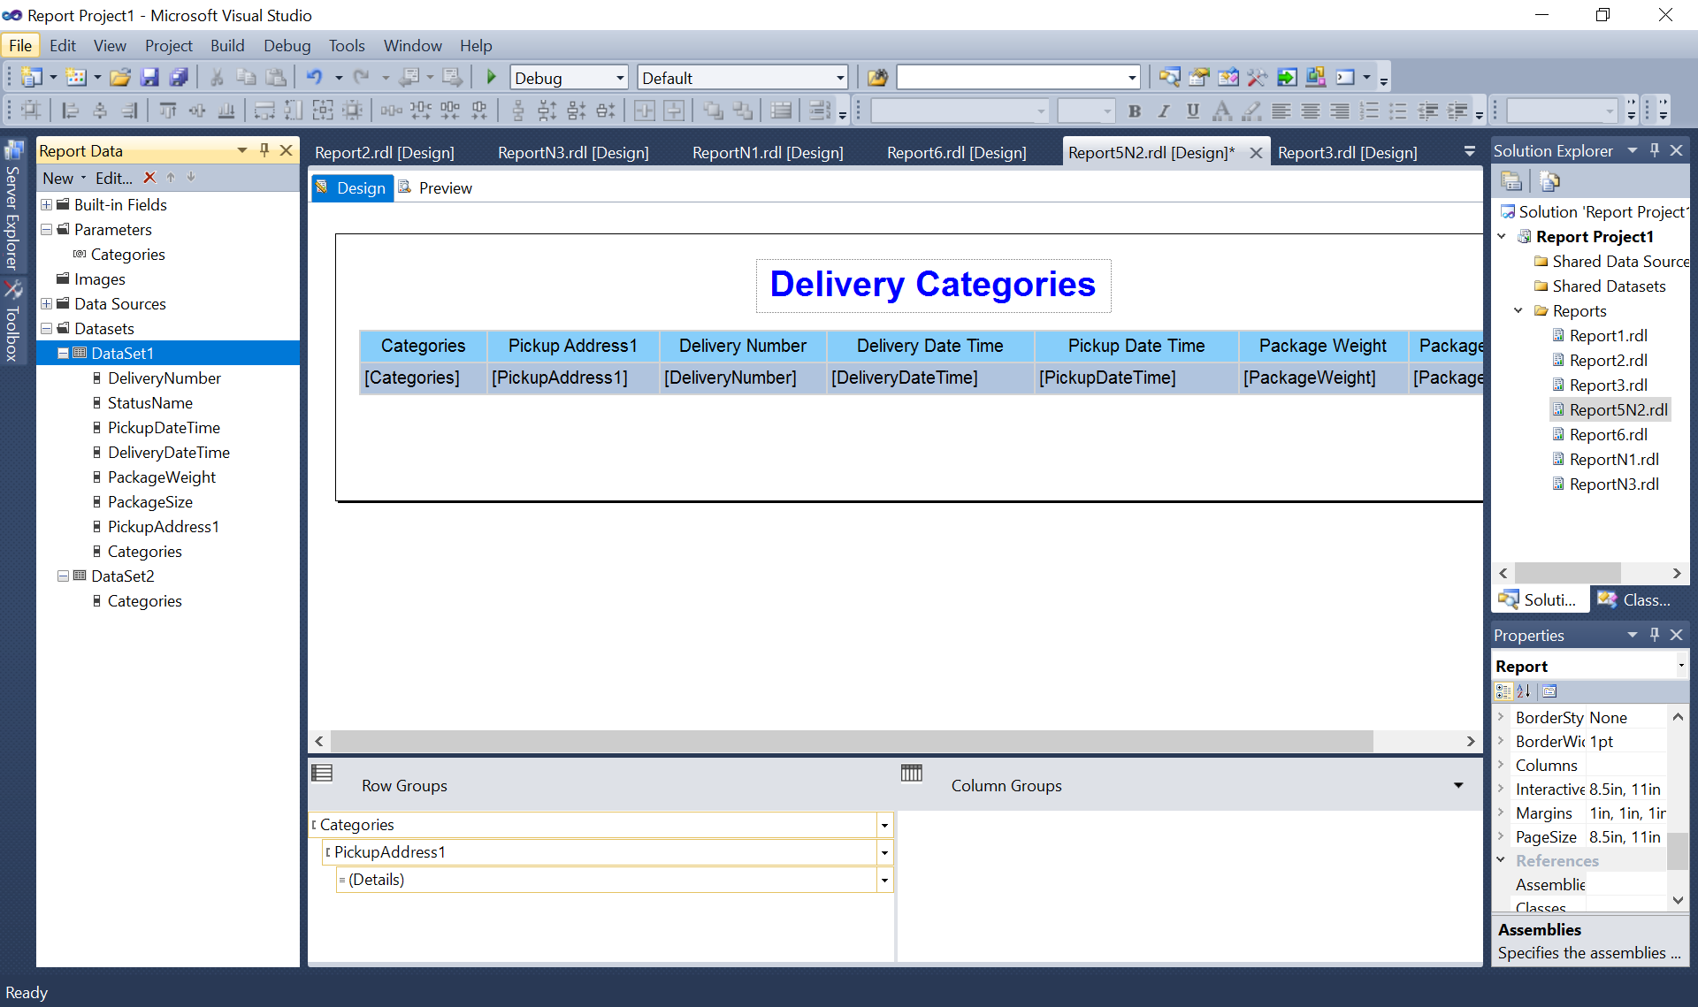

* 1. Report view after completion

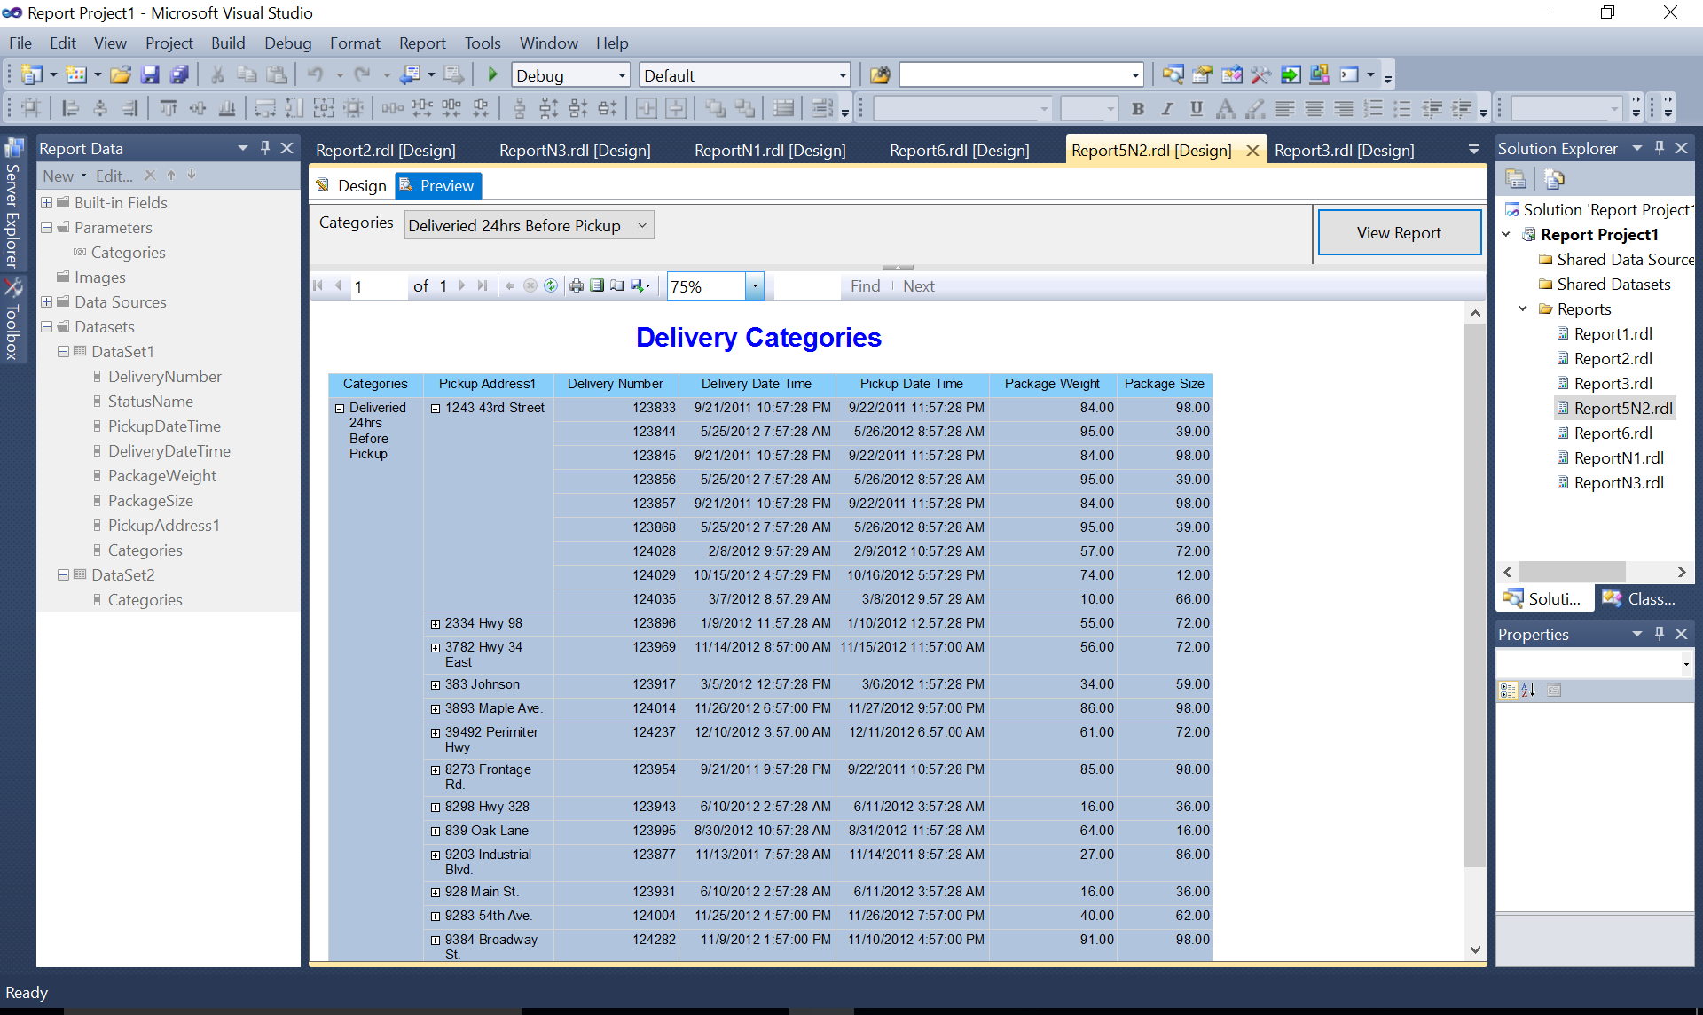

Question 3

* 1. The finalized query text

SELECT TransportType.Description AS TransportType,

WorkDone.Description AS workDone,

RepairCause.Description AS RepairCause,

Transport.TransportNumber,

CASE WHEN (RepairCause.Description = 'Scheduled Maintenance')

THEN 'Scheduled maintenance'

WHEN (RepairCause.Description != 'Scheduled Maintenance')

THEN 'Malfunction'

END AS Maintenance

FROM Transport INNER JOIN

RepairCause INNER JOIN

Repair ON RepairCause.CauseCode = Repair.CauseCode ON Transport.TransportNumber = Repair.TransportNumber INNER JOIN

TransportType ON Transport.TransportTypeID = TransportType.TransportTypeID INNER JOIN

RepairWorkDoneLink AS RepairWorkDoneLink_1 ON Repair.RepairID = RepairWorkDoneLink_1.RepairID INNER JOIN

WorkDone ON RepairWorkDoneLink_1.WorkDoneCode = WorkDone.WorkDoneCode

ORDER BY TransportType

* 1. A snapshot of query ran successfully with it’s result in SQL Server Management Studio

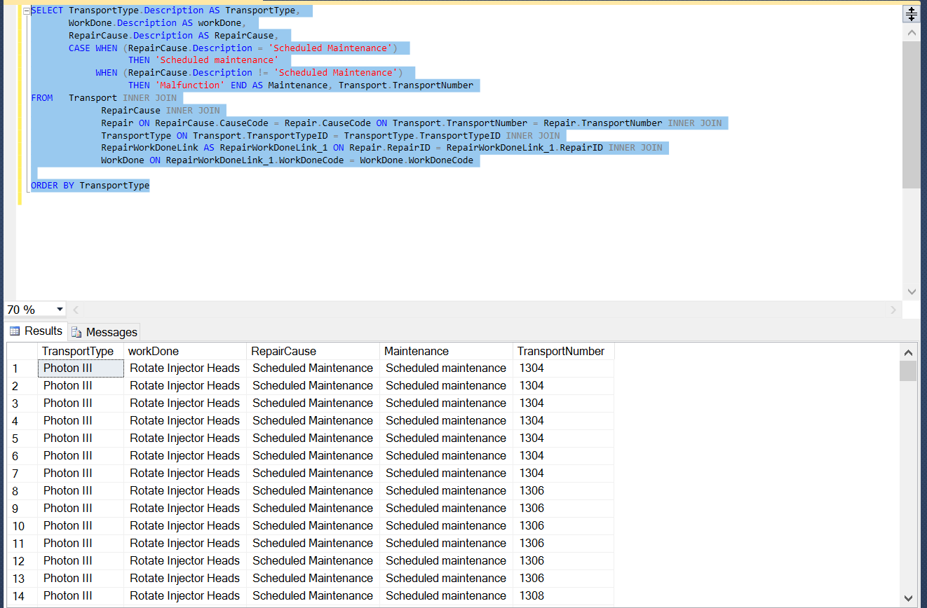

* 1. Data Sets details

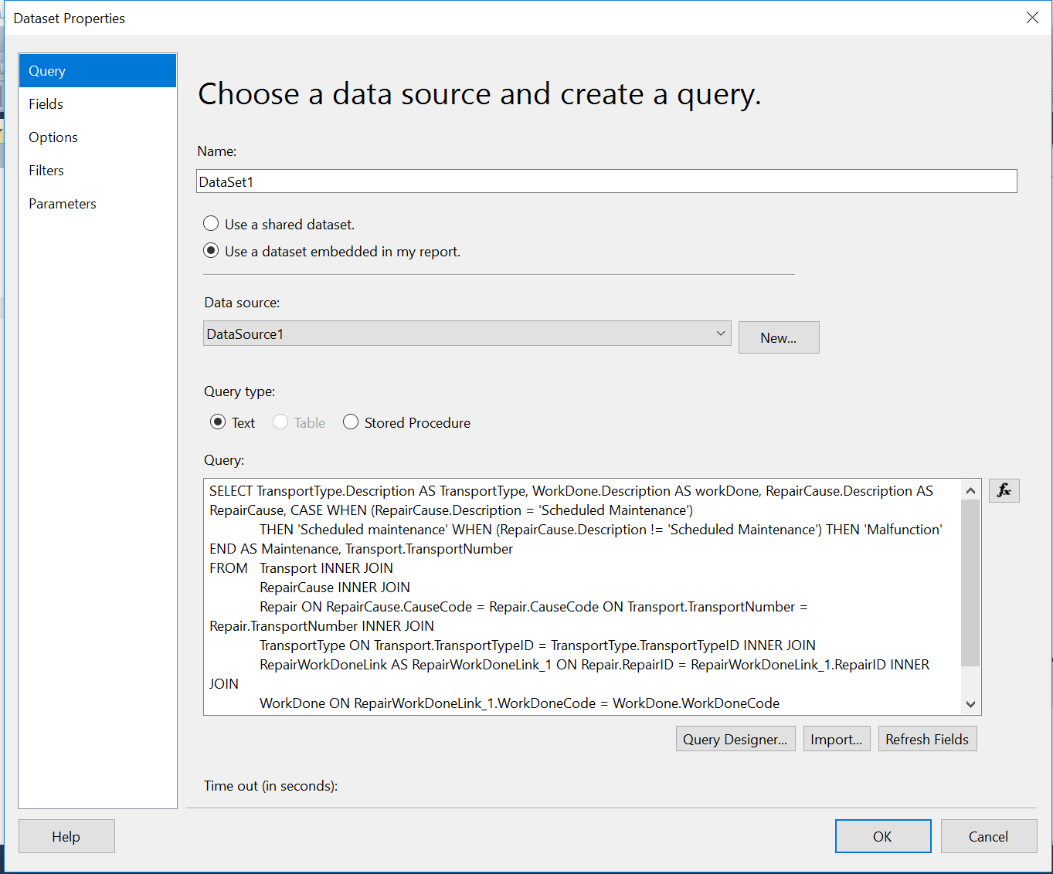

* 1. Parameter details

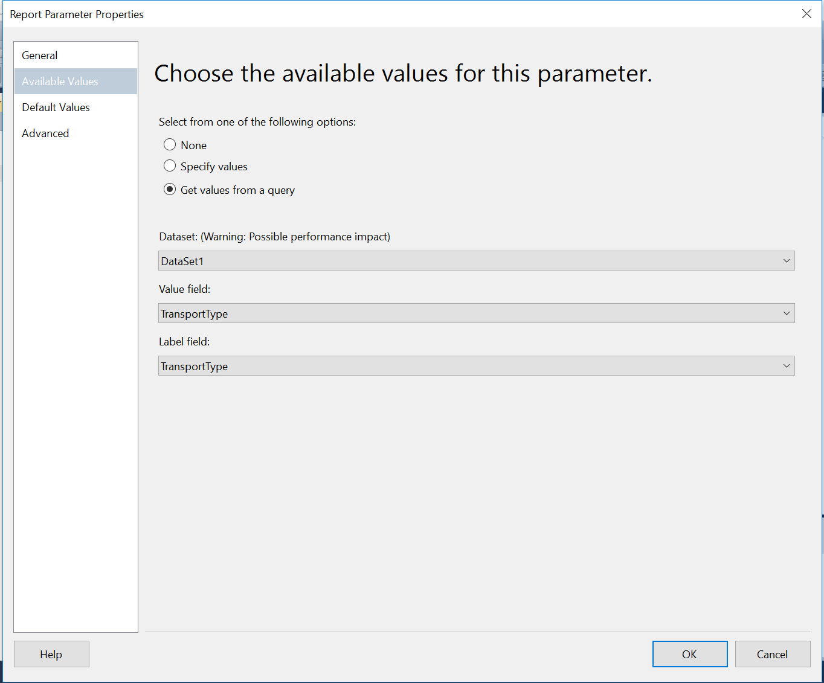

* 1. Table in design tab

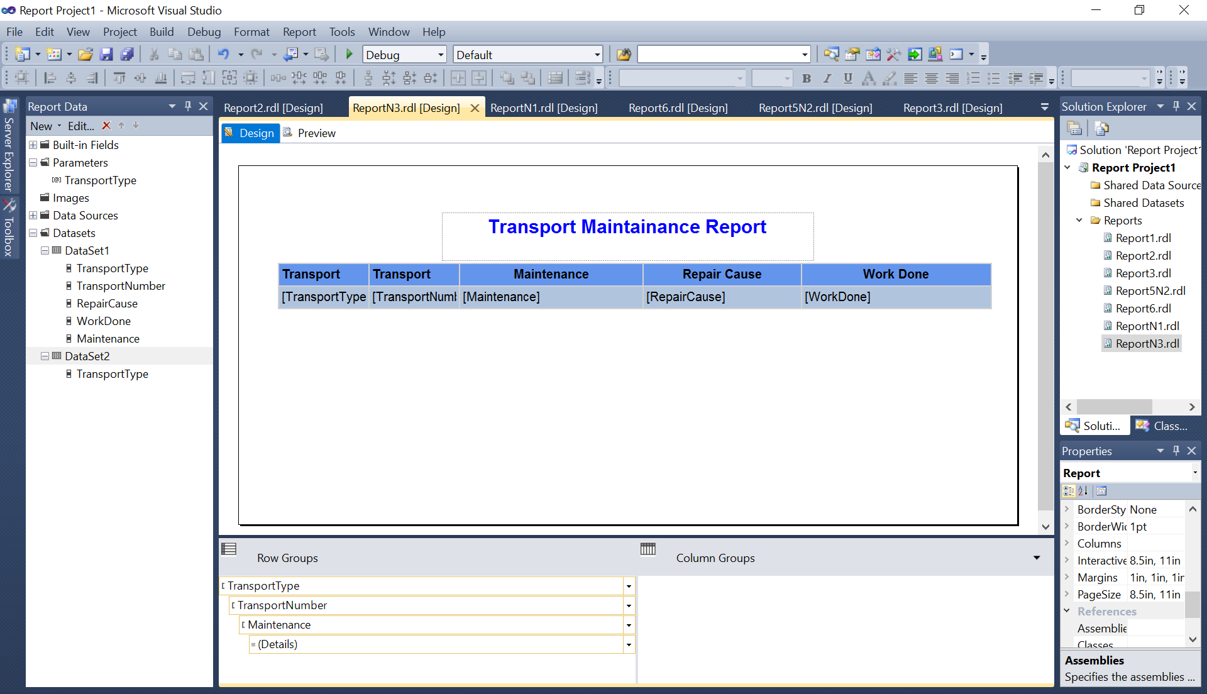

* 1. Report view after completion

