# 第六次練習

## 建立檢視表

CREATE VIEW [View_1] AS

(SELECT 學號, 姓名, YEAR(GETDATE()) - YEAR([出生日期]) AS 歲

FROM [dbo].[students])

select * from [dbo].[View_1]

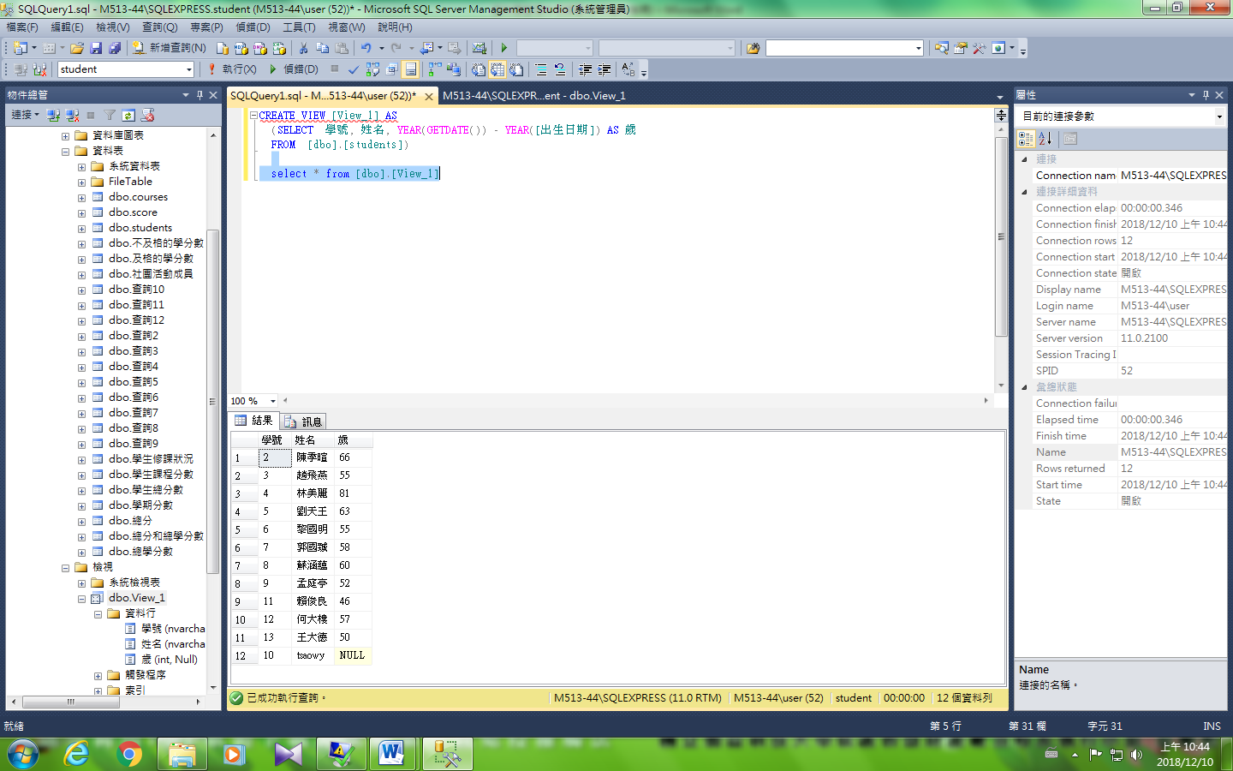

## --欄子集視界(垂直取)

### --取作家姓名、電話和簽約

create view view1 as

SELECT au_lname, au_fname, phone, contract

FROM dbo.authors

select * from [dbo].[view1]

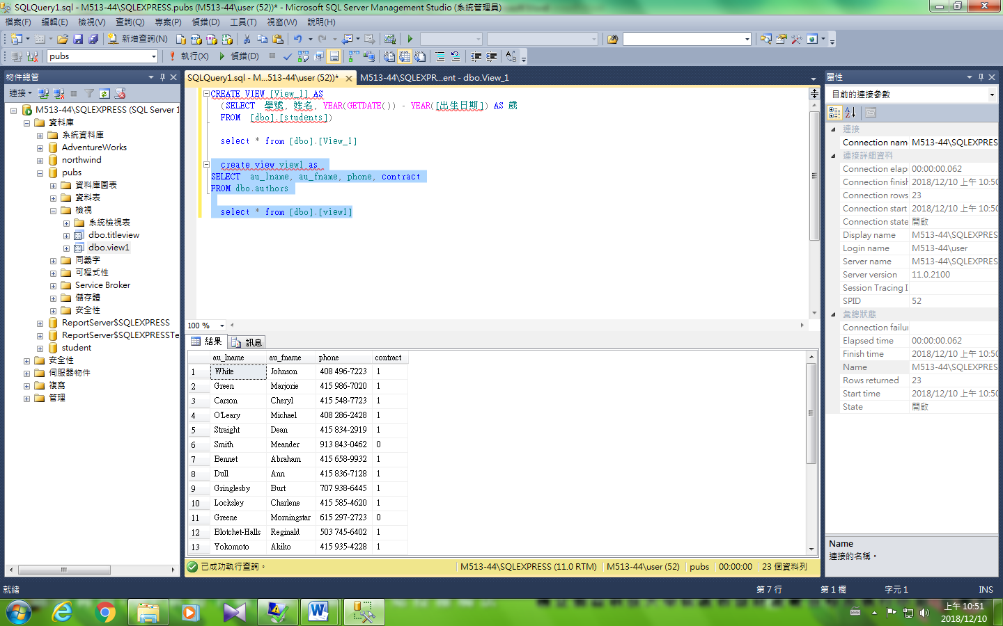

## --列欄子集視界(平行取)

### --取沒有簽約作家所有資料

create view view2 as

SELECT *

FROM dbo.authors

where [contract] <> 1

select * from [dbo].[view2]

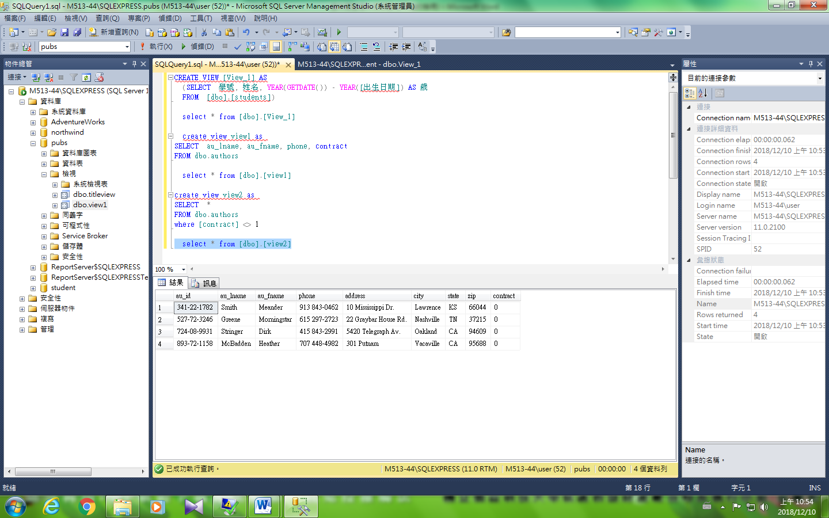

## --合併子集視界

### --取作家所編著的書本，其中顯示姓名、電話、簽約和書本名稱資料

create view view3 as

SELECT au_lname, au_fname, phone, contract, title

FROM dbo.authors, [dbo].[titles],[dbo].[titleauthor]

where [dbo].[authors].au_id=[dbo].[titleauthor].au_id

and [dbo].[titleauthor].title_id=[dbo].[titles].title_id

select * from [dbo].[view3]

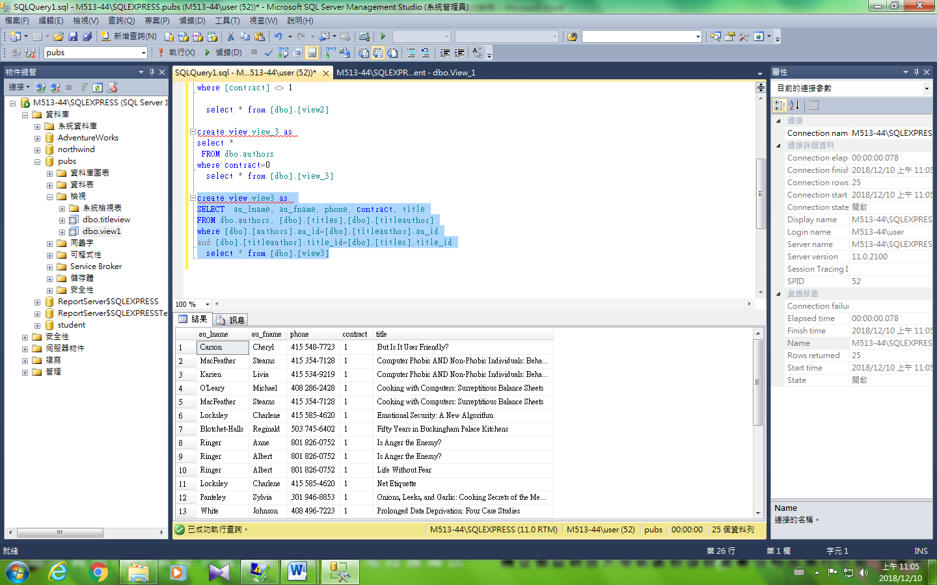

## --統計子集視界

### --顯示作家姓名與所編著書本的本數

create view view4 as

SELECT au_lname, au_fname, count(titles.title_id) '本數'

FROM dbo.authors, [dbo].[titles],[dbo].[titleauthor]

where [dbo].[authors].au_id=[dbo].[titleauthor].au_id

and [dbo].[titleauthor].title_id=[dbo].[titles].title_id

group by au_lname, au_fname

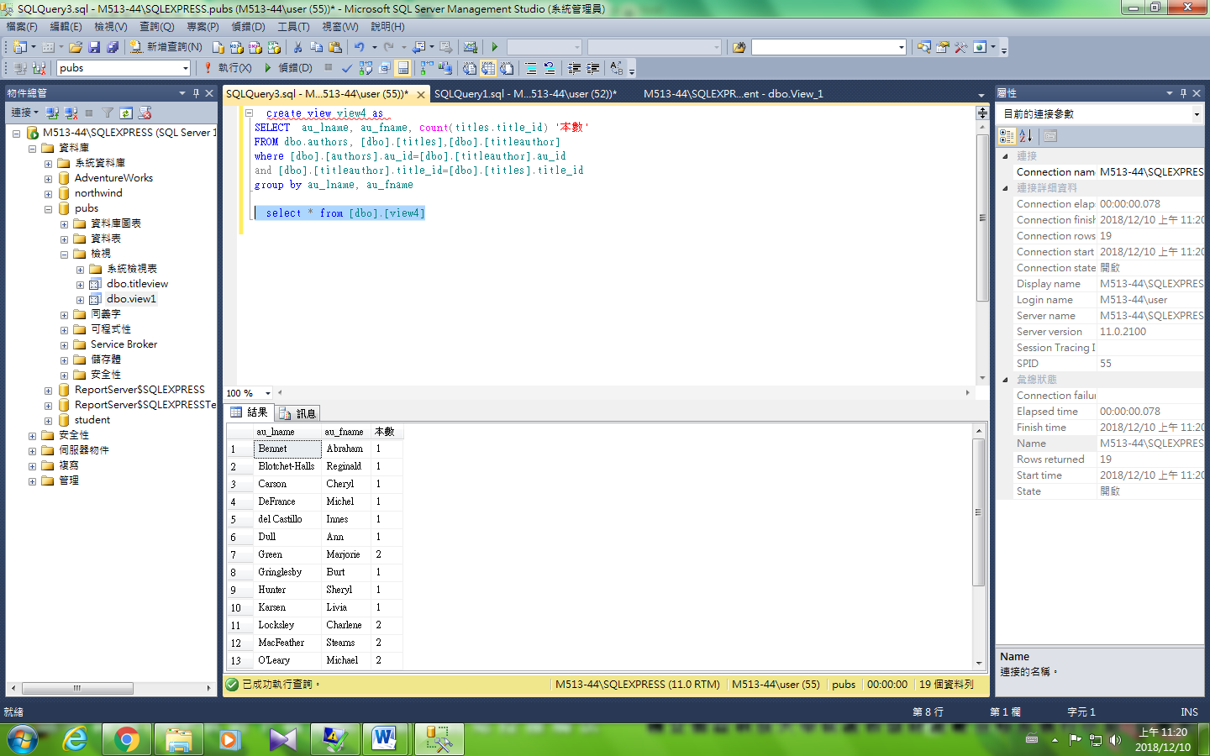

## 總表

|  |  |  |  |  |  |  |  |  |
| --- | --- | --- | --- | --- | --- | --- | --- | --- |
| view | 欄子集視界 | | 列子集視界 | | 合併視界 | | 統計視界 | |
| 含主鍵 | 不含主鍵 | 含主鍵 | 不含主鍵 | 含主鍵 | 不含主鍵 | 含主鍵 | 不含主鍵 |
| insert | Ex1√ | Ex2X | Ex3√ | Ex4X | Ex5X | Ex6X | Ex7X | Ex8X |
| update | √ | √ | √ | √ | √ | √ | √ | √ |
| delete | √ | √ | √ | √ | X | X | X | X |

### --Ex1欄子集視界含主鍵

create view ex1 as

SELECT au_id, au_lname, au_fname, phone, contract

FROM dbo.authors

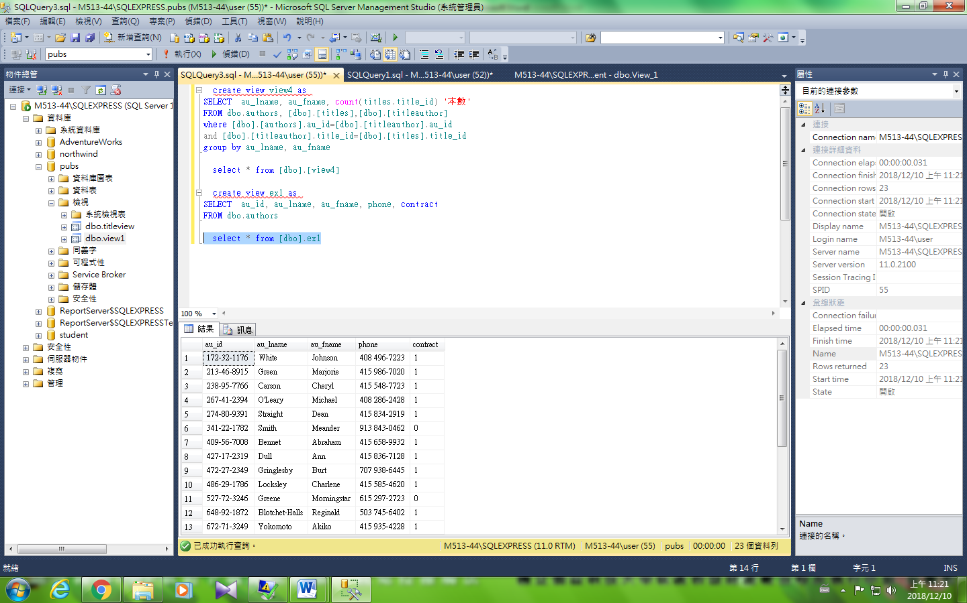

create view view_3 as

select *

FROM dbo.authors

where contract=0

select * from [dbo].[view_3]

