**PROGRAM 2**

**AIM:**

Write a program that demonstrates Activity Lifecycle.

|  |  |
| --- | --- |
| activity_main | <?xml version="1.0" encoding="utf-8"?>  <androidx.constraintlayout.widget.ConstraintLayout xmlns:android="http://schemas.android.com/apk/res/android"  xmlns:app="http://schemas.android.com/apk/res-auto"  xmlns:tools="http://schemas.android.com/tools"  android:layout_width="match_parent"  android:layout_height="match_parent"  android:background="#009688"  tools:context=".MainActivity">  <TextView  android:layout_width="170dp"  android:layout_height="60dp"  android:background="#009688"  android:shadowColor="#636262"  android:text="Hello World!"  android:textAlignment="center"  android:textColor="#E1DADA"  android:textColorHighlight="#F4FAF9"  android:textColorHint="#E8E0E0"  android:textSize="24sp"  app:layout_constraintBottom_toBottomOf="parent"  app:layout_constraintLeft_toLeftOf="parent"  app:layout_constraintRight_toRightOf="parent"  app:layout_constraintTop_toTopOf="parent" />  </androidx.constraintlayout.widget.ConstraintLayout> |

|  |  |
| --- | --- |
| MainActivity | package com.example.lifecycle;  import androidx.appcompat.app.AppCompatActivity;  import android.os.Bundle;  import android.util.Log;  public class MainActivity extends AppCompatActivity {  @Override  protected void onCreate(Bundle savedInstanceState) {  super.onCreate(savedInstanceState);  setContentView(R.layout.activity_main);  Log.d("lifecycle","onCreate invoked");  }  @Override  protected void onStart() {  super.onStart();  Log.d("lifecycle","onStart invoked");  }  @Override  protected void onResume() {  super.onResume();  Log.d("lifecycle","onResume invoked");  }  @Override  protected void onPause() {  super.onPause();  Log.d("lifecycle","onPause invoked");  }  @Override  protected void onStop() {  super.onStop();  Log.d("lifecycle","onStop invoked");  }  @Override  protected void onRestart() {  super.onRestart();  Log.d("lifecycle","onRestart invoked");  }  @Override  protected void onDestroy() {  super.onDestroy();  Log.d("lifecycle","onDestroy invoked");  }  } |

**OUTPUT:**

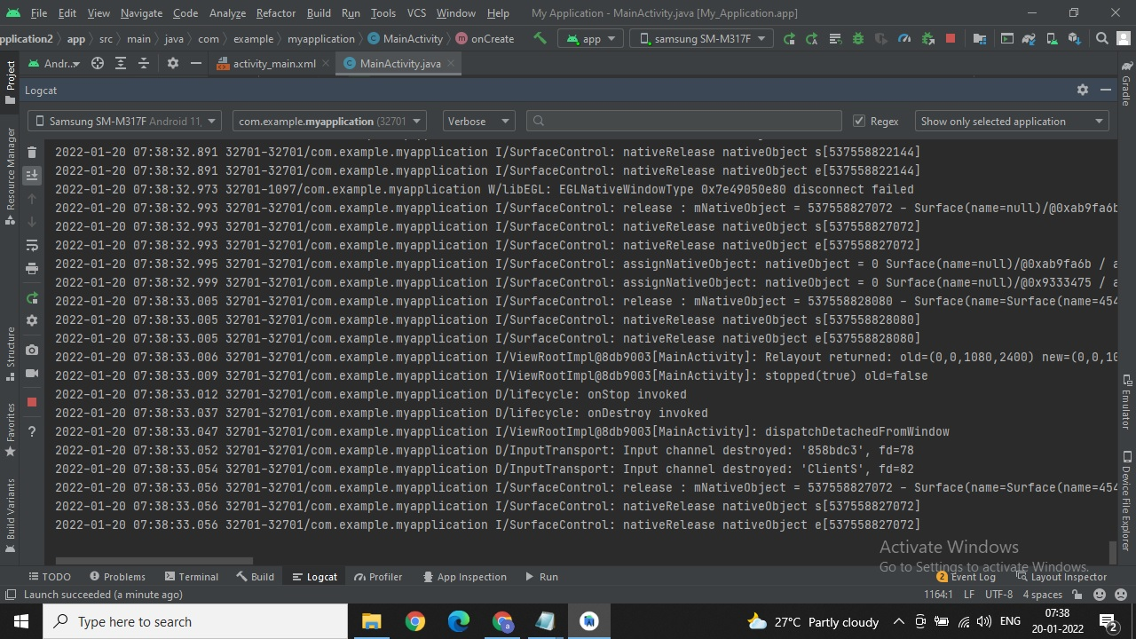

**RESULT:**

Program Has Been Successfully Executed And Output Is Obtained.