**PROGRAM 3**

**AIM:**

Implementing basic arithmetic operations of a simple calculator

|  |  |
| --- | --- |
| activity_main | <?xml version="1.0" encoding="utf-8"?>  <androidx.constraintlayout.widget.ConstraintLayout xmlns:android="http://schemas.android.com/apk/res/android"  xmlns:app="http://schemas.android.com/apk/res-auto"  xmlns:tools="http://schemas.android.com/tools"  android:layout_width="match_parent"  android:layout_height="match_parent"  android:background="#8BC34A"  android:backgroundTint="@color/teal_700"  tools:context=".MainActivity">  <EditText  android:id="@+id/num1"  android:layout_width="191dp"  android:layout_height="53dp"  android:layout_marginStart="72dp"  android:layout_marginTop="70dp"  android:layout_marginEnd="71dp"  android:layout_marginBottom="416dp"  android:background="@android:color/white"  android:ems="10"  android:hint="Enter number 1"  android:inputType="number"  android:textColor="#02655C"  app:layout_constraintBottom_toBottomOf="parent"  app:layout_constraintEnd_toEndOf="parent"  app:layout_constraintHorizontal_bias="0.493"  app:layout_constraintStart_toStartOf="parent"  app:layout_constraintTop_toTopOf="parent"  app:layout_constraintVertical_bias="0.33" />  <EditText  android:id="@+id/num2"  android:layout_width="190dp"  android:layout_height="53dp"  android:layout_marginStart="72dp"  android:layout_marginTop="112dp"  android:layout_marginEnd="71dp"  android:layout_marginBottom="374dp"  android:background="@android:color/white"  android:ems="10"  android:hint="Enter number 2"  android:inputType="number"  android:textColor="#02655C"  app:layout_constraintBottom_toBottomOf="parent"  app:layout_constraintEnd_toEndOf="parent"  app:layout_constraintHorizontal_bias="0.476"  app:layout_constraintStart_toStartOf="parent"  app:layout_constraintTop_toTopOf="parent"  app:layout_constraintVertical_bias="0.421" />  <TextView  android:id="@+id/result"  android:layout_width="260dp"  android:layout_height="41dp"  android:layout_marginStart="41dp"  android:layout_marginTop="151dp"  android:layout_marginEnd="48dp"  android:layout_marginBottom="287dp"  android:background="@android:color/background_light"  android:textColor="#02655C"  android:textColorLink="@color/black"  android:textSize="25sp"  app:layout_constraintBottom_toBottomOf="parent"  app:layout_constraintEnd_toEndOf="parent"  app:layout_constraintHorizontal_bias="0.489"  app:layout_constraintStart_toStartOf="parent"  app:layout_constraintTop_toTopOf="parent"  app:layout_constraintVertical_bias="0.445" />  <Button  android:id="@+id/sum"  android:layout_width="87dp"  android:layout_height="47dp"  android:background="#03574F"  android:backgroundTint="@android:color/transparent"  android:onClick="doSum"  android:text="+"  android:textSize="20sp"  app:layout_constraintBottom_toBottomOf="parent"  app:layout_constraintEnd_toEndOf="parent"  app:layout_constraintHorizontal_bias="0.148"  app:layout_constraintStart_toStartOf="parent"  app:layout_constraintTop_toTopOf="parent" />  <Button  android:id="@+id/sub"  android:layout_width="87dp"  android:layout_height="45dp"  android:layout_marginTop="292dp"  android:layout_marginBottom="263dp"  android:background="#03574F"  android:backgroundTint="@android:color/transparent"  android:onClick="doSub"  android:text="-"  android:textSize="20sp"  app:layout_constraintBottom_toBottomOf="parent"  app:layout_constraintEnd_toEndOf="parent"  app:layout_constraintHorizontal_bias="0.456"  app:layout_constraintStart_toStartOf="parent"  app:layout_constraintTop_toTopOf="parent"  app:layout_constraintVertical_bias="0.389" />  <Button  android:id="@+id/div"  android:layout_width="85dp"  android:layout_height="42dp"  android:background="#03574F"  android:backgroundTint="@android:color/transparent"  android:onClick="doDiv"  android:text="/"  android:textSize="20sp"  app:layout_constraintBottom_toBottomOf="parent"  app:layout_constraintEnd_toEndOf="parent"  app:layout_constraintHorizontal_bias="0.757"  app:layout_constraintStart_toStartOf="parent"  app:layout_constraintTop_toTopOf="parent"  app:layout_constraintVertical_bias="0.6" />  <Button  android:id="@+id/mul"  android:layout_width="83dp"  android:layout_height="45dp"  android:background="#03574F"  android:backgroundTint="@android:color/transparent"  android:onClick="doMul"  android:text="x"  android:textSize="18sp"  app:layout_constraintBottom_toBottomOf="parent"  app:layout_constraintEnd_toEndOf="parent"  app:layout_constraintHorizontal_bias="0.757"  app:layout_constraintStart_toStartOf="parent"  app:layout_constraintTop_toTopOf="parent" />  <Button  android:id="@+id/button"  android:layout_width="86dp"  android:layout_height="47dp"  android:background="#03574F"  android:backgroundTint="@android:color/transparent"  android:onClick="doMod"  android:text="%"  android:textSize="20sp"  app:layout_constraintBottom_toBottomOf="parent"  app:layout_constraintEnd_toEndOf="parent"  app:layout_constraintHorizontal_bias="0.15"  app:layout_constraintStart_toStartOf="parent"  app:layout_constraintTop_toTopOf="parent"  app:layout_constraintVertical_bias="0.597" />  <Button  android:id="@+id/pow"  android:layout_width="85dp"  android:layout_height="44dp"  android:background="#03574F"  android:backgroundTint="@android:color/transparent"  android:onClick="doPow"  android:text="n1^n2"  android:textSize="16sp"  app:layout_constraintBottom_toBottomOf="parent"  app:layout_constraintEnd_toEndOf="parent"  app:layout_constraintHorizontal_bias="0.453"  app:layout_constraintStart_toStartOf="parent"  app:layout_constraintTop_toTopOf="parent"  app:layout_constraintVertical_bias="0.598" />  </androidx.constraintlayout.widget.ConstraintLayout> |

|  |  |
| --- | --- |
| MainActivity | package com.example.calculator;  import androidx.appcompat.app.AppCompatActivity;  import android.os.Bundle;  import android.view.View;  import android.widget.EditText;  import android.widget.TextView;  public class MainActivity extends AppCompatActivity {  EditText e1, e2;  TextView t1;  int num1, num2;  @Override  protected void onCreate(Bundle savedInstanceState) {  super.onCreate(savedInstanceState);  setContentView(R.layout.activity_main);  }  public boolean getNumbers() {  e1 = (EditText) findViewById(R.id.num1);  e2 = (EditText) findViewById(R.id.num2);  t1 = (TextView) findViewById(R.id.result);  String s1 = e1.getText().toString();  String s2 = e2.getText().toString();  if ((s1.equals(null) && s2.equals(null))  || (s1.equals("") && s2.equals(""))) {  String result = "Please enter a value";  t1.setText(result);  return false;  } else {  num1 = Integer.parseInt(s1);  num2 = Integer.parseInt(s2);  }  return true;  }  public void doSum(View v) {  if (getNumbers()) {  int sum = num1 + num2;  t1.setText(Integer.toString(sum));  }  }  public void doPow(View v) {  if (getNumbers()) {  double sum = Math.pow(num1, num2);  t1.setText(Double.toString(sum));  }  }  public void doSub(View v) {  if (getNumbers()) {  int sum = num1 - num2;  t1.setText(Integer.toString(sum));  }  }  public void doMul(View v) {  if (getNumbers()) {  int sum = num1 * num2;  t1.setText(Integer.toString(sum));  }  }  public void doDiv(View v) {  if (getNumbers()) {  double sum = num1 / (num2 * 1.0);  t1.setText(Double.toString(sum));  }  }  public void doMod(View v) {  if (getNumbers()) {  double sum = num1 % num2;  t1.setText(Double.toString(sum));  }  }  } |

**OUTPUT:**

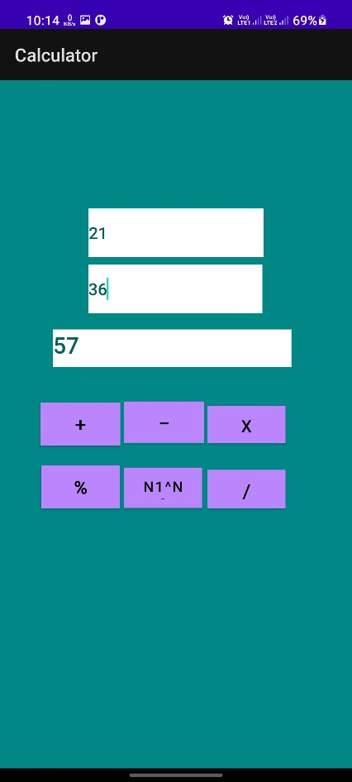

**RESULT:**

Program Has Been Successfully Executed And Output Is Obtained.