**PROGRAM 4**

**AIM:**

Implement validations on various UI controls

|  |  |
| --- | --- |
| activity_main | <?xml version="1.0" encoding="utf-8"?>  <androidx.constraintlayout.widget.ConstraintLayout xmlns:android="http://schemas.android.com/apk/res/android"  xmlns:app="http://schemas.android.com/apk/res-auto"  xmlns:tools="http://schemas.android.com/tools"  android:layout_width="match_parent"  android:layout_height="match_parent"  tools:context=".MainActivity">  <androidx.constraintlayout.widget.ConstraintLayout  android:layout_width="match_parent"  android:layout_height="match_parent"  app:layout_constraintBottom_toBottomOf="parent"  app:layout_constraintEnd_toEndOf="parent"  app:layout_constraintStart_toStartOf="parent"  app:layout_constraintTop_toTopOf="parent">  <EditText  android:id="@+id/name"  android:layout_width="wrap_content"  android:layout_height="wrap_content"  android:ems="10"  android:hint="Name"  android:inputType="textPersonName"  app:layout_constraintBottom_toBottomOf="parent"  app:layout_constraintEnd_toEndOf="parent"  app:layout_constraintHorizontal_bias="0.482"  app:layout_constraintStart_toStartOf="parent"  app:layout_constraintTop_toTopOf="parent"  app:layout_constraintVertical_bias="0.086" />  <EditText  android:id="@+id/add"  android:layout_width="wrap_content"  android:layout_height="wrap_content"  android:ems="10"  android:hint="Address"  android:inputType="textPersonName"  app:layout_constraintBottom_toBottomOf="parent"  app:layout_constraintEnd_toEndOf="parent"  app:layout_constraintHorizontal_bias="0.497"  app:layout_constraintStart_toStartOf="parent"  app:layout_constraintTop_toTopOf="parent"  app:layout_constraintVertical_bias="0.215" />  <EditText  android:id="@+id/email"  android:layout_width="wrap_content"  android:layout_height="wrap_content"  android:ems="10"  android:hint="Email"  android:inputType="textPersonName"  app:layout_constraintBottom_toBottomOf="parent"  app:layout_constraintEnd_toEndOf="parent"  app:layout_constraintHorizontal_bias="0.482"  app:layout_constraintStart_toStartOf="parent"  app:layout_constraintTop_toTopOf="parent"  app:layout_constraintVertical_bias="0.421" />  <EditText  android:id="@+id/pass"  android:layout_width="wrap_content"  android:layout_height="wrap_content"  android:ems="10"  android:hint="password"  android:inputType="textPersonName"  app:layout_constraintBottom_toBottomOf="parent"  app:layout_constraintEnd_toEndOf="parent"  app:layout_constraintHorizontal_bias="0.497"  app:layout_constraintStart_toStartOf="parent"  app:layout_constraintTop_toTopOf="parent"  app:layout_constraintVertical_bias="0.526" />  <Button  android:id="@+id/button"  android:layout_width="117dp"  android:layout_height="59dp"  android:text="Submit"  app:layout_constraintBottom_toBottomOf="parent"  app:layout_constraintEnd_toEndOf="parent"  app:layout_constraintStart_toStartOf="parent"  app:layout_constraintTop_toTopOf="parent"  app:layout_constraintVertical_bias="0.66" />  <EditText  android:id="@+id/ph"  android:layout_width="wrap_content"  android:layout_height="wrap_content"  android:ems="10"  android:hint="Phone no."  android:inputType="textPersonName"  app:layout_constraintBottom_toBottomOf="parent"  app:layout_constraintEnd_toEndOf="parent"  app:layout_constraintHorizontal_bias="0.497"  app:layout_constraintStart_toStartOf="parent"  app:layout_constraintTop_toTopOf="parent"  app:layout_constraintVertical_bias="0.322" />  </androidx.constraintlayout.widget.ConstraintLayout>  </androidx.constraintlayout.widget.ConstraintLayout> |

|  |  |
| --- | --- |
| MainActivity | package com.example.regvalidation;  import androidx.appcompat.app.AppCompatActivity;  import android.content.Intent;  import android.os.Bundle;  import android.widget.Button;  import android.widget.EditText;  import android.view.View;  import android.widget.Toast;  import java.util.regex.Matcher;  import java.util.regex.Pattern;  public class MainActivity extends AppCompatActivity {  EditText name, add, phn, em,pass;  Button bts1;  Pattern patterns;  Matcher matches;  String emailPattern = "[a-zA-Z0-9._-]+@[a-z]+\\.+[a-z]+";  @Override  protected void onCreate(Bundle savedInstanceState) {  super.onCreate(savedInstanceState);  setContentView(R.layout.activity_main);  name = (EditText) findViewById(R.id.name);  add = (EditText) findViewById(R.id.add);  phn = (EditText) findViewById(R.id.add);  em = (EditText) findViewById(R.id.email);  pass = (EditText) findViewById(R.id.pass);  String emailPattern = "[a-zA-Z0-9._-]+@[a-z]+\\.+[a-z]+";  bts1 = (Button) findViewById(R.id.button);  bts1.setOnClickListener(new View.OnClickListener() {  @Override  public void onClick(View v) {  login();  Intent i = new Intent(getApplicationContext(),explicit.class);  startActivity(i);  }  });  }  public void login() {  String email = em.getText().toString().trim();  String nm = name.getText().toString();  if (name.getText().toString().length() == 0) {  name.requestFocus();  name.setError("Enter valid name");  return;  }  String namePattern = "[0-9!@#$%^&*]";  if (name.getText().toString().matches(namePattern)) {  name.requestFocus();  name.setError("Enter valid name");  return;  }  if (add.getText().toString().length() == 0) {  add.requestFocus();  add.setError("Enter valid address");  return;  }  if (phn.getText().toString().length() == 0) {  phn.requestFocus();  phn.setError("Enter valid Number");  return;  }  if (em.getText().toString().length() == 0) {  Toast.makeText(getApplicationContext(), "Invalid Email Address", Toast.LENGTH_SHORT).show();  em.requestFocus();  em.setError("Enter valid email");  return;  }  if (!email.matches(emailPattern)) {  em.requestFocus();  em.setError("Invalid email");  } else {  Toast.makeText(getApplicationContext(), "valid Email Address", Toast.LENGTH_SHORT).show();  }  if (pass.getText().toString().length() == 0) {  pass.requestFocus();  pass.setError("Enter valid password");  return;  }  if (pass.getText().toString().length() < 8) {  pass.requestFocus();  pass.setError("Enter minimum 8 digit password");  return;  }  }  } |

**OUTPUT:**

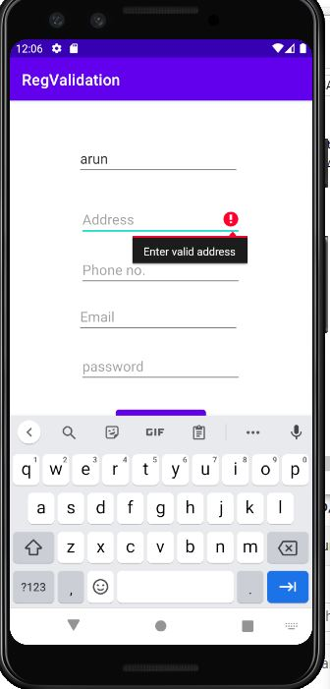

**RESULT:**

Program Has Been Successfully Executed and Output Is Obtained.