**XML**

**activity_main.xml**

**<?xml version="1.0" encoding="utf-8"?>**

**<androidx.constraintlayout.widget.ConstraintLayout xmlns:android="http://schemas.android.com/apk/res/android"**

**xmlns:app="http://schemas.android.com/apk/res-auto"**

**xmlns:tools="http://schemas.android.com/tools"**

**android:layout_width="match_parent"**

**android:layout_height="match_parent"**

**tools:context=".MainActivity">**

**<TextView**

**android:layout_width="wrap_content"**

**android:layout_height="wrap_content"**

**android:text="Hello World!"**

**app:layout_constraintBottom_toBottomOf="parent"**

**app:layout_constraintLeft_toLeftOf="parent"**

**app:layout_constraintRight_toRightOf="parent"**

**app:layout_constraintTop_toTopOf="parent" />**

**</androidx.constraintlayout.widget.ConstraintLayout>**

**options_menu.xml**

**<?xml version="1.0" encoding="utf-8"?>**

**<menu xmlns:app="http://schemas.android.com/apk/res-auto"**

**xmlns:android="http://schemas.android.com/apk/res/android">**

**<item**

**android:id="@+id/item1"**

**android:title="settings" />**

**<item**

**android:id="@+id/item2"**

**android:title="share" />**

**<item**

**android:id="@+id/item3"**

**android:title="gallery" />**

**<item**

**android:id="@+id/item4"**

**android:title="contacts" />**

**</menu>**

**activity_gallery.xml**

**<?xml version="1.0" encoding="utf-8"?>**

**<androidx.constraintlayout.widget.ConstraintLayout xmlns:android="http://schemas.android.com/apk/res/android"**

**xmlns:app="http://schemas.android.com/apk/res-auto"**

**xmlns:tools="http://schemas.android.com/tools"**

**android:layout_width="match_parent"**

**android:layout_height="match_parent"**

**tools:context=".gallery">**

**<GridView**

**android:id="@+id/grid"**

**android:layout_width="409dp"**

**android:layout_height="729dp"**

**app:layout_constraintBottom_toBottomOf="parent"**

**app:layout_constraintEnd_toEndOf="parent"**

**app:layout_constraintHorizontal_bias="0.5"**

**app:layout_constraintStart_toStartOf="parent"**

**app:layout_constraintTop_toTopOf="parent" />**

**</androidx.constraintlayout.widget.ConstraintLayout>**

**JAVA**

**MainActivity.java**

**package com.example.myapplication;**

**import androidx.annotation.NonNull;**

**import androidx.appcompat.app.AppCompatActivity;**

**import android.content.Intent;**

**import android.os.Bundle;**

**import android.view.Menu;**

**import android.view.MenuInflater;**

**import android.view.MenuItem;**

**public class MainActivity extends AppCompatActivity {**

**@Override**

**protected void onCreate(Bundle savedInstanceState) {**

**super.onCreate(savedInstanceState);**

**setContentView(R.layout.*activity_main*);**

**}**

**@Override**

**public boolean onCreateOptionsMenu(Menu menu) {**

**MenuInflater inflater = getMenuInflater();**

**inflater.inflate(R.menu.*options_menu*,menu);**

**return super.onCreateOptionsMenu(menu);**

**}**

**@Override**

**public boolean onOptionsItemSelected(MenuItem item) {**

**switch(item.getItemId()){**

**case R.id.*item1*:break;**

**case R.id.*item2*:break;**

**case R.id.*item3*: Intent i = new Intent(getApplicationContext(),gallery.class);**

**startActivity(i);**

**break;**

**case R.id.*item4*:break;**

**default:**

**}**

**return super.onOptionsItemSelected(item);**

**}**

**}**

**gallery.java**

**package com.example.myapplication;**

**import androidx.appcompat.app.AlertDialog;**

**import androidx.appcompat.app.AppCompatActivity;**

**import android.content.DialogInterface;**

**import android.os.Bundle;**

**import android.view.View;**

**import android.widget.AdapterView;**

**import android.widget.GridView;**

**public class gallery extends AppCompatActivity {**

**String [] names = {"Snoopy","Simpsons"};**

**int logo[] = {R.drawable.*snoopy*,R.drawable.*simpsons*};**

**AlertDialog.Builder builder;**

**@Override**

**protected void onCreate(Bundle savedInstanceState) {**

**super.onCreate(savedInstanceState);**

**setContentView(R.layout.*activity_gallery*);**

**GridView gv = findViewById(R.id.*grid*);**

**gv.setAdapter(new ImageAdapter(this));**

**builder = new AlertDialog.Builder(this);**

**gv.setOnItemClickListener(new AdapterView.OnItemClickListener() {**

**@Override**

**public void onItemClick(AdapterView<?> adapterView, View view, int i, long l) {**

**builder.setMessage("Do you want to delete this image -"+String.*valueOf*(names[i])).setCancelable(false).setPositiveButton("ok",new DialogInterface.OnClickListener(){**

**public void onClick(DialogInterface dialog, int id){}**

**});**

**AlertDialog alert = builder.create();**

**alert.setTitle("");**

**alert.show();**

**}**

**});**

**}**

**}**

**ImageAdapter.java**

**package com.example.myapplication;**

**import android.content.Context;**

**import android.view.View;**

**import android.view.ViewGroup;**

**import android.widget.BaseAdapter;**

**import android.widget.GridView;**

**import android.widget.ImageView;**

**public class ImageAdapter extends BaseAdapter {**

**private Context mContext;**

**public ImageAdapter(Context c) {**

**mContext = c;**

**}**

**public int getCount() {**

**return thumbImages.length;**

**}**

**public Object getItem(int position) {**

**return null;**

**}**

**public long getItemId(int position) {**

**return 0;**

**}**

**public View getView(int position, View convertView, ViewGroup parent) {**

**ImageView imageView = new ImageView(mContext);**

**imageView.setLayoutParams(new GridView.LayoutParams(1000, 1000));**

**imageView.setScaleType(ImageView.ScaleType.*CENTER_CROP*);**

**imageView.setPadding(80, 80, 8, 8);**

**imageView.setImageResource(thumbImages[position]);**

**return imageView;**

**}**

**public Integer[] thumbImages = {**

**R.drawable.*simpsons*,**

**R.drawable.*snoopy*,**

**};**

**}**

**Screenshots**

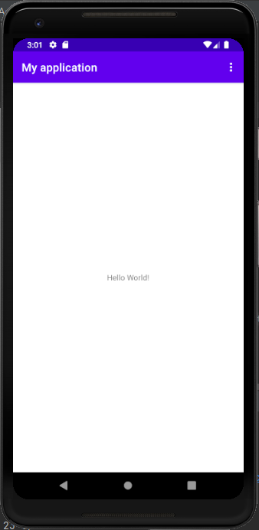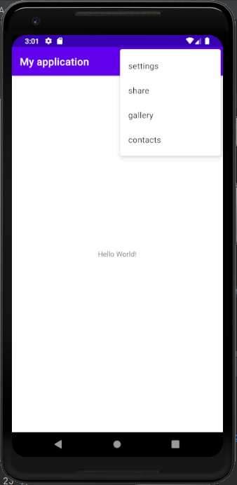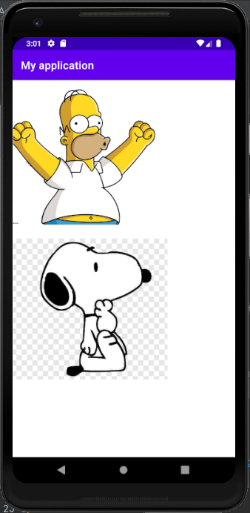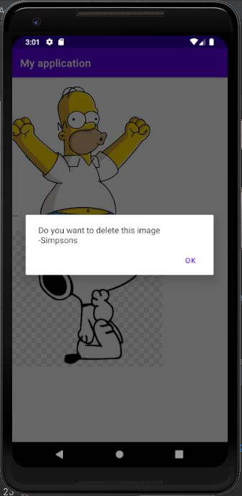

**OUTPUT**

Output successfully obtained