**PROGRAM NO :2**

**AIM:** Write a program that demonstrates Activity Lifecycle.

**PROGRAM CODE:**

|  |  |
| --- | --- |
| Mainac tivity.ja va | package com.example.lifecycle;  import androidx.appcompat.app.AppCompatActivity;  import android.os.Bundle;  import androidx.appcompat.app.AppCompatActivity;  import android.app.Activity;  import android.os.Bundle;  import android.util.Log;  public class MainActivity extends AppCompatActivity {  @Override  protected void onCreate(Bundle savedInstanceState) {  super.onCreate(savedInstanceState);  setContentView(R.layout.activity_main);  Log.d("lifecycle","onCreate invoked");  }  protected void onStart(){  super.onStart();  Log.d("lifecycle","onStart invoked");  }  protected void onResume(){  super.onResume();  Log.d("lifecycle","onResume invoked");  }  protected void onPause(){  super.onPause();  Log.d("lifecycle","onPause invoked");  }  protected void onStop(){  super.onStop();  Log.d("lifecycle","onStop invoked");  }  protected void onRestart() {  super.onRestart();  Log.d("lifecycle","onRestart invoked");  }  protected void onDestroy() {  super.onDestroy();  Log.d("lifecycle","onDestroy invoked");  }  } |

|  |  |
| --- | --- |
| activity_main.xml | <?xml version="1.0" encoding="utf-8"?>  <androidx.constraintlayout.widget.ConstraintLayout xmlns:android="http://schemas.android.com/apk/res/android"  xmlns:app="http://schemas.android.com/apk/res-auto"  xmlns:tools="http://schemas.android.com/tools"  android:layout_width="match_parent"  android:layout_height="match_parent"  tools:context=".MainActivity">  <TextView  android:layout_width="222dp"  android:layout_height="50dp"  android:layout_marginStart="92dp"  android:text="Email ID"  android:textSize="36sp"  app:layout_constraintBottom_toBottomOf="parent"  app:layout_constraintLeft_toLeftOf="parent"  app:layout_constraintRight_toRightOf="parent"  app:layout_constraintStart_toStartOf="parent"  app:layout_constraintTop_toTopOf="parent"  app:layout_constraintVertical_bias="0.327" />  <EditText  android:id="@+id/editText"  android:layout_width="256dp"  android:layout_height="55dp"  android:ems="10"  android:inputType="textEmailAddress"  app:layout_constraintBottom_toBottomOf="parent"  app:layout_constraintEnd_toEndOf="parent"  app:layout_constraintHorizontal_bias="0.593"  app:layout_constraintStart_toStartOf="parent"  app:layout_constraintTop_toTopOf="parent"  app:layout_constraintVertical_bias="0.44" />  </androidx.constraintlayout.widget.ConstraintLayout> |

**OUTPUT:**

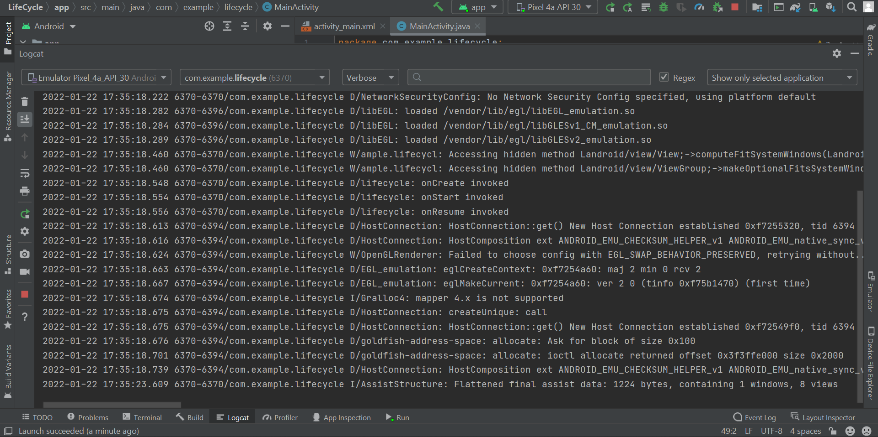 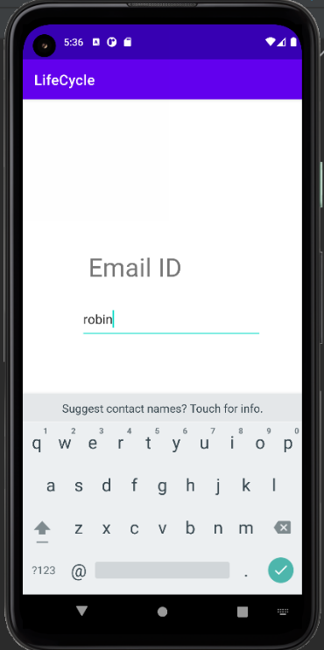

RESULT

Program Has Been Succesfully Executed And Output Is Obtained.