**Aim**

Develop an application that toggles image using FrameLayout

**Activity_main.xml**

*<?***xml version="1.0" encoding="utf-8"***?>*

<**FrameLayout xmlns:android="http://schemas.android.com/apk/res/android"**

**xmlns:app="http://schemas.android.com/apk/res-auto"**

**xmlns:tools="http://schemas.android.com/tools"**

**android:layout_width="match_parent"**

**android:layout_height="match_parent"**

**tools:context=".MainActivity"**>

<**ImageView**

**android:id="@+id/imageView"**

**android:layout_width="266dp"**

**android:layout_height="421dp"**

**app:srcCompat="@drawable/a1"** />

<**ImageView**

**android:id="@+id/imageView2"**

**android:layout_width="290dp"**

**android:layout_height="441dp"**

**android:visibility="gone"**

**app:srcCompat="@drawable/a2"** />

</**FrameLayout**>

**Activity_main.java**

**package** com.example.admin.toggle;

**import** android.support.v7.app.AppCompatActivity;

**import** android.os.Bundle;

**import** android.view.View;

**import** android.widget.ImageView;

**public class** MainActivity **extends** AppCompatActivity **implements** View.OnClickListener {

ImageView **i1**,**i2**;

@Override

**protected void** onCreate(Bundle savedInstanceState) {

**super**.onCreate(savedInstanceState);

setContentView(R.layout.***activity_main***);

**i1**=findViewById(R.id.***imageView***);

**i2**=findViewById(R.id.***imageView2***);

**i1**.setOnClickListener(**this**);

**i2**.setOnClickListener(**this**);

}

@Override

**public void** onClick(View v) {

**if**(v.getId()==R.id.***imageView***)

{

**i1**.setVisibility(v.***GONE***);

**i2**.setVisibility(v.***VISIBLE***);

}

**else**

{

**i2**.setVisibility(v.***GONE***);

**i1**.setVisibility(v.***VISIBLE***);

}

}

}

**Output**

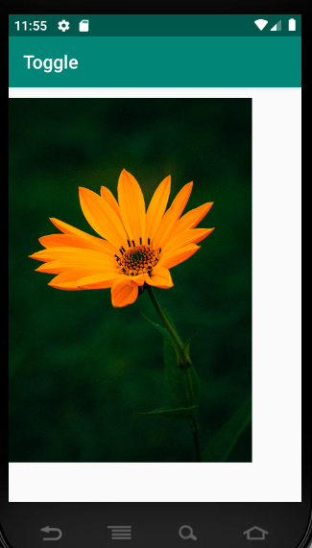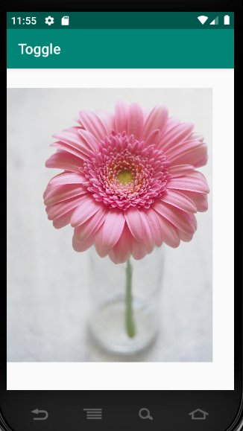

**Result**

The program is executed successfully and obtained the output.