**PROGRAM-1**

**AIM:** Design a registration activity and store registration details in local memory of phone using  Intents and SharedPreferences.

**PROGRAM CODE**

|  |  |
| --- | --- |
| Main 2activity.java | package com.example.intent_and_sharedpreferences;  import androidx.appcompat.app.AppCompatActivity;  import android.content.Intent;  import android.content.SharedPreferences;  import android.os.Bundle;  import android.view.View;  import android.widget.EditText;  import android.widget.Toast;  public class MainActivity extends AppCompatActivity {  EditText name,number,email;  @Override  protected void onCreate(Bundle savedInstanceState) {  super.onCreate(savedInstanceState);  setContentView(R.layout.activity_main);}  public void onSubmit(View view){  name=findViewById(R.id.name);  number=findViewById(R.id.number);  email=findViewById(R.id.email);  SharedPreferences sharedPreferences = getSharedPreferences("myfile",MODE_PRIVATE);  SharedPreferences.Editor myEdit=sharedPreferences.edit();  myEdit.putString("name",name.getText().toString());  myEdit.putString("number",number.getText().toString());  myEdit.putString("email",email.getText().toString());  myEdit.apply();;  Toast.makeText(this,"Successfully Registered",Toast.LENGTH_LONG).show();  Intent i=new Intent(getApplicationContext(),MainActivity2.class);  i.putExtra("name",name.getText().toString());  i.putExtra("email",email.getText().toString());  i.putExtra("number",number.getText().toString());  startActivity(i);}  @Override  protected void onResume() {  super.onResume();  SharedPreferences sharedPreferences=getSharedPreferences("myfile",MODE_PRIVATE);  name=findViewById(R.id.name);  number=findViewById(R.id.number);  email=findViewById(R.id.email);  name.setText(sharedPreferences.getString("name",""));  number.setText(sharedPreferences.getString("number",""));  email.setText(sharedPreferences.getString("email","")); }} |
| MainActivity2.java | package com.example.intent_and_sharedpreferences;  import androidx.appcompat.app.AppCompatActivity;  import android.os.Bundle;  import android.widget.EditText;  import android.widget.TextView;  public class MainActivity2 extends AppCompatActivity {  TextView name_view,number_view,email_view;  @Override  protected void onCreate(Bundle savedInstanceState) {  super.onCreate(savedInstanceState);  setContentView(R.layout.activity_main2);  name_view=findViewById(R.id.name_view);  number_view=findViewById(R.id.number_view);  email_view=findViewById(R.id.email_view);  Bundle values=getIntent().getExtras();  String name=values.getString("name");  String number=values.getString("number");  String email=values.getString("email");  name_view.setText("Hai "+name+",You have Successfully Registred");  number_view.setText("Your Mobile Number is: "+number);  email_view.setText("Your Email Address is: "+email);}} |
| Activitymain.xml | <?xml version="1.0" encoding="utf-8"?>  <androidx.constraintlayout.widget.ConstraintLayout xmlns:android="http://schemas.android.com/apk/res/android"  xmlns:app="http://schemas.android.com/apk/res-auto"  xmlns:tools="http://schemas.android.com/tools"  android:id="@+id/on"  android:layout_width="match_parent"  android:layout_height="match_parent"  tools:context=".MainActivity">  <TextView  android:id="@+id/textView"  android:layout_width="wrap_content"  android:layout_height="wrap_content"  android:text="Registration"  android:textColor="#910707"  android:textSize="34sp"  app:layout_constraintBottom_toBottomOf="parent"  app:layout_constraintEnd_toEndOf="parent"  app:layout_constraintHorizontal_bias="0.497"  app:layout_constraintStart_toStartOf="parent"  app:layout_constraintTop_toTopOf="parent"  app:layout_constraintVertical_bias="0.078" />  <EditText  android:id="@+id/name"  android:layout_width="291dp"  android:layout_height="51dp"  android:ems="10"  android:hint="Enter the Name"  android:inputType="textPersonName"  android:textSize="14sp"  app:layout_constraintBottom_toBottomOf="parent"  app:layout_constraintEnd_toEndOf="parent"  app:layout_constraintHorizontal_bias="0.425"  app:layout_constraintStart_toStartOf="parent"  app:layout_constraintTop_toTopOf="parent"  app:layout_constraintVertical_bias="0.276" />  <EditText  android:id="@+id/email"  android:layout_width="291dp"  android:layout_height="51dp"  android:ems="10"  android:hint="Enter the Email"  android:inputType="textPersonName"  android:textSize="14sp"  app:layout_constraintBottom_toBottomOf="parent"  app:layout_constraintEnd_toEndOf="parent"  app:layout_constraintHorizontal_bias="0.425"  app:layout_constraintStart_toStartOf="parent"  app:layout_constraintTop_toTopOf="parent"  app:layout_constraintVertical_bias="0.404" />  <EditText  android:id="@+id/number"  android:layout_width="291dp"  android:layout_height="51dp"  android:ems="10"  android:hint="Enter the Mobile Number"  android:inputType="textPersonName"  app:layout_constraintBottom_toBottomOf="parent"  app:layout_constraintEnd_toEndOf="parent"  app:layout_constraintHorizontal_bias="0.425"  app:layout_constraintStart_toStartOf="parent"  app:layout_constraintTop_toTopOf="parent"  app:layout_constraintVertical_bias="0.53" />  <Button  android:id="@+id/button"  android:layout_width="wrap_content"  android:layout_height="wrap_content"  android:onClick="onSubmit"  android:text="Submit"  app:layout_constraintBottom_toBottomOf="parent"  app:layout_constraintEnd_toEndOf="parent"  app:layout_constraintStart_toStartOf="parent"  app:layout_constraintTop_toTopOf="parent"  app:layout_constraintVertical_bias="0.733" />  </androidx.constraintlayout.widget.ConstraintLayout> |
| Activitymain2.xml | <?xml version="1.0" encoding="utf-8"?>  <androidx.constraintlayout.widget.ConstraintLayout xmlns:android="http://schemas.android.com/apk/res/android"  xmlns:app="http://schemas.android.com/apk/res-auto"  xmlns:tools="http://schemas.android.com/tools"  android:layout_width="match_parent"  android:layout_height="match_parent"  tools:context=".MainActivity2">  <TextView  android:id="@+id/name_view"  android:layout_width="wrap_content"  android:layout_height="wrap_content"  android:textColor="#ED0C0C"  android:textSize="20sp"  app:layout_constraintBottom_toBottomOf="parent"  app:layout_constraintEnd_toEndOf="parent"  app:layout_constraintHorizontal_bias="0.26"  app:layout_constraintStart_toStartOf="parent"  app:layout_constraintTop_toTopOf="parent"  app:layout_constraintVertical_bias="0.069" />  <TextView  android:id="@+id/email_view"  android:layout_width="wrap_content"  android:layout_height="wrap_content"  android:textSize="20sp"  app:layout_constraintBottom_toBottomOf="parent"  app:layout_constraintEnd_toEndOf="parent"  app:layout_constraintHorizontal_bias="0.26"  app:layout_constraintStart_toStartOf="parent"  app:layout_constraintTop_toTopOf="parent"  app:layout_constraintVertical_bias="0.301" />  <TextView  android:id="@+id/number_view"  android:layout_width="wrap_content"  android:layout_height="wrap_content"  android:textSize="20sp"  app:layout_constraintBottom_toBottomOf="parent"  app:layout_constraintEnd_toEndOf="parent"  app:layout_constraintHorizontal_bias="0.26"  app:layout_constraintStart_toStartOf="parent"  app:layout_constraintTop_toTopOf="parent"  app:layout_constraintVertical_bias="0.184" />  </androidx.constraintlayout.widget.ConstraintLayout> |

**OUTPUT**

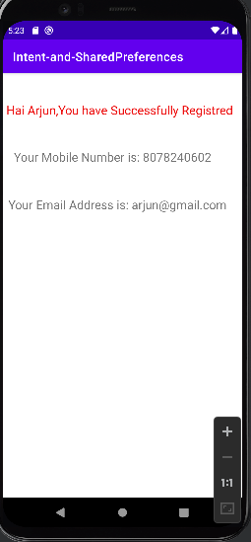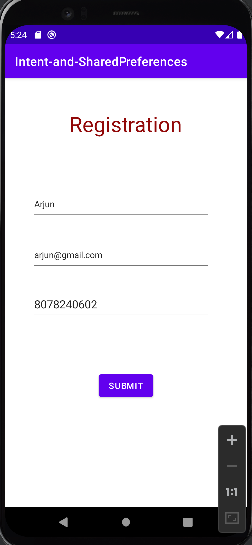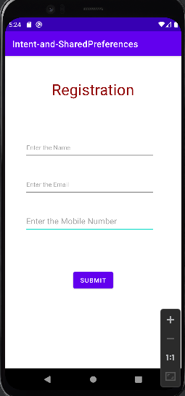

**RESULT:**

The above program is successfully executed and obtained the output.

**PROGRAM 2**

**AIM:** Design a simple Calculator using GridLayout and Cascaded LinearLayout.

**PROGRAM CODE**

|  |  |
| --- | --- |
| MainActivity.java | package com.example.calculator;  import androidx.appcompat.app.AppCompatActivity;  import android.os.Bundle;  import android.view.View;  import android.widget.EditText;  public class MainActivity extends AppCompatActivity {  EditText result;  String ans;  float num1,num2,calcu;  int flag=0;  @Override  protected void onCreate(Bundle savedInstanceState) {  super.onCreate(savedInstanceState);  setContentView(R.layout.activity_main);  result=findViewById(R.id.editTextTextPersonName);}  public void clear(View view){  result.setText("");}  public void one(View view){  ans=result.getText().toString();  result.setText(ans+"1");}  public void two(View view){  ans=result.getText().toString();  result.setText(ans+"2");}  public void three(View view){  ans=result.getText().toString();  result.setText(ans+"3");}  public void four(View view){  ans=result.getText().toString();  result.setText(ans+"4");}  public void five(View view){  ans=result.getText().toString();  result.setText(ans+"5");}  public void six(View view){  ans=result.getText().toString();  result.setText(ans+"6");}  public void seven(View view){  ans=result.getText().toString();  result.setText(ans+"7");}  public void eight(View view){  ans=result.getText().toString();  result.setText(ans+"8");}  public void nine(View view){  ans=result.getText().toString();  result.setText(ans+"9");}  public void zero(View view){  ans=result.getText().toString();  result.setText(ans+"0");}  public void add(View view){  num1=Float.parseFloat(result.getText().toString());  result.setText("+");  flag=1;}  public void sub(View view){  num1=Float.parseFloat(result.getText().toString());  result.setText("-");  flag=2;}  public void multiple(View view){  num1=Float.parseFloat(result.getText().toString());  result.setText("*");  flag=3;}  public void div(View view){  num1=Float.parseFloat(result.getText().toString());  result.setText("/");  flag=4;}  public void equal(View view){  num2=Float.parseFloat(result.getText().toString());  switch(flag){  case 1:  calcu=num1+num2;  result.setText(String.valueOf(calcu));  break;  case 2:  calcu=num1-num2;  result.setText(String.valueOf(calcu));  break;  case 3:  calcu=num1*num2;  result.setText(String.valueOf(calcu));  break;  case 4:  calcu=num1/num2;  result.setText(String.valueOf(calcu));  break;  }}} |
| Activity_main.xml | <?xml version="1.0" encoding="utf-8"?>  <androidx.constraintlayout.widget.ConstraintLayout xmlns:android="http://schemas.android.com/apk/res/android"  xmlns:app="http://schemas.android.com/apk/res-auto"  xmlns:tools="http://schemas.android.com/tools"  android:layout_width="match_parent"  android:layout_height="match_parent"  tools:context=".MainActivity">  <androidx.gridlayout.widget.GridLayout  android:layout_width="418dp"  android:layout_height="427dp"  app:layout_constraintBottom_toBottomOf="parent"  app:layout_constraintEnd_toEndOf="parent"  app:layout_constraintHorizontal_bias="0.0"  app:layout_constraintStart_toStartOf="parent"  app:layout_constraintTop_toTopOf="parent"  app:layout_constraintVertical_bias="1.0">  <LinearLayout  android:layout_width="96dp"  android:layout_height="match_parent"  android:orientation="vertical"  app:layout_column="0"  app:layout_row="0">  <Button  android:id="@+id/button2"  android:layout_width="match_parent"  android:layout_height="77dp"  android:onClick="one"  android:text="1" />  <Button  android:id="@+id/button3"  android:layout_width="match_parent"  android:layout_height="78dp"  android:onClick="four"  android:text="4" />  <Button  android:id="@+id/button"  android:layout_width="match_parent"  android:layout_height="88dp"  android:onClick="seven"  android:text="7" />  <Button  android:id="@+id/button4"  android:layout_width="match_parent"  android:layout_height="79dp"  android:onClick="clear"  android:text="C" />  </LinearLayout>  <LinearLayout  android:layout_width="107dp"  android:layout_height="match_parent"  android:orientation="vertical"  app:layout_column="1"  app:layout_row="0">  <Button  android:id="@+id/button5"  android:layout_width="match_parent"  android:layout_height="75dp"  android:onClick="two"  android:text="2" />  <Button  android:id="@+id/button6"  android:layout_width="match_parent"  android:layout_height="78dp"  android:onClick="five"  android:text="5" />  <Button  android:id="@+id/button7"  android:layout_width="match_parent"  android:layout_height="87dp"  android:onClick="eight"  android:text="8" />  <Button  android:id="@+id/button8"  android:layout_width="match_parent"  android:layout_height="79dp"  android:onClick="zero"  android:text="0" />  </LinearLayout>  <LinearLayout  android:layout_width="107dp"  android:layout_height="match_parent"  android:orientation="vertical"  app:layout_column="2"  app:layout_row="0">  <Button  android:id="@+id/button9"  android:layout_width="match_parent"  android:layout_height="79dp"  android:onClick="three"  android:text="3" />  <Button  android:id="@+id/button10"  android:layout_width="match_parent"  android:layout_height="74dp"  android:onClick="six"  android:text="6" />  <Button  android:id="@+id/button12"  android:layout_width="match_parent"  android:layout_height="83dp"  android:onClick="nine"  android:text="9" />  <Button  android:id="@+id/button11"  android:layout_width="match_parent"  android:layout_height="83dp"  android:onClick="equal"  android:text="=" />  </LinearLayout>  <LinearLayout  android:layout_width="100dp"  android:layout_height="match_parent"  android:orientation="vertical"  app:layout_column="3"  app:layout_row="0">  <Button  android:id="@+id/button16"  android:layout_width="match_parent"  android:layout_height="83dp"  android:onClick="add"  android:text="+" />  <Button  android:id="@+id/button14"  android:layout_width="match_parent"  android:layout_height="70dp"  android:onClick="sub"  android:text="-" />  <Button  android:id="@+id/button15"  android:layout_width="match_parent"  android:layout_height="83dp"  android:onClick="multiple"  android:text="*" />  <Button  android:id="@+id/button13"  android:layout_width="match_parent"  android:layout_height="83dp"  android:onClick="div"  android:text="/" />  </LinearLayout>  </androidx.gridlayout.widget.GridLayout>  <EditText  android:id="@+id/editTextTextPersonName"  android:layout_width="413dp"  android:layout_height="85dp"  android:ems="10"  android:inputType="textPersonName"  android:text="0"  android:textColor="#282BEC"  app:layout_constraintBottom_toBottomOf="parent"  app:layout_constraintEnd_toEndOf="parent"  app:layout_constraintHorizontal_bias="0.447"  app:layout_constraintStart_toStartOf="parent"  app:layout_constraintTop_toTopOf="parent"  app:layout_constraintVertical_bias="0.164" />  <TextView  android:id="@+id/textView"  android:layout_width="289dp"  android:layout_height="54dp"  android:text="CALCULATOR"  android:textColor="#3E4CCD"  android:textSize="20sp"  android:textStyle="bold"  app:layout_constraintBottom_toBottomOf="parent"  app:layout_constraintEnd_toEndOf="parent"  app:layout_constraintHorizontal_bias="1.0"  app:layout_constraintStart_toStartOf="parent"  app:layout_constraintTop_toTopOf="parent"  app:layout_constraintVertical_bias="0.023" />  </androidx.constraintlayout.widget.ConstraintLayout> |

**OUTPUT**

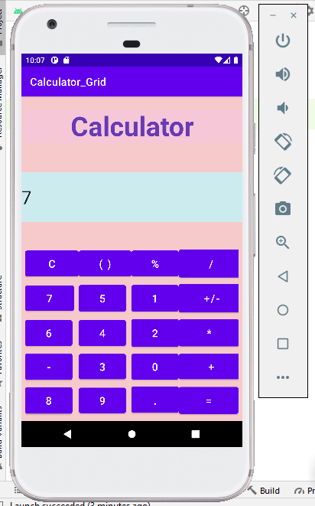

**RESULT:** The above program is successfully executed and obtained the output.

**PROGRAM 3**

**AIM:**

Create a Facebook page using RelativeLayout; set properties using .xml file.

**PROGRAM CODE**

|  |  |
| --- | --- |
| MainActivity.java | package com.example.linearlayout;  import androidx.appcompat.app.AppCompatActivty;  import android.os.Bundle;  public class MainActivity extends AppCompatActivity {  @Override  protected void onCreate(Bundle savedInstanceState) {  super.onCreate(savedInstanceState); setContentView(R.layout.activity_main);}} |
| Activity_main.xml | <androidx.constraintlayout.widget.ConstraintLayout xmlns:android="http://schemas.android.com/apk/res/android" xmlns:app="http://schemas.android.com/apk/res-auto" xmlns:tools="http://schemas.android.com/tools" android:layout_width="match_parent" android:layout_height="match_parent" android:background="#E4ECEA" android:backgroundTint="#E4ECEA" tools:context=".MainActivity">  <LinearLayout android:id="@+id/linearLayout" android:layout_width="404dp" android:layout_height="42dp" android:orientation="horizontal" app:layout_constraintBottom_toBottomOf="parent" app:layout_constraintEnd_toEndOf="parent" app:layout_constraintHorizontal_bias="1.0" app:layout_constraintStart_toStartOf="parent" app:layout_constraintTop_toTopOf="parent" app:layout_constraintVertical_bias="0.989">  <TextView android:id="@+id/textView" android:layout_width="match_parent" android:layout_height="49dp" android:text="CREATE NEW ACCOUNT"/>  </LinearLayout>  <RelativeLayout android:id="@+id/relativeLayout" android:layout_width="413dp" android:layout_height="728dp" android:background="#3b5998" android:backgroundTint="#3b5998" app:layout_constraintBottom_toBottomOf="@+id/linearLayout" app:layout_constraintEnd_toEndOf="parent" app:layout_constraintHorizontal_bias="0.0" app:layout_constraintStart_toStartOf="parent">  <ImageView android:id="@+id/imageView5" android:layout_width="wrap_content" android:layout_height="68dp" android:layout_alignParentStart="true" android:layout_alignParentTop="true" android:layout_alignParentEnd="true" android:layout_alignParentBottom="true" android:layout_marginStart="138dp" android:layout_marginTop="141dp" android:layout_marginEnd="190dp" android:layout_marginBottom="519dp" app:srcCompat="@drawable/download"/>  <EditText android:id="@+id/editTextTextPersonName4" android:layout_width="wrap_content" android:layout_height="58dp" android:layout_alignParentStart="true" android:layout_alignParentTop="true" android:layout_alignParentEnd="true" android:layout_alignParentBottom="true" android:layout_marginStart="78dp" android:layout_marginTop="248dp" android:layout_marginEnd="85dp" android:layout_marginBottom="422dp" android:background="#E4ECEA" android:backgroundTint="#FFFEFE" android:ems="10" android:hint="emailid/phone number" android:inputType="textPersonName"/>  <EditText android:id="@+id/editTextTextPassword2" android:layout_width="wrap_content" android:layout_height="58dp" android:layout_alignParentStart="true" android:layout_alignParentTop="true" android:layout_alignParentEnd="true" android:layout_alignParentBottom="true" android:layout_marginStart="80dp" android:layout_marginTop="316dp" android:layout_marginEnd="83dp" android:layout_marginBottom="354dp" android:background="#E4ECEA" android:backgroundTint="#E4ECEA" android:ems="10" android:hint="password" android:inputType="textPassword"/>  <Button android:id="@+id/button" android:layout_width="312dp" android:layout_height="54dp" android:layout_alignParentStart="true" android:layout_alignParentTop="true" android:layout_alignParentEnd="true" android:layout_alignParentBottom="true" android:layout_marginStart="47dp" android:layout_marginTop="422dp" android:layout_marginEnd="51dp" android:layout_marginBottom="252dp" android:background="#2B59A8" android:text="Login "/>  <Button android:id="@+id/button2" android:layout_width="314dp" android:layout_height="58dp" android:layout_alignParentStart="true" android:layout_alignParentTop="true" android:layout_alignParentEnd="true" android:layout_alignParentBottom="true" android:layout_marginStart="49dp" android:layout_marginTop="490dp" android:layout_marginEnd="49dp" android:layout_marginBottom="180dp" android:background="#2B59A8" android:text=" Login with browser"/>  <TextView android:id="@+id/textView2" android:layout_width="wrap_content" android:layout_height="41dp" android:layout_alignParentStart="true" android:layout_alignParentTop="true" android:layout_alignParentEnd="true" android:layout_alignParentBottom="true" android:layout_marginStart="125dp" android:layout_marginTop="590dp" android:layout_marginEnd="109dp" android:layout_marginBottom="97dp" android:text="create new account"/>  </RelativeLayout>  </androidx.constraintlayout.widget.ConstraintLayout> |

**OUTPUT**

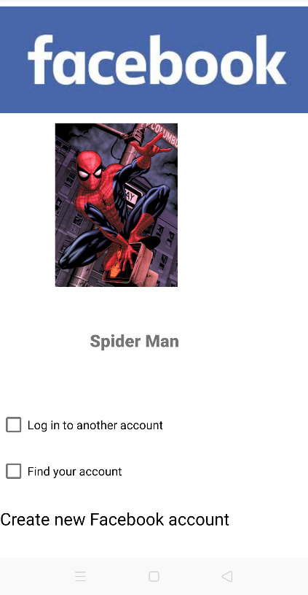

**RESULT:** The above program is successfully executed and obtained the output.

**PROGRAM 4**

**AIM:**

Develop an application that toggles image using FrameLayout.

**PROGRAM CODE:**

|  |  |
| --- | --- |
| MainActivity.java | package com.example.frame_layout;  import androidx.appcompat.app.AppCompatActivity;  import android.os.Bundle;  import android.view.View;  import android.widget.ImageView;  public class MainActivity extends AppCompatActivity implements View.OnClickListener {  ImageView i1,i2;  @Override  protected void onCreate(Bundle savedInstanceState){  super.onCreate(savedInstanceState);  setContentView(R.layout.activity_main);  i1=(ImageView) findViewById(R.id.imageView1);  i2=(ImageView) findViewById(R.id.imageView2);  i1.setOnClickListener(this);  i2.setOnClickListener(this);}  @Override  public void onClick(View v) {  if(v.getId()==R.id.imageView1){  i1.setVisibility(v.GONE);  i2.setVisibility(v.VISIBLE);}  else{  i2.setVisibility(v.GONE);  i1.setVisibility(v.VISIBLE);}}} |
| Activity_main.xml | <?xml version="1.0" encoding="utf-8"?>  <FrameLayout xmlns:android="http://schemas.android.com/apk/res/android"  xmlns:app="http://schemas.android.com/apk/res-auto"  xmlns:tools="http://schemas.android.com/tools"  android:layout_width="match_parent"  android:layout_height="match_parent"  android:background="#BDBABA"  tools:context=".MainActivity">  <ImageView  android:id="@+id/imageView1"  android:layout_width="427dp"  android:layout_height="wrap_content"  android:layout_gravity="left|top"  android:background="#CACAC8"  app:srcCompat="@drawable/switchon" />  <ImageView  android:id="@+id/imageView2"  android:layout_width="396dp"  android:layout_height="wrap_content"  android:layout_gravity="left|top"  android:visibility="gone"  app:srcCompat="@drawable/fanon" />  </FrameLayout> |

**OUTPUT**

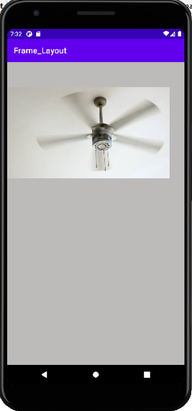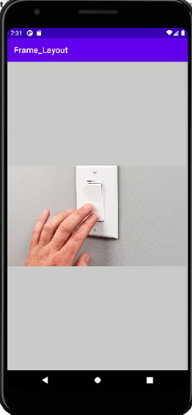

**RESULT:**

The above program is successfully executed and obtained the output.