**COURSE OUTCOME-3**

**By,**

**Arjun V Pankajakshan**

**20MCA311**

**PROGRAM 1**

**AIM:**

Implement Adapters and perform exception handling

**PROGRAM CODE**

|  |  |
| --- | --- |
| MainActivity.java | package com.example.workshow1;  import androidx.appcompat.app.AppCompatActivity;  import android.os.Bundle;  import android.widget.ArrayAdapter;  import android.widget.ListView;  import android.widget.TextView;  import android.widget.Toast;  public class MainActivity extends AppCompatActivity {  ListView l1;  String [] nam = {"Shajahan","Tovino","Ragav","Bineesh"};  protected void onCreate(Bundle savedInstanceState) {  super.onCreate(savedInstanceState);  setContentView(R.layout.activity_main);  try {  ArrayAdapter <String> adap = new ArrayAdapter<>(this,android.R.layout.simple_list_item_1,nam);  l1.setAdapter(adap);  }  catch (Exception e){  Toast.makeText(this, e.getMessage(), Toast.LENGTH_SHORT).show();  }}} |
| activity_main.xml | <?xml version="1.0" encoding="utf-8"?>  <androidx.constraintlayout.widget.ConstraintLayout xmlns:android="http://schemas.android.com/apk/res/android"  xmlns:app="http://schemas.android.com/apk/res-auto"  xmlns:tools="http://schemas.android.com/tools"  android:layout_width="match_parent"  android:layout_height="match_parent"  tools:context=".MainActivity">  <ListView  android:id="@+id/l1"  android:layout_width="411dp"  android:layout_height="335dp"  tools:layout_editor_absoluteX="1dp"  tools:layout_editor_absoluteY="1dp" />  <TextView  android:id="@+id/t1"  android:layout_width="137dp"  android:layout_height="44dp"  android:textAlignment="center"  android:textStyle="bold"  app:layout_constraintBottom_toBottomOf="parent"  app:layout_constraintEnd_toEndOf="parent"  app:layout_constraintHorizontal_bias="0.5"  app:layout_constraintStart_toStartOf="parent"  app:layout_constraintTop_toBottomOf="@+id/l1" /></androidx.constraintlayout.widget.ConstraintLayout> |

**RESULT:** The above program is successfully executed and obtained the output.

**OUTPUT**

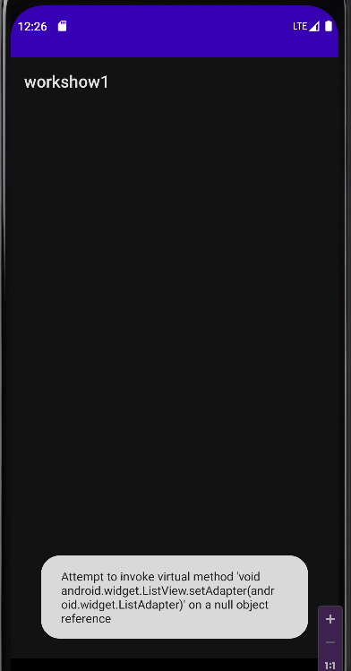

**PROGRAM 2**

**AIM:**

Implement Intent to navigate between multiple activities

**PROGRAM CODE**

|  |  |
| --- | --- |
| MainActivity.java | package com.example.explicit;  import androidx.appcompat.app.AppCompatActivity;  import android.content.Intent;  import android.os.Bundle;  import android.text.TextUtils;  import android.util.Patterns;  import android.view.View;  import android.widget.Button;  import android.widget.EditText;  import android.widget.Toast;  import java.util.Objects;  public class MainActivity extends AppCompatActivity {  EditText Name;  EditText address;  EditText email;  Button Submit;  @Override  protected void onCreate(Bundle savedInstanceState) {  super.onCreate(savedInstanceState);  setContentView(R.layout.activity_main);  Name = findViewById(R.id.s1);  address = findViewById(R.id.s2);  email = findViewById(R.id.s3);  Submit = findViewById(R.id.b1); }  public void callSecondActivity(View view) {  Intent i = new Intent(getApplicationContext(), MainActivity2.class);  String str = "Name : "+ Name.getText().toString();  i.putExtra("Value1", str);  String str1 ="Address : "+ address.getText().toString();  i.putExtra("Value2", str1);  String str2 = "Email : "+ email.getText().toString();  i.putExtra("Value3", str2);  startActivity(i);  }} |

|  |  |
| --- | --- |
| MainActivity2.java | package com.example.explicit;  import androidx.appcompat.app.AppCompatActivity;  import android.os.Bundle;  import androidx.appcompat.app.AppCompatActivity;  import android.content.Intent;  import android.os.Bundle;  import android.view.View;  import android.widget.TextView;  import android.widget.Toast;  public class MainActivity2 extends AppCompatActivity {  @Override  protected void onCreate(Bundle savedInstanceState) {  TextView t1;  TextView t2;  TextView t3;  super.onCreate(savedInstanceState);  setContentView(R.layout.activity_main2);  t1 = (TextView) findViewById(R.id.t1);  t2 = (TextView) findViewById(R.id.t2);  t3 = (TextView) findViewById(R.id.t3);  Intent intent = getIntent();  String str = intent.getStringExtra("Value1");  String str1 = intent.getStringExtra("Value2");  String str2 = intent.getStringExtra("Value3");  t1.setText(str);  t2.setText(str1);  t3.setText(str2);  }  } |
| Activity_main.xml | <?xml version="1.0" encoding="utf-8"?>  <androidx.constraintlayout.widget.ConstraintLayout xmlns:android="http://schemas.android.com/apk/res/android"  xmlns:app="http://schemas.android.com/apk/res-auto"  xmlns:tools="http://schemas.android.com/tools"  android:layout_width="match_parent"  android:layout_height="match_parent"  tools:context=".MainActivity">  <TextView  android:id="@+id/r1"  android:layout_width="191dp"  android:layout_height="39dp"  android:background="#009688"  android:text="Registration Form"  app:layout_constraintBottom_toBottomOf="parent"  app:layout_constraintEnd_toEndOf="parent"  app:layout_constraintHorizontal_bias="0.581"  app:layout_constraintStart_toStartOf="parent"  app:layout_constraintTop_toTopOf="parent"  app:layout_constraintVertical_bias="0.111" />  <TextView  android:id="@+id/a1"  android:layout_width="113dp"  android:layout_height="33dp"  android:text="Name"  app:layout_constraintBottom_toBottomOf="parent"  app:layout_constraintEnd_toEndOf="parent"  app:layout_constraintHorizontal_bias="0.167"  app:layout_constraintStart_toStartOf="parent"  app:layout_constraintTop_toTopOf="parent"  app:layout_constraintVertical_bias="0.289" />  <EditText  android:id="@+id/s1"  android:layout_width="wrap_content"  android:layout_height="wrap_content"  android:ems="10"  android:inputType="textPersonName"  app:layout_constraintBottom_toBottomOf="parent"  app:layout_constraintEnd_toEndOf="parent"  app:layout_constraintHorizontal_bias="0.919"  app:layout_constraintStart_toStartOf="parent"  app:layout_constraintTop_toTopOf="parent"  app:layout_constraintVertical_bias="0.276" />  <TextView  android:id="@+id/a2"  android:layout_width="115dp"  android:layout_height="32dp"  android:text="Address"  app:layout_constraintBottom_toBottomOf="parent"  app:layout_constraintEnd_toEndOf="parent"  app:layout_constraintHorizontal_bias="0.162"  app:layout_constraintStart_toStartOf="parent"  app:layout_constraintTop_toTopOf="parent"  app:layout_constraintVertical_bias="0.417" />  <EditText  android:id="@+id/s2"  android:layout_width="wrap_content"  android:layout_height="wrap_content"  android:ems="10"  android:inputType="textPersonName"  app:layout_constraintBottom_toBottomOf="parent"  app:layout_constraintEnd_toEndOf="parent"  app:layout_constraintHorizontal_bias="0.919"  app:layout_constraintStart_toStartOf="parent"  app:layout_constraintTop_toTopOf="parent"  app:layout_constraintVertical_bias="0.406" />  <TextView  android:id="@+id/a3"  android:layout_width="116dp"  android:layout_height="30dp"  android:text="Email"  app:layout_constraintBottom_toBottomOf="parent"  app:layout_constraintEnd_toEndOf="parent"  app:layout_constraintHorizontal_bias="0.167"  app:layout_constraintStart_toStartOf="parent"  app:layout_constraintTop_toTopOf="parent"  app:layout_constraintVertical_bias="0.525" />  <EditText  android:id="@+id/s3"  android:layout_width="wrap_content"  android:layout_height="wrap_content"  android:ems="10"  android:inputType="textPersonName"  app:layout_constraintBottom_toBottomOf="parent"  app:layout_constraintEnd_toEndOf="parent"  app:layout_constraintHorizontal_bias="0.915"  app:layout_constraintStart_toStartOf="parent"  app:layout_constraintTop_toTopOf="parent"  app:layout_constraintVertical_bias="0.525" />  <Button  android:id="@+id/b1"  android:layout_width="140dp"  android:layout_height="54dp"  android:background="#009688"  android:onClick="callSecondActivity"  android:text="Submit"  android:textColorLink="#03A9F4"  app:layout_constraintBottom_toBottomOf="parent"  app:layout_constraintEnd_toEndOf="parent"  app:layout_constraintHorizontal_bias="0.557"  app:layout_constraintStart_toStartOf="parent"  app:layout_constraintTop_toTopOf="parent"  app:layout_constraintVertical_bias="0.749" />  </androidx.constraintlayout.widget.ConstraintLayout> |

|  |  |
| --- | --- |
|  |  |
| Activity_main2.xml | <?xml version="1.0" encoding="utf-8"?>  <androidx.constraintlayout.widget.ConstraintLayout xmlns:android="http://schemas.android.com/apk/res/android"  xmlns:app="http://schemas.android.com/apk/res-auto"  xmlns:tools="http://schemas.android.com/tools"  android:layout_width="match_parent"  android:layout_height="match_parent"  tools:context=".MainActivity2">  <TextView  android:id="@+id/t1"  android:layout_width="312dp"  android:layout_height="73dp"  app:layout_constraintBottom_toBottomOf="parent"  app:layout_constraintEnd_toEndOf="parent"  app:layout_constraintHorizontal_bias="0.517"  app:layout_constraintStart_toStartOf="parent"  app:layout_constraintTop_toTopOf="parent"  app:layout_constraintVertical_bias="0.387" />  <TextView  android:id="@+id/t2"  android:layout_width="309dp"  android:layout_height="77dp"  app:layout_constraintBottom_toBottomOf="parent"  app:layout_constraintEnd_toEndOf="parent"  app:layout_constraintHorizontal_bias="0.509"  app:layout_constraintStart_toStartOf="parent"  app:layout_constraintTop_toTopOf="parent"  app:layout_constraintVertical_bias="0.559" />  <TextView  android:id="@+id/t3"  android:layout_width="313dp"  android:layout_height="70dp"  app:layout_constraintBottom_toBottomOf="parent"  app:layout_constraintEnd_toEndOf="parent"  app:layout_constraintStart_toStartOf="parent"  app:layout_constraintTop_toTopOf="parent"  app:layout_constraintVertical_bias="0.728" />  <TextView  android:id="@+id/textView3"  android:layout_width="391dp"  android:layout_height="100dp"  android:background="#009688"  android:text="DETAILS"  android:textSize="36sp"  android:textAlignment="center"  app:layout_constraintBottom_toBottomOf="parent"  app:layout_constraintEnd_toEndOf="parent"  app:layout_constraintStart_toStartOf="parent"  app:layout_constraintTop_toTopOf="parent"  app:layout_constraintVertical_bias="0.147" />  </androidx.constraintlayout.widget.ConstraintLayout> |

**RESULT:** The above program is successfully executed and obtained the output.

**OUTPUT**

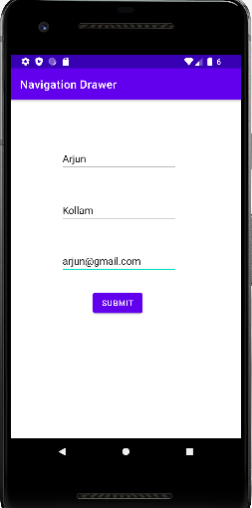

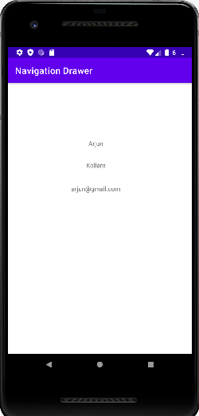

**PROGRAM 3**

**AIM:** Develop application that works with explicit intents

**PROGRAM CODE**

|  |  |
| --- | --- |
| **APP1** | |
| MainActivity.java | package com.example.explicitintent;  import androidx.appcompat.app.AppCompatActivity;  import android.content.Intent;  import android.net.Uri;  import android.os.Bundle;  import android.view.View;  import android.widget.Toast;  public class MainActivity extends AppCompatActivity {  @Override  protected void onCreate(Bundle savedInstanceState) {  super.onCreate(savedInstanceState);  setContentView(R.layout.activity_main);}  public void onClick(View view) {  Intent i = new Intent(Intent.ACTION_VIEW);  i.setData(Uri.parse("https://www.instagram.com/?hl=en"));  startActivity(i);}} |
| activity_main.xml | <?xml version="1.0" encoding="utf-8"?>  <androidx.constraintlayout.widget.ConstraintLayout xmlns:android="http://schemas.android.com/apk/res/android"  xmlns:app="http://schemas.android.com/apk/res-auto"  xmlns:tools="http://schemas.android.com/tools"  android:layout_width="match_parent"  android:layout_height="match_parent"  tools:context=".MainActivity">  <Button  android:id="@+id/button"  android:layout_width="308dp"  android:layout_height="50dp"  android:onClick="onClick"  android:text="Click to go INSTAGRAM"  android:textAllCaps="false"  app:layout_constraintBottom_toBottomOf="parent"  app:layout_constraintEnd_toEndOf="parent"  app:layout_constraintHorizontal_bias="0.495"  app:layout_constraintStart_toStartOf="parent"  app:layout_constraintTop_toTopOf="parent"  app:layout_constraintVertical_bias="0.317" />  </androidx.constraintlayout.widget.ConstraintLayout> |
| **APP2** | |
| MainActivity.java | package com.example.explicitintent2;  import androidx.appcompat.app.AppCompatActivity;  import android.content.Intent;  import android.net.Uri;  import android.os.Bundle;  import android.webkit.WebView;  import android.webkit.WebViewClient;  import android.widget.Toast;  import java.net.URL;  public class MainActivity extends AppCompatActivity {  @Override  protected void onCreate(Bundle savedInstanceState) {  super.onCreate(savedInstanceState);  setContentView(R.layout.activity_main);  Intent i = getIntent();  Uri uri = i.getData();  URL pageurl = null;  if(uri !=null){  try{  pageurl = new URL(uri.getScheme(),uri.getHost(),uri.getPath()); }  catch ( Exception e) { Toast.makeText(getApplicationContext(),"Error",Toast.LENGTH_LONG).show();}}  WebView wb =(WebView) findViewById(R.id.webvi);  wb.setWebViewClient(new WebViewClient());  wb.loadUrl(String.valueOf(pageurl));}} |
| activity_main.xml | <?xml version="1.0" encoding="utf-8"?>  <androidx.constraintlayout.widget.ConstraintLayout xmlns:android="http://schemas.android.com/apk/res/android"  xmlns:app="http://schemas.android.com/apk/res-auto"  xmlns:tools="http://schemas.android.com/tools"  android:layout_width="match_parent"  android:layout_height="match_parent"  tools:context=".MainActivity">  <WebView  android:id="@+id/webvi"  android:layout_width="409dp"  android:layout_height="729dp"  android:layout_marginStart="1dp"  android:layout_marginTop="1dp"  android:layout_marginEnd="1dp"  android:layout_marginBottom="1dp"  app:layout_constraintBottom_toBottomOf="parent"  app:layout_constraintEnd_toEndOf="parent"  app:layout_constraintStart_toStartOf="parent"  app:layout_constraintTop_toTopOf="parent" />  </androidx.constraintlayout.widget.ConstraintLayout> |

**RESULT:**

The above program is successfully executed and obtained the output.

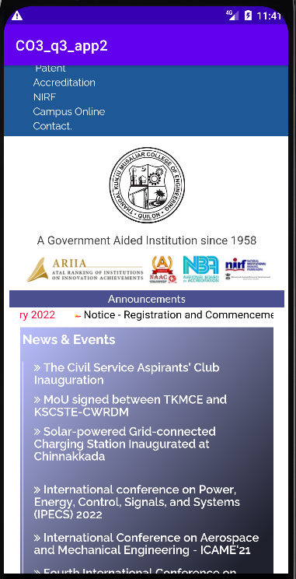**OUTPUT**

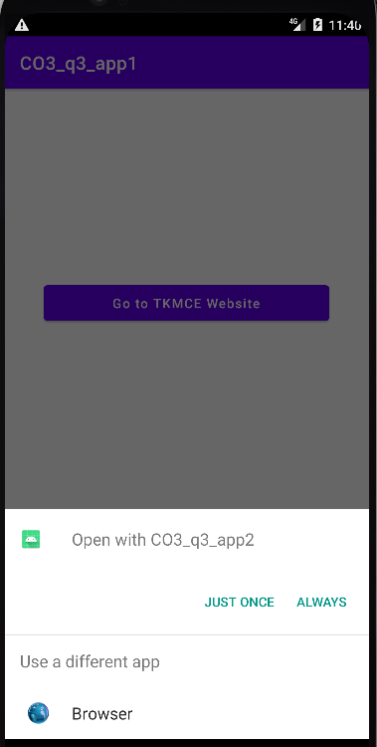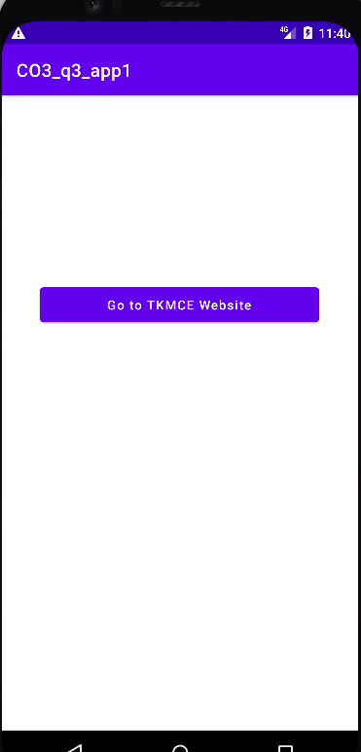

**PROGRAM 4**

**AIM:**

Implement Options Menu to navigate to activities

**PROGRAM CODE**

|  |  |
| --- | --- |
| MainActivity.java | package com.example.optionmenu;  import androidx.annotation.NonNull;  import androidx.appcompat.app.AppCompatActivity;  import android.content.Intent;  import android.os.Bundle;  import android.view.Menu;  import android.view.MenuInflater;  import android.view.MenuItem;  public class MainActivity extends AppCompatActivity {  @Override  protected void onCreate(Bundle savedInstanceState) {  super.onCreate(savedInstanceState);  setContentView(R.layout.activity_main);}  @Override  public boolean onCreateOptionsMenu(Menu menu) {  MenuInflater inflater=getMenuInflater();  inflater.inflate(R.menu.menu_option,menu);  return true;}  @Override  public boolean onOptionsItemSelected(@NonNull MenuItem item) {  int id=item.getItemId();  if(id==R.id.action_settings){  Intent i=new Intent(MainActivity.this,settings.class);  startActivity(i);}  if(id==R.id.action_call){  Intent i=new Intent(MainActivity.this,call.class);  startActivity(i);}  return super.onOptionsItemSelected(item);}} |
| Settings.java | package com.example.optionmenu;  import androidx.appcompat.app.AppCompatActivity;  import android.os.Bundle;  public class settings extends AppCompatActivity {  @Override  protected void onCreate(Bundle savedInstanceState) {  super.onCreate(savedInstanceState);  setContentView(R.layout.activity_settings);}} |
| Call.java | package com.example.optionmenu;  import androidx.appcompat.app.AppCompatActivity;  import android.os.Bundle;  public class call extends AppCompatActivity {  @Override  protected void onCreate(Bundle savedInstanceState) {  super.onCreate(savedInstanceState);  setContentView(R.layout.activity_call);}} |
| activity_main.xml | <?xml version="1.0" encoding="utf-8"?>  <androidx.constraintlayout.widget.ConstraintLayout xmlns:android="http://schemas.android.com/apk/res/android"  xmlns:app="http://schemas.android.com/apk/res-auto"  xmlns:tools="http://schemas.android.com/tools"  android:layout_width="match_parent"  android:layout_height="match_parent"  tools:context=".MainActivity"/> |
| Activity_settings.xml | <?xml version="1.0" encoding="utf-8"?>  <androidx.constraintlayout.widget.ConstraintLayout xmlns:android="http://schemas.android.com/apk/res/android"  xmlns:app="http://schemas.android.com/apk/res-auto"  xmlns:tools="http://schemas.android.com/tools"  android:layout_width="match_parent"  android:layout_height="match_parent"  tools:context=".call">  <TextView  android:id="@+id/textView2"  android:layout_width="184dp"  android:layout_height="62dp"  android:text="You just clicked call menu"  app:layout_constraintBottom_toBottomOf="parent"  app:layout_constraintEnd_toEndOf="parent"  app:layout_constraintStart_toStartOf="parent"  app:layout_constraintTop_toTopOf="parent" />  </androidx.constraintlayout.widget.ConstraintLayout> |
| Activity_call.xml | <?xml version="1.0" encoding="utf-8"?>  <androidx.constraintlayout.widget.ConstraintLayout xmlns:android="http://schemas.android.com/apk/res/android"  xmlns:app="http://schemas.android.com/apk/res-auto"  xmlns:tools="http://schemas.android.com/tools"  android:layout_width="match_parent"  android:layout_height="match_parent"  tools:context=".settings">  <TextView  android:id="@+id/textView"  android:layout_width="226dp"  android:layout_height="72dp"  android:text="Settings"  app:layout_constraintBottom_toBottomOf="parent"  app:layout_constraintEnd_toEndOf="parent"  app:layout_constraintStart_toStartOf="parent"  app:layout_constraintTop_toTopOf="parent" />  </androidx.constraintlayout.widget.ConstraintLayout> |

**RESULT:** The above program is successfully executed and obtained the output.

**OUTPUT**

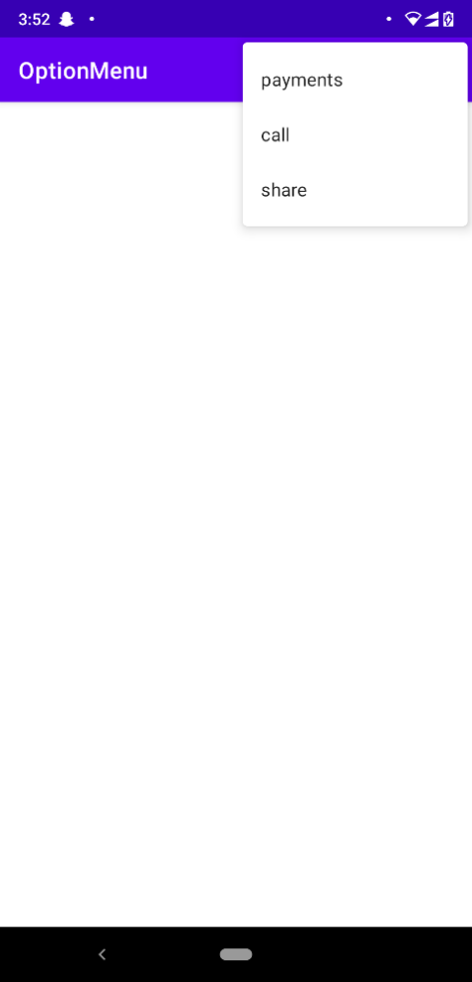 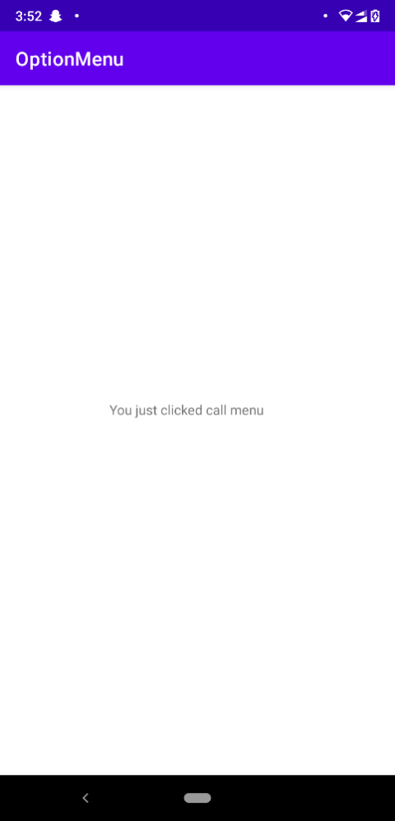 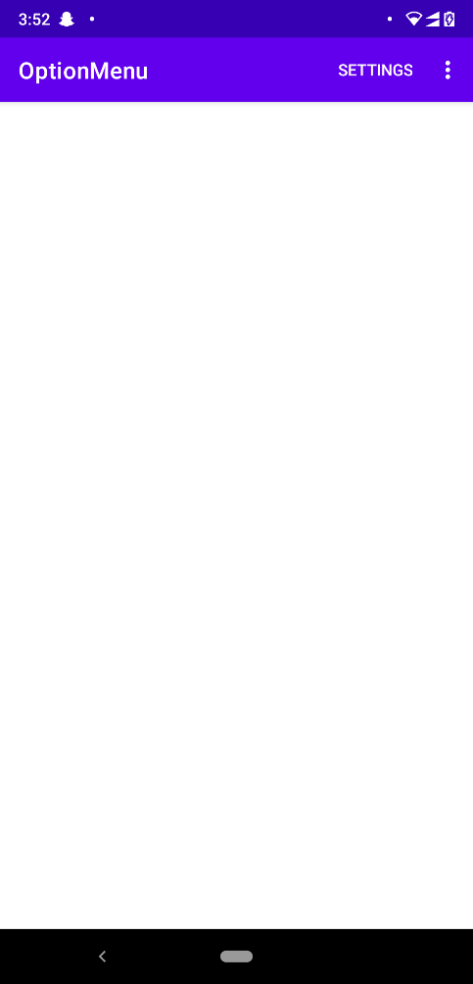 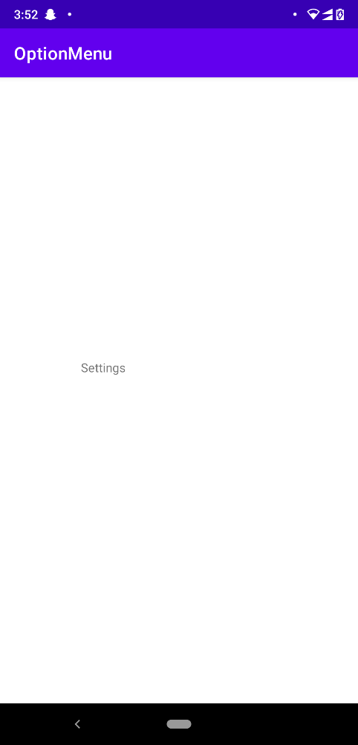

**PROGRAM 5**

**AIM:** Develop an application that uses ArrayAdapter with ListView.

**PROGRAM CODE**

|  |  |
| --- | --- |
| MainActivity.java | package com.example.arrayadapter;  import androidx.appcompat.app.AppCompatActivity;  import android.os.Bundle;  import android.view.View;  import android.widget.Adapter;  import android.widget.AdapterView;  import android.widget.ArrayAdapter;  import android.widget.ListView;  import android.widget.Toast;  public class MainActivity extends AppCompatActivity {  @Override  protected void onCreate(Bundle savedInstanceState) {  super.onCreate(savedInstanceState);  setContentView(R.layout.activity_main);  ListView list=findViewById(R.id.listview);  String[] item=new String[]{"Home","Address","Email","Phone"};  ArrayAdapter <String> adapter=new ArrayAdapter<String>(MainActivity.this,  android.R.layout.simple_list_item_1,item);  list.setAdapter(adapter);  list.setOnItemClickListener(new AdapterView.OnItemClickListener() {  @Override  public void onItemClick(AdapterView<?> adapterView, View view, int position, long id) {  String item_name=item[position];  Toast.makeText(MainActivity.this,item_name,Toast.LENGTH_LONG).show();}});}} |
| Activity_main.xml | <?xml version="1.0" encoding="utf-8"?>  <androidx.constraintlayout.widget.ConstraintLayout xmlns:android="http://schemas.android.com/apk/res/android"  xmlns:app="http://schemas.android.com/apk/res-auto"  xmlns:tools="http://schemas.android.com/tools"  android:layout_width="match_parent"  android:layout_height="match_parent"  tools:context=".MainActivity">  <ListView  android:id="@+id/listview"  android:layout_width="403dp"  android:layout_height="770dp"  tools:layout_editor_absoluteX="1dp"  tools:layout_editor_absoluteY="1dp" />  </androidx.constraintlayout.widget.ConstraintLayout> |

**RESULT:** The above program is successfully executed and obtained the output.

**OUTPUT**

