**COURSE OUTCOME-4**

**By,**

**Arjun Pankajakshan**

**20MCA311**

**PROGRAM 1**

**AIM:** Develop an application that use GridView with images and display Alert box on selection

**PROGRAM CODE**

|  |  |
| --- | --- |
| ImageAdapter.java | package com.example.myapplication;  import android.content.Context;  import android.view.View;  import android.view.ViewGroup;  import android.widget.BaseAdapter;  import android.widget.GridView;  import android.widget.ImageView;  public class ImageAdapter extends BaseAdapter {  private Context mContext;  public ImageAdapter(Context c) {  mContext = c;}  public int getCount() {  return thumbImages.length;}  public Object getItem(int position) {  return null;}  public long getItemId(int position) {  return 0;}  public View getView(int position, View convertView, ViewGroup parent) {  ImageView imageView = new ImageView(mContext);  imageView.setLayoutParams(new GridView.LayoutParams(200, 200));  imageView.setScaleType(ImageView.ScaleType.CENTER_CROP);  imageView.setPadding(8, 8, 8, 8);  imageView.setImageResource(thumbImages[position]);  return imageView;}  public Integer[] thumbImages = {  R.drawable.cl1,  R.drawable.cl2,  R.drawable.cl3,  R.drawable.cl4,};} |
| MainActivity.java | package com.example.myapplication;  import androidx.appcompat.app.AlertDialog;  import androidx.appcompat.app.AppCompatActivity;  import android.content.Context;  import android.content.DialogInterface;  import android.os.Bundle;  import android.view.View;  import android.widget.AdapterView;  import android.widget.GridView;  public class MainActivity extends AppCompatActivity {  GridView gd;  int logos[] = {R.drawable.cl1, R.drawable.cl2, R.drawable.cl3, R.drawable.cl4};  String[] names ={"Flower","Tiger","Panda","Wallpaper"};  final Context context = this;  AlertDialog.Builder builder;  @Override  protected void onCreate(Bundle savedInstanceState) {  super.onCreate(savedInstanceState);  setContentView(R.layout.activity_main);  GridView gv = (GridView) findViewById(R.id.gridView);  gv.setAdapter(new ImageAdapter(this));  builder = new AlertDialog.Builder(this);  gv.setOnItemClickListener(new AdapterView.OnItemClickListener(){  public void onItemClick(AdapterView<?> parent, View v, int position, long id) {  builder.setMessage("Name : "+String.valueOf(names[position]))  .setCancelable(false)  .setPositiveButton("Ok", new DialogInterface.OnClickListener() {  public void onClick(DialogInterface dialog, int id) {}});  AlertDialog alert = builder.create();  alert.setTitle("Info Alert");  alert.show(); }  });}} |
| activity_main.xml | <?xml version="1.0" encoding="utf-8"?>  <LinearLayout xmlns:android="http://schemas.android.com/apk/res/android"  xmlns:app="http://schemas.android.com/apk/res-auto"  xmlns:tools="http://schemas.android.com/tools"  android:layout_width="match_parent"  android:layout_height="match_parent"  android:background="#B5A830"  tools:context=".MainActivity">  <GridView  android:id="@+id/gridView"  android:layout_width="fill_parent"  android:layout_height="wrap_content"  android:footerDividersEnabled="false"  android:numColumns="3"  android:padding="1dp" />  </LinearLayout> |

**OUTPUT**

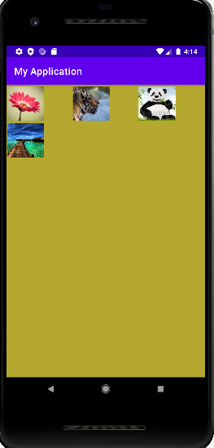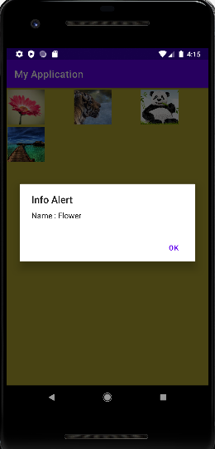

**RESULT:**

The above program is successfully executed and obtained the output.

**PROGRAM 2**

**AIM:**

Develop an application that implements Spinner component and perform event handling

**PROGRAM CODE**

|  |  |
| --- | --- |
| MainActivity.java | package com.example.co4_q2;  import androidx.appcompat.app.AppCompatActivity;  import android.os.Bundle;  import android.view.View;  import android.widget.AdapterView;  import android.widget.AdapterView.OnItemSelectedListener;  import android.widget.ArrayAdapter;  import android.widget.Spinner;  import android.widget.Toast;  public class MainActivity extends AppCompatActivity implements OnItemSelectedListener {  String[] names = {"_","First","Second","Third","Fourth"};  @Override  protected void onCreate(Bundle savedInstanceState) {  super.onCreate(savedInstanceState);  setContentView(R.layout.activity_main);  Spinner sp = (Spinner) findViewById(R.id.spinner);  sp.setOnItemSelectedListener(this);  ArrayAdapter ar = new ArrayAdapter(this,android.R.layout.simple_spinner_item,names); ar.setDropDownViewResource(android.R.layout.simple_spinner_dropdown_item);  sp.setAdapter(ar);}  @Override  public void onItemSelected(AdapterView<?> adapterView, View view, int i, long l) {  Toast.makeText(this, names[i], Toast.LENGTH_SHORT).show();  }  @Override  public void onNothingSelected(AdapterView<?> adapterView) {  }} |
| Activity_main.xml | <?xml version="1.0" encoding="utf-8"?>  <androidx.constraintlayout.widget.ConstraintLayout xmlns:android="http://schemas.android.com/apk/res/android"  xmlns:app="http://schemas.android.com/apk/res-auto"  xmlns:tools="http://schemas.android.com/tools"  android:layout_width="match_parent"  android:layout_height="match_parent"  android:background="#00BCD4"  tools:context=".MainActivity">  <Spinner  android:id="@+id/spinner"  android:layout_width="248dp"  android:layout_height="35dp"  android:background="#D7E268"  android:backgroundTint="#E6DFDF"  app:layout_constraintBottom_toBottomOf="parent"  app:layout_constraintEnd_toEndOf="parent"  app:layout_constraintHorizontal_bias="0.5"  app:layout_constraintStart_toEndOf="@+id/textView"  app:layout_constraintTop_toTopOf="parent"  app:layout_constraintVertical_bias="0.363" />  <TextView  android:id="@+id/textView"  android:layout_width="124dp"  android:layout_height="34dp"  android:background="#B59D60"  android:text="Select Any"  android:textAlignment="center"  app:layout_constraintBottom_toBottomOf="parent"  app:layout_constraintEnd_toStartOf="@+id/spinner"  app:layout_constraintHorizontal_bias="0.5"  app:layout_constraintStart_toStartOf="parent"  app:layout_constraintTop_toTopOf="parent"  app:layout_constraintVertical_bias="0.362" />  </androidx.constraintlayout.widget.ConstraintLayout> |

**RESULT:** The above program is successfully executed and obtained the output.

**OUTPUT**

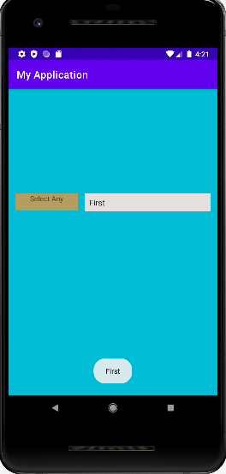

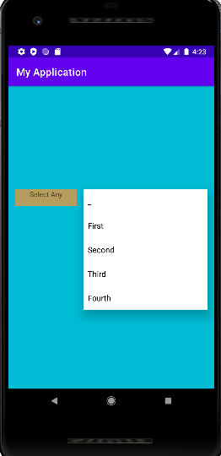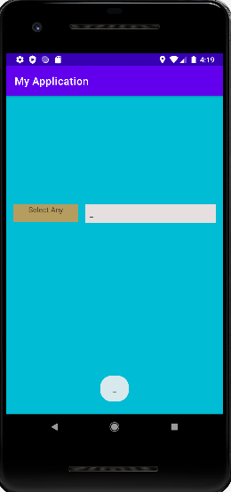

**PROGRAM 3**

**AIM:**

Apply themes via code and manifest file

**PROGRAM CODE**

|  |  |
| --- | --- |
| MainActivity.java | package com.example.theme;  import androidx.appcompat.app.AppCompatActivity;  import android.content.Intent;  import android.os.Bundle;  import android.view.View;  public class MainActivity extends AppCompatActivity {  @Override  protected void onCreate(Bundle savedInstanceState) {  super.onCreate(savedInstanceState);  setContentView(R.layout.activity_main);}  public void click(View view){  Intent i=new Intent(getApplicationContext(),MainActivity2.class);  startActivity(i);}} |
| MainActivity2.java | package com.example.theme;  import androidx.appcompat.app.AppCompatActivity;  import android.os.Bundle;  public class MainActivity2 extends AppCompatActivity {  @Override  protected void onCreate(Bundle savedInstanceState) {  super.onCreate(savedInstanceState);  setContentView(R.layout.activity_main2);}} |
| Activity_main.xml | <?xml version="1.0" encoding="utf-8"?>  <androidx.constraintlayout.widget.ConstraintLayout xmlns:android="http://schemas.android.com/apk/res/android"  xmlns:app="http://schemas.android.com/apk/res-auto"  xmlns:tools="http://schemas.android.com/tools"  android:layout_width="match_parent"  android:layout_height="match_parent"  tools:context=".MainActivity">  <TextView  android:layout_width="wrap_content"  android:layout_height="wrap_content"  android:text="Hello World!"  app:layout_constraintBottom_toBottomOf="parent"  app:layout_constraintLeft_toLeftOf="parent"  app:layout_constraintRight_toRightOf="parent"  app:layout_constraintTop_toTopOf="parent"  app:layout_constraintVertical_bias="0.351" />  <Button  android:id="@+id/button"  android:layout_width="124dp"  android:layout_height="45dp"  android:onClick="click"  android:text="theme"  app:layout_constraintBottom_toBottomOf="parent"  app:layout_constraintEnd_toEndOf="parent"  app:layout_constraintHorizontal_bias="0.55"  app:layout_constraintStart_toStartOf="parent"  app:layout_constraintTop_toTopOf="parent" />  </androidx.constraintlayout.widget.ConstraintLayout> |
| Activity_main2.xml | <?xml version="1.0" encoding="utf-8"?>  <androidx.constraintlayout.widget.ConstraintLayout xmlns:android="http://schemas.android.com/apk/res/android"  xmlns:app="http://schemas.android.com/apk/res-auto"  xmlns:tools="http://schemas.android.com/tools"  android:layout_width="match_parent"  android:layout_height="match_parent"  tools:context=".MainActivity2">  </androidx.constraintlayout.widget.ConstraintLayout> |
| AndroidManifest.xml | <?xml version="1.0" encoding="utf-8"?>  <manifest xmlns:android="http://schemas.android.com/apk/res/android"  package="com.example.theme">  <application  android:allowBackup="true"  android:icon="@mipmap/ic_launcher"  android:label="@string/app_name"  android:roundIcon="@mipmap/ic_launcher_round"  android:supportsRtl="true"  android:theme="@style/Theme.Theme">  <activity  android:name=".MainActivity2"  android:exported="false"  android:theme="@style/Theme.Thememanifest1"/>  <activity  android:name=".MainActivity"  android:exported="true">  <intent-filter>  <action android:name="android.intent.action.MAIN" />  <category android:name="android.intent.category.LAUNCHER" />  </intent-filter>  </activity>  </application>  </manifest> |
| Themes.xml | <resources xmlns:tools="http://schemas.android.com/tools">  <!-- Base application theme. -->  <style name="Theme.Theme" parent="Theme.MaterialComponents.DayNight.DarkActionBar">  <!-- Primary brand color. -->  <item name="colorPrimary">@color/purple_500</item>  <item name="colorPrimaryVariant">@color/purple_700</item>  <item name="colorOnPrimary">@color/white</item>  <!-- Secondary brand color. -->  <item name="colorSecondary">@color/teal_200</item>  <item name="colorSecondaryVariant">@color/teal_700</item>  <item name="colorOnSecondary">@color/black</item>  <!-- Status bar color. -->  <item name="android:statusBarColor" tools:targetApi="l">?attr/colorPrimaryVariant</item>  <!-- Customize your theme here. -->  </style>  <style name="Theme.Thememanifest1" parent="Theme.MaterialComponents.DayNight.DarkActionBar">  <!-- Primary brand color. -->  <item name="colorPrimary">@color/teal_700</item>  <item name="android:windowBackground">#1772B9</item>  <item name="colorPrimaryVariant">#D09909</item>  <item name="colorOnPrimary">@color/white</item>  <!-- Secondary brand color. -->  <item name="colorSecondary">@color/teal_200</item>  <item name="colorSecondaryVariant">@color/purple_200</item>  <item name="colorOnSecondary">#D54444</item>  <!-- Status bar color. -->  <item name="android:statusBarColor" tools:targetApi="l">?attr/colorPrimaryVariant</item>  <!-- Customize your theme here. -->  </style>  </resources> |

**RESULT:**

The above program is successfully executed and obtained the output.

**OUTPUT**

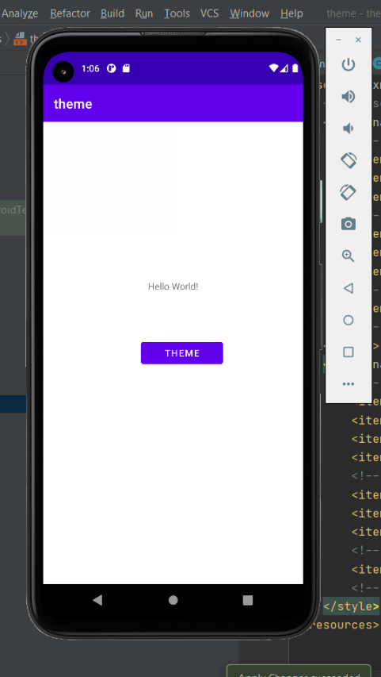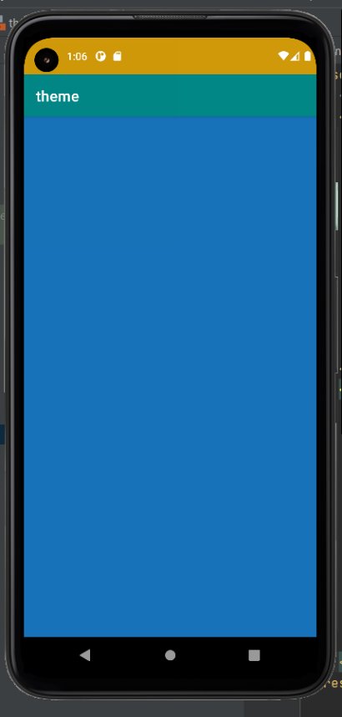

**PROGRAM 4**

**AIM:** Develop application using Fragments

**PROGRAM CODE**

|  |  |
| --- | --- |
| MainActivity.java | //Develop application using Fragments  package com.example.co4_q4;  import androidx.appcompat.app.AppCompatActivity;  import androidx.fragment.app.Fragment;  import androidx.fragment.app.FragmentManager;  import androidx.fragment.app.FragmentTransaction;  import android.os.Bundle;  import android.view.View;  import android.widget.Toast;  public class MainActivity extends AppCompatActivity {  @Override  protected void onCreate(Bundle savedInstanceState) {  super.onCreate(savedInstanceState);  setContentView(R.layout.activity_main);}  public void fragement1Start(View view){  replaceFragement(new Fragment1());}  public void fragement2Start(View view){  replaceFragement(new Fragment2());}  public void replaceFragement(Fragment pragment){  FragmentManager fm = getSupportFragmentManager();  FragmentTransaction ft = fm.beginTransaction();  ft.replace(R.id.fra,pragment);  ft.commit();}} |
| Fragment1.java | package com.example.co4_q4;  import android.os.Bundle;  import androidx.fragment.app.Fragment;  import android.view.LayoutInflater;  import android.view.View;  import android.view.ViewGroup;  public class Fragment1 extends Fragment {  @Override  public View onCreateView(LayoutInflater inflater, ViewGroup container,  Bundle savedInstanceState) {  // Inflate the layout for this fragment  return inflater.inflate(R.layout.fragment_1, container, false);}} |
| Fragment2.java | package com.example.co4_q4;  import android.os.Bundle;  import androidx.fragment.app.Fragment;  import android.view.LayoutInflater;  import android.view.View;  import android.view.ViewGroup;  public class Fragment2 extends Fragment {  @Override  public View onCreateView(LayoutInflater inflater, ViewGroup container,  Bundle savedInstanceState) {  // Inflate the layout for this fragment  return inflater.inflate(R.layout.fragment_2, container, false);}} |
| Activity_main.xml | <?xml version="1.0" encoding="utf-8"?>  <androidx.constraintlayout.widget.ConstraintLayout xmlns:android="http://schemas.android.com/apk/res/android"  xmlns:app="http://schemas.android.com/apk/res-auto"  xmlns:tools="http://schemas.android.com/tools"  android:layout_width="match_parent"  android:layout_height="match_parent"  tools:context=".MainActivity">  <Button  android:id="@+id/f2"  android:layout_width="wrap_content"  android:layout_height="wrap_content"  android:layout_marginStart="32dp"  android:layout_marginTop="100dp"  android:onClick="fragement2Start"  android:text="Fragment 2"  app:layout_constraintEnd_toEndOf="parent"  app:layout_constraintHorizontal_bias="0.5"  app:layout_constraintStart_toEndOf="@+id/f1"  app:layout_constraintTop_toTopOf="parent" />  <Button  android:id="@+id/f1"  android:layout_width="wrap_content"  android:layout_height="wrap_content"  android:layout_marginTop="100dp"  android:onClick="fragement1Start"  android:text="Fragment 1"  app:layout_constraintEnd_toStartOf="@+id/f2"  app:layout_constraintHorizontal_bias="0.5"  app:layout_constraintStart_toStartOf="parent"  app:layout_constraintTop_toTopOf="parent" />  <FrameLayout  android:id="@+id/fra"  android:layout_width="409dp"  android:layout_height="581dp"  tools:layout_editor_absoluteX="2dp"  tools:layout_editor_absoluteY="148dp">  </FrameLayout>  </androidx.constraintlayout.widget.ConstraintLayout> |
| fragment_1.xml | <?xml version="1.0" encoding="utf-8"?>  <androidx.constraintlayout.widget.ConstraintLayout xmlns:android="http://schemas.android.com/apk/res/android"  xmlns:app="http://schemas.android.com/apk/res-auto"  xmlns:tools="http://schemas.android.com/tools"  android:id="@+id/frameLayout2"  android:layout_width="match_parent"  android:layout_height="match_parent"  android:background="#0DBED5"  tools:context=".Fragment1">  <TextView  android:id="@+id/textView2"  android:layout_width="154dp"  android:layout_height="46dp"  android:text="Fragment 1"  android:textAlignment="center"  android:textColor="#3F51B5"  android:textSize="24sp"  android:textStyle="bold|italic"  app:layout_constraintBottom_toBottomOf="parent"  app:layout_constraintEnd_toEndOf="parent"  app:layout_constraintHorizontal_bias="0.498"  app:layout_constraintStart_toStartOf="parent"  app:layout_constraintTop_toTopOf="parent"  app:layout_constraintVertical_bias="0.499" />  </androidx.constraintlayout.widget.ConstraintLayout> |
| fragment_2.xml | <?xml version="1.0" encoding="utf-8"?>  <androidx.constraintlayout.widget.ConstraintLayout xmlns:android="http://schemas.android.com/apk/res/android"  xmlns:app="http://schemas.android.com/apk/res-auto"  xmlns:tools="http://schemas.android.com/tools"  android:id="@+id/frameLayout"  android:layout_width="match_parent"  android:layout_height="match_parent"  android:background="#D315AA"  tools:context=".Fragment2">  <!-- TODO: Update blank fragment layout -->  <TextView  android:id="@+id/textView"  android:layout_width="131dp"  android:layout_height="61dp"  android:text="Fragment 2"  android:textAlignment="center"  android:textColor="#A52E2E"  android:textSize="24sp"  android:textStyle="bold"  app:layout_constraintBottom_toBottomOf="parent"  app:layout_constraintEnd_toEndOf="parent"  app:layout_constraintStart_toStartOf="parent"  app:layout_constraintTop_toTopOf="parent" />  </androidx.constraintlayout.widget.ConstraintLayout> |

**RESULT:** The above program is successfully executed and obtained the output.

**OUTPUT**

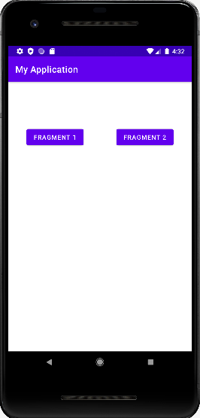

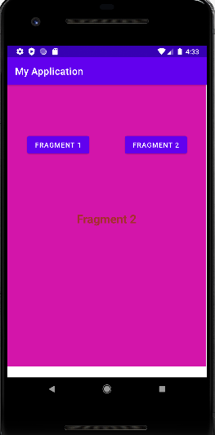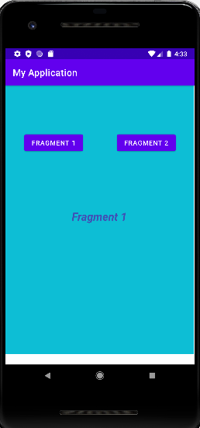

**PROGRAM 5**

**AIM:**

Implement Navigation drawer

**PROGRAM CODE**

|  |  |
| --- | --- |
| MainActivity.java | package com.example.nav_drawer;  import androidx.appcompat.app.AppCompatActivity;  import android.os.Bundle;  import androidx.annotation.NonNull;  import androidx.appcompat.app.ActionBarDrawerToggle;  import androidx.drawerlayout.widget.DrawerLayout;  import android.view.MenuItem;  public class MainActivity extends AppCompatActivity {  public DrawerLayout drawerLayout;  public ActionBarDrawerToggle actionBarDrawerToggle;  @Override  protected void onCreate(Bundle savedInstanceState) {  super.onCreate(savedInstanceState);  setContentView(R.layout.activity_main);  drawerLayout = findViewById(R.id.my_drawer_layout);  actionBarDrawerToggle = new ActionBarDrawerToggle(this, drawerLayout, R.string.nav_open, R.string.nav_close);  drawerLayout.addDrawerListener(actionBarDrawerToggle);  actionBarDrawerToggle.syncState();  getSupportActionBar().setDisplayHomeAsUpEnabled(true);}  @Override  public boolean onOptionsItemSelected(@NonNull MenuItem item) {  if (actionBarDrawerToggle.onOptionsItemSelected(item)) {  return true;}  return super.onOptionsItemSelected(item);}} |
| Activity_main.xml | <?xml version="1.0" encoding="utf-8"?>  <androidx.drawerlayout.widget.DrawerLayout  xmlns:android="http://schemas.android.com/apk/res/android"  xmlns:app="http://schemas.android.com/apk/res-auto"  xmlns:tools="http://schemas.android.com/tools"  android:id="@+id/my_drawer_layout"  android:layout_width="match_parent"  android:layout_height="match_parent"  tools:context=".MainActivity"  tools:ignore="HardcodedText">  <LinearLayout  android:layout_width="match_parent"  android:layout_height="match_parent">  <TextView  android:layout_width="match_parent"  android:layout_height="wrap_content"  android:layout_marginTop="128dp"  android:gravity="center"  android:text="Home Window"  android:textSize="18sp" />  </LinearLayout>  <com.google.android.material.navigation.NavigationView  android:layout_width="wrap_content"  android:layout_height="match_parent"  android:layout_gravity="start"  app:menu="@menu/navigation_menu" />  </androidx.drawerlayout.widget.DrawerLayout> |
| navigation_menu.xml | <?xml version="1.0" encoding="utf-8"?>  <menu xmlns:android="http://schemas.android.com/apk/res/android">  xmlns:tools="http://schemas.android.com/tools"  tools:ignore="HardcodedText">  <item  android:id="@+id/nav_account"  android:title="Home" />  <item  android:id="@+id/nav_settings"  android:title="Gallery" />  <item  android:id="@+id/nav_logout"  android:title="Info" /></menu> |
| Strings.xml | <resources>  <string name="app_name">Navigation Drawer</string>  <string name="nav_open">Open</string>  <string name="nav_close">Close</string>  </resources> |

**RESULT:**

The above program is successfully executed and obtained the output.

**OUTPUT**

