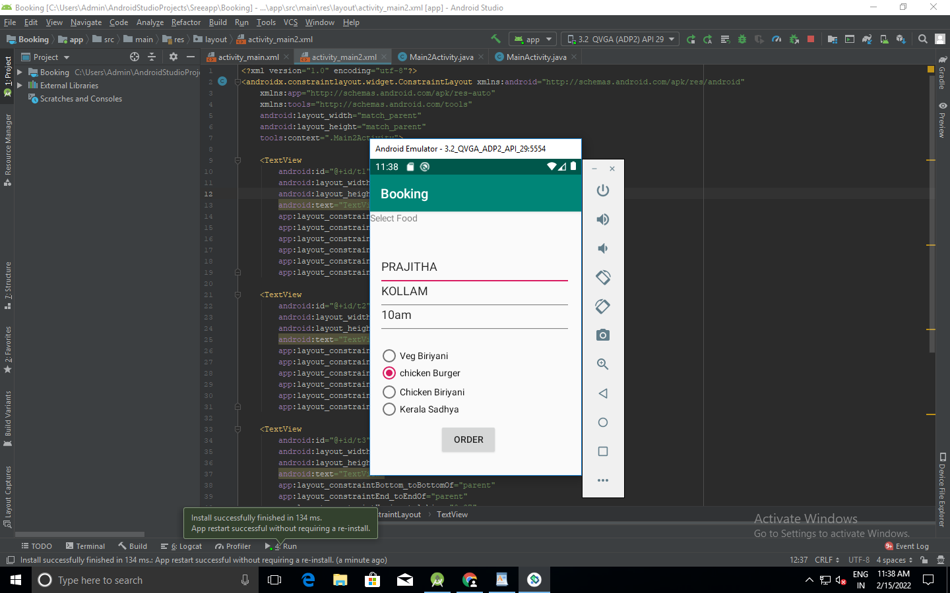
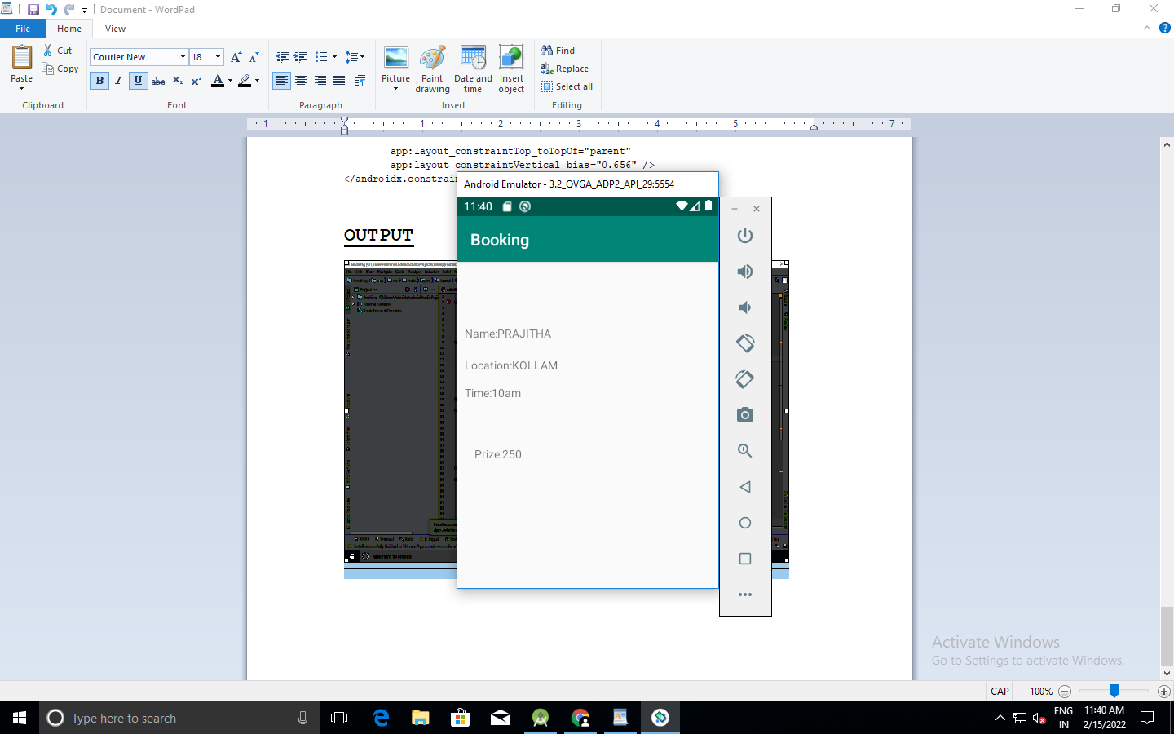
PRAJITHA P
20MCA328

MainActivity.java

package com.example.booking;
import androidx.appcompat.app.AppCompatActivity;
import android.content.Intent;
import android.os.Bundle;
import android.view.View;
import android.widget.Button;
import android.widget.EditText;
import android.widget.TextView;
public class MainActivity extends AppCompatActivity {
TextView t1;
EditText name,place,time;
Button b1,f1,f2,f3,f4;
@Override
protected void onCreate(Bundle savedInstanceState) {
super.onCreate(savedInstanceState);
setContentView(R.layout.activity_main);
t1=(TextView)findViewById(R.id.food);
b1=(Button) findViewById(R.id.order);
f1=(Button) findViewById(R.id.f1);
f2=(Button) findViewById(R.id.f2);
f3=(Button) findViewById(R.id.f3);
f4=(Button) findViewById(R.id.f4);
name=(EditText) findViewById(R.id.name);
place=(EditText) findViewById(R.id.location);
time=(EditText) findViewById(R.id.time);
b1.setOnClickListener(new View.OnClickListener(){
public void onClick(View view){
String name1=name.getText().toString();
String place1=place.getText().toString();
String time1=time.getText().toString();
Intent intent=new Intent(MainActivity.this, Main2Activity.class);
intent.putExtra("Name",name1);
intent.putExtra("Place",place1);
intent.putExtra("Time",time1);
startActivity(intent);
}
});
}
}

activity_main.xml
<?xml version="1.0" encoding="utf-8"?>
<androidx.constraintlayout.widget.ConstraintLayout xmlns:android="http://schemas.android.com/apk/res/android"
xmlns:app="http://schemas.android.com/apk/res-auto"
xmlns:tools="http://schemas.android.com/tools"
android:layout_width="match_parent"
android:layout_height="match_parent"
tools:context=".MainActivity">
<Button
android:id="@+id/order"
android:layout_width="wrap_content"
android:layout_height="wrap_content"
android:onClick="orderfunc"
android:text="Order"
app:layout_constraintBottom_toBottomOf="parent"
app:layout_constraintEnd_toEndOf="parent"
app:layout_constraintHorizontal_bias="0.452"
app:layout_constraintStart_toStartOf="parent"
app:layout_constraintTop_toTopOf="parent"
app:layout_constraintVertical_bias="0.915" />
<EditText
android:id="@+id/name"
android:layout_width="291dp"
android:layout_height="59dp"
android:ems="10"
android:hint="Name"
android:inputType="textPersonName"
app:layout_constraintBottom_toBottomOf="parent"
app:layout_constraintEnd_toEndOf="parent"
app:layout_constraintHorizontal_bias="0.441"
app:layout_constraintStart_toStartOf="parent"
app:layout_constraintTop_toTopOf="parent"
app:layout_constraintVertical_bias="0.159" />
<EditText
android:id="@+id/location"
android:layout_width="291dp"
android:layout_height="59dp"
android:ems="10"
android:hint="Location"
android:inputType="textPersonName"
app:layout_constraintBottom_toBottomOf="parent"
app:layout_constraintEnd_toEndOf="parent"
app:layout_constraintHorizontal_bias="0.441"
app:layout_constraintStart_toStartOf="parent"
app:layout_constraintTop_toTopOf="parent"
app:layout_constraintVertical_bias="0.266" />
<EditText
android:id="@+id/time"
android:layout_width="291dp"
android:layout_height="59dp"
android:ems="10"
android:hint="time"
android:inputType="time"
app:layout_constraintBottom_toBottomOf="parent"
app:layout_constraintEnd_toEndOf="parent"
app:layout_constraintHorizontal_bias="0.441"
app:layout_constraintStart_toStartOf="parent"
app:layout_constraintTop_toTopOf="parent"
app:layout_constraintVertical_bias="0.372" />
<RadioButton
android:id="@+id/f2"
android:layout_width="291dp"
android:layout_height="42dp"
android:checked="false"
android:text="chicken Burger"
app:layout_constraintBottom_toBottomOf="parent"
app:layout_constraintEnd_toEndOf="parent"
app:layout_constraintHorizontal_bias="0.441"
app:layout_constraintStart_toStartOf="parent"
app:layout_constraintTop_toTopOf="parent"
app:layout_constraintVertical_bias="0.626" />
<RadioButton
android:id="@+id/f1"
android:layout_width="291dp"
android:layout_height="42dp"
android:checked="false"
android:text="Veg Biriyani"
app:layout_constraintBottom_toBottomOf="parent"
app:layout_constraintEnd_toEndOf="parent"
app:layout_constraintHorizontal_bias="0.441"
app:layout_constraintStart_toStartOf="parent"
app:layout_constraintTop_toTopOf="parent"
app:layout_constraintVertical_bias="0.552" />
<RadioButton
android:id="@+id/f3"
android:layout_width="291dp"
android:layout_height="42dp"
android:checked="false"
android:text="Chicken Biriyani"
app:layout_constraintBottom_toBottomOf="parent"
app:layout_constraintEnd_toEndOf="parent"
app:layout_constraintHorizontal_bias="0.441"
app:layout_constraintStart_toStartOf="parent"
app:layout_constraintTop_toTopOf="parent"
app:layout_constraintVertical_bias="0.706" />
<RadioButton
android:id="@+id/f4"
android:layout_width="291dp"
android:layout_height="42dp"
android:checked="false"
android:text="Kerala Sadhya"
app:layout_constraintBottom_toBottomOf="parent"
app:layout_constraintEnd_toEndOf="parent"
app:layout_constraintHorizontal_bias="0.441"
app:layout_constraintStart_toStartOf="parent"
app:layout_constraintTop_toTopOf="parent"
app:layout_constraintVertical_bias="0.779" />
<TextView
android:id="@+id/food"
android:layout_width="291dp"
android:layout_height="42dp"
android:text="Select Food"
tools:layout_editor_absoluteX="53dp"
tools:layout_editor_absoluteY="321dp" />
</androidx.constraintlayout.widget.ConstraintLayout>

Main2Activity.java
package com.example.booking;
import androidx.appcompat.app.AppCompatActivity;
import android.content.Intent;
import android.os.Bundle;
import android.view.View;
import android.widget.Button;
import android.widget.TextView;
public class Main2Activity extends AppCompatActivity {
@Override
protected void onCreate(Bundle savedInstanceState) {
super.onCreate(savedInstanceState);
setContentView(R.layout.activity_main2);
Intent intent=getIntent();
String name=intent.getStringExtra("Name");
String place=intent.getStringExtra("Place");
String time=intent.getStringExtra("Time");
TextView n1=findViewById(R.id.t1);
TextView p1=findViewById(R.id.t2);
TextView l1=findViewById(R.id.t3);
TextView prize=findViewById(R.id.t4);
n1.setText("Name:"+name);
p1.setText("Location:"+place);
l1.setText("Time:"+time);
prize.setText("Prize:250");
}
}
activity_main2.xml

<?xml version="1.0" encoding="utf-8"?>
<androidx.constraintlayout.widget.ConstraintLayout xmlns:android="http://schemas.android.com/apk/res/android"
xmlns:app="http://schemas.android.com/apk/res-auto"
xmlns:tools="http://schemas.android.com/tools"
android:layout_width="match_parent"
android:layout_height="match_parent"
tools:context=".Main2Activity">
<TextView
android:id="@+id/t1"
android:layout_width="295dp"
android:layout_height="55dp"
android:text="TextView"
app:layout_constraintBottom_toBottomOf="parent"
app:layout_constraintEnd_toEndOf="parent"
app:layout_constraintHorizontal_bias="0.37"
app:layout_constraintStart_toStartOf="parent"
app:layout_constraintTop_toTopOf="parent"
app:layout_constraintVertical_bias="0.226" />
<TextView
android:id="@+id/t2"
android:layout_width="295dp"
android:layout_height="55dp"
android:text="TextView"
app:layout_constraintBottom_toBottomOf="parent"
app:layout_constraintEnd_toEndOf="parent"
app:layout_constraintHorizontal_bias="0.37"
app:layout_constraintStart_toStartOf="parent"
app:layout_constraintTop_toTopOf="parent"
app:layout_constraintVertical_bias="0.338" />
<TextView
android:id="@+id/t3"
android:layout_width="295dp"
android:layout_height="55dp"
android:text="TextView"
app:layout_constraintBottom_toBottomOf="parent"
app:layout_constraintEnd_toEndOf="parent"
app:layout_constraintHorizontal_bias="0.37"
app:layout_constraintStart_toStartOf="parent"
app:layout_constraintTop_toTopOf="parent"
app:layout_constraintVertical_bias="0.439" />
<TextView
android:id="@+id/t4"
android:layout_width="229dp"
android:layout_height="55dp"
android:text="TextView"
app:layout_constraintBottom_toBottomOf="parent"
app:layout_constraintEnd_toEndOf="parent"
app:layout_constraintHorizontal_bias="0.236"
app:layout_constraintStart_toStartOf="parent"
app:layout_constraintTop_toTopOf="parent"
app:layout_constraintVertical_bias="0.656" />
</androidx.constraintlayout.widget.ConstraintLayout>
OUTPUT
RESULT OBTAINED

