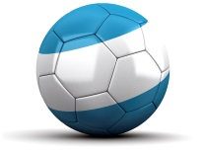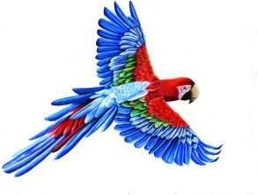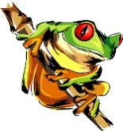The Physical World  
Seen through Latin America

DIRECTIONS- Use the following notes page to fill in the appropriate information from the in class presentation.

|  |  |  |  |
| --- | --- | --- | --- |
| Think and Hypothesize about the answers to the introductory questions. | | | |
| How was this created? | …and these? | What causes such a change? | What forces cause these conditions? |
|  |  |  |  |

|  |
| --- |
| “The World is a Wonderful & Mysterious Place” - Write down your impressions of the stunning landmarks of Latin America. |
|  |

|  |
| --- |
| Hypothesize - What are the physical forces that shape our planet? |
|  |

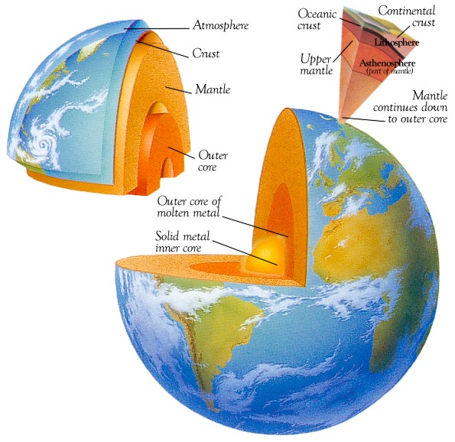  
What is the Earth made of?

What is the center of the planet? (2 parts: inner & outer)  
______________________________

What is the middle layer of the planet? (thickest layer)  
______________________________

What is the outer layer of the planet? (thinnest layer)  
______________________________

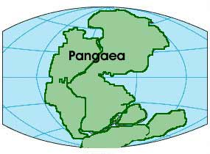A Little Historical Background

______________________________ developed the idea of Continental Drift when he found _________________________ evidence of the same animal on different continents and a tropical plant _________________________ in a polar zone.  
______________________________ is the theory the continents float over the surface of the planet.  
_________________________ is the name Alfred Wegener gave to the super continent.  
  
Tectonic Plate Theory

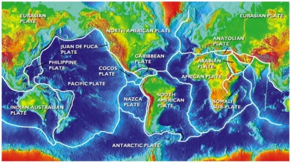______________________________ is the theory the planet’s outer shell is made up of individual moving plates that are in constant motion. This officially replaced the Continental Drift Theory.  
_________________________ and _________________________ are the two types of tectonic plates.  
_________________________ and _________________________ were the two geologic events used to learn about tectonic plates.  
______________________________ is the area around the Pacific Ocean with the most active volcanic and earthquake activity  
  
How is the surface changed?

_________________________ is the breakdown of earth materials. There are two types:

1. _________________________ which is the physical breakdown of materials.
2. _________________________ which is the chemical breakdown of materials.

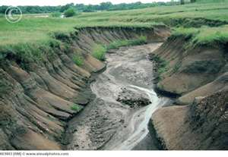_________________________ is the movement of weathered earth materials. This occurs through:

1. ____________________, 2. ____________________, 3. ____________________,   
   4. ____________________, 5. ____________________

How does this impact Latin America?

1. _________________________ is two plates moving away from one another. This means South America is moving away from ____________________ along the ______________________________ on the Atlantic Ocean’s floor.
2. _________________________ is one plate being forced beneath another plate. This means the

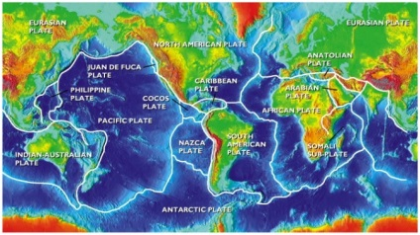____________________ Mountains formed from the Nazca Plate moving below South American Plate.

1. ________________________ is when one plate slides past another plate.