MCj04133900000[1]Latin America- **Introduction**

Name: _________________________________________ Date: ________________________ Period: __________

**Directions-** Using only your memory (*no books, maps, images, etc.*) draw a map of Latin America.   
(HINT- don’t forget the North American part)

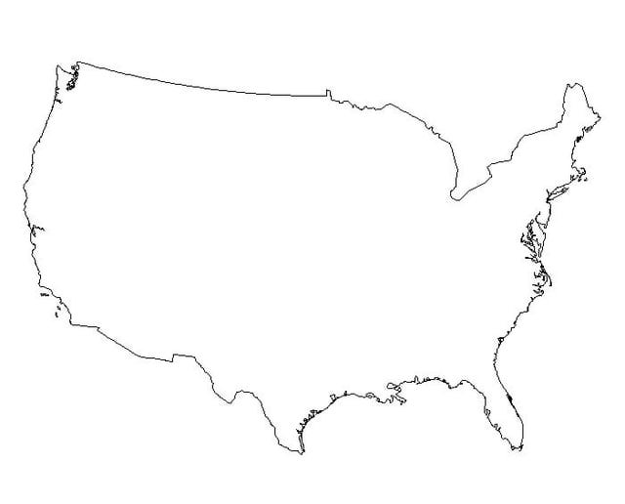

Latin America is found in which **hemispheres**?

* A *hemisphere* is _____________________________________________________________________.
* Based upon the _________________________ , Latin America is found in the ____________________ and ____________________ *hemispheres*.

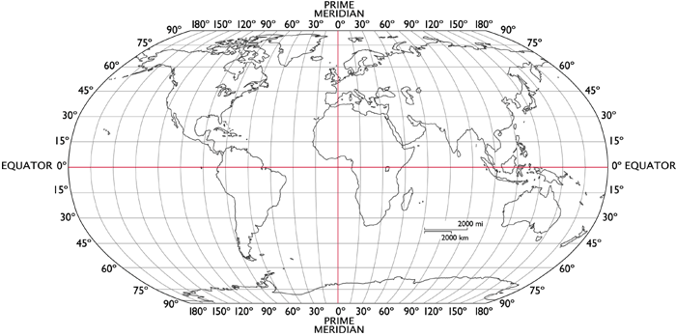

* Based upon the ___________________________________ , Latin America is found in the _______________ *hemisphere*.



The world **region** of Latin America is found directly south of the United States.

* A *region* is __________________________________________________________________________.

What 3 *regions* make up the larger *region* of Latin America?  
(label the map as we fill in the responses)

* The *regions* that make up Latin America are _____________________________________________ ,  
  ___________________________________ & ___________________________________.
* The shared characteristics of the *region* are political and cultural.
* Latin America spreads across part of the continent of ____________________________________ and  
  the entire continent of _________________________________.

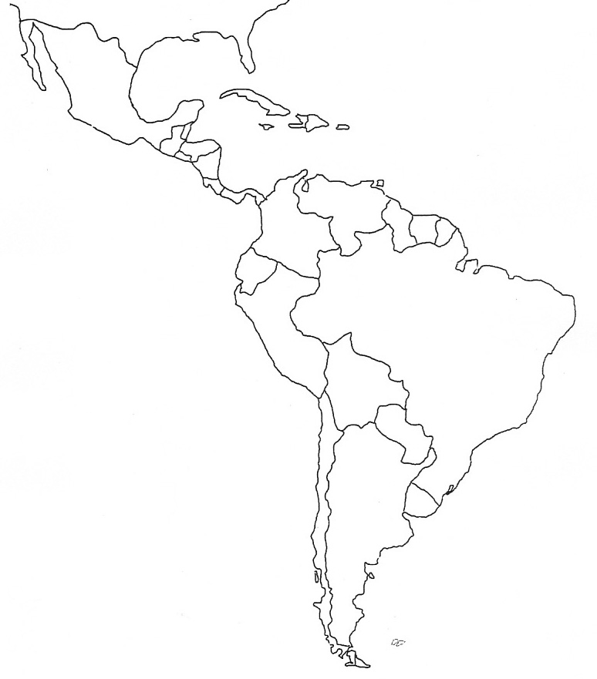

What **continents** can be found near Latin America?   
(label the map as we fill in the responses)

* A *continent* is _______________________________________________________________________.
* ______________________________ is part of and lies to the north of Latin America.
* ______________________________ is northeast across the Atlantic Ocean from Latin America.
* ______________________________ is east across the Atlantic Ocean from Latin America.

What **oceans** can be found along the **coasts** of Latin America?   
(label the map as we fill in the responses)

* An *ocean* is _________________________________________________________________________.
* A *coast* is ___________________________________________________________________________.
* The ______________________________ lies along the east *coast* of Latin America.
* The ______________________________ lies along the west *coast* of Latin America.
* The ______________________________ lies off the southern tip of Latin America.



Latin

America