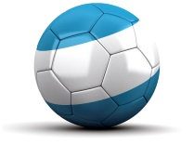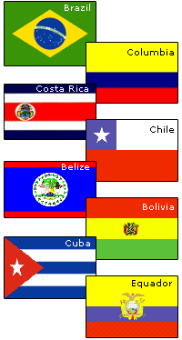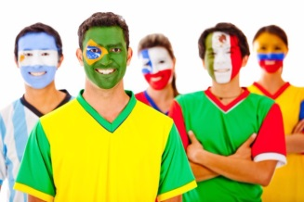Latin America- Location  
Countries & Political Maps

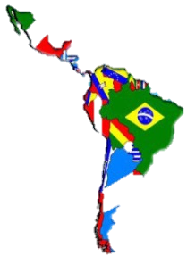NAME: ________________________________________ DATE: ___________________________ PERIOD: _______

**DIRECTIONS:** Use your mapping skills and textbook pages: 127, 97, and 3 to complete Mrs. Willen’s Story. Transfer the ***countries*** to the map on the last page. Shade the map to look like a political map.

**Mrs. Willen’s Adventure**  
Over summer vacations, Mrs. Willen writes for Fromer’s. They write detailed and informative travel books about places all over the world. Mrs. Willen spent last vacation writing about Latin America. Trace Mrs. Willen’s journey through Latin America.

the Caribbean

Mrs. Willen began her trip in the Caribbean. She left New York on a plane heading south to 18˚N, 66˚W. She landed in _________________________ the capital of _________________________, which is a territory of the United States. Mrs. Willen was looking forward to many adventures. As Mrs. Willen toured the western coast of the island, she came across a beautiful crystal clear harbor. Here, Mrs. Willen set sail west for the country of the _________________________. After enjoying a series of competitive baseball games, Mrs. Willen drove across the border to the west into ____________________. Here she was surprised to see a country still recovering from the magnitude 7.0 earthquake in 2010. At Port-au-Prince, Mrs. Willen took a cruise ship ____________________ to Kingston, the capital city of _________________________. Mrs. Willen enjoyed an evening celebration of reggae music at a beach front cook out. Her cruise then set sail north to the largest island in the Caribbean, ____________________. Mrs. Willen was most excited about visiting here because of their improving relationship with the U.S. She was amazed at how many classic cars drove the streets of Havana, the capital city.

Middle America (Mexico & Central America)

Mrs. Willen’s time in the Caribbean was at a wrap, so she boarded a plane and headed west to 19˚N, 99˚W. She landed in _________________________the capital of _________________________. Mrs. Willen rented a jeep and took a road trip southeast through the Mexican Plateau. She visited little villages in search of silver crafts made by local artisans. Along the way she saw amazing Aztec ruins. Mrs. Willen decided to visit Mexico’s Yucatan Peninsula so that she could also view the Mayan ruins. From the Yucatan Peninsula, Mrs. Willen traveled south along the Caribbean Coast to _________________________. Mrs. Willen, while fluent in Spanish, went back to speaking English because the British colonized this area of Central America. From here, Mrs. Willen traveled _________________________ to Guatemala City, which is the capital of _________________________. After a short stop in Guatemala city, Mrs. Willen continued _________________________ to San Salvador, the capital of _________________________.

Mrs. Willen heard about a special tour through four countries to view the exciting wonders of Central America’s rainforests. The trip began in Tegucigalpa, the capital of _________________________. It then ran south through the highlands of _________________________ and _________________________before ending at Panama City, the capital of _________________________. Mrs. Willen took many awesome pictures of the beautiful animals and plants during this part of her trip.

South America

Mrs. Willen departed Panama City by plane heading east to 5˚N, 52˚W. Mrs. Willen landed in _________________________ the largest city of _________________________, which is a French controlled territory. With winding dirt roads and dense rainforests, Mrs. Willen traveled by dirt bike through the Guyana Highlands west across the two countries of _________________________ and _________________________. Mrs. Willen busted out her GPS and used it to guide her northwest to 10˚N, 67˚W, which is _________________________ the capital of Venezuela. Mrs. Willen visited our exchange student friends here. After departing, Mrs. Willen traveled _________________________ to Bogota, the capital of _________________________.

Mrs. Willen left on a quad to travel through the cities of the Andes Mountains, which are the longest mountain range in the world. Mrs, Willen left Bogota heading southwest to Quito, _________________________. Her journey then moved south to Lima, Peru. Mrs. Willen visited a series of Native America villages and Incan ruins. The Andes journey continued _________________________ through La Paz and Sucre, the two capitals of _________________________ before ending in Santiago, _________________________. Mrs. Willen was amazed at the constant changes in climate and vegetation as she went up and down mountains and through the valleys of the Andes.

Mrs. Willen had a very long trek through South America up to this point. She needed to take a break and wind down before returning home. From Santiago, Mrs. Willen boarded a flight to 35˚S, 56˚W. She landed in _________________________ the capital of _________________________. Here, Mrs. Willen did some quick shopping and preparing for some fishing with her good friend Jeremy Wade. The two left by boat heading west to Buenos Aires, the capital of _________________________. Here the two followed the story of a river monster north up the Rio Parana until they reached Asuncion, _________________________. After catching an arapaima, one of the largest fish in South America, Mrs. Willen said good-bye to Jeremy.

Mrs. Willen hopped a flight to 23˚S, 43˚W. She landed along the Atlantic Coast in _________________________, which is the former capital of _________________________. Mrs. Willen enjoyed her last few days in Latin America relaxing along the white sand beaches, and basking in the sun. Soon, Mrs. Willen would need to return home, and begin another fun filled year of teaching.

Latin America- Political Map

