MASTER PROJECT STEPBOOK

Weekly Outbound Demand
Analysis & Forecasting
Meridian Commerce | Fictional fulfilment operation | BLR-FC-01
LOCKED PROJECT DECISION
One business question only: What is the likely weekly outbound unit demand over the next 12 weeks? We will analyse the existing 78-week demand series and validate a small number of forecasting benchmarks. We are not building a workforce, capacity, backlog or procurement model.

1. Project definition
The project demonstrates practical demand analysis and short-term forecasting for a fictional e-commerce fulfilment operation. The output is a variable 12-week demand projection, supported by descriptive statistics and a holdout comparison of three simple forecast methods.
Item | Locked definition
Project title | Weekly Outbound Demand Analysis & Forecasting
Business entity | Meridian Commerce (fictional)
Facility label | BLR-FC-01 (fictional)
Demand measure | Outbound units requested per week
Forecast horizon | 12 weeks: 19-Oct-2026 to 04-Jan-2027
Primary user | Fulfilment planning / operations planning team
Final deliverable | One clean Excel workbook with source data, forecast validation and dashboard

2. Scope boundaries
Included | Explicitly excluded
78-week demand profile and variability | Headcount planning and labour cost
Naïve, 4-week moving average and 52-week seasonal naïve benchmarks | Capacity, utilisation and overtime calculations
Last-12-week holdout MAE and RMSE comparison | Backlog and service-level / on-time dispatch analysis
12-week forecast and monthly forecast mix | Supplier, procurement, transport and inventory optimisation
Formula-linked KPI dashboard | External live-data integration

Why we narrowed the scope: the uploaded workbook contains inconsistencies across processed units, on-time units and corrected backlog calculations. Those fields are not needed to answer the demand question and will not be used in this version. The original workbook remains an archive; the clean workbook is the working version.

3. Data specification and quality decision
The clean project reuses the demand observations already present in the uploaded workbook: Operational_History columns A:B, rows 2:79. No replacement demand values have been invented for this new version.
Data attribute | Value / definition
Data status | Synthetic / simulated case data; not actual company records
Records | 78 weekly observations
Date range | 21-Apr-2025 through 12-Oct-2026
Frequency | One record per Monday-start reporting week
Field 1 | Week_Start — reporting week start date
Field 2 | Actual_Demand_Units — units requested during the week
Source in old workbook | Operational_History!A1:B79
Clean workbook location | Demand_History!A1:B79

4. Historical demand profile
Measure | Calculated result
Average weekly demand | 740,979 units
Median weekly demand | 731,093 units
Standard deviation | 63,518 units
Coefficient of variation | 8.57%
Minimum | 601,479 units — week starting 15-Jun-2026
Maximum | 890,678 units — week starting 24-Aug-2026

Interpretation: weekly demand varies meaningfully. The coefficient of variation is approximately 8.6%, so the series is not flat. The mean of the last 39 weeks is modestly higher than the first 39 weeks; however, this project does not add a separate trend model.

5. Data rules
- Do not describe the dataset as real company data. Use the phrase “realistic synthetic data for a fictional fulfilment operation.”
- Do not use the prior workbook’s Corrected_Processed_Units, Ending_Backlog_Units2, Check_A, Check_B, Check_C, or on-time measures in this demand-only project.
- Do not add product categories, promotions, staffing or capacity fields: they are not present in the source demand history and would require invented drivers.
- If additional weeks are added later, update the forecast formulas and validation window deliberately; do not simply paste rows below the table and assume the model will extend itself.

6. Forecast method and validation
We compare three basic methods on the final 12 historical weeks (27-Jul-2026 to 12-Oct-2026). Each forecast is generated using only data available before the actual week being tested. This is a rolling one-week-ahead holdout comparison.
Method | Rule | Holdout MAE | Holdout RMSE
Naïve | Next week = previous week actual | 67,375 | 78,235
4-week moving average | Next week = average of previous 4 actual weeks | 73,424 | 90,070
Seasonal naïve (52-week) | Next week = actual demand 52 weeks earlier | 59,688 | 73,524

Selected method: Seasonal naïve (52-week). It has the lowest MAE and RMSE on this holdout. This is a selection based on this 12-week validation window, not a claim that it will always outperform other methods.

7. Forecast formula
Forecast origin: 12-Oct-2026 (the latest observed week). The 12-week outlook therefore begins on 19-Oct-2026. This is a dated case-study forecast, not a live forecast issued today. For each future week, use the demand value from 52 weeks earlier:
Concept: Forecast(t) = Actual_Demand(t - 52 weeks)
First future week: Forecast_Analysis!B21 = Demand_History!B28
Last forecast week: Forecast_Analysis!B32 = Demand_History!B39
The 12 projected weekly values are:
Week starting | Forecast units
19-Oct-2026 | 799,240
26-Oct-2026 | 725,324
02-Nov-2026 | 777,159
09-Nov-2026 | 781,888
16-Nov-2026 | 772,586
23-Nov-2026 | 757,794
30-Nov-2026 | 805,731
07-Dec-2026 | 687,412
14-Dec-2026 | 674,522
21-Dec-2026 | 720,107
28-Dec-2026 | 683,279
04-Jan-2027 | 694,264

Forecast summary | Result
12-week total | 8,879,306 units
Average per week | 739,942 units
Peak week | 805,731 units — 30-Nov-2026
Lowest week | 674,522 units — 14-Dec-2026

8. Canonical workbook structure
Sheet | Role | Locked content
Start_Here | Project brief | Purpose, data disclosure, scope, workbook map
Demand_History | Only historical input | A1:B79 — 78 dates and demand values
Forecast_Analysis | Forecast model | Holdout comparison, metrics, 12-week projection, chart helper data
Dashboard | Presentation layer | Four KPIs, three charts, validation comparison and note

9. Forecast_Analysis — fixed cell map
Range | Purpose
A3:K16 | Last-12-week holdout: actual, naïve, MA4, seasonal forecast, absolute and squared errors
M3:O10 | Model accuracy: MAE and RMSE for all three methods; selected-model label
A19:C32 | Selected 12-week forecast: date, forecast units, forecast month
E19:G24 | Monthly forecast totals and percentage shares
A35:C74 | Chart helper table: last 26 actual weeks and next 12 forecast weeks

10. Exact formulas
Enter the first-row formulas below, then fill down only through the stated ranges. The clean workbook already contains these formulas; these references are provided for controlled maintenance.
Holdout first actual date: A5 = Demand_History!A68
Holdout first actual units: B5 = Demand_History!B68
Naïve forecast: C5 = Demand_History!B67
4-week moving average: D5 = AVERAGE(Demand_History!B64:B67)
52-week seasonal naïve: E5 = Demand_History!B16
Absolute errors: F5 = ABS(B5-C5) | G5 = ABS(B5-D5) | H5 = ABS(B5-E5)
Squared errors: I5 = (B5-C5)^2 | J5 = (B5-D5)^2 | K5 = (B5-E5)^2
Accuracy metrics: N5 = AVERAGE(F5:F16) | O5 = SQRT(AVERAGE(I5:I16))
First future date: A21 = MAX(Demand_History!$A$2:$A$79)+7
Next dates: A22 = A21+7 (fill through A32)
First future demand: B21 = Demand_History!B28 (fill through B32; source ends at B39)
Month label: C21 = TEXT(A21,"mmm-yyyy") (fill through C32)
Monthly total: F21 = SUMIF($C$21:$C$32,E21,$B$21:$B$32)
Monthly share: G21 = F21/SUM($F$21:$F$24)

11. Dashboard design specification
The dashboard should look like a compact operations-planning report: dark navy title bar, four coloured KPI cards, a demand trend chart, a weekly forecast chart, a monthly forecast doughnut and a small model-accuracy table. Do not add capacity-utilisation or workforce charts to this version.
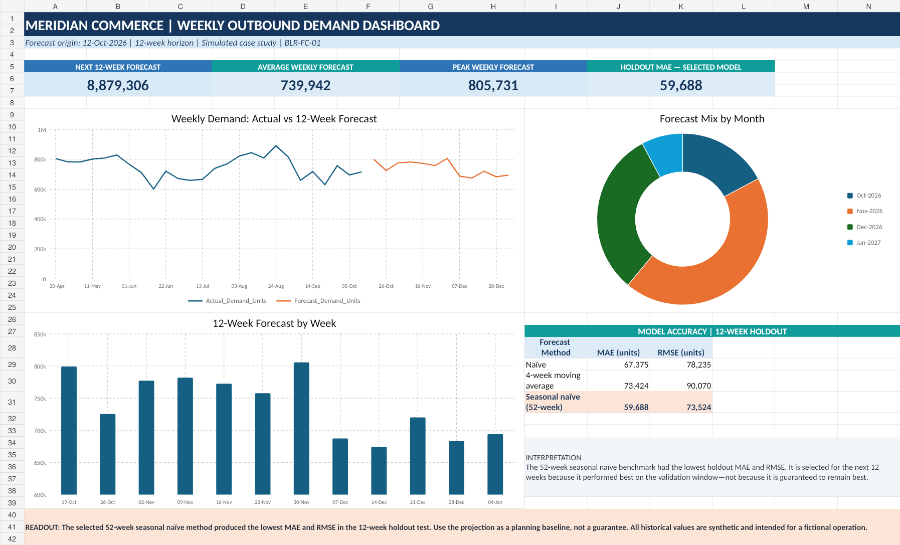
Reference render of the clean dashboard workbook.
Dashboard area | Formula / source
A1:N2 title | MERIDIAN COMMERCE | WEEKLY OUTBOUND DEMAND DASHBOARD
A6:C7 — next 12-week total | =SUM(Forecast_Analysis!$B$21:$B$32)
D6:F7 — average forecast/week | =AVERAGE(Forecast_Analysis!$B$21:$B$32)
G6:I7 — peak weekly forecast | =MAX(Forecast_Analysis!$B$21:$B$32)
J6:L7 — selected-model MAE | =Forecast_Analysis!$N$7
A9:H25 — line chart | Forecast_Analysis!A36:C74; last 26 actual weeks + next 12 forecast weeks
A26:H39 — column chart | Forecast_Analysis!A20:B32; 12 forecast weeks
I9:N25 — doughnut | Forecast_Analysis!E20:F24; forecast share by calendar month
I27:K31 — accuracy table | Forecast_Analysis!M5:O7

12. Dashboard interpretation
- The actual line varies week to week; the forecast line also varies because each future week references the corresponding week 52 weeks earlier.
- The weekly column chart makes the 12 forecast values visible and comparable.
- The doughnut chart shows how the 12-week forecast volume is distributed across Oct-2026, Nov-2026, Dec-2026 and Jan-2027; it is not a product-category mix chart. The dashboard recalculates from workbook inputs but does not fetch live external data.
- The KPI labelled Holdout MAE is an error measure: lower is better. It is not a demand quantity.

13. Build and maintenance sequence
Step | Action | Completion check
1 | Open the clean workbook and review Start_Here. | Project scope and simulated-data disclosure are understood.
2 | Review Demand_History. | 78 consecutive weekly dates; no blank or duplicate rows; demand is numeric.
3 | Review Forecast_Analysis holdout table. | 12 test weeks; all three forecast methods and errors calculate.
4 | Review MAE and RMSE. | Seasonal naïve is selected on this holdout; values match the benchmark table.
5 | Review the next 12-week forecast. | Dates run 19-Oct-2026 to 04-Jan-2027; forecast values vary.
6 | Review Dashboard. | Four KPI cards and three charts display; no overlapping objects or formula errors.
7 | Prepare the portfolio summary. | Explain the business question, dataset disclosure, validation, forecast and limitations.

14. Quality-control rules
- Never change sheet names or the fixed cell map without updating this stepbook first.
- Do not insert new columns into Forecast_Analysis without checking every formula and chart source.
- Do not describe synthetic observations as actual company performance or claim real cost savings.
- Do not describe the seasonal naïve method as universally best; say it had the lowest error on this 12-week holdout.
- No additional forecast methods, capacity model, staffing model, scenarios or extra charts unless the project owner explicitly approves a scope change.
- Before any future edit, inspect the actual workbook tabs and ranges; never assume the user is working in the latest version.

15. Continuity protocol for future ChatGPT sessions
When this stepbook is uploaded in a later session, treat it as the controlling project specification. Follow these rules:
- Read this stepbook before recommending a formula, sheet, column, chart or new analysis.
- Use the clean workbook Meridian_Weekly_Demand_Forecast.xlsx as the working file unless the user explicitly supplies a newer approved version.
- Work on one numbered step at a time. Give exact sheet names, cell addresses, formulas and fill ranges. Do not reuse a cell already assigned to another purpose.
- Do not invent data, business drivers or metrics. Clearly label all source observations as synthetic case data.
- After each edit, verify the affected cells and formulas before moving to the next step.
- If a requested change conflicts with this specification, explain the conflict and ask before changing the locked scope.

16. Final acceptance checklist
Final check | Final check
Demand analysis and forecasting only. | 78 historical demand observations preserved.
Synthetic / simulated data disclosure is visible. | Holdout uses the final 12 historical weeks.
Seasonal naïve has the best MAE and RMSE on this holdout. | Forecast contains 12 non-identical weekly values.
Dashboard labels, dates, legends and KPI units are readable. | No formula errors (#REF!, #DIV/0!, #VALUE!, #NAME? or #N/A).

