Нефёдов Д.А Тивончик Р.А

1

<!DOCTYPE html>

<html>

<head>

<title>Nev and Tuv</title>

</head>

<body>

<script type="text/javascript">

let a = prompt(" вв ");

if (a>0) { alert( "1, если значение больше нуля," );}

else if (a<0) { alert( "-1, если значение меньше нуля" );}

else { alert ("0, если значение равно нулю");};

</script>

</body>

</html>

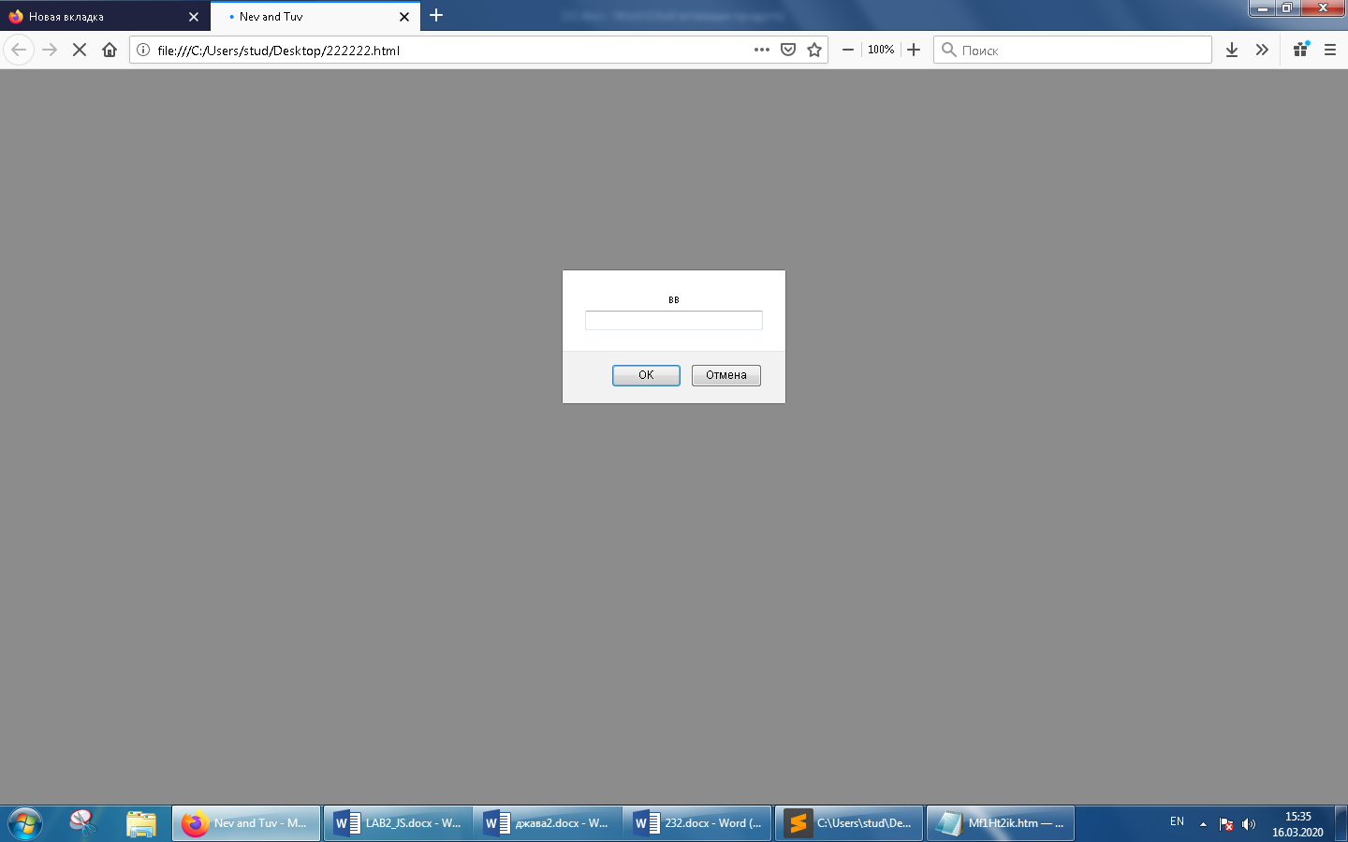





2

<!DOCTYPE html>

<html>

<head>

<title>Nev and Tuv</title>

</head>

<body>

<script type="text/javascript">

let a = 6

let b = 3

let result = (a + b > 5 ) ? "Мало " : "Много" ;

console.log(result)

</script>

</body>

</html>

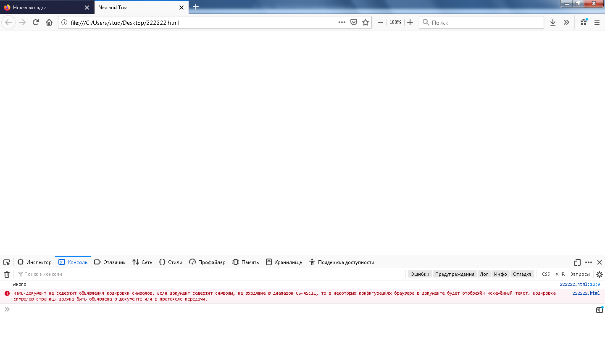

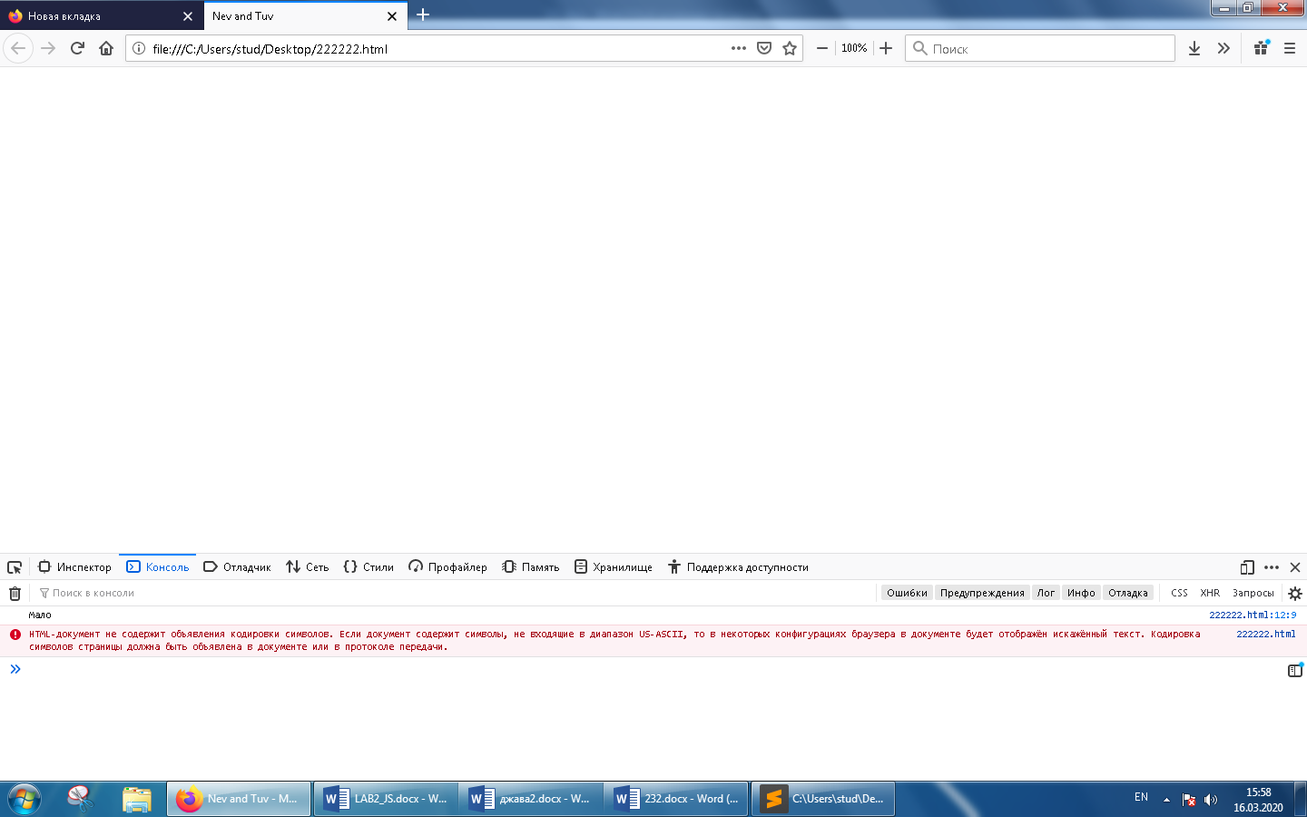

3

<!DOCTYPE html>

<html>

<head>

<title>Nev and Tuv</title>

</head>

<body>

<script type="text/javascript">

let a = prompt(" ");

if (a<14) { alert( "True" );}

else if (a>90) { alert( "False" );}

else { alert ("False");};

</script>

</body>

</html>

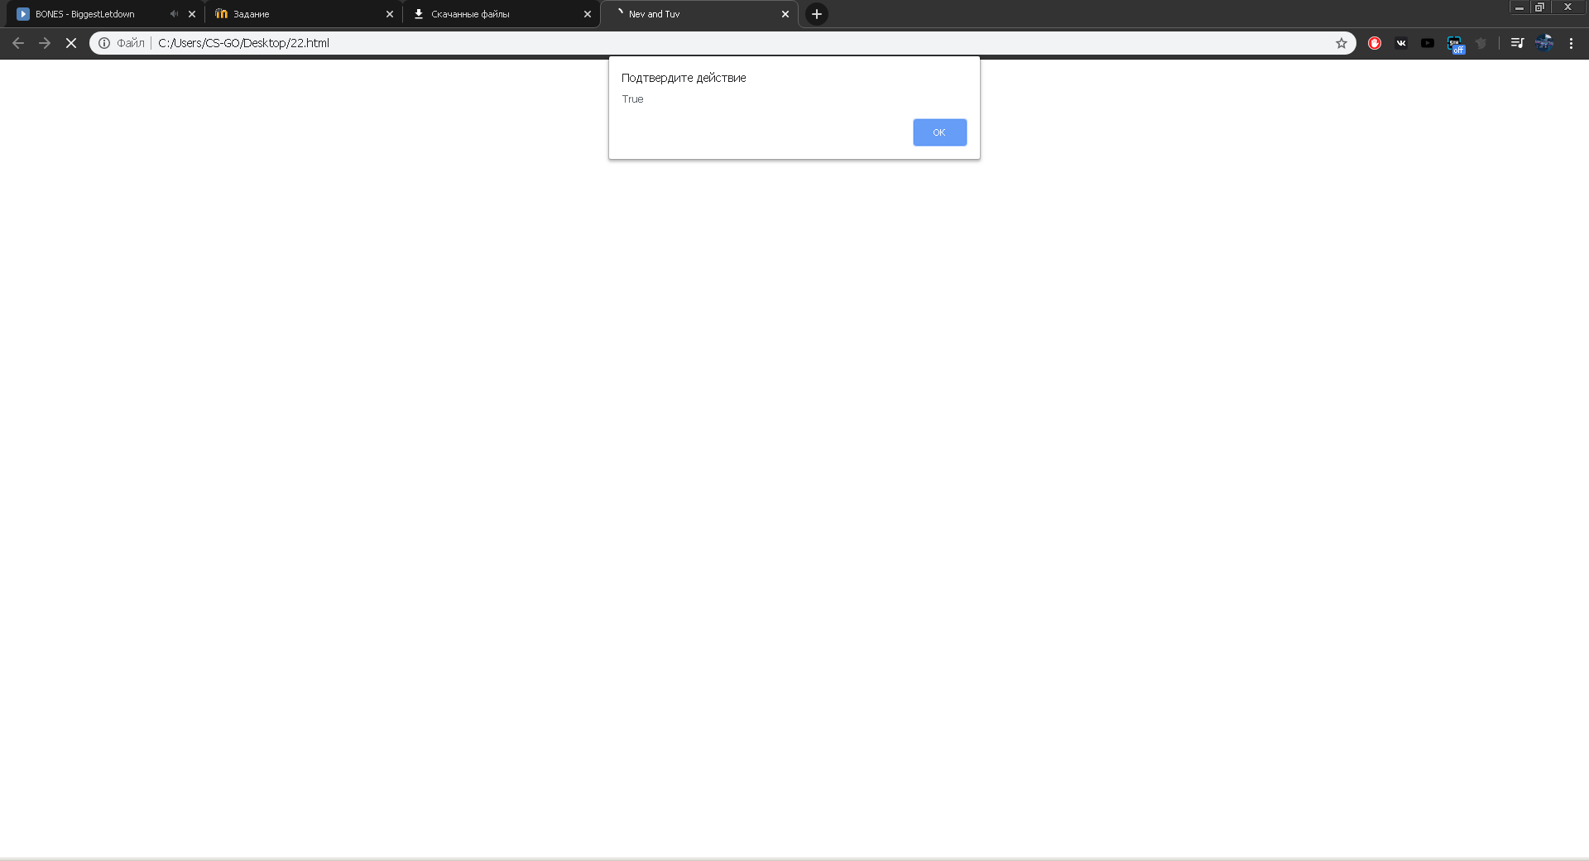

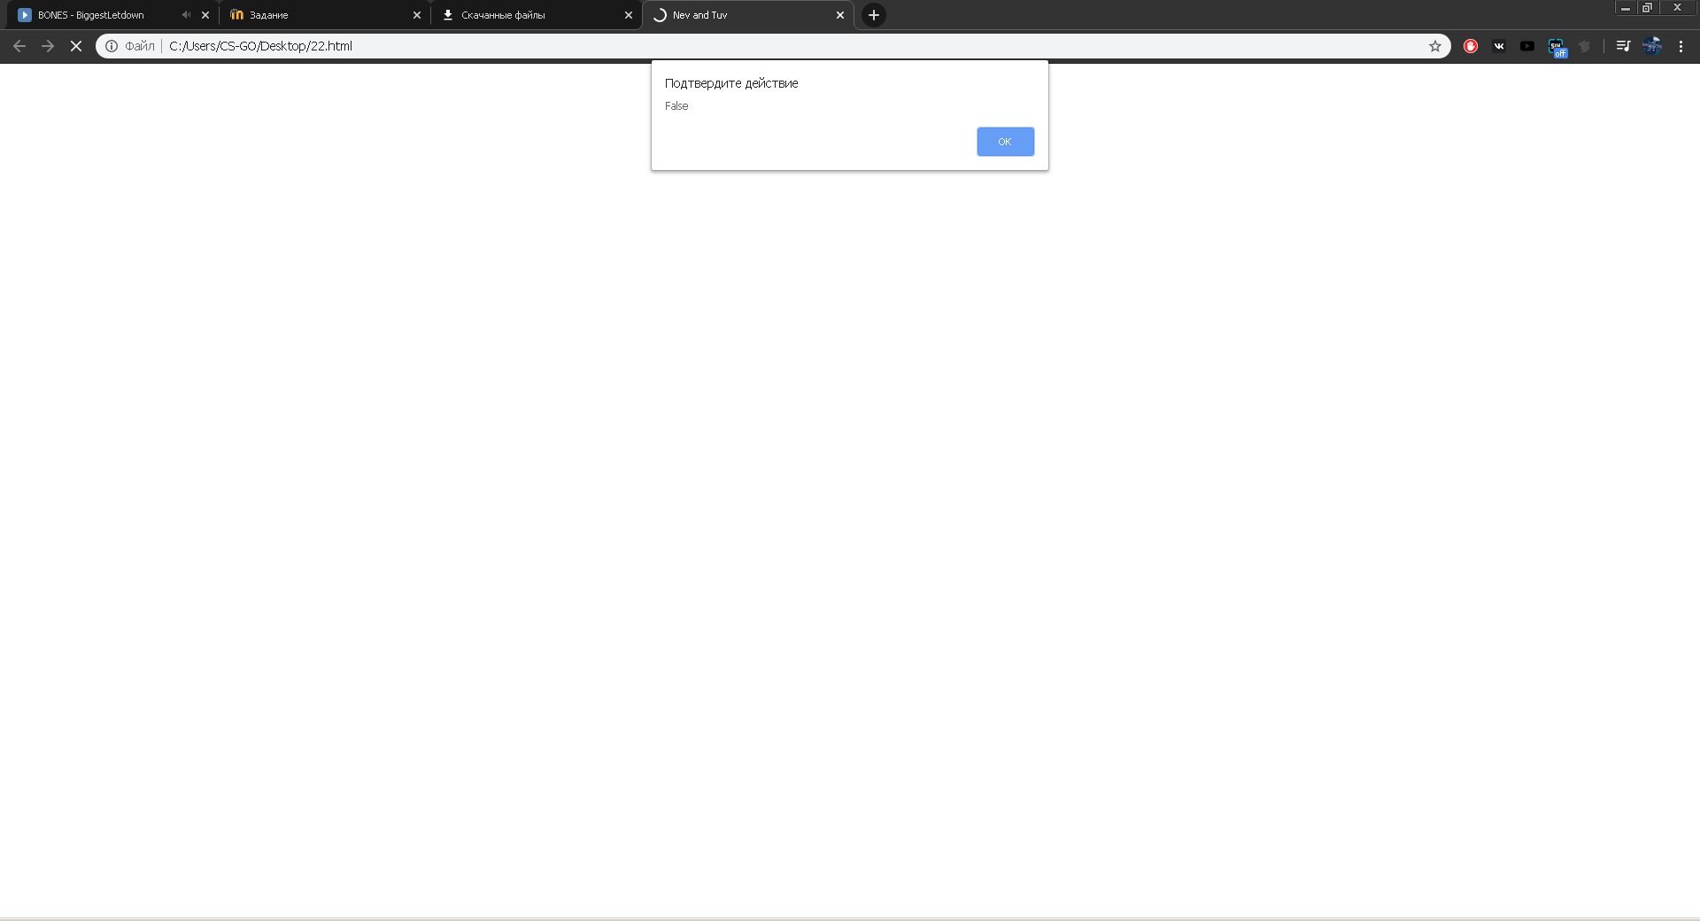

4

<!DOCTYPE html>

<html>

<head>

<title>Nev and Tuv</title>

</head>

<body>

<script type="text/javascript">

alert (5>4);

alert ("ананас">"яблоко");

alert ("2">"12");

alert (undefined == null);

alert (null == "\n0\n");

alert (null === +"\n0\n");

</script>

</body>

</html>

Тут меняется на false true

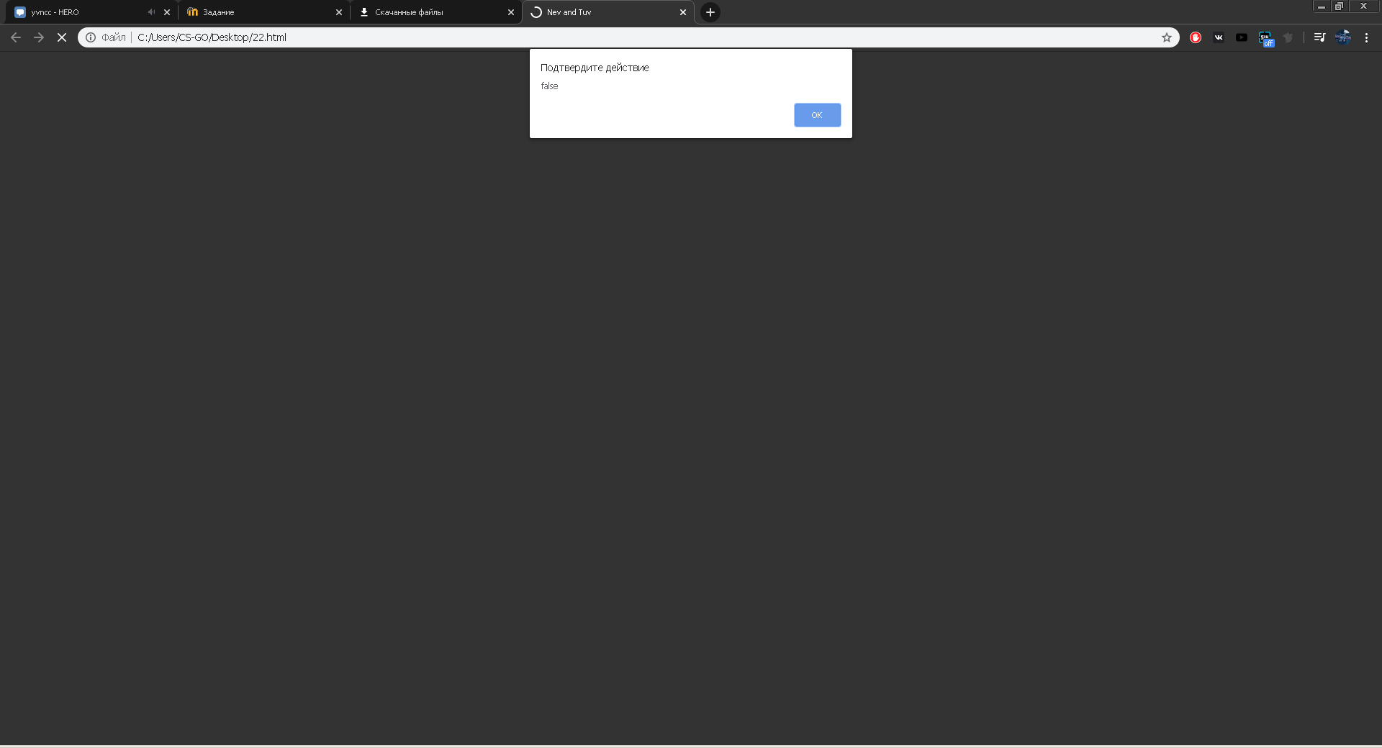

5

<!DOCTYPE html>

<html>

<head>

</head>

<body>

<script type="text/javascript">

let array = [];

array[0] = { operandLeft: 2 , operandRight: 9}

array[1] = { operandLeft: 4 , operandRight: 7}

array[2] = { operandLeft: 1 , operandRight: 1}

array[3] = { operandLeft: 54 , operandRight: 14}

array[4] = { operandLeft: 12 , operandRight: 731}

array[5] = { operandLeft: 147 , operandRight: 841}

array[6] = { operandLeft: 97 , operandRight: 67}

array[7] = { operandLeft: 4 , operandRight: 841}

array[8] = { operandLeft: 23 , operandRight: 89}

array[9] = { operandLeft: 17 , operandRight: 57}

console.log(array);

let array2 = array.map(function(value,index){

return value.operandLeft > value.operandRight

})

console.log(array2);

</script>

</body>

</html>

