**DEPARTMENT OF COMPUTER SCIENCE AND ENGINEERING**

**COMPUTER VISION (CO411)**

PRS ASSIGNMENT



|  |  |
| --- | --- |
| **SUBMITTED BY:** | **SUBMITTED TO:** |
| Name: Tanvi Kayat | Prof. Chingmuankim |

Roll Number: 2K20/CO/458

### **Vehicle Counting and Classification**

## **INTRODUCTION**

An image is a visual representation of something. In information technology, the term has several usages. An image is a picture that has been created or copied and stored in electronic form. An image can be described in terms of vector graphics or raster graphics. Digital image processing deals with manipulation of digital images through a digital computer.

It is a subfield of signals and systems but focus particularly on images. DIP focuses on developing a computer system that is able to perform processing on an image. The input of that system is a digital image and the system process that image using efficient algorithms, and gives an image as an output. It allows much wider range of algorithms to be applied to the input image and can avoid problems such as build-up of noise and signal distortion during processing.

**An image can be classified into the following three types.**

* A binary image is one that consists of pixels that can have one of exactly two colours, usually black and white.
* Binary images are also called bi-level or two-level. This means that each pixel is stored as a single bit—i.e., a 0 or 1. Grey is an intermediate colour between black and white. It is a neutral colour or achromatic colour, meaning literally that it is a colour "without colour" because it can be composed of black and white. It is the colour of a cloud-covered sky, of ash and of lead.
* A (digital) colour image is a digital image that includes colour information for each [pixel.](https://en.wikipedia.org/wiki/Pixel) For visually acceptable results, it is necessary (and almost sufficient) to provide three [samples](https://en.wikipedia.org/wiki/Sample_(signal)) (colour channels) for each pixels, which are interpreted as coordinates in some [colour space.](https://en.wikipedia.org/wiki/Color_space)
* The process is environmentally friendly since it does not require chemical processing. Digital imaging is also frequently used to help document and record historical, scientific and personal life events.
* **PROPOSED METHOD**

The steps that are involved in the process of vehicle detection and counting are given as follows.

**1. Input Video**

In this type of processing typically needs input data provided by the computer vision system and acting as a vision sensor and providing a high-level information. Then the video frames which are captured by the surveillance cameras are given as an input video for vehicle detection and counting.

### **2. Background Registration**

The Background registration technique is used to construct a reliable background image from the accumulated frame difference information. The moving object region is separated from that background region by comparing the current frame with the background image. In background registration, the history of the frame difference mask is considered in constructing and updating the background buffer. If a pixel is marked as changing in the frame difference mask, the corresponding value in the stationary map is cleared to zero. Otherwise, if the pixel is stationary the corresponding value is incremented by one. The value in the stationary map is indicate that the corresponding pixel has been not changing for how many consecutive frames. If the pixel is stationary for the past several frames, then the probability is high that it belongs to the background region.

### **3. Image Subtraction**

Image subtraction or pixel subtraction are process where the digital numeric value one pixel or whole image are subtracted from another image.

This is primarily done for one of two reasons levelling uneven sections of an image such as half an image having a shadow on it, or detecting changes between two images. This detection of changes can be used to tell if something in the image move.

In which the target is moving and would be in one place in one image, and another from an image one hour later and where using this technique would make the fixed stars in the background disappear leaving only the target.

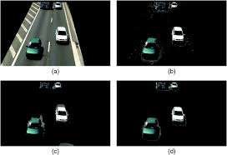

**Fig 1**: Subtraction of image

### **4. Foreground Detection**

Foreground detection is one of the major tasks in the field of computer vision and image processing whose aim is to detect changes in image sequences. Background subtraction is any technique which allows an image's foreground to be extracted for further processing (object recognition etc.).

Foreground detection separates foreground from background based on these changes taking place in the fore ground. It is a set of techniques that typically analyse video sequences recorded in real time with a stationary camera.

**Fig 2**

:

Flowchart

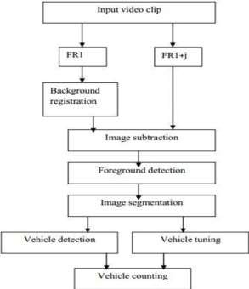

### **5 Image Segmentation**

Image segmentation techniques are interested in segmenting out different parts of the image as per the region of interest. As videos are sequences of images, motion segmentation aims at decomposing a video in moving objects and background by segmenting the objects that undergo different motion patterns. The analysis of these spatial and temporal changes occurring in the image sequence by separating visual features from the scenes into different groups lets us extract visual information. Each group corresponds to the motion of an object in the dynamic sequence.

### **6. Vehicle Detection**

Vehicle detection is a technique used in computer vision and image processing. Multiple consecutive frames from a video are compared by various methods to determine if any moving object is detected. Moving objects detection has been used for wide range of applications like video surveillance, activity recognition, road condition monitoring, airport safety, monitoring of protection along marine border.

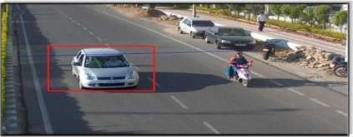

**Fig 3:** Detection of vehicles

### 7. **Vehicle Counting**

In counting step, a counter is used to store the sum value of them. A counter should count the vehicles which are passing in the specific direction. So, if any vehicle stops, move turn in any direction in detection zone which are not counted. In this technique, counting is according to the number of moving vehicles detected in the detection zone.

## **RESULTS**

A program was coded to detecting and counting vehicles using the Python programming language. The following screenshots of the results obtained when detecting vehicles using three different videos to check the efficiency and the working of the program.

### **Detection of Bus**

To check the number of buses entering in our college, we recorded a video of our college bus entering into our college. When running the video obtained by us with the python program, the output that was obtained is given in the following figure.

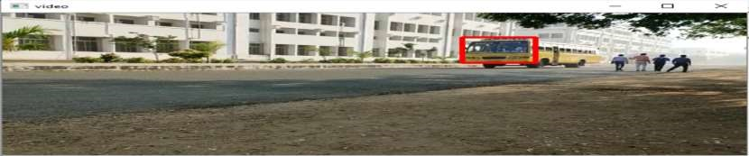

**Fig 4**: Detection of bus from a real-time video

### **Detection of Car**

Similarly, we made a few changes in our program and the program was run with a video that we obtained from the internet. These changes were made in order to check if vehicles like cars is being detected or not.

The following figure was obtained as the output.

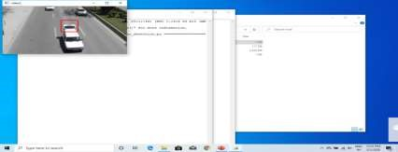

**Fig 5:** Detection of car from a real-time video

From the above figure, it is clearly seen that the car in the video was detected.

### **Detection of Multiple Vehicles**

In order get the count of the vehicles, another video was run with the program. When running the program with another video, the following output was obtained.

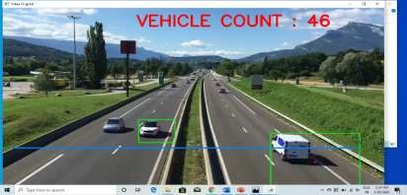

**Fig 6:** Counting of vehicles

When any vehicle crosses the blue colour line which was drawn using the program, the count of the vehicles will be increased which is displayed on top of the screen as shown.

### **Count of Vehicles**

From the following figure, we can obtain the count of the vehicles detected in words.

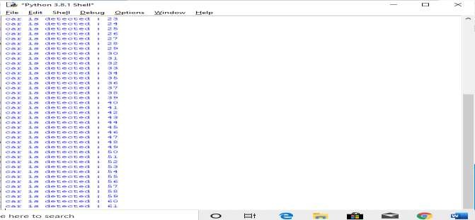

**Fig 7:** Count of the vehicles detected

## **CONCLUSION**

This single project produces multi domain outputs. It can count and classify vehicles on highways by the methods mentioned above and help with highway management and toll collection, it can calculate traffic density on busy traffic roads for better monitoring. Some more work is needed in reducing the occlusions present in the image.