TKlamp TK2303D User Manual

© 2024 TKlamp

2024-09-25

Table of Contents

# TKlamp Lighting Tester Docs

TKlamp Flashlight Tester is a specialized lighting meter designed to measure lumen, candela and lux values of flashlights.

The TK2303D model offers data logging capabilities, allowing users to transfer measurement data to a PC for further analysis. This repository contains a quickstart guide to exporting data from TK2303D, a detailed user manual and serial data specifications.

If you are instead looking for:

TKlamp Lighting Testers, visit [website](https://tklamp.co).

Purchasing TKlamp Tester, visit [online store](https://www.tklamp.co/order-online).

## Documentations

1. [Data Logging Tutorial](https://github.com/TKlamp/Data-Logging-Tutorial) - Quickstart guide to exporting data to PC
2. [User Manual](https://github.com/TKlamp/TKlamp-Docs/blob/main/docs/manual.md)
3. [Serial Data Specifications](https://github.com/TKlamp/TKlamp-Docs/blob/main/docs/serial_data_reference.md) - How to interprent raw serial data from UBS serial port

## Contributing

To make contributions, join [Discord](https://discord.gg/xVy4j9JcYx).

To suggest any changes in the repos, use pull request or Discord.

# TK2303D Specifications

## Table of Content

* Measurements & Range
* Resolution
* Live Plotting
* Sensor sampling time interval
* Lux and Candela Measurement
* Wavelength
* Data Logging and Transfer
* Timer
* Power Supply
* Dimensions

## Measurements & Range

* Luminous flux. Range: 0-25,000 lm
* Luminous intensity. Range: 0-6,500,000 cd
* Illuminance. Range: 0-250,000 lux

## Resolution

* Live reading and plotting: 1lm/1cd/1lux
* Data logging: 1lm. cd and lux x1/x10/x100

Select cd/lux multiplier in settings based on estimated value:

* cd/lux < 65,535: select x1. (Max value: 65,535. Resolution 1 cd/lux)
* 65,535 <= cd/lux < 655,350: select x10 resolution (Max value: 655,350. Resolution 10 cd/lux )
* cd/lux >= 655,350: select x100 resolution (Max value: 6,553,500. Resolution 100 cd/lux)

This is because log data is stored and transferred in 2 bytes, which can only represent up to 65,535 in value.

## Live Plotting

* Lumen/Candela/Lux each has 600 sampling data points
* Sampling time: adjustable between 0.2s - 60.0s
* Maximum logging time: 600 mins (10 hrs)

## Sensor sampling time interval

* Sensor sampling time interval: 150ms
* Sampling rate: ~6.6 times per second.

## Lux and Candela Measurement

* Distance to surface range: 1-10m
* External sensor cable length: 2m
* External sensor extension cable length: 10m (Not included. Can be purchased separately)

## Wavelength

* Range: 450-650nm (Not for UV/IR light)

## Data Logging and Transfer

* Data length: 3620 bytes
* Data transfer time: approx. 5s
* Cmmunication interface: RS485 USB

## Timer

* Up timer: up to 24 hours
* Down timer: 1-999 minutes

## Power Supply

* Power consumption: < 4w
* AC power/DC power
* AC power range: 90~240V
* DC power range: 5~24V

## Dimensions

* Sphere openning sizes: 0.7”, 1.5”, 2.9”
* Sphere diameter: 6.29”

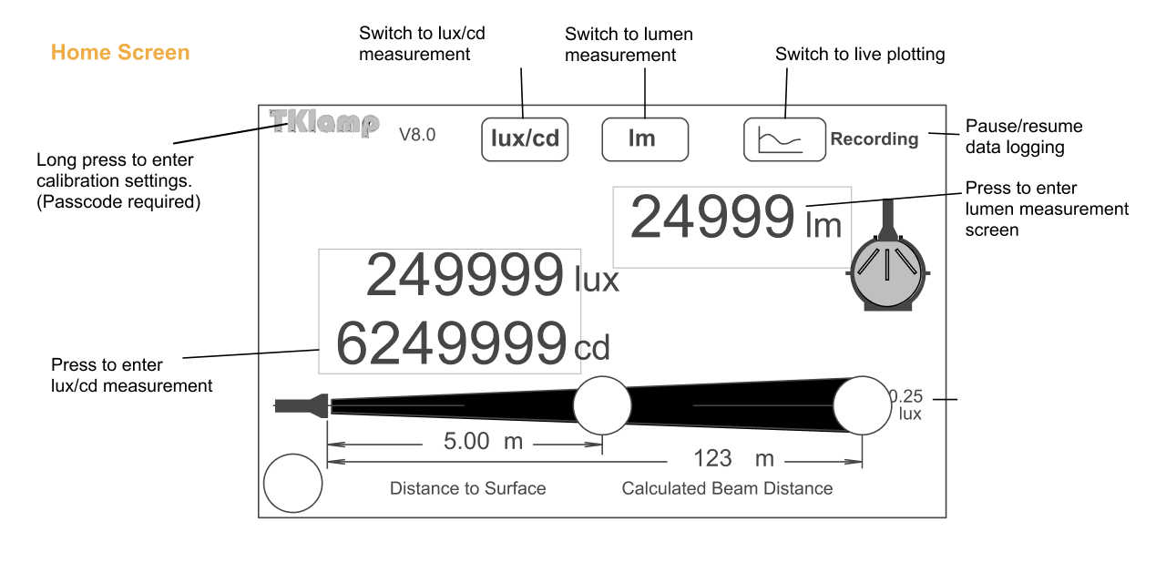  
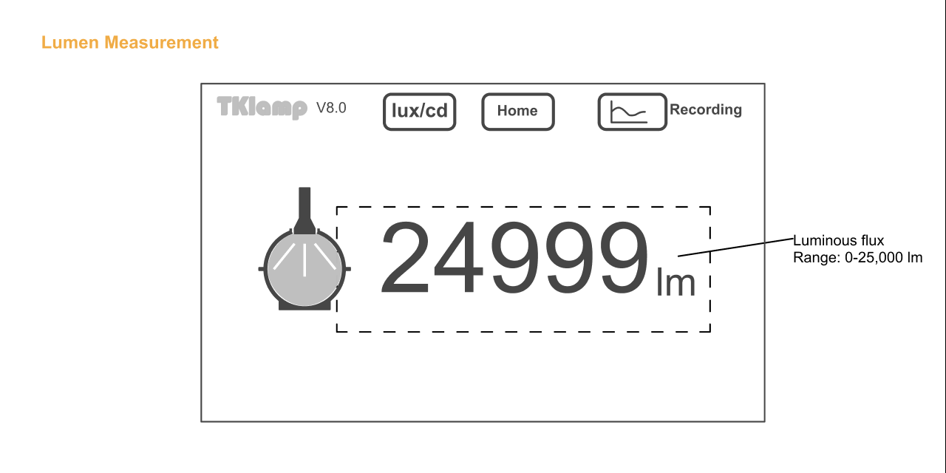  
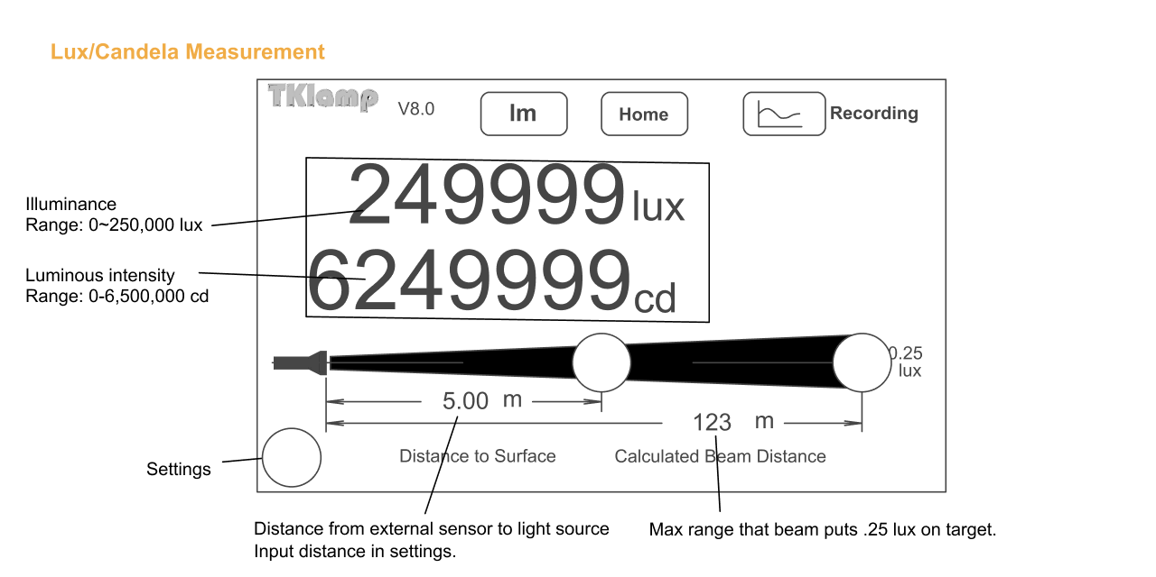  
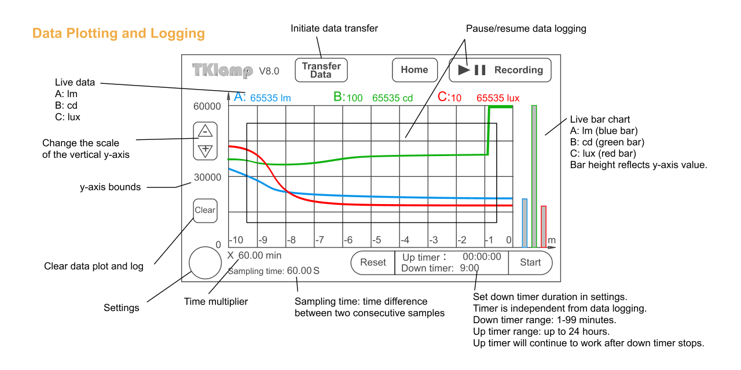  
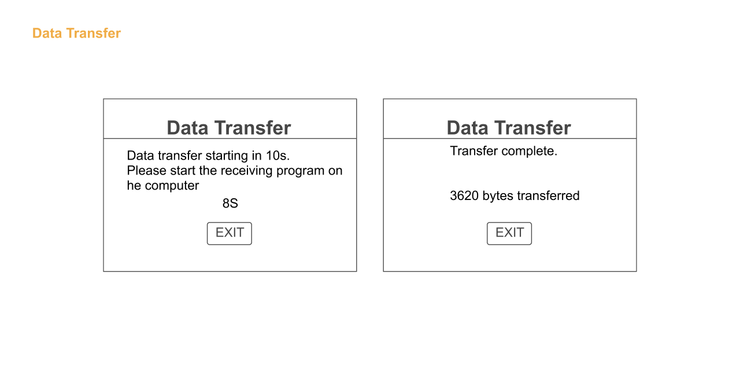  
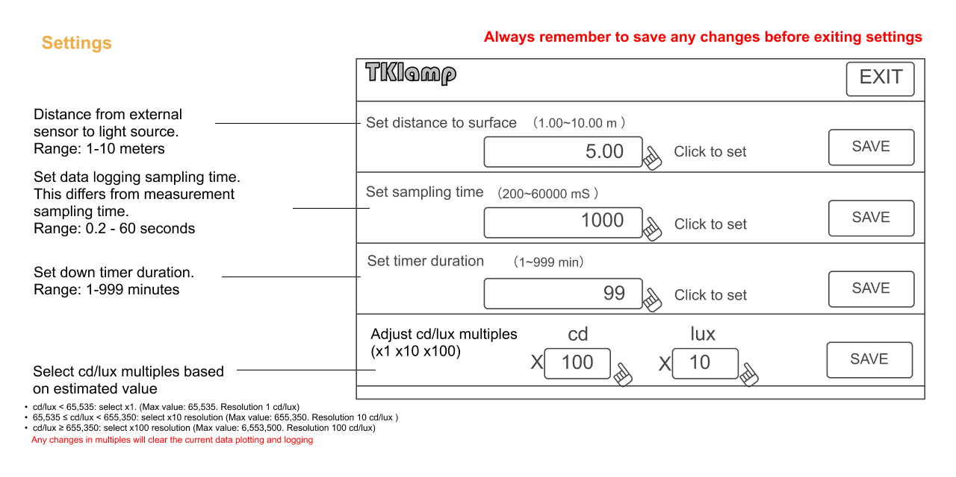

# Serial Data Reference

This reference is created for decoding raw serial data read directly from USB serial port or 3rd party application such as CoolTerm.

To see a sample serial data output, click [here](https://github.com/TKlamp/TKlamp-Protocol/blob/main/docs/raw_serial_data_example.txt). The same data is used in the examples below.

Total length: **3620 bytes**

* Header: 1-16 bytes
* Body: 17-3616 bytes
* Ending: 3616-3620 bytes

## Table of Content

* Header
* Body
* Ending

## Header

<table>  
 <tr>  
 <th>Byte position</th>  
 <td>1-2</td>  
 <td>3-4</td>  
 <td>5-6</td>  
 <td>7-8</td>  
 <td>9-10</td>  
 <td>11-12</td>  
 <td>13-14</td>  
 <td>15-16</td>  
 </tr>  
 <tr>  
 <th>Example data</th>  
 <td>aa aa</td>  
 <td>0e 10</td>  
 <td>01 f4</td>  
 <td>00 64</td>  
 <td>00 01</td>  
 <td>00 01</td>  
 <td>00 01</td>  
 <td>56 44</td>  
 </tr>  
 <tr>  
 <th>Explanation</th>  
 <td>Start indicator</td>  
 <td>Data body length (3600 bytes fixed) </td>  
 <td>Sampling time</td>  
 <td>Distance to surface</td>  
 <td>Lumen multiples</td>  
 <td>Candela multiples</td>  
 <td>Lux multiples</td>  
 <td>Version</td>  
 </tr>  
</table>

## Body

<table>  
 <tr>  
 <th>Byte position</th>  
 <td>17-1216</td>  
 <td>1217-2416</td>  
 <td>2417-3616</td>  
 </tr>  
 <tr>  
 <th>Example data</th>  
 <td>44 00 .. .. 00 00 </td>  
 <td>00 00 .. .. 00 00 </td>  
 <td>75 00 .. .. 00 00</td>  
 </tr>  
 <tr>  
 <th>Explanation</th>  
 <td>Lumen (each data point is 2 bytes) </td>  
 <td>Candela (each data point is 2 bytes) </td>  
 <td>Lux (each data point is 2 bytes) </td>  
 </tr>  
</table>

* TK2303D tester can take 600 sample points. Each sample point consists of 2 bytes.
* Lumen, Lux and Candela each has 600 * 2 = 1200 bytes data total.
* Data persists time ascending order.

## Ending

<table>  
 <tr>  
 <th>Byte position</th>  
 <td>3617-3618</td>  
 <td>3619-3620</td>  
 </tr>  
 <tr>  
 <th>Example data</th>  
 <td>ee ee</td>  
 <td>1a b0</td>  
 </tr>  
 <tr>  
 <th>Explanation</th>  
 <td>Ending indicator </td>  
 <td>No meaning</td>  
 </tr>  
</table>

© 2024 TKlamp