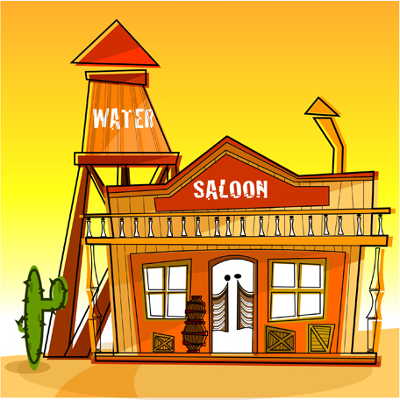

Saloon!

Based on “Kaboom!”

Tarang Khandpur – tk8435

Victor Gonzalez – vg7893

# kaboom.pngOverview

Use the slide-pot to prevent an explosion while avoiding harmful objects. The objective is to survive as long as possible. You are given 3 lives.

# Rules

* + You lose a life if you fail to defuse a bomb or you get hit by a piano.
  + Intoxication inverts the slide pot.
  + Getting hit by piano or having a hangover results in temporary jet-lag.
  + Point values are assigned for properly defusing a bomb or obtaining caffeine.
  + The rate of the falling objects increases proportionally with time.
  + A score is kept.

# Features

* + The player is allowed to maintain an inventory of caffeine to be used for temporarily slowing down time, undoing jet-lag, or reverting back to the original controls.
  + Jet-lag is a condition in where the players slide pot I/O will lose precision – movement may be offset by a random amount of spaces.
  + Reversals is a condition where the slide pot functions in the opposite manner. It is based on the ever so famous philosophy of “Go home ________, your drunk”.
  + Easter eggs that are pseudo-random.

# Easter Eggs

## Perfection

At the end of a round, the player will be awarded an extra life and coffee for their stellar performance (avoiding all alcohol and pianos while defusing all bombs).

## Dedicated

A random reward of coffee or a life for players who managed to defuse all bombs, but accidently got intoxicated or hit with a piano.

## Hangover

A random chance of starting the next round with jet-lag for players who became intoxicated during the current round.

Difficulty

* + Jet-lag results in imprecise movement.
  + Intoxication requires the player to quickly adapt to a new set of I/O rules.
  + Increasing speed guarantees eventual loss. This makes it a game of attrition and skill.

# Structures, Variables, and Conditions

## Score and Lives

These table depicts the interaction with objects that will affect the player, the effects on the score, the sound, and any possible effect that they may provoke.

|  |  |  |  |  |
| --- | --- | --- | --- | --- |
| Object | Life | Score | Sound | Additional Effects |
| Defused |  | Increase **x** | Defuse |  |
| Detonated | Decrease **x** |  | Boom |  |
| Whiskey |  |  | Confuse | Reversal[1] |
| Piano | Decrease **x** | Decrease **x** | Smack | Jet-lag |
| Coffee |  | Increase **x** | Pit-Stop[2] | Clarity |

## Milestones

|  |  |  |  |
| --- | --- | --- | --- |
| Milestone | Life | Score | Carry-Over |
| Perfection | Increase | Increase | Clarity |
| Dedicated |  |  | Clarity |
| Hungover |  |  | Jet-lag |

## Flags

These are the flags that can be set by in game or I/O events. Keep in mind that this list does not list how they will be serviced.

### Perfection

Initialized to **true** every round. Triggered to off for if the player messes up. This flag is **invisible** to the player.

### Hangover

Initialized to **false** every round. Triggered only once if whiskey is consumed. **Invisible** to player.

### Dedicated

Initialized to **true** every round. Triggered only once by detonation. **Invisible** to player.

### Drunk

Initialized to **false** every round. Triggered only once if whiskey is consumed. **Visible** to player. Once triggered, it initiates a countdown timer until it is deactivated.

### Jet-Lag

Initialized to **false** every round. Triggered only once if hit by piano. **Visible** to player. Once triggered, it initiates a countdown timer until it is deactivated.

### Caffeine

Initialized to **false** every round. **Triggered by** player pressing **switch**. **Invisible** to player. Once triggered, it initiates a countdown timer until it is deactivated. **Reset** after service.

### Detonate

Initialized to **false** every round. Triggered by colliding with floor. **Invisible** to player. **Reset** after service.

## I/O

These are the rules for the slide pot and button. They will vary based on other conditions.

## Speed

$$Speed_Drop\left(level, caffeine\right)=d_base+level×\left(.05d_base\right)-caffeine(level×\left(.05d_base\right))$$

$$Speed_Villan\left(level, caffeine\right)=v_base+level×\left(.05v_base\right)-caffeine(level×\left(.05v_base\right))$$

## Random Variables

### Decide_Drop

### Decide_Object

Must return 1 of 3 values, with a frequency of .7 for bombs, .2 for alcohol, .1 for coffee.

### Random_Lag

Determines the amount of jet-lag offset. **Must have boundaries**.

### Reward_or_Punish

Used to determine the rewards or punishment for in game performance. Uniform Binary outcome.

## Sprites

# Acknowledgements

## Original Game

Kaboom! is an Activision published in 1981 for Atari 2600 that was designed by Larry Kaplan. It was well-received and successful commercially, selling over one million cartridges by 1983.

<http://www.classicgamesarcade.com/game/21674/kaboom.html>

1. A player could easily undo the effects of whiskey by drinking it twice, however, they may incur a hangover.
2. Nascar pit crew sound.