Versatile Augmentation

Timothy Kokotajlo
Villanova University
College of Arts and Sciences
Villanova, PA
tkokotaj@villanova.edu
Kimberly Zhang
Villanova University
College of Arts and Sciences
Villanova, PA
kzhang02@villanova.edu

Abstract—This document goes over our 2016 Fall Senior Project, where we designed and built an Augmented reality application, Versatile Augmentation, for the Android. The paper goes over aspects of its design, build, and operation.
Keywords—Augmented reality; Senior Project; Unity; 3d; User-based

Introduction

Augmented Reality is the step in-between a camera and complete virtual reality. It relies heavily on computer vision to place objects over a real image in such a way so that they appear part of the original picture/video. It has been widely growing in popularity, with applications such as Google Translate, (finds and translates text with the phone's camera) Pokémon GO (uses real-time data to place your location on a real-world map and overlays Pokémon onto your phone screen), and Star Chart (returns information on which stars are on the phone screen, and more) all use this burgeoning field in different ways. Versatile Augmentation is an Android application designed to provide an easy to use and flexible tool allowing users to create their own AR scenes without having to learn and design software themselves. Instead of using pre-built rules defining what the software is looking for, and what it will do once it finds it, the images and objects to overlay are all selected in app by the user.

Background
One of the primary usages that inspired this project was Tabletop games (think Dungeon and Dragons). These are essentially games where players build a fantasy universe and characters and construct a story as they play. Several players control individual characters and choose their actions, and one player, the Dungeon Master, (DM) runs the background universe and sets up the basic plot that the characters will follow. These games run long, usually months on end, and can traverse a large amount of creative ground. We realized that in order to change the medium from simply the imagination of the players into something more graphical, either a wide variety of fragile models would have to be made, or the scope of the adventures would have to be limited by the resources available.
Instead of models, therefore, Augmented Reality can present a different solution. Almost every app out there right now has built in associations between an Image Target and an Object or Function associated with the target. For some the database of targets are quite large, and can contain entire languages even, but the functions and/or objects are limited.
Our app aimed to address this issue, and provide a more general structure that can be changed on a scene by scene basis, and provide a relatively simple augmented reality addition to traditional tabletop games.
In addition, while the functionality was originally designed for these types of games, by its very nature the app is user-defined. With enough managing on the user side it can be used for much more than just games- business cards, decoration, visualization tools, organizing files, or more.

Methodology
Vuforia is an AR library that can be used in a variety of development settings, from Phone Dev kits, to OS kits, to Unity, which we used. Vuforia works through natural feature detection and tracking; target files are assigned feature points which it is then able to recognize in an image, and recognize the distortion and apply the three-dimensional shift. Thus, the entire 3d world is all placed relative to the tracked image, and when the image moves, so does the world.
Using Vuforia through Unity was deceptively easy. The Vuforia package we imported came with AR camera and image marker prefabs, which made creating a simple AR app very easy. Simply replacing a default scene camera with a Vuforia AR camera and placing a 3D model as a child an image marker was enough for a simple app.
For markers to place images onto we had two options: framed markers and image markers. Vuforia handled framed markers by looking at a black and white encoded outline, completely ignoring the inner sections of the image. Like QR codes, frame markers all have the same pattern, and use the stark contrast between solid black and solid white to lessen the burden on the image recognition. The content of the Frame marker did not matter, just the border. See “Fig 1” Image markers were the opposite-- they were recognized by the content of the image. See “Fig 2.” Framed markers were already in the Vuforia package, and image markers could be custom generated by uploading images to Vuforia. We could then download and import a unity package with all that Vuforia needed to recognize the image. Attaching the image to an image marker prefab was as simple as selecting the right one from a dropdown in Unity's inspector. Although both options were good choices, we chose to use image markers because of their ability to scale. Though framed markers would allow users to create their own markers, the assets we had were not in vector format and thus did not retain their sharpness after being resized.
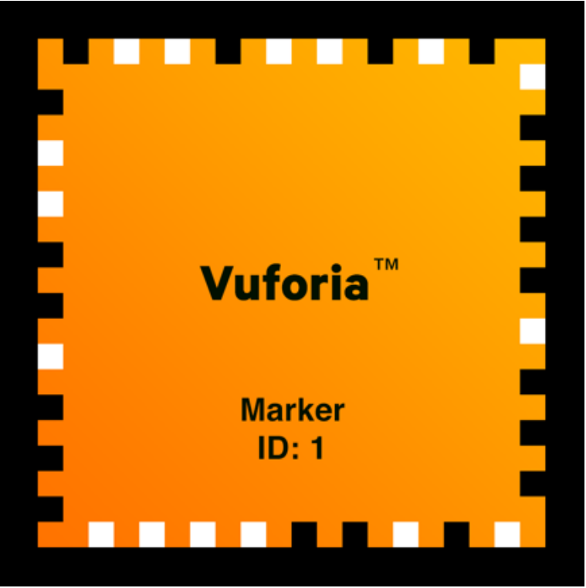
- Example of the features of a frameTarget
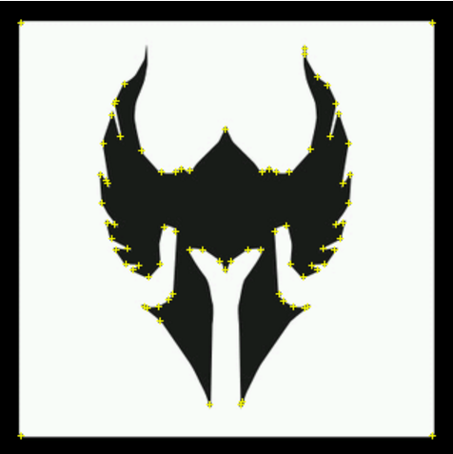
- Example of the feature points in a imageTarget
From there it became a matter of allowing user interaction. After some amount of trial and error, we hit upon our current setup: a menu where a user chooses both an image and a model from dropdowns and then a button runs a script which links them together. We ran into some issues because Vuforia doesn't recognize multiple instances of the same image target. Because of that, we had to rethink the way we assigned models to images, as our script at the time simply removed any existing models on the selected marker before adding the correct one. Instead, any model assigned to an image target is now cloned, with the clone placed on the appropriate marker and removing the model is now just deleting the clone.

Results
Our application currently supports Android and allows the user to choose between over a dozen targets and half a dozen models. It would be possible to build to different devices and operating systems, (IOS, desktops, etc.) but for our purposes, and with our limited testing capabilities, we choose to stick with Android phones exclusively.
Vuforia has an option for the user to select their own images in app for targets, but it severely degrades the quality of the tracking ability, which also factored into our deciding to have a premade database of image markers. Image markers cannot be reused; that is, it is not possible to have two instances of the same image marker with different (or the same) object overlaid on them. This is an issue with how Vuforia tracks targets, and as of our research was unsolvable.
AR is resource intensive and we have not optimized any part of the app, so while adding more models is trivial, it significantly slows the app down (or crashes it). Alternatively, neither of us have very much experience with modeling, so though there may be ways to reduce the size of the models, we aren't experienced enough to know what can safely be removed. The models we used were taken from databases of free online models, and represent a sample size of the possibilities that are out there.
We have some issues with depth of field as well, but they could probably be attributed to Vuforia, and the limitations of AR as it is today. Image markers too far away from device cameras tend not to be recognized well, or even have their models "sink" into the markers. Perhaps Vuforia is not able to properly grasp how far away the table is? Whatever is causing it, it limits the size of the playing field, unless users are willing to pan across the table.

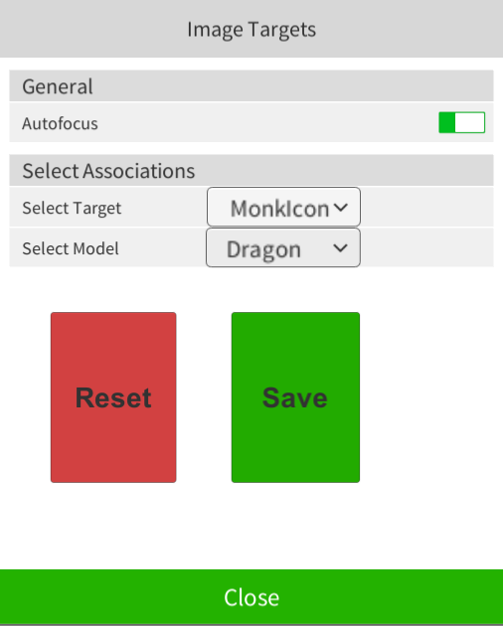
- Example of the GUI for Versitile AR
Our GUI is simple, and made only to be functional. Users can select which targets go with which model, save their configuration, and enter and exit the menu. See "Fig 3." Autofocus is also an option, but it is recommended to always leave on for best performance.
Our website with our results, posters, and presentations can be found at: https://tkoko.github.io/AugmentEverything/ It also contains a downloadable APK file with Versatile AR contained.

Conclusions
What we have working is a very crude version of the idea. Many of the difficulties came from us learning the software and trying things out, or from issues with the software itself. A future polished version of the app would be much more optimized, with a more cohesive set of models to choose from. Ideally there would also be ways to share settings to others using the app, perhaps via some sort of QR code.
AR is relatively new, so as the technology gets better, many of the issue we had will be solved. Vuforia image tracking software can crash Unity occasionally, especially if the scene in question has a large number of objects displayed at once. When tracking objects, the algorithm isn't perfect, leading to a slight jittering effect in the models as it updates the rotation. There are other AR packages available that partially solve this issue, down the road Vuforia will have those features and they Vuforia's. And finally, and perhaps most crucially, the size and performance speed of Augmented Reality applications will be vastly improved. Our application currently is limited most by size and speed, once the hardware on the phones and the software for augmented realistically improves the feasibility of a commercial version of Versatile Augmentation increases dramatically.
There are almost infinite things we can do to make this better, were we to do this again we would aim for the crude but workable version from the start to give us more time to prioritize features and fixes afterwards.

References

- https://unity3d.com/ "Unity - Game Engine". Unity. N.p., 2016. Web. 19 Dec. 2016.
- https://www.vuforia.com/ "Vuforia | Augmented Reality". Vuforia.com. N.p., 2016. Web. 19 Dec. 2016.
- https://developer.android.com/studio/index.html "Download Android Studio And SDK Tools | Android Studio". Developer.android.com. N.p., 2016. Web. 19 Dec. 2016

