Report

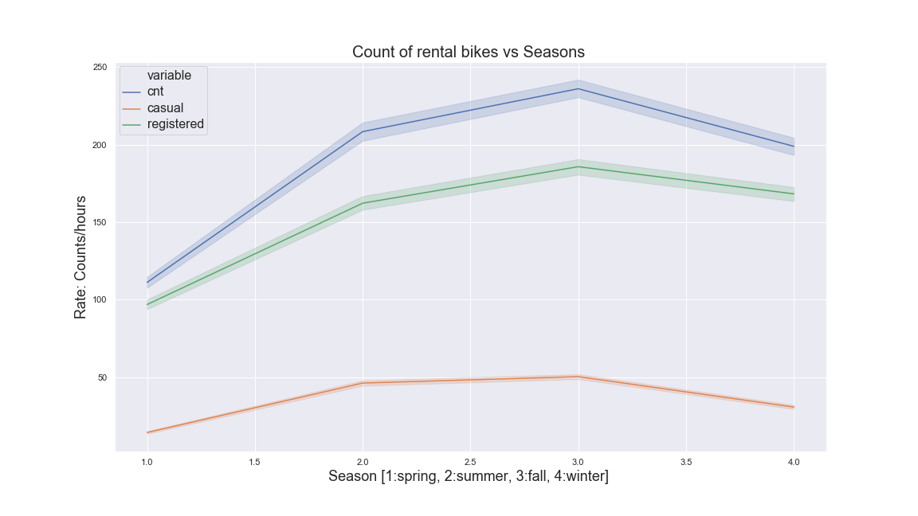

**Figure .** method: cnt_vs_season()

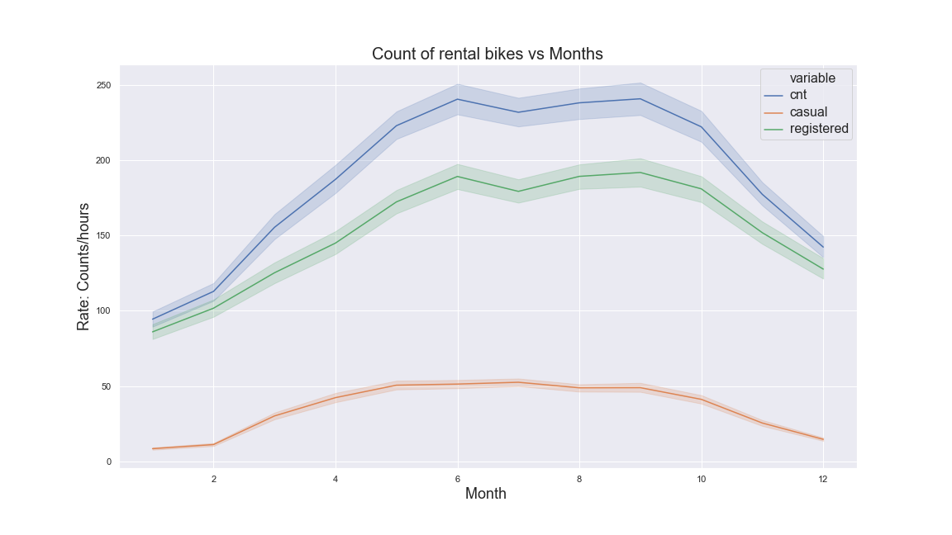

**Figure .** method: cnt_vs_month()

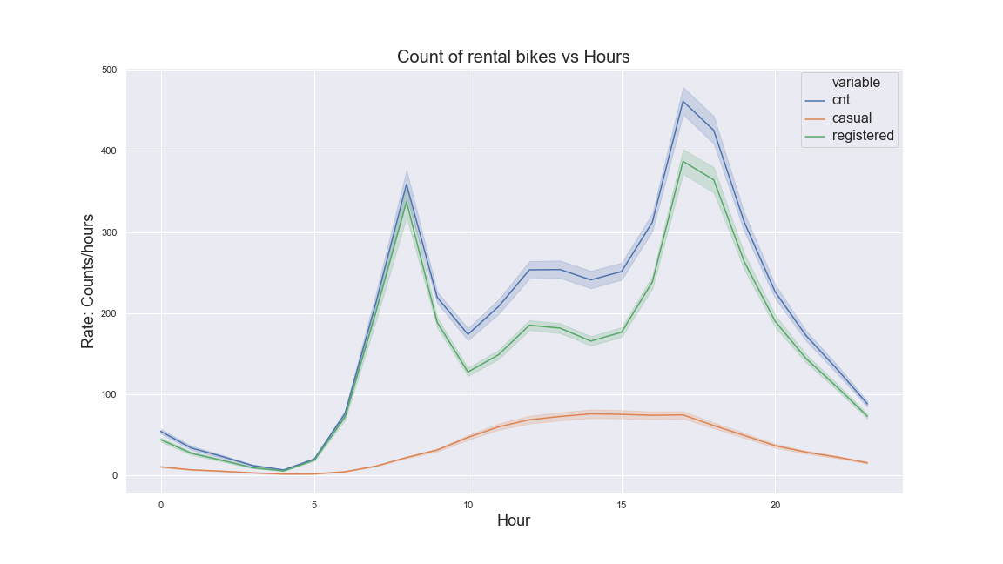

**Figure .** method: cnt_vs_hour()

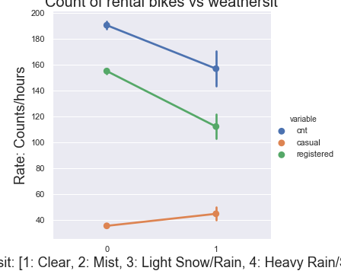

**Figure .** method: cnt_vs_holiday()

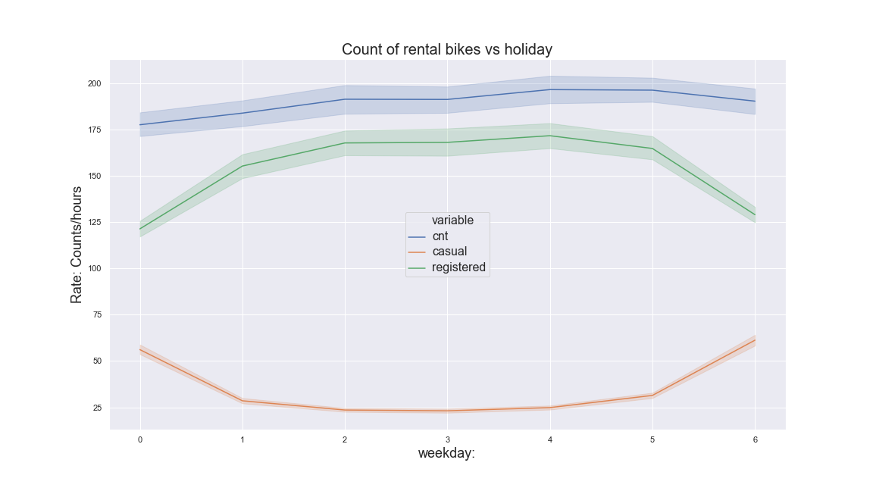

**Figure .** method: cnt_vs_weekday()

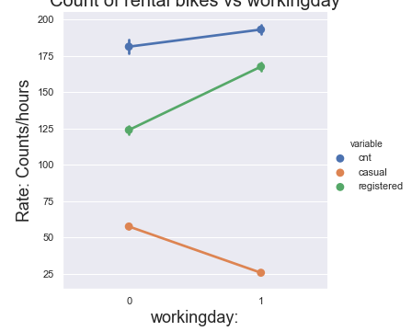

**Figure .** method: cnt_vs_workingday()

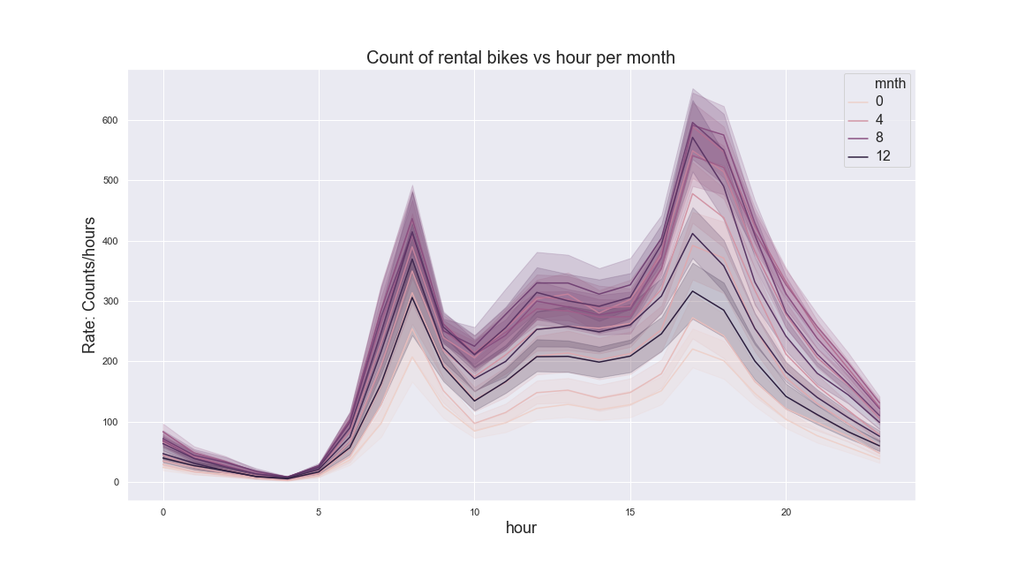

**Figure .** method: cnt_vs_hours_per_month()

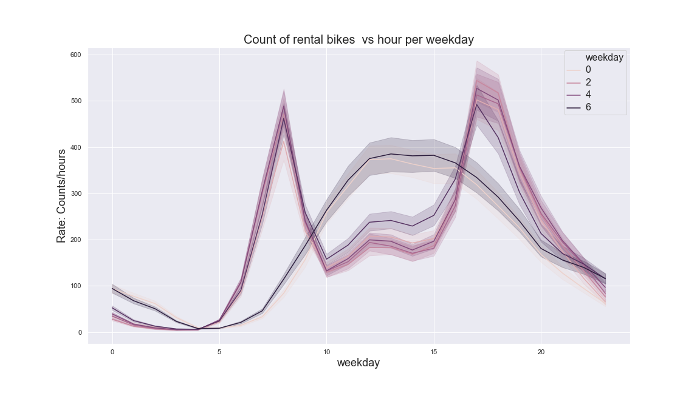

**Figure .** method: cnt_vs_hours_per_weekday()

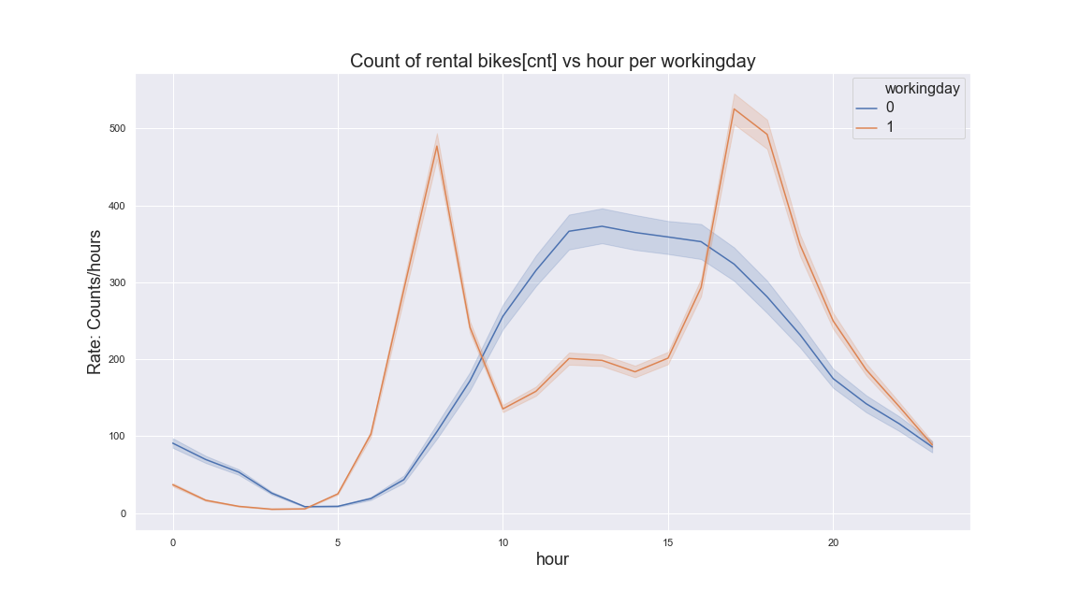

**Figure .** method: cnt_vs_hours_per_working_day()

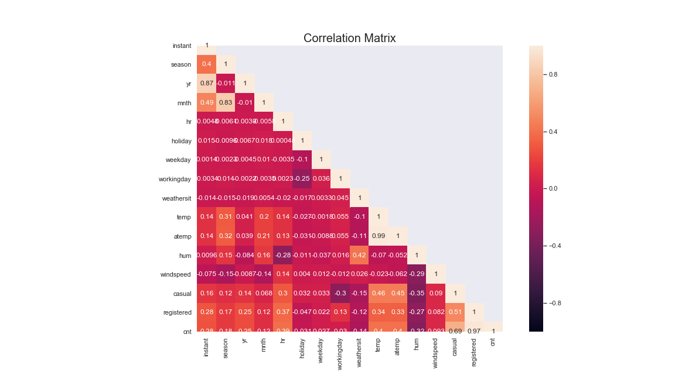

**Figure .** method: corr_matrix()

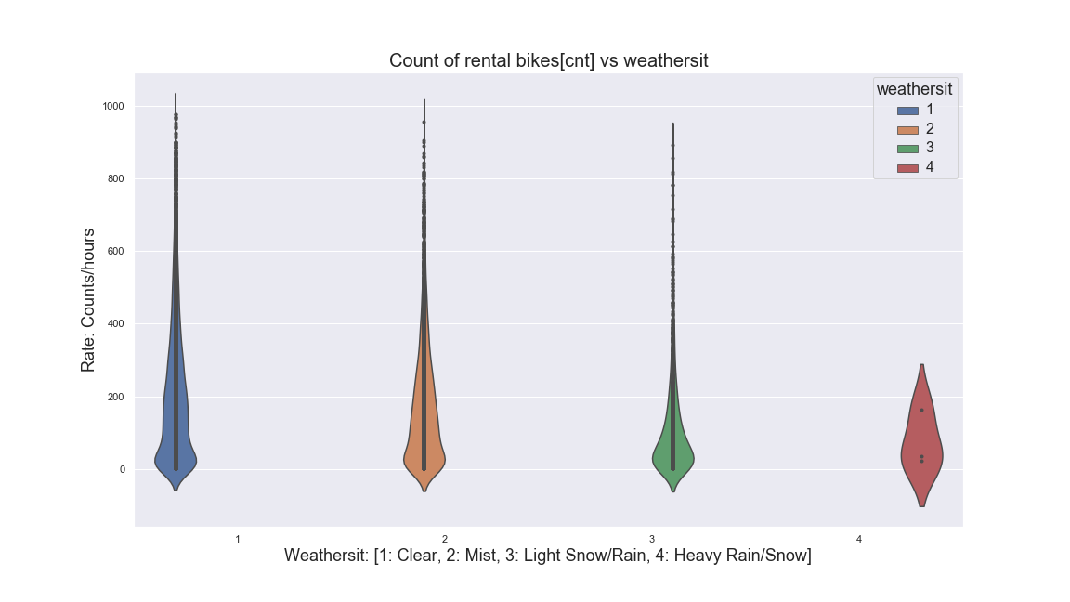

**Figure .** method: cnt_violin_weathersit()

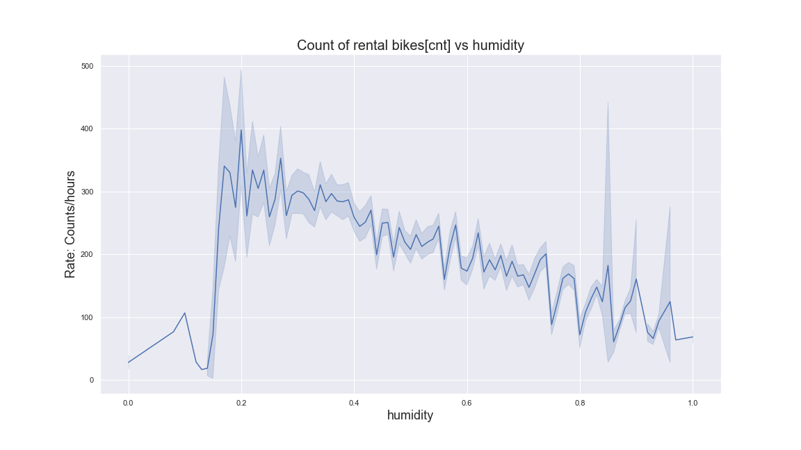

**Figure .** method: cnt_vs_hum()

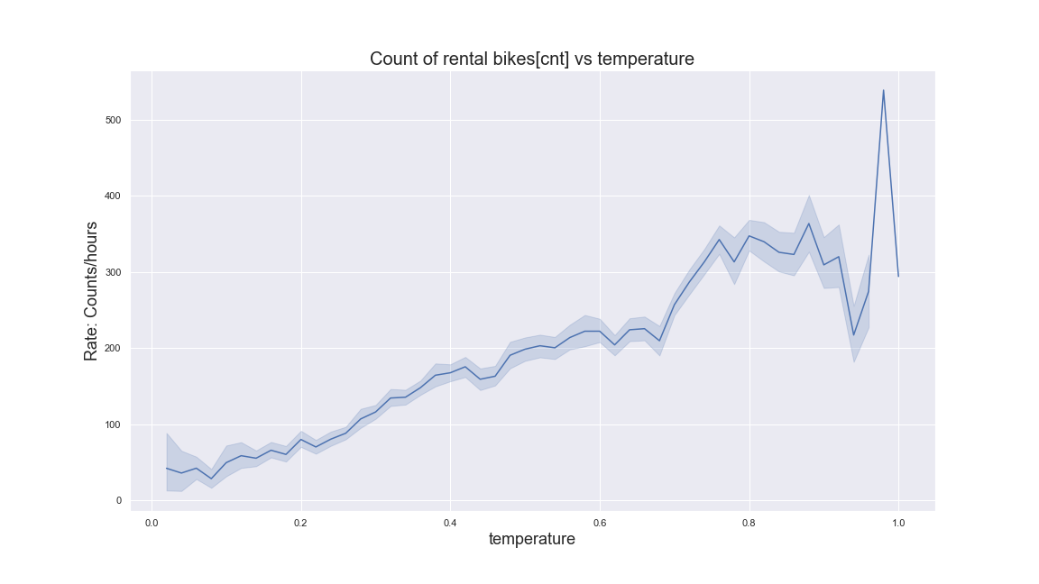

**Figure .** method: cnt_vs_temp()

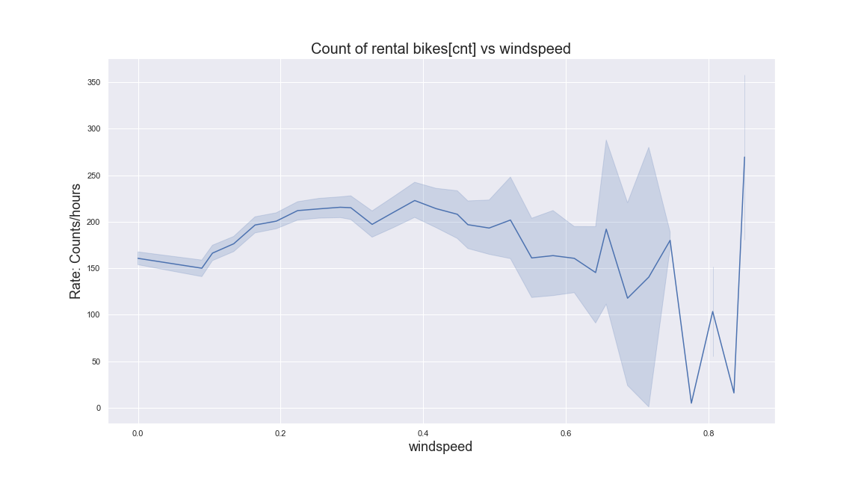

**Figure .** method: cnt_vs_windspeed()

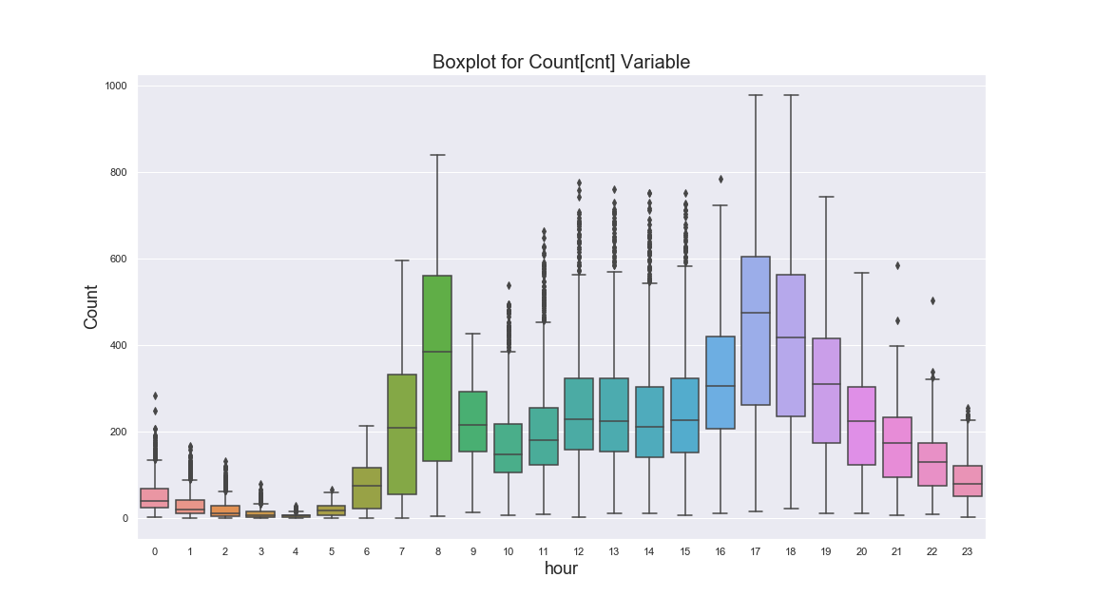

**Figure .** method: box_plot_cnt_vs_hours()

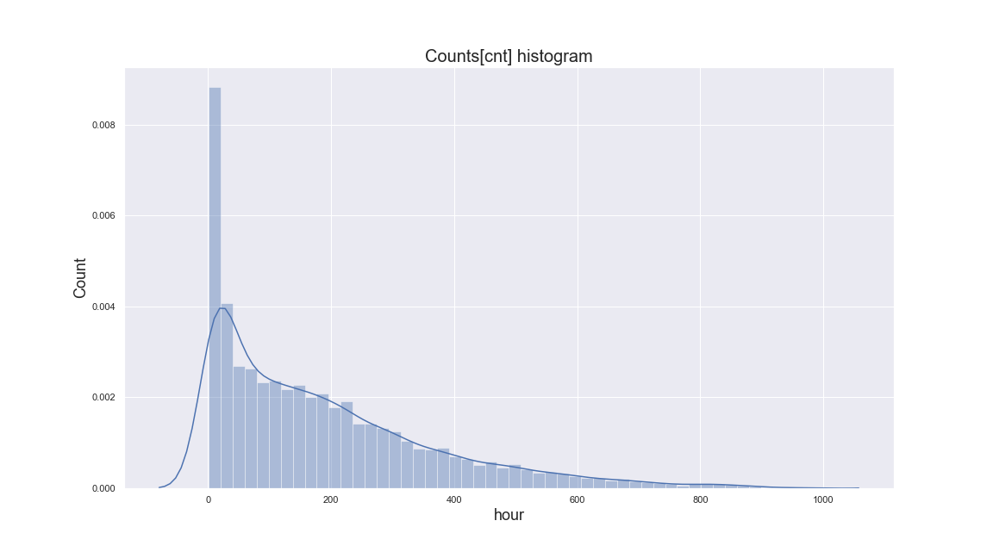

**Figure .** method: histagram_cnt_vs_hours()