# Lab 1 & 2

# Getting Started with Amazon Relational Database Service.

# Create a DB instance running the MySQL database engine

# Wickramasundara D.G.T.K

# IT13 0378 02

# Weekdays

# Log into the AWS using your username and password.

# There select “RDS” option under DATABASE category.

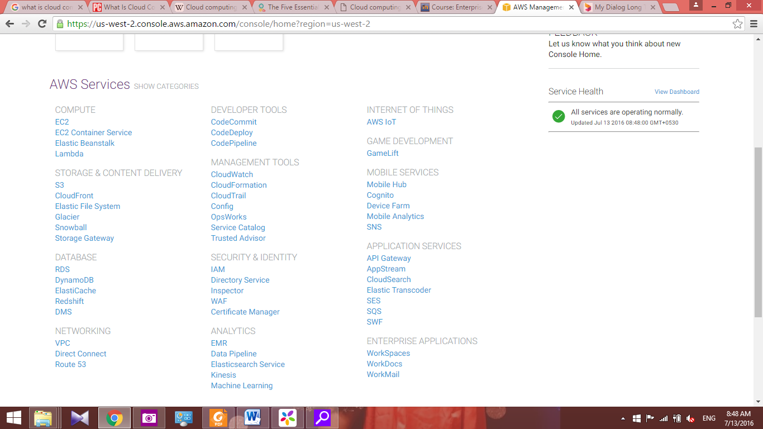

1. Click “**Launch DB Instance**”

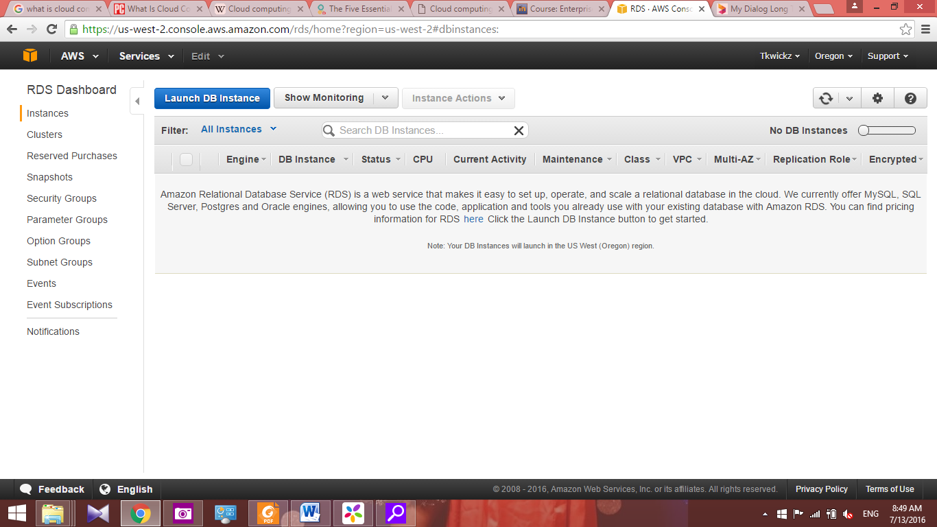

1. Select “**MySQL**”

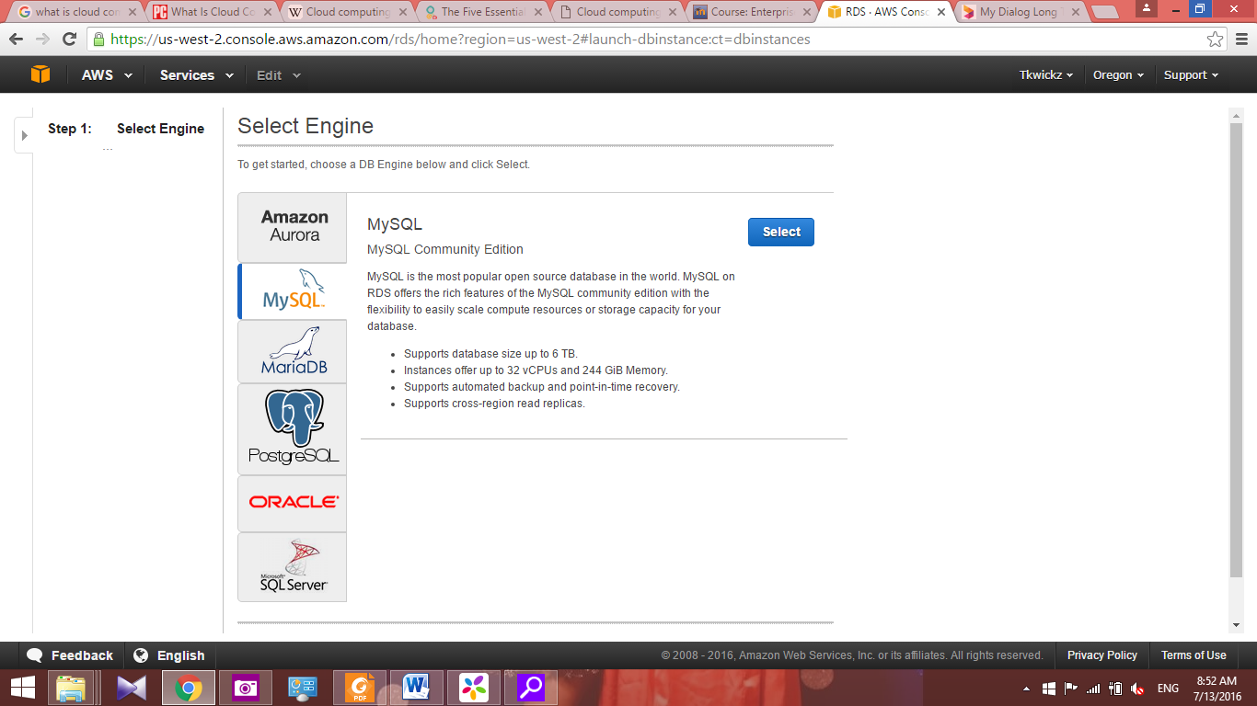

1. Select MySQL **option** and click “**Next Step**”.

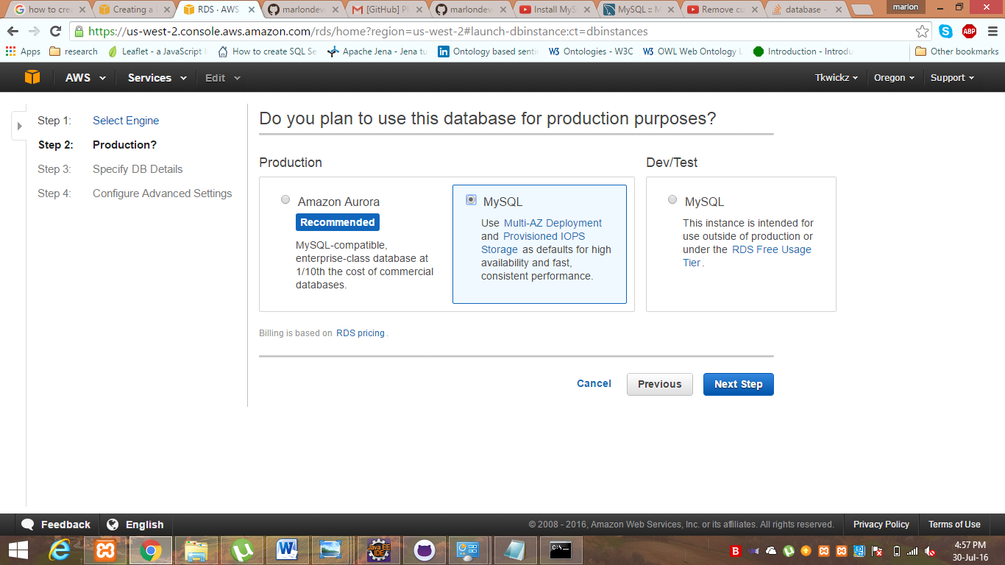

1. Fill the form as below and click “**Next Step**” (associate storage you can put any value below 30 since we are using free tier).

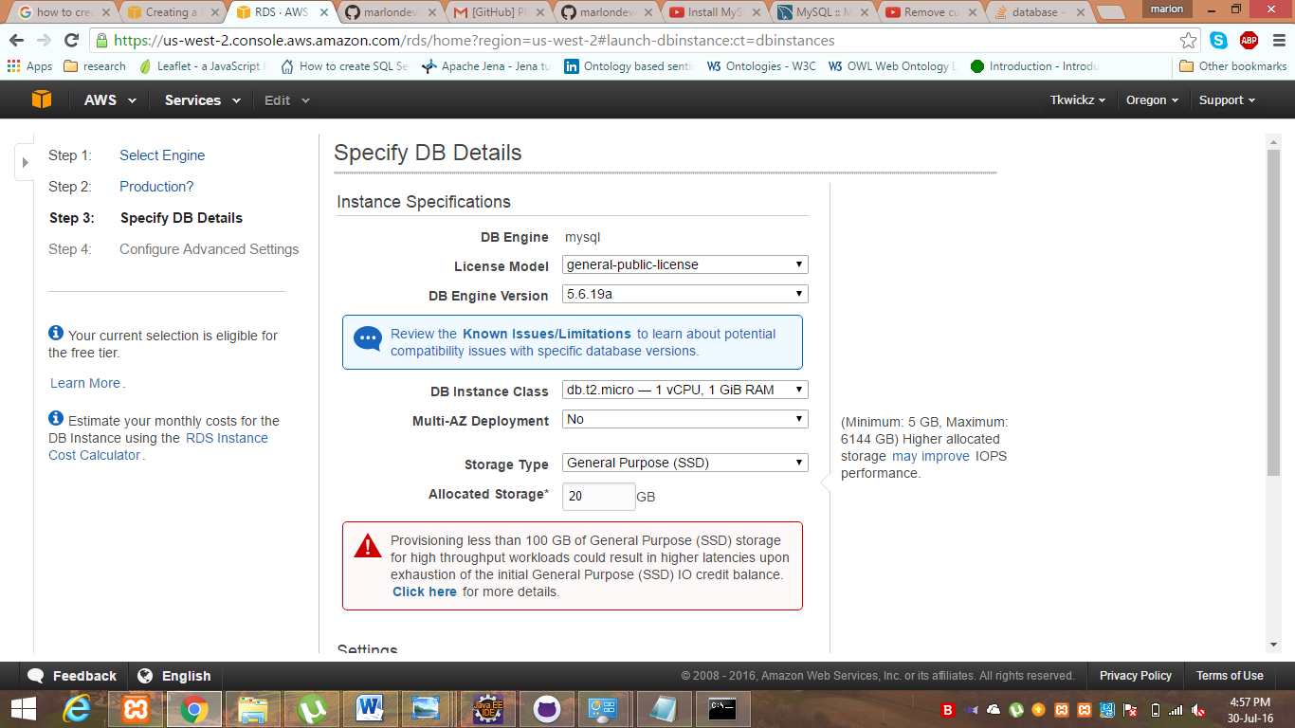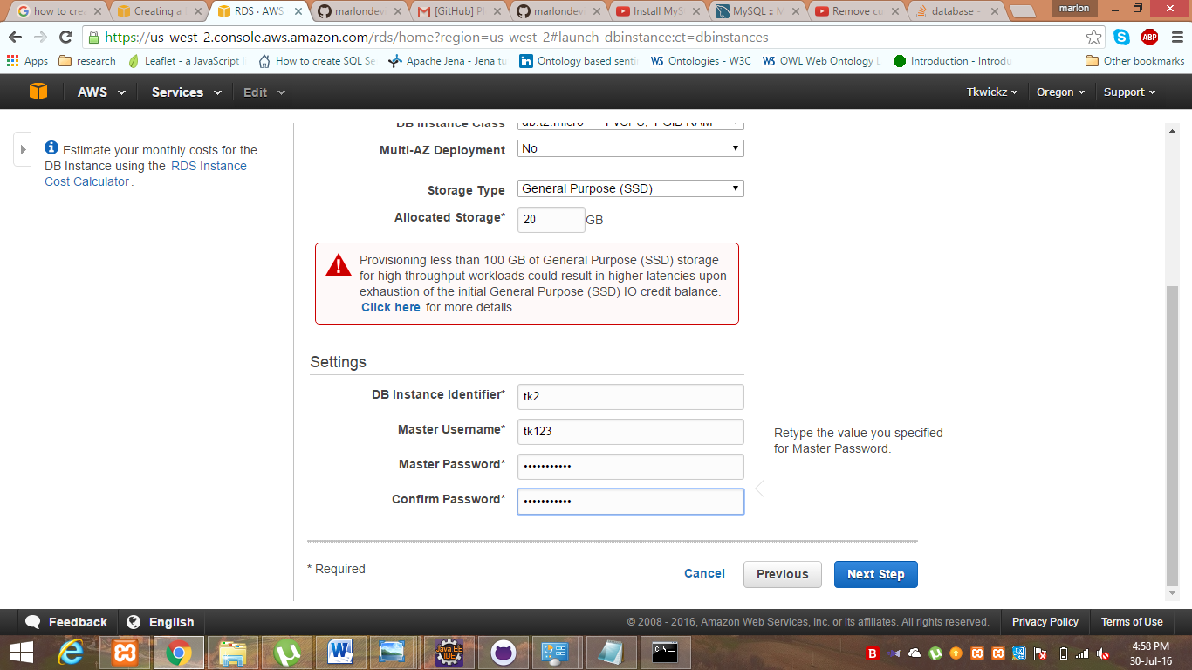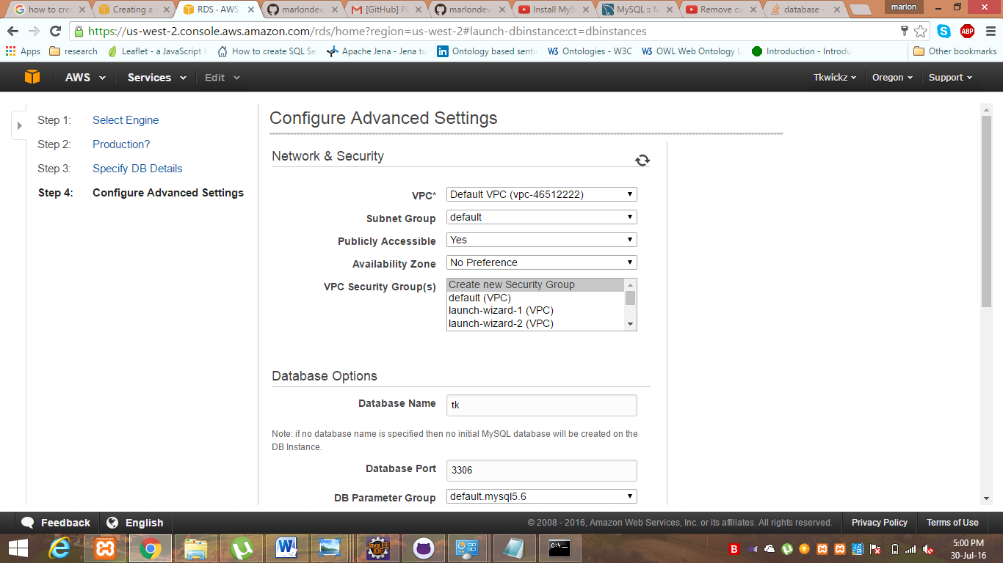

1. Finally, click “**Launch DB Instance”** 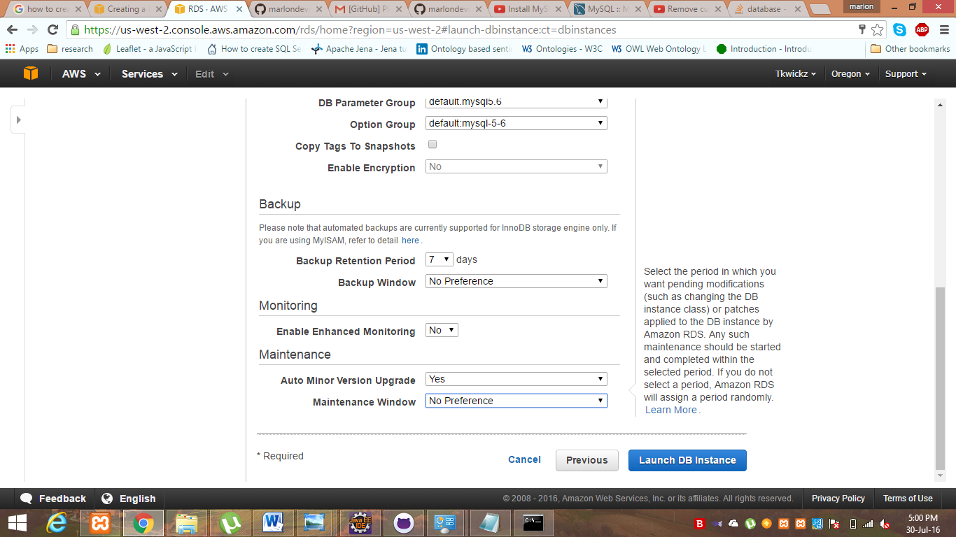

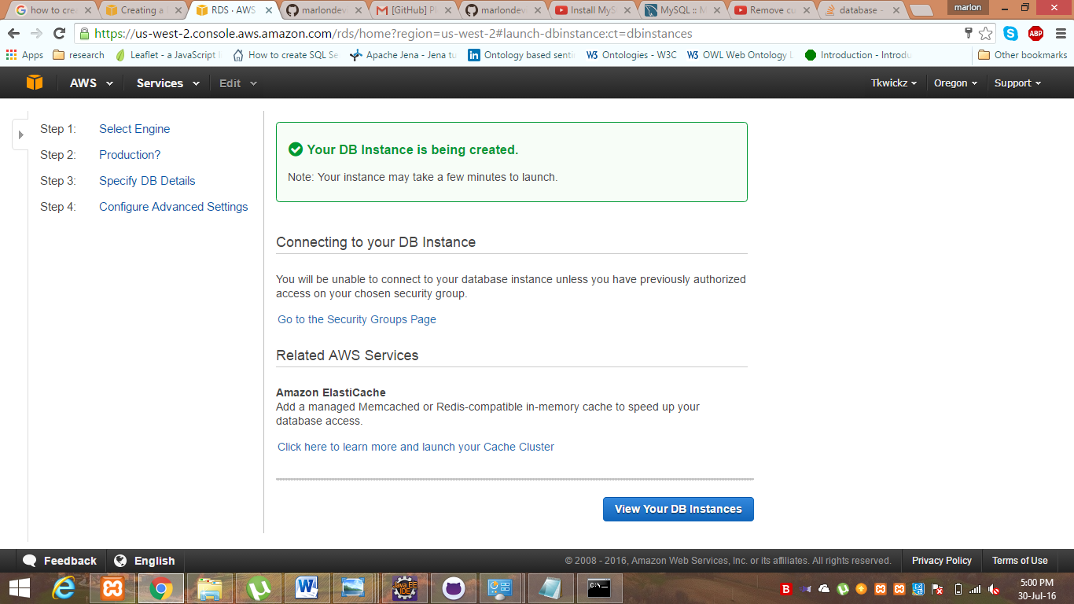

1. Now it is shown that the DB instance is created

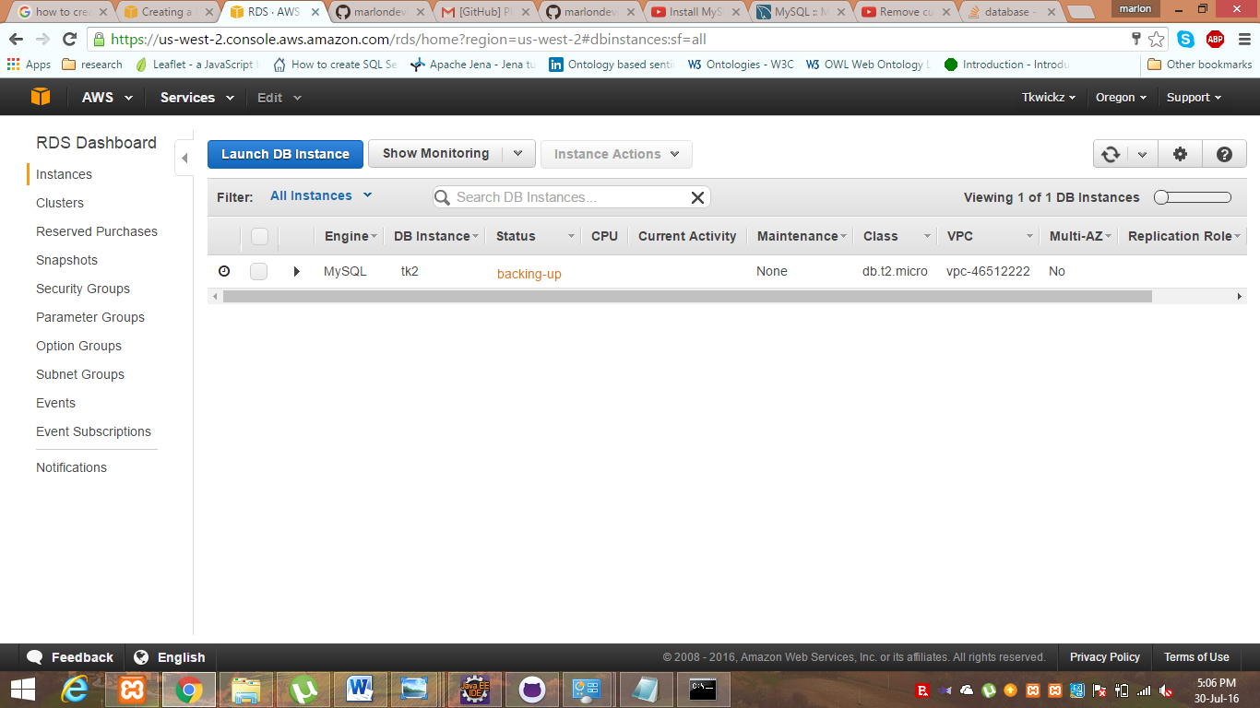

1. Now we are going connect DB instance with MySQL. To do so I use Xampp. In its shell we write below command.

“mysql -h <endpoint> -P 3306 -u <mymasteruser> -p

