Week1-Day2-
Deep Dive Lang-Flow – Lang flow API
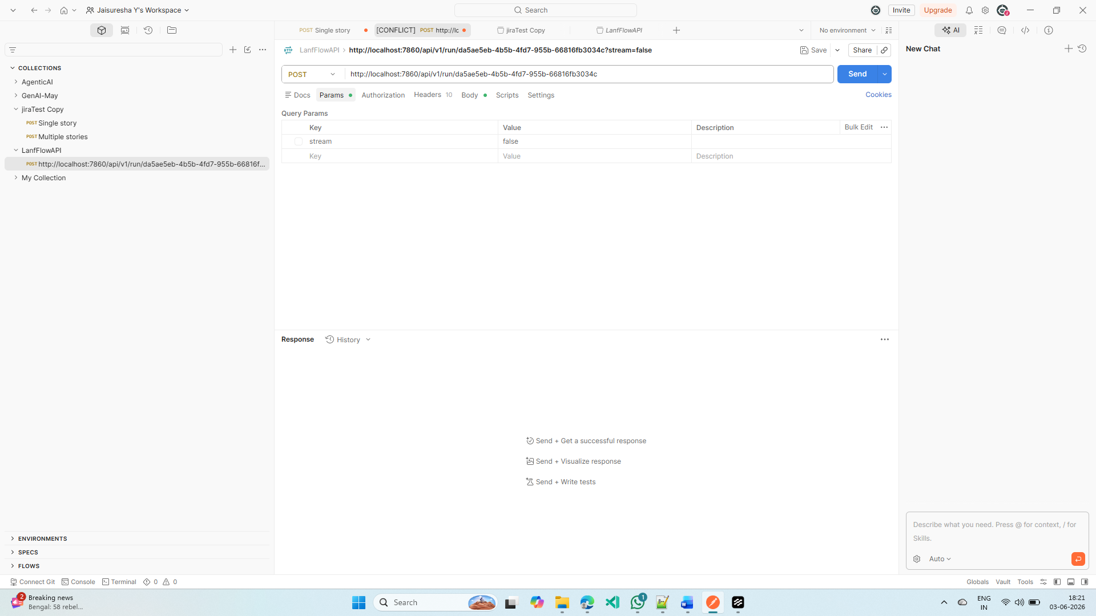
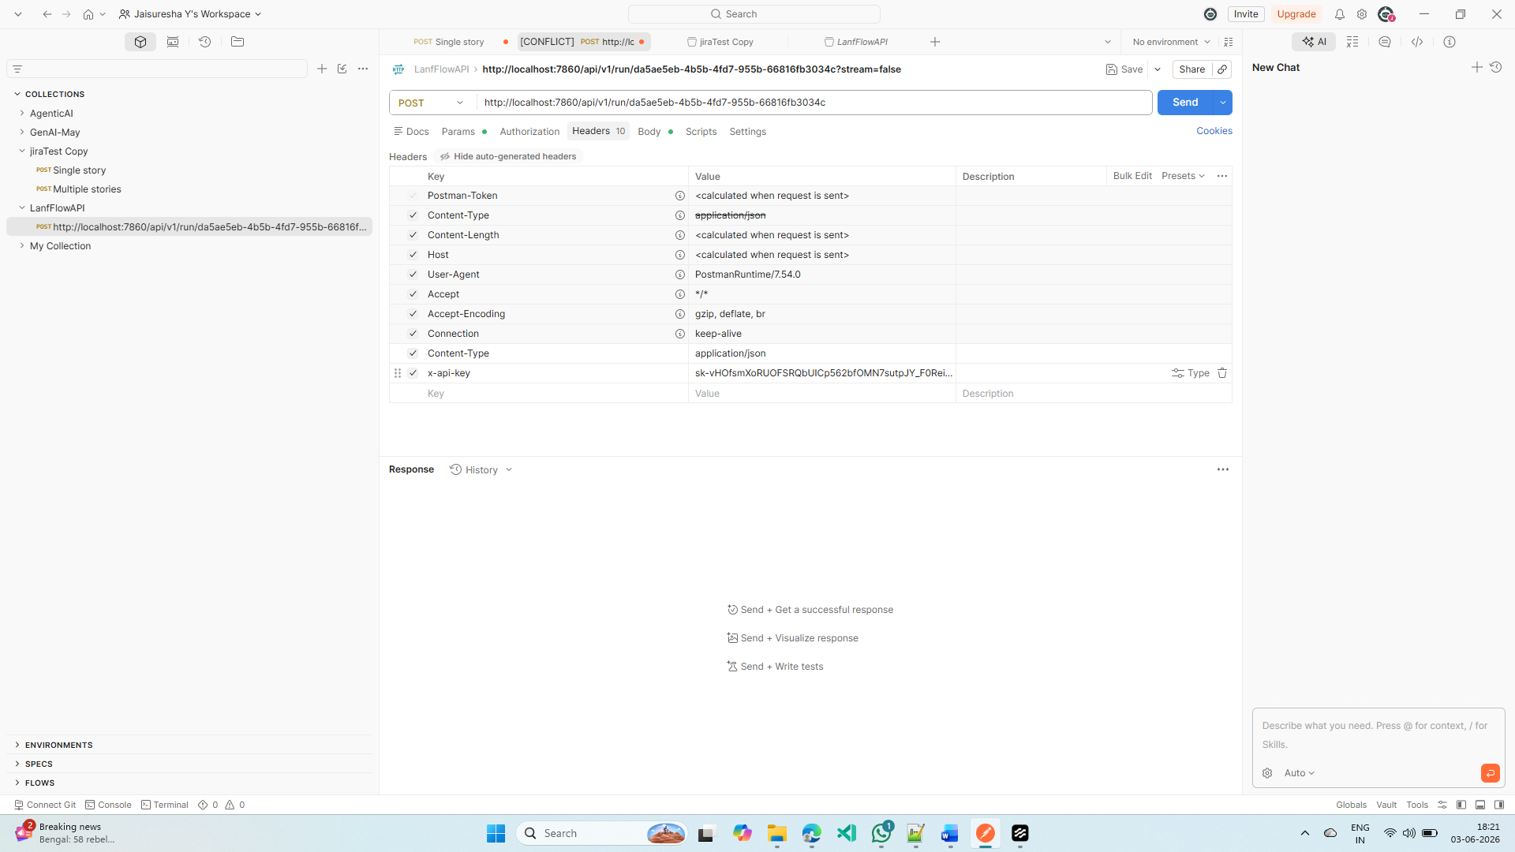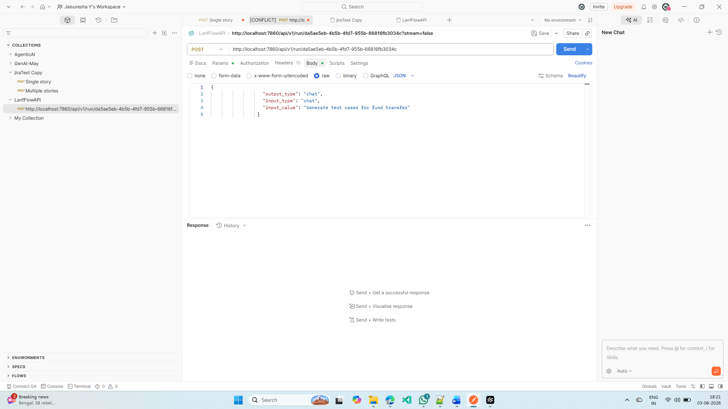
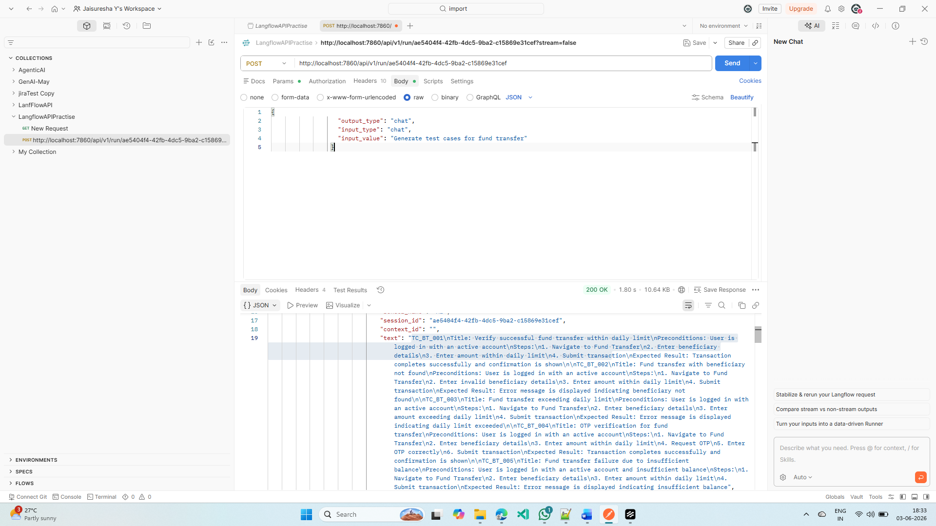
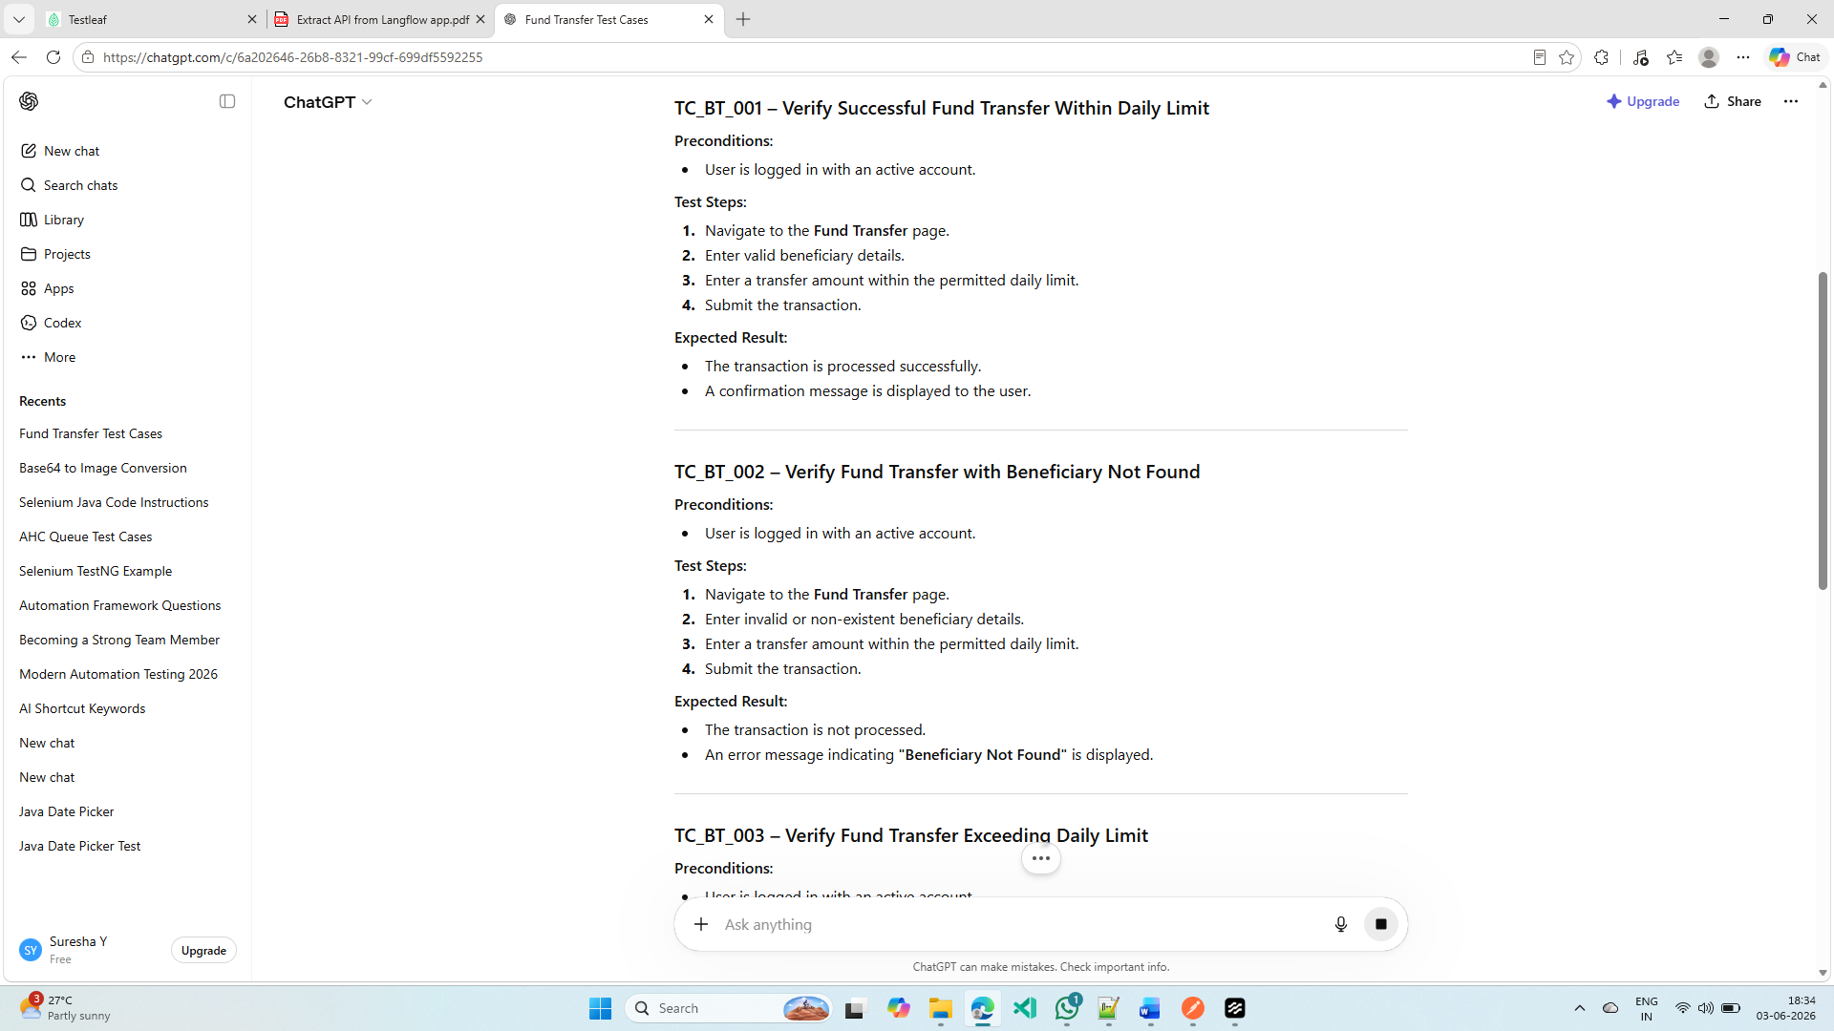
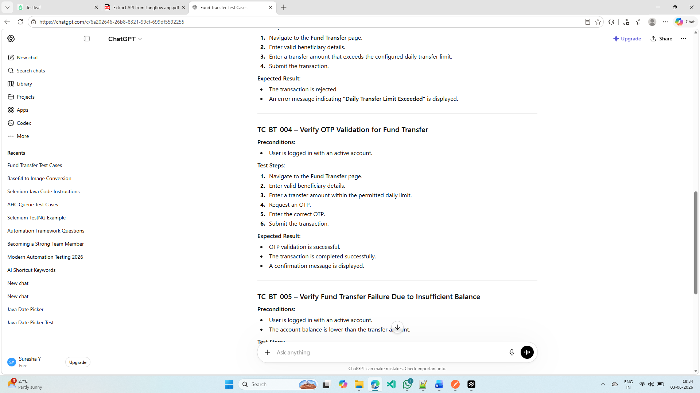

User Story from Jira to review Postman data
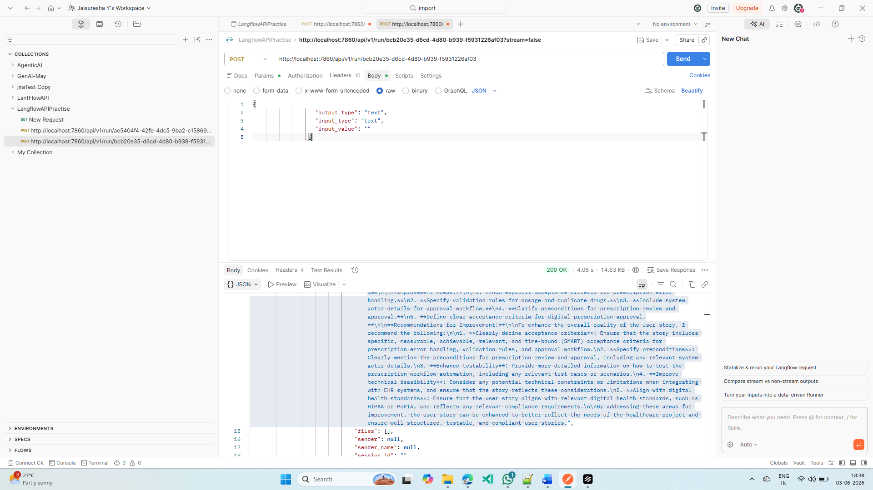
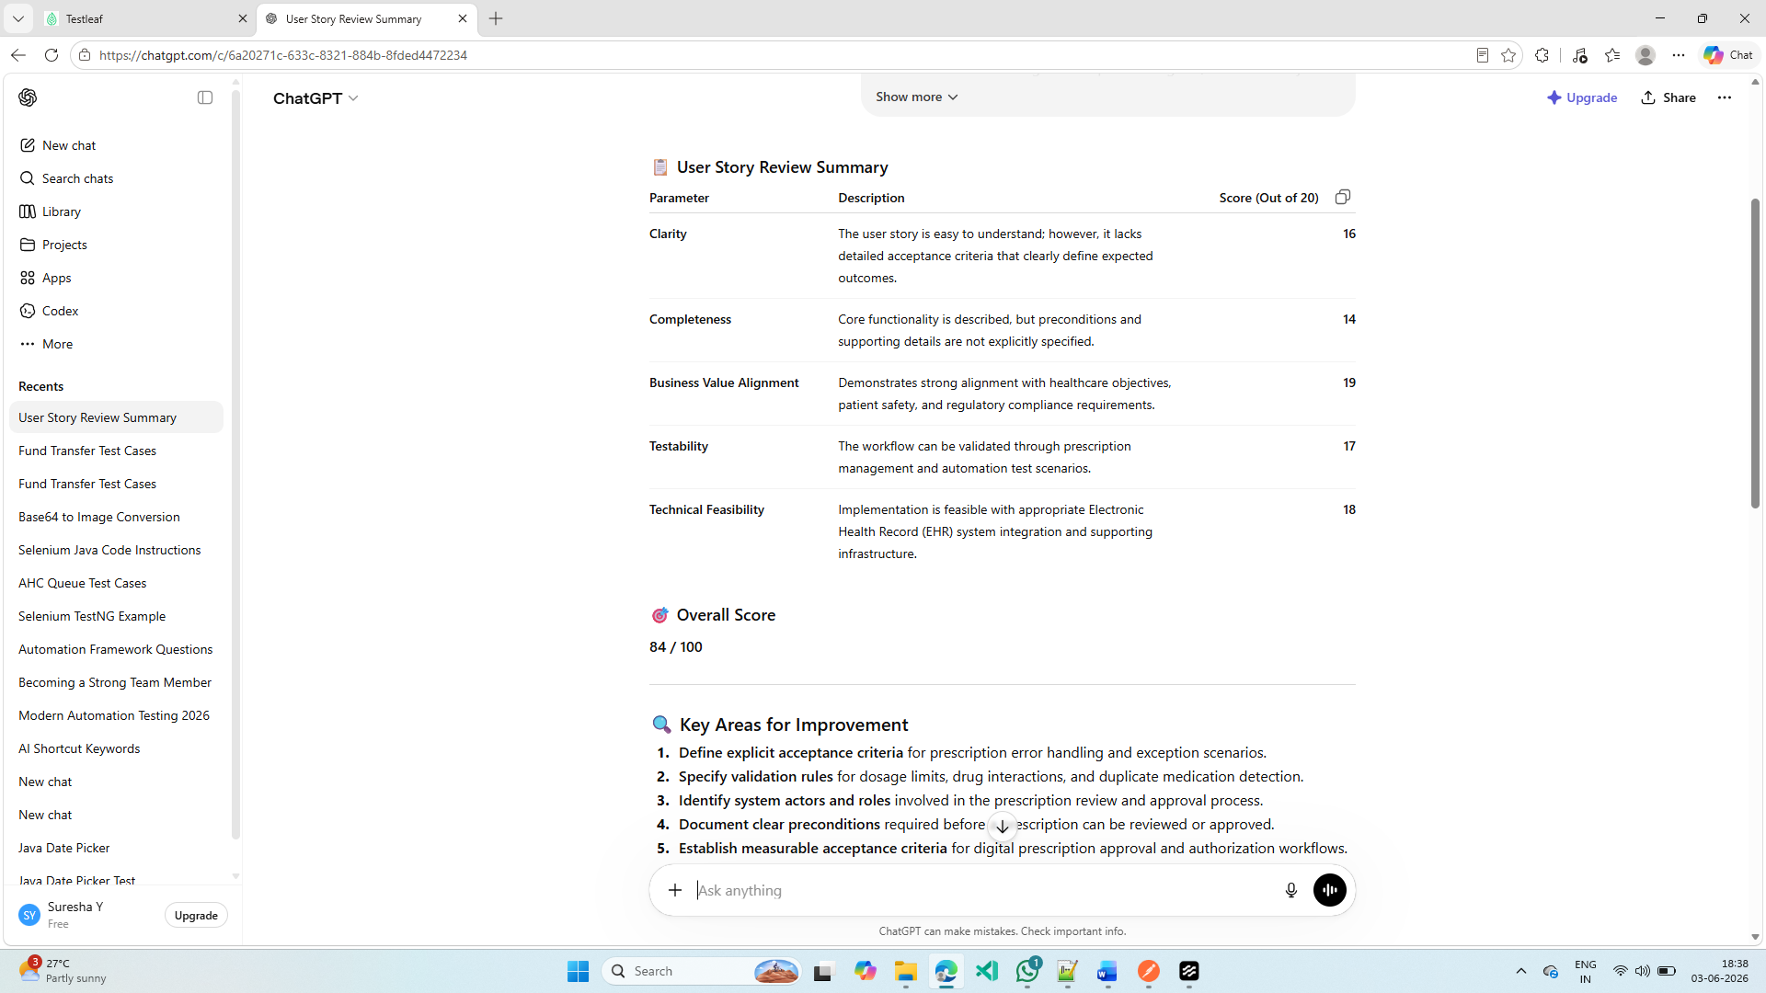
Read PDF Value
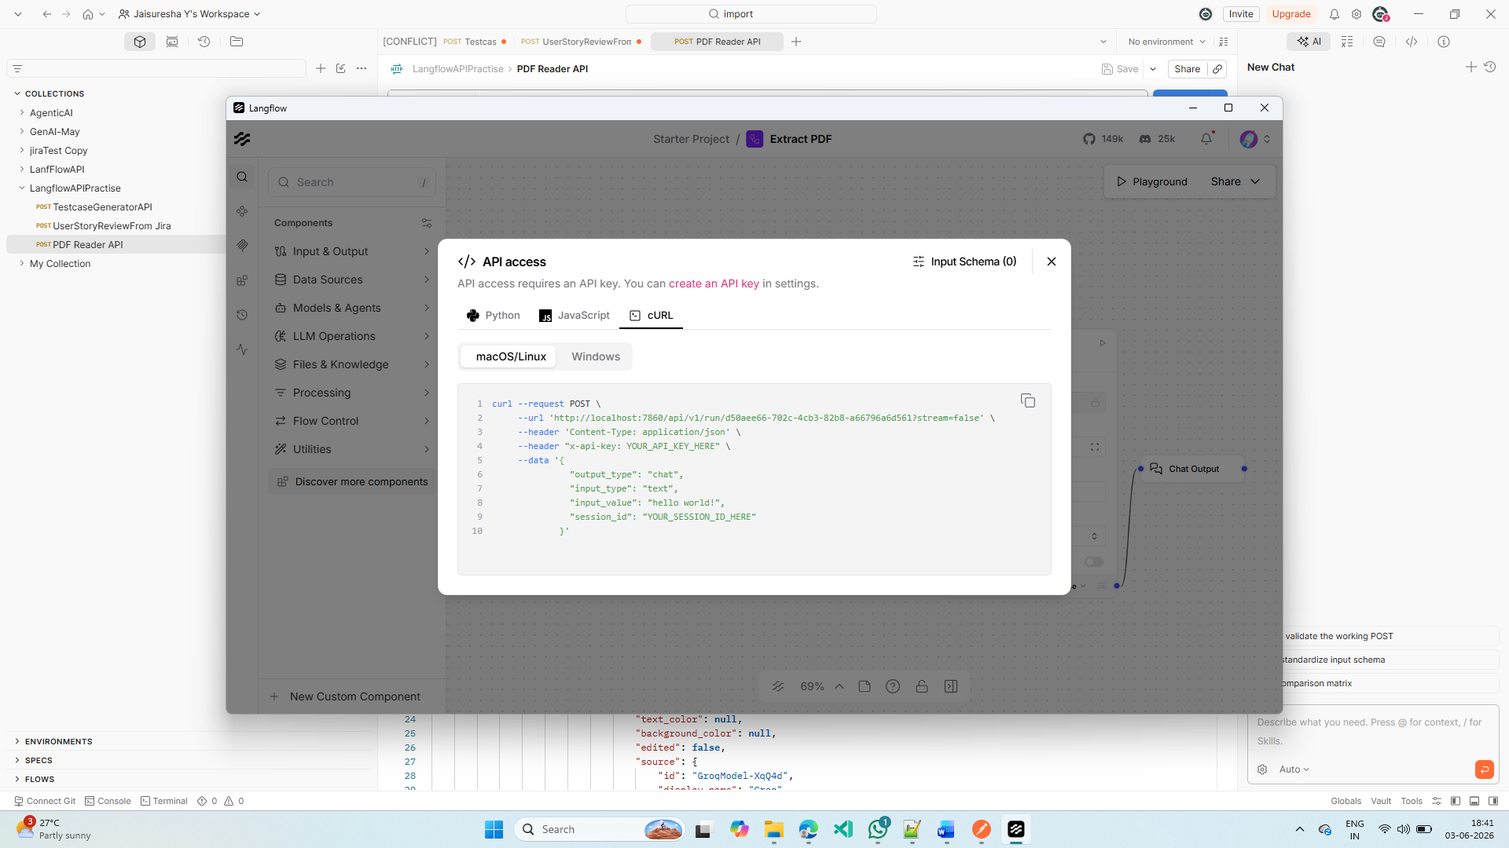
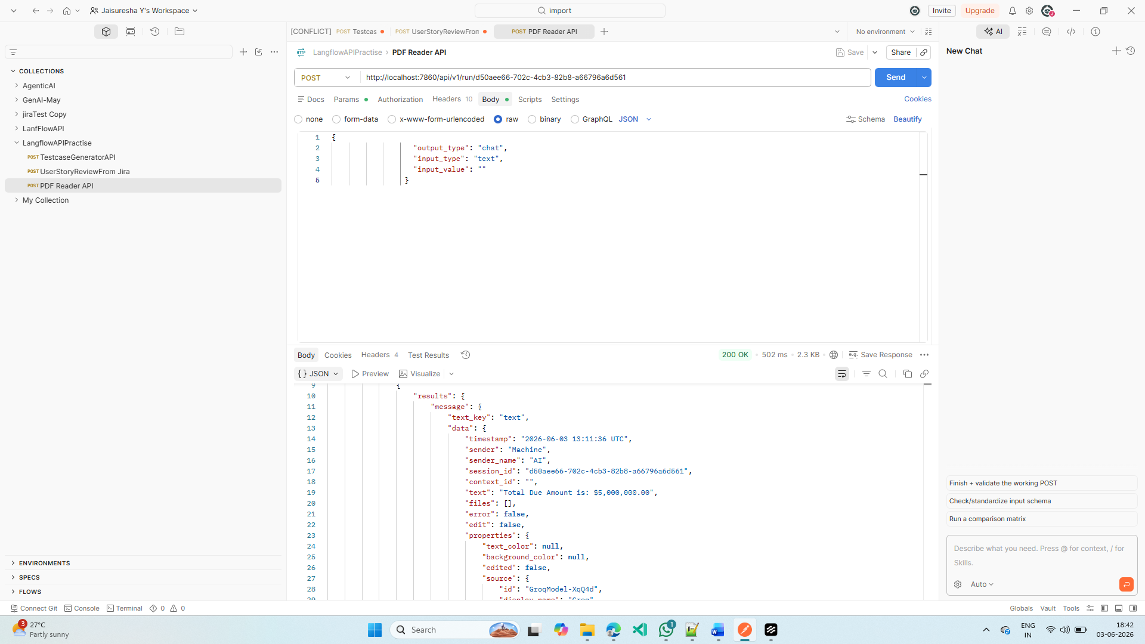
Read Issue Date and Due Amount From PDF:
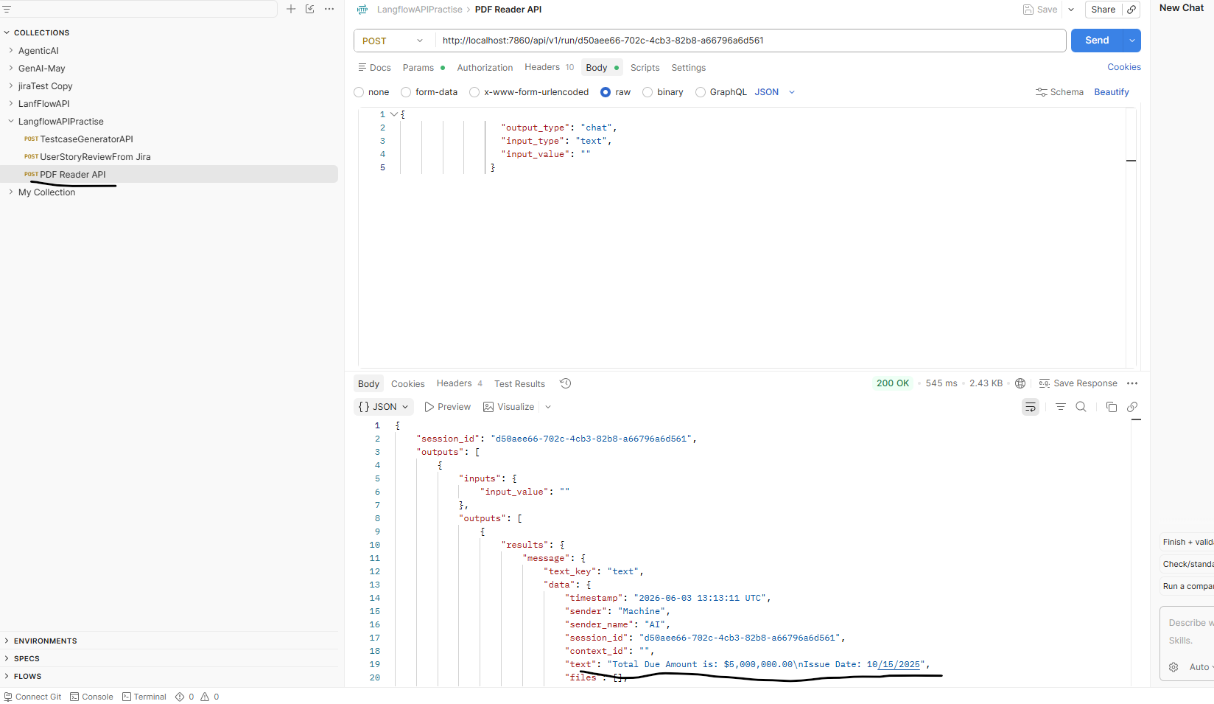

Customized API For Test case generator with Output tokens max and API
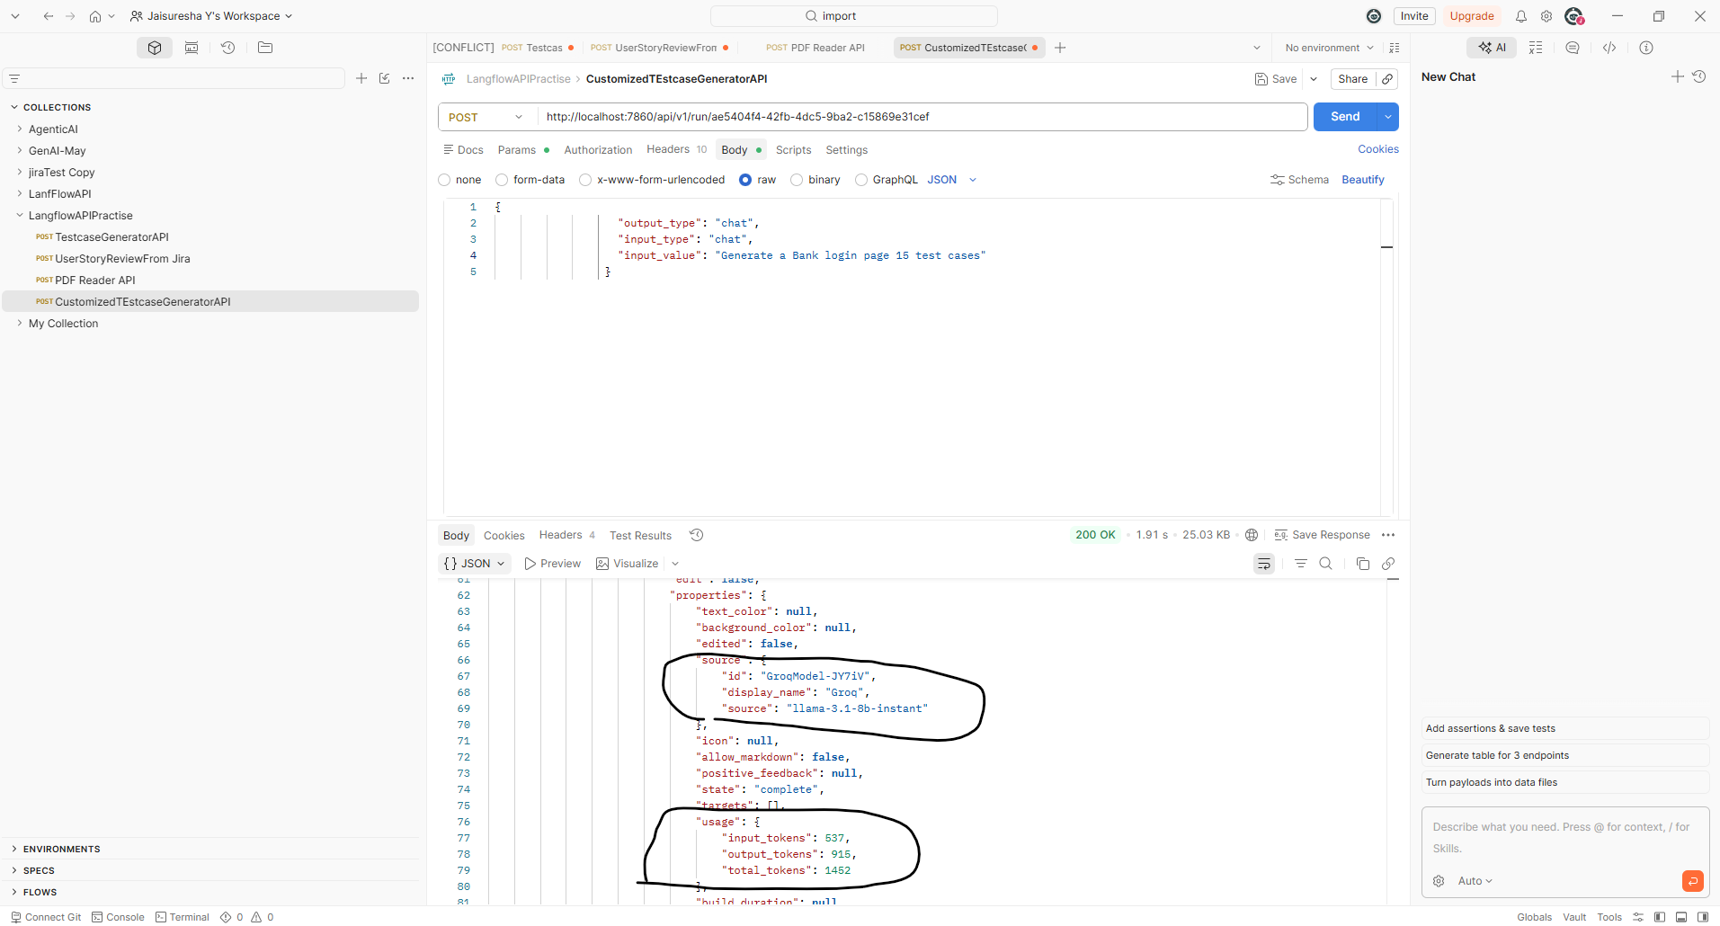

After Changing the Max token output as 300, system is limited only with below numbers of test cases
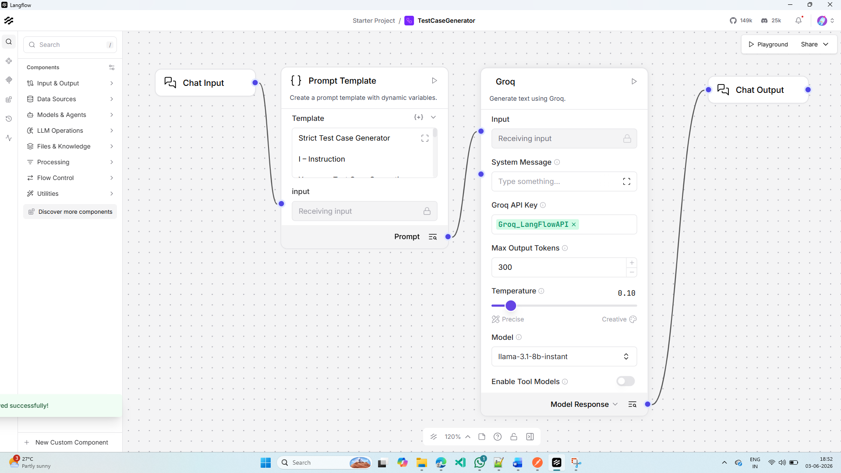
User
Generate a fund transfer 15 test case
AI
Finished in836|0.8s
TC_FT_001 Title: Verify successful fund transfer within daily limit Preconditions: User is logged in with an active account, sufficient balance, and daily transfer limit is not exceeded Steps:
- Navigate to Fund Transfer
- Enter beneficiary details
- Enter amount within daily limit
- Submit transaction Expected Result: Transaction completes successfully and confirmation is shown
TC_FT_002 Title: Fund transfer with insufficient balance Preconditions: User is logged in with an active account, insufficient balance Steps:
- Navigate to Fund Transfer
- Enter beneficiary details
- Enter amount exceeding available balance
- Submit transaction Expected Result: Error message indicating insufficient balance is displayed
TC_FT_003 Title: Fund transfer with invalid beneficiary details Preconditions: User is logged in with an active account Steps:
- Navigate to Fund Transfer
- Enter invalid beneficiary details (e.g., incorrect account number)
- Enter amount within daily limit
- Submit transaction Expected Result: Error message indicating invalid beneficiary details is displayed
TC_FT_004 Title: Fund transfer with daily limit exceeded Preconditions: User is logged in with an active account, daily transfer limit is exceeded Steps:
- Navigate to Fund Transfer
- Enter beneficiary details
- Enter amount exceeding daily limit
- Submit transaction Expected Result: Error message indicating daily limit exceeded is displayed
TC_FT_005 Title: Fund transfer with

