# Files to be distributed

The design tables/charts, the main document, and all worksheets need to be distributed to the class. Please include the following items:

1. File ENCN336.pdf
2. Folder /REF
3. Folder /WORKSHEET

# To generate pictures

The python script **GENERATOR.py** is written to generate the TeX file to compile all pictures.

Executing **GENERATOR.py** creates a file named **PICCOMPILATION.tex**, compiling it gives PICCOMPILATION.pdf file.

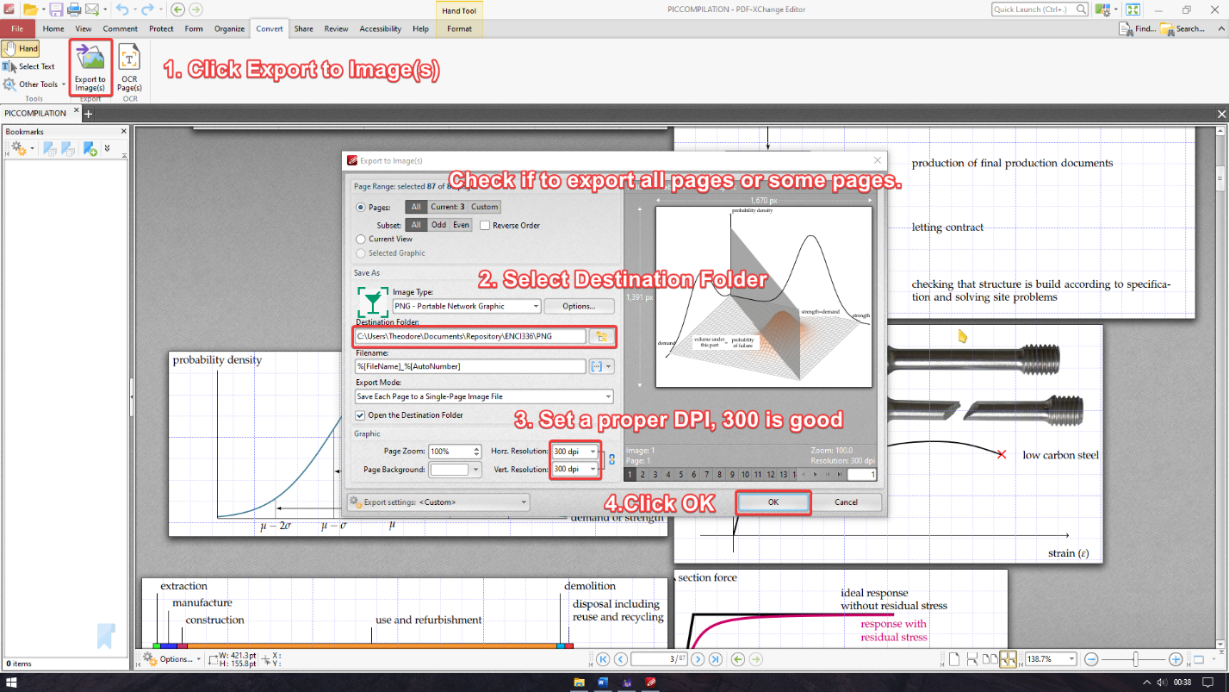[PDF-XChange Editor](https://www.tracker-software.com/product/pdf-xchange-editor) provides functions to export PDF files to PNG pictures.

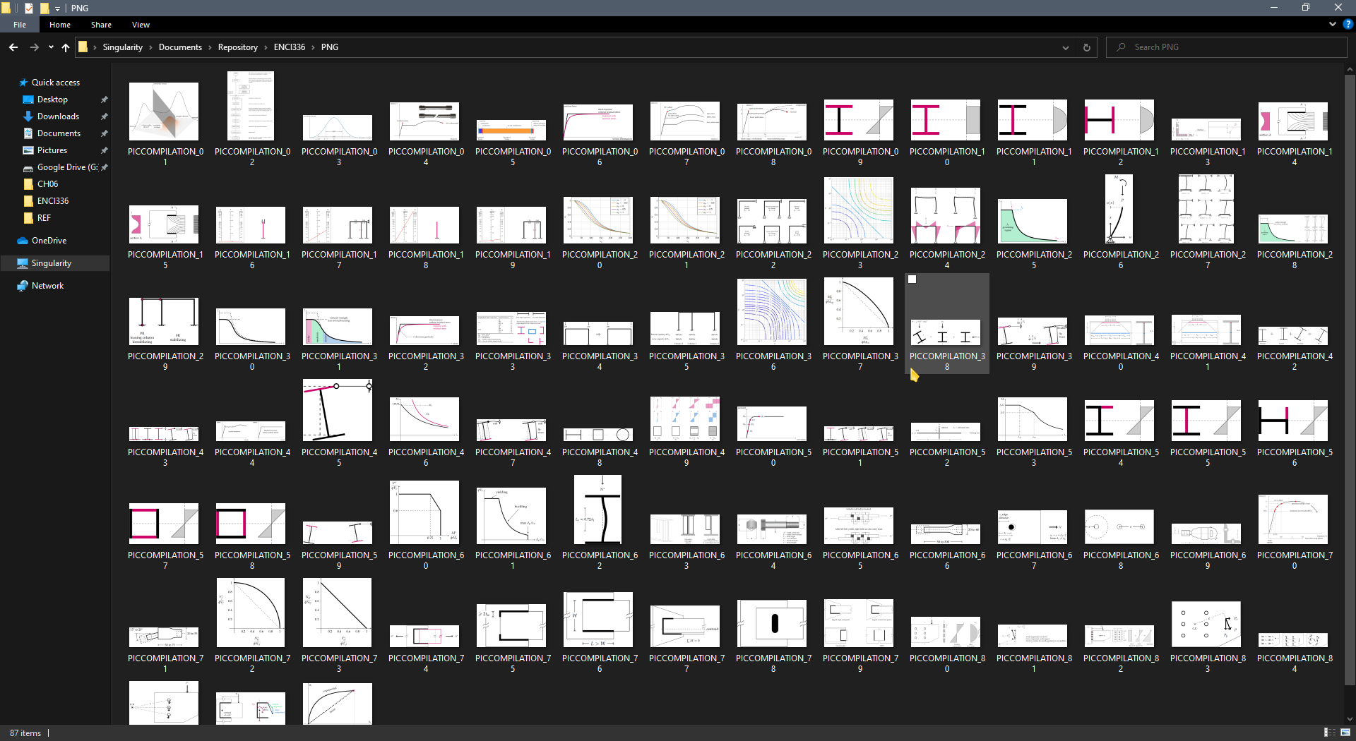The generated PNG files can be used in slides if needed.