SUPPLEMENTAL LEARNING PRACTICE JAM

TOPIC: Paragraph Structure

APPLICABLE COURSES: All courses that require writing.
LEARNING OUTCOMES
- Students will be able to arrange a set of sentences to create a logically organized paragraph.
- Students will be able to create a paragraph outline for a given topic sentence
  - Compose main points that logically follow the topic sentence
  - Compose examples or other supporting details that support the main points
  - Add commentary sentences that explain how the examples support the main points
  - Select appropriate transitions to use between the main points
  - Write a fitting conclusion

CONTENT
- the components of a well-developed paragraph

PREPARATION & MATERIALS
Review materials from Paragraph Structure Workshop and the model paragraph provided prior to session.
- Workbooks to review 8-11 sentence source-based paragraph outline
- “March to Freedom” model paragraph (for LCD screen or document camera)
- Laminated sentence strips of “Genetically Modified Food” paragraph (5 sets)
- Laminated 8½x11 cardstock for arranging strips (5 pieces)
- Outline template handouts (20) with one type of outline style on each side
- Instructions for Activity1, 2 (for LCD screen or document camera)
- Tutor key for Activity 1 (sentence strips)

METHOD
Review Paragraph Structure (10 minutes)
- On LCD projector, or at document camera, Tutor reviews the components of an effective paragraph, including transitional expressions, using the model paragraph. (5 min)

Activity 1. Logically Arranging Sentence Strips into a Paragraph (15 minutes)
- Tutor puts Activity 1 instructions on document camera or LCD projector and reviews with class. Students break into pairs or groups of 3.
- Tutor distributes one set of sentence strips and one laminated card stock page to each group.
- In groups, Students:
- read their sentences and identify the topic sentence and conclusion sentence
- lay topic sentence at the top of the page and conclusion at the bottom
- identify three main points
- Identify three supporting details (direct quotations)
- Identify the commentary sentences that explain about each quotation
- Place the sentences in logical order to form an effective paragraph outline
- Tutor circulates to answer questions
- Two volunteers from one group bring their group’s work to the document camera to show their results. Tutor checks for accuracy. Other groups review their paragraphs for correct sentence order. Tutor asks for questions.

Activity 2. Outlining a Paragraph for a Given Topic (25 minutes)
- Tutor displays a topic sentence for all students to use:
Topic sentence: I’ve learned that success in college isn’t easy.
- Tutor distributes two-sided outline template and reviews each paragraph component on the outline. Students are encouraged to use the outline that is easiest for them.(5 min)
- Students write the topic sentence on their outline.
- Using the brainstorm worksheet, students individually brainstorm ideas about the difficulties in achieving success in college. Then in Pairs, students compare ideas and brainstorm more together. (5 min)
- Students write main points on the outline, adding transitional expressions for each.
- Students add supporting details (examples) and commentary sentences for each example. Tutor circulates and provides feedback. (20 min)
- Volunteer shares outline on document camera (5 min)

FINAL REFLECTION
What Do You Want To Remember? (5 minutes)
Student pairs share with each other:
- What part of today’s activity helped you learn to effectively outline a paragraph?
- What is important to remember when writing paragraphs?

ASSESSMENT METHOD
Throughout the practice jam, the Tutor circulates and notes the satisfactory responses from students.

Well Developed Source-Based Paragraph
Name
Instructor
English 081
Date
Qualities That Helped Edith Singer Survive
Edith Singer possessed three qualities that helped her survive Auschwitz: optimism, bravery, and resourcefulness. Edith’s optimism is one important trait that helped her survive. After she received her tattoo, Singer stated, “After they finished tattooing me I did not feel humiliated at all. I felt hopeful. I will live” (55). Even though she was branded and treated cruelly, she had hope that they would not have tattooed her if they were going to kill her. This optimism gave her the will to live. Another quality Singer possesses is bravery. She bravely attempted to defeat the Nazis in order to save herself and others at Auschwitz. When Singer was working in the factory she said, “When I realized that I could not convince the workers and that I had to act alone, I started sabotaging another way. Cautiously, I mismatched the holes of the metal plate with the holes of the pipe”(66). She showed bravery when she tried to rally a rebellion. When it failed, she courageously sabotaged the anti-tank missiles knowing that if they caught her they would kill her. Her final trait and possibly her most important one is her resourcefulness. After figuring out how to steal food for her sister and mother, she said, “The very thought that I could lessen their hunger and my own gave me strength to continue doing this until I left Auschwitz” (48). Her resourcefulness helped her to steal food, shoes and other necessities without getting caught, and ultimately that gave her the strength to get through Auschwitz. Singer’s survival can be attributed to her bravery, optimism and resourcefulness. These qualities helped her to eventually share her stories with the world.
Genetically Engineered Food
The United States Food and Drug Administration should require that genetically engineered food be clearly labeled to protect the health, rights, and preferences of American citizens.
The first reason for clear labeling is that genetically modified food products pose possible health risks since they are not subject to mandatory safety tests.
Shahin Berenji reports in the Journal of Research for Consumers that Americans “have not only been exposed to potentially unsafe food, but the risks are largely invisible and imperceptible to consumers” (21).
An important role of the government is to protect the health of citizens, so alerting consumers through labeling is an important way of helping them avoid potential health problems.
In addition, labels must be mandatory because not doing so withholds necessary information from consumers as they make decisions at the supermarket.
According to Berenji, because the current law “withholds crucial information from consumers” and shoppers are “unable to differentiate GE from non-GE foods,” they cannot make informed decisions (21).
Consumers have the right to know if their food has been genetically modified so that they can make knowledgeable choices about which foods they want to buy.
Finally, not labeling GE foods is unethical because it violates the will of the majority of Americans.
Results from a survey undertaken in 2004 by the Pew Initiative on Food and Biotechnology reveal that “92% of those polled favor the labeling of foods that are genetically modified” (Berenji 21).
The FDA should heed the will of the majority and respect the preferences of American citizens.
With the rapid expansion of biotechnology producing more and more genetically engineered crops and animals, it is vital that the government protect its citizens by mandating full disclosure on food labels.

Activity 1
Logically Arranging Sentence Strips into a Paragraph
(15 minutes)

This set of sentences will make a good paragraph—in the correct order.

- Read your sentences out loud (or ask a group member to read yours out loud).

- Find the topic sentence and conclusion sentence. Lay the topic sentence at the top of the page and the conclusion sentence at the bottom.

- Find three main points and place them on the page.

- Find three supporting details (direct quotations) and place them under the main points that they illustrate

- Add a commentary sentence to each supporting detail sentence

- Determine the order of the sentences.

- Place sentence strips in the envelope for tutor pickup.

Activity 2
Paragraph Brainstorming & Outlining.
(25 minutes)

Activity 2 Topic Sentence

I’ve learned that success in college isn’t easy.

- Write the topic sentence on your outline.

- Using the Brainstorm worksheet, brainstorm ideas about the difficulties in achieving success in college.

- Compare ideas with a partner and brainstorm more together.

- Write the main points on your outline. Be sure to start each main point sentence with a transition.

- Add a supporting detail (example) for each main point.

- Add a commentary sentence (explanation) for each example.

- Share your outline with a partner.

- Volunteer to share your outline with the class.

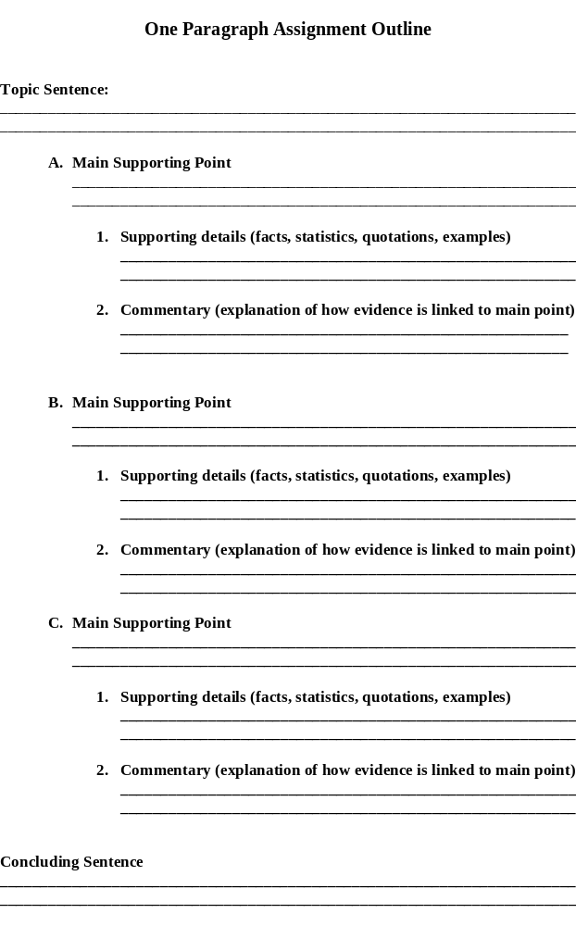
One Paragraph Composition Outline

Topic Sentence:

Main Supporting Point #1  Complete sentence with transition: | Main Supporting Point #2  Complete sentence with transition: | Main Supporting Point #3  Complete sentence with transition:
Supporting details:  (facts, statistics, quotations, examples) | Supporting details:  (facts, statistics, quotations, examples) | Supporting details:  (facts, statistics, quotations, examples)
Commentary:  (explanation of how evidence is linked to main point) | Commentary:  (explanation of how evidence is linked to main point) | Commentary:  (explanation of how evidence is linked to main point)
Thoughtful Conclusion Sentence:

Brainstorming Worksheet
Use this space to write down as many ideas as you can about the difficulties of achieving success in college

Final Self-Reflection

What part of today’s activity helped you learn to effectively outline a paragraph?

What’s important to remember when writing paragraphs?

