Adding&Subtracting Decimals  Quiz | Name:  Date:

- Which digit is the thousandths place in the Decimal 38.692174? 1. _________________

- What does the “6” mean in the decimal 0.0241673? 2. _________________

- Round the Decimal 37.96129 to the Tenths place. 3. _________________

- Round $572.93518 to the nearest cent. 4. _________________

- 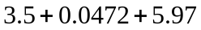 5._________________

- 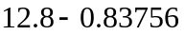 6._________________

