Adding&Subtracting Decimals  Quiz KEY | Name:  Date:

- Which digit is the thousandths place in the Decimal 38.692174? 1. _______2__________

- What does the “6” mean in the decimal 0.0241673? 2. __6 out of 100,000___

- Round the Decimal 37.96129 to the Tenths place. 3. ____38.0_____________

- Round $572.93518 to the nearest cent. 4. ___$572.94____________

- 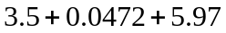 5.___9.5172______________

- 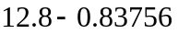 6.__11.96244_____________

