Equations of Lines  Quiz-KEY | Name_________________________  Date__________________________

- Find the equation of the line in slope-intercept form that goes through the points 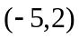and 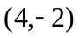.
Answer: 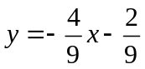

- Find the equation of the line in slope-intercept form that goes through (–3, 1) with slope .

Answer: 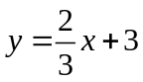

- Find the equation of the line in the slope-intercept form that passes through the point (0, 3) and perpendicular to the line whose equation is 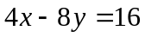.

Answer: 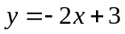

- Find the equation of the line that passes through the point (-4, 3) and has an undefined slope.

Answer: x = -4

- Find the equation of the line in slope-intercept form that goes through the point (1, 4) and is parallel to 2x – 5y = 7.

Answer: