Multiplying & Dividing Decimals  Quiz | Name:  Date:

- Multiply the following: 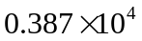 1. _________________

- Multiply the following: 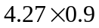 2. _________________

- Multiply the following: 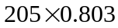 3. _________________

- Divide the following: 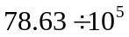 4. _________________

- Divide the following: 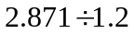 5._________________

- Divide the following and round your answer to the tenths place. 6._________________

